Group B: Project 1

1. a)

The first part of the problem is to generate arrays of N = 1,000 and 1,000,000 random numbers between [0, 1]. Then the probability distribution was plotted with a variety of bin numbers. The random numbers in the interval [0, 1] are generated using the command random.random(). To obtain an array of N values, a function is created which takes in the desired size of the array and sets up a while-loop to calculate N random values and place them in an array. The function then returns the array.

In order to graph the probability distribution, another function is created with the arguments being the array of random values,its size, and the number of bins. This function made use of the function plt.hist(). This function was called four times for each array size for bins = 10, 20, 50, and 100. Figures 1. d. and 2. d. are most illuminating as the uniform nature of the distribution is more prominent for N = 1,000,000. However, as the resolution increases via a higher number of bins, the slight uneven nature of the distribution is evident. In the case of N = 1000 values, the array is relatively small and the distribution does not exhibit uniform behavior.

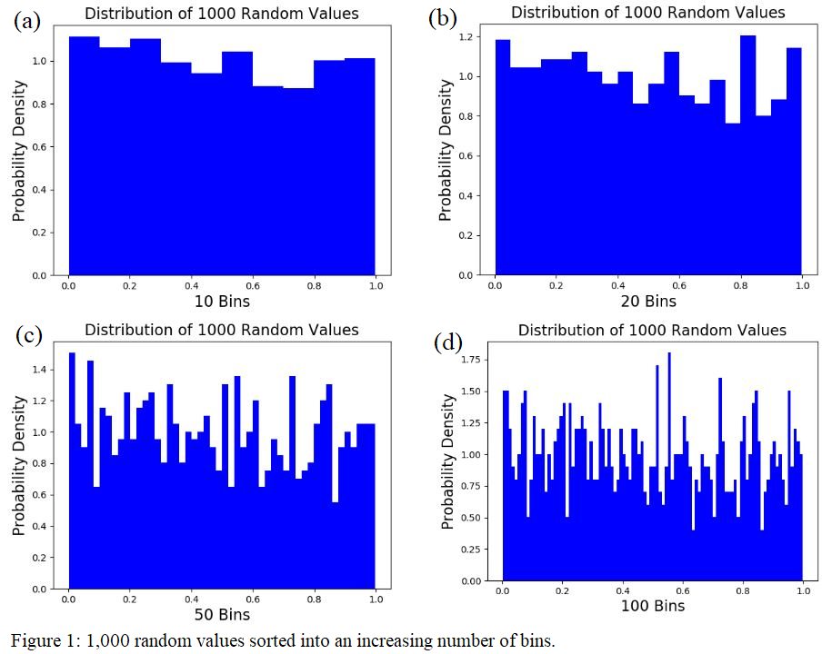

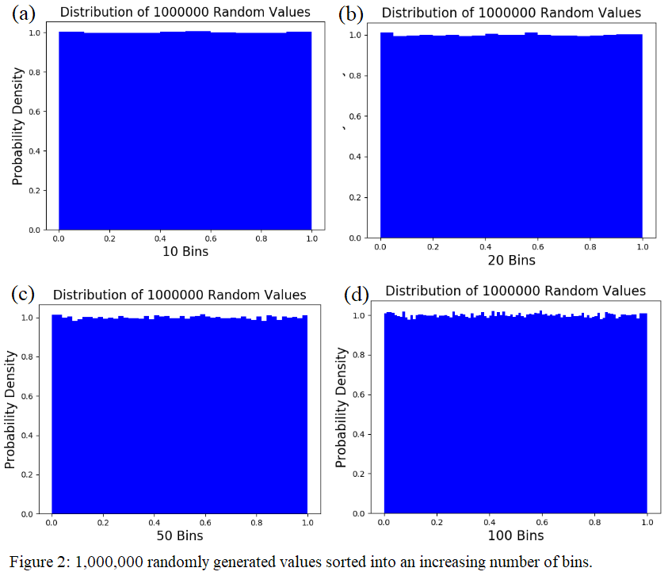

1. b)

The second portion consists of creating an array of random values that are distributed following a Gaussian curve. Again, two arrays of sizes N = 1,000 and N = 1,000,000 are computed. The values are then plotted in a histogram to clearly see the Gaussian distribution of the array.

The array of random values distributed according to a Gaussian curve were calculated using the Rejection Method, also known as the hit-or-miss method. This was achieved using a function which took as an argument the size of the desired array. Then, a y-value was calculated in the interval [0, f_max], where f_max is the amplitude of the Gaussian function that was given. This was done using a simple if-statement which rejected random values generated out of the interval. Then a random x-value is created using the same method as in part (a).

The final step involves using this x-value in a function which calculates P(x). This value is then compared to the y-value in [0, f_max]. If P(x) ≥ y, then this x-value is added to the random Gaussian values array. Histograms were then created for a variety of number of bins. In figures 3 and 4, there are some bins which have no values. This is an issue that is currently being resolved.

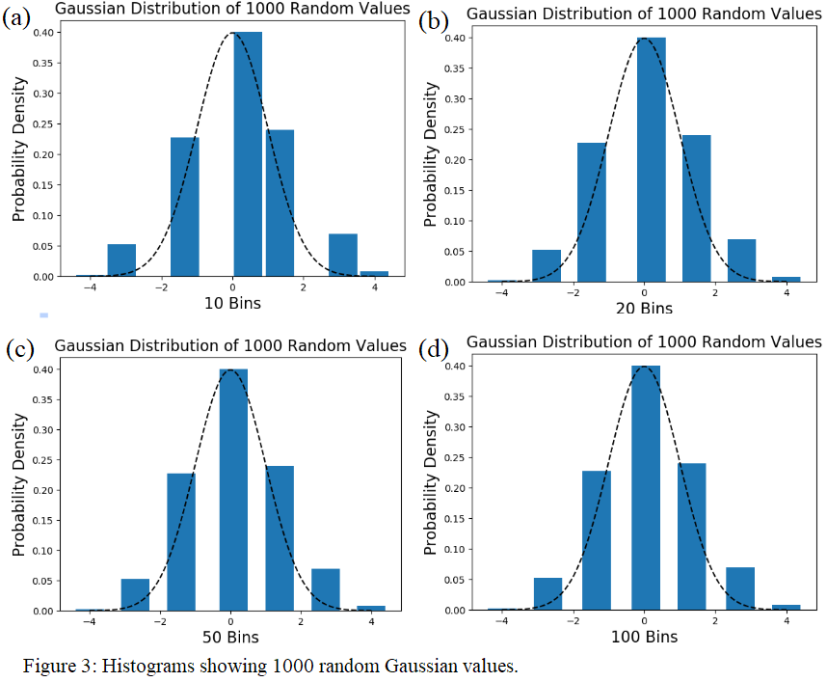

2. a). Using the symmetry of the Gaussian function, and the fact that $\int_{0}^{∞}{}x^{2}e^{-x^{2}/σ{}^{2}} = 2\sqrt{ℼ} (\frac{σ}{2}){}^{3} = (1/4)\sqrt{ℼ}σ{}^{3}$, 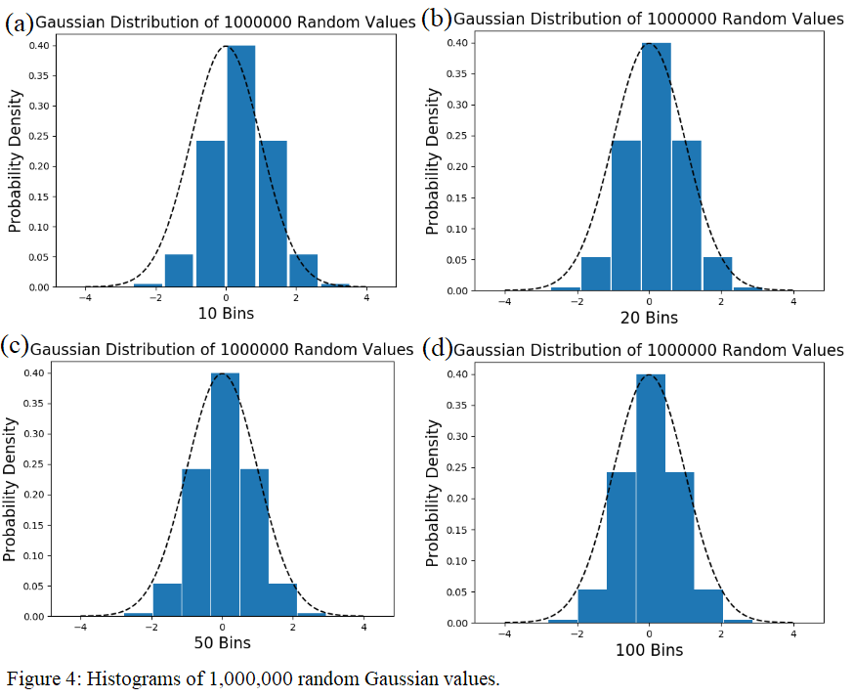

we can find $\int_{-∞}^{∞}{}x^{2}e^{-x^{2}/2σ{}^{2}} =2 \int_{0}^{∞}{}x^{2}e^{-x^{2}/2σ{}^{2}} = \sqrt{2ℼ}σ{}^{3}$

and, therefore, $\frac{1}{σ\sqrt{2π}}\int_{-∞}^{∞}{}x^{2}e^{-x^{2}/2σ{}^{2}} = \sqrt{2ℼ}σ{}^{3}/(\sqrt{2ℼ}σ) = σ^{2}$.