Problem 1A:

* Simulated percolation for several different grid sizes
  + For each grid size, sampled 100 probabilities of a grid point being occupied
  + Used RNG to assign each grid point as occupied or unoccupied
  + Made second grid to assign each occupied grid point a number based on the cluster its in
  + Iterated through each point 500 more times to ensure that clusters that intersect are renamed as the same cluster
  + For each probability, I checked if any clusters reach both ends of the vertical or horizontal axis
    - If so, cluster is labeled as spanning
      * The first spanning cluster for each probability is plotted on a visible lattice

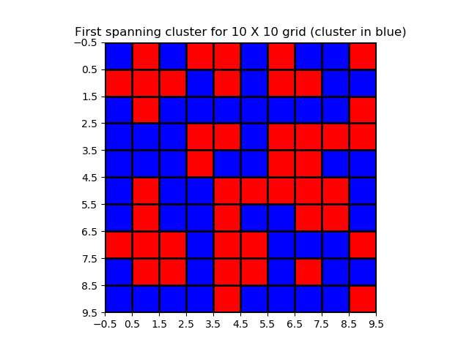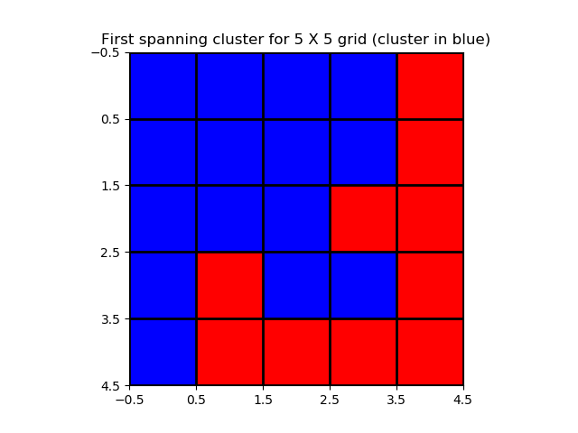

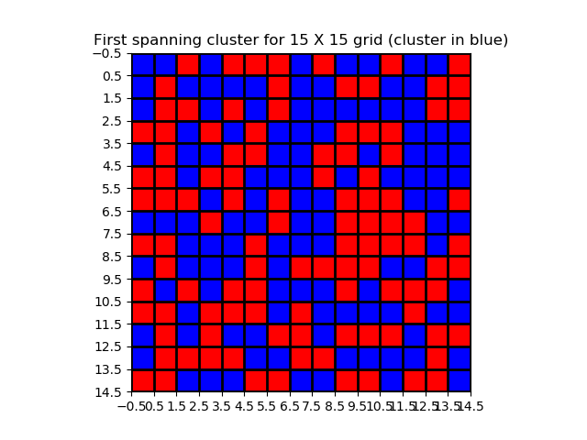

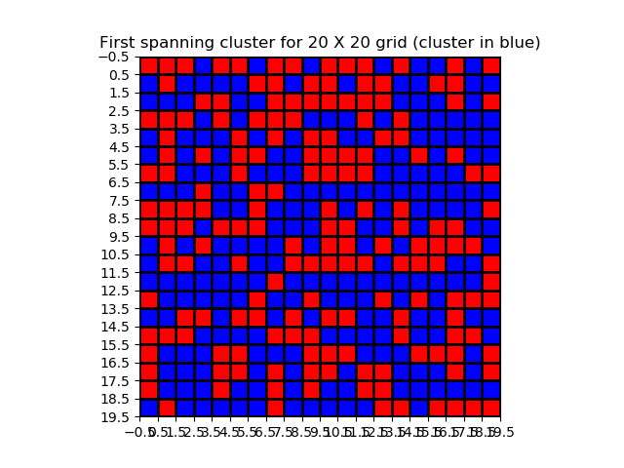

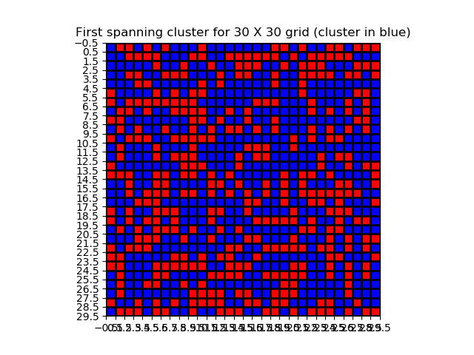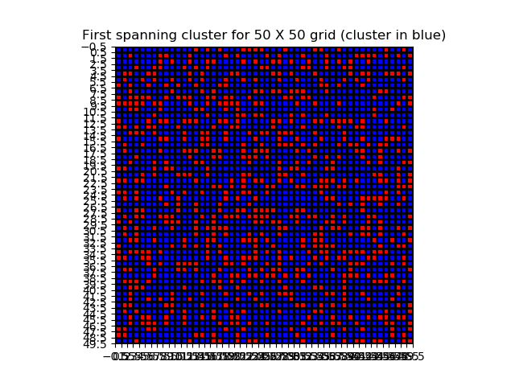

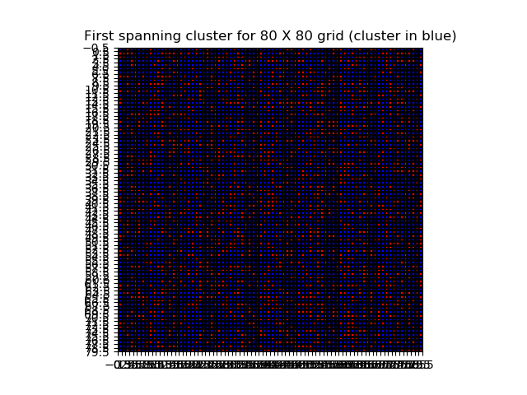

* The probability for the first cluster for each grid size is plotted with respect to grid size.
  + For smaller grid sizes, the critical probability, where the first spanning cluster appears, is much smaller
  + The lack of consistency for smaller grid sizes is likely due to random sampling error
  + The inverted graph has an asymptote at around P = 75 , which estimates that an infinitely large grid would have a critical probability close to 75

