EBNS Digital Marketing Strategy
Executive Summary
This report analyzes The Shop by EBNS’s digital marketing strategy and identifies key opportunities to improve brand awareness, search visibility, and customer engagement. While EBNS benefits from strong brand authenticity and popular seasonal offerings, its efforts lack consistency and effective SEO, limiting its reach, particularly due to poor website performance. To address this, the report recommends improving website speed and SEO, implementing a consistent social media content strategy, and leveraging student ambassadors and partnerships to expand reach. These actions aim to increase online visibility, grow social media followings, and position EBNS as a leading campus coffee shop.
Overview of Business
EBNS Coffee is an independent shop in Madison serving the UW–Madison community relying on foot traffic, word-of-mouth, and a strong campus presence. Its rotating seasonal menu drives repeat visits, and beyond the products, staff-created content on TikTok and Instagram gives the shop a face and a personality online. The website presents a welcoming search presence for guests simply browsing for an authentic Madison coffee shop.
After speaking with business management and assessing the business’s strengths and weaknesses, some strong business goals stand out. In the short term, the business would like to build widespread brand awareness on and around UW-Madison campus, establish EBNS as a recognizable name for incoming freshmen before and upon arrival, and improve search visibility so that EBNS appears at the top of “coffee shops near me” results. In the long term, the business would like to become the go-to, staple coffee shop on campus - a place where incoming freshman look forward to visiting, expand reach to non-student audiences during the slower summer months when student traffic declines, and develop retail sales as a meaningful revenue stream, particularly during off-peak periods. This directly relates to the digital marketing goals which are specific, rational goals with recommendations to start working towards the larger long and short term business goals using social media and website optimization. The digital marketing goals are as follows:
- Improve overall organic search engine placement ranking by 50% using Google PageSpeed to ensure EBNS appears prominently when prospective customers search for coffee shops near campus.
- Increase reach and follower count across all active social media platforms by 15% by December 2026, using a consistent content cadence and strategic partnerships with relevant local and campus pages. Target goals include Instagram reaching 10,044 followers (+1,310), TikTok reaching 4,827 followers (+630), and Facebook reaching 623 (+81).
Digital Marketing Audit
EBNS has a strong foundation to begin with regarding its digital marketing strategy, but could be even more strategic in their efforts to capture new audiences and retain existing ones. They’ve tried paid TikTok promotions, and those promotions bring in views and followers, but that success doesn’t seem to carry over to their regular posts.
One thing working in the shop’s favor is their knowledge of top selling products. About 95% of their revenue during the school year comes from food and drinks, especially seasonal menu items. This provides them with important direction for content to focus on, particularly when it comes to new or limited-time items. Their loyalty program is also a strong tool for engagement, with things like double star days and reward tracking through texts. The issue is that most of the promotion is happening in-store, so they’re missing opportunities to push it through more digital channels.
EBNS is currently missing opportunities to expand through digital channels. Compared to other student-targeted coffee shops in Madison, the biggest gaps are consistency and visibility. Successful competitors post regularly, use short-form video, and highlight not just products, but the overall space and people. They also rank highly in organic search terms like “coffee shops near me,” which EBNS wants to improve. While paid ads can help, they are most effective when supported by a strong organic presence.
Online listening reveals several important insights for EBNS’s strategy. Overall sentiment is very positive, with customers consistently praising drink quality, aesthetics, and the welcoming atmosphere. This reinforces that the experience matters as much as the product. EBNS is often described as “aesthetic” and “study-friendly,” language that also appears broadly in conversations about coffee shops on Reddit and social media. At the same time, most discovery in the Madison coffee market happens through broad search terms like “coffee shop” rather than brand names, explaining EBNS’s low direct search volume. This highlights a key opportunity to build brand awareness and improve local SEO by targeting “coffee near me” and creating content that emphasizes its study environment and visually appealing drinks.
Running EBNS's website through Google PageSpeed Insights revealed a clear opportunity relating to their search performance: a mobile performance score of 11 out of 100, well below the small business average of 50–60. This matters because Google uses page speed as a direct ranking factor, so slower sites rank lower meaning fewer students find EBNS when searching "coffee shops near me." The biggest culprits are a 20.4-second load time (Google's standard is under 2.5 seconds), a layout shift score of 1.135 (anything above 0.1 is poor), and over 700 kilobytes of unnecessary code blocking the page from rendering quickly. Beyond speed, 83% of pages are missing the short descriptions that appear in Google search results, no page title includes a location like "Madison, WI," and a formerly listed page now returns an error. These are all factors that suppress local search visibility. Despite these gaps, the foundation is strong: a 4.9-star Google Business Profile, backlinks from Madison Magazine and the Badger Herald, and a 92 out of 100 on Google's SEO structure checklist mean the performance issues are fixable and represent one of the most direct paths to gaining free organic traffic.
Target Market Online
To understand how to position a brand, it is important to fully understand one's target market. EBNS primarily targets 17-24 year old females who live in Madison, Wisconsin and are attending post-secondary education. A customer profile to represent this population is a girl named Lilly. She is attending the University of Wisconsin - Madison, is 19 years old, and involved in a sorority. Her hobbies include hanging out with friends, online shopping, attending workout classes, crafts, and trying new restaurants. Even though she makes coffee at home, Mintel noted that she enjoys going to a coffee shop for a “premiumization” experience focusing on a premium and customizable experience. Additionally, Lilly uses social media platforms such as Instagram, TikTok, YouTube, and Snapchat according to Pew Research, and she posts on her TikTok and Instagram page. When searching for reviews, she starts on a search engine like TikTok that shows her user generated content from peers. The short form content she watches will lead her to continue searching on her mobile device or computer according to Encoura. When searching, she trusts links that appear closer to the top as well as AI responses because of the simple and fast result. Lilly enjoys trying new things like the EBNS menu changes, and Lilly may post a review on her social media. She goes on social media when seeking advice, so it is important to have the answers accessible on your page. Things she may wonder about are the seasonal drinks options, store hours, shop location. More about Lilly is located in Appendix B.
Recommendations
Recommendation 1: Implement targeted website and SEO improvements to increase Google PageSpeed score by 50% within three months.
EBNS's most immediate digital marketing opportunity isn't a new campaign; it's making sure the website works for the customers who are already looking. A PageSpeed score of 11 out of 100 shows how vital this fix is to boost the site's organic traffic. The highest impact fix is reducing the volume of unnecessary code loading on every page visit. Disabling unused apps and features in the site's backend is the single fastest way to cut load time and would move the performance score more than any other action. To view additional Google PageSpeed results, visit Appendix A. From there, the hero image, the first thing a visitor sees, should be set to load first and fast, rather than waiting in line behind background scripts. Every product and menu image also needs a defined size so the page stops rearranging itself as photos load in, which is the primary driver of the poor layout shift score. Images should also be resized and reduced to decrease load times, which can be done through many different apps depending on the platform you're using. On the SEO side, each page needs a short, unique description written for it (the line of text that appears under a link in Google search results) with "Madison, WI" included so Google connects EBNS to local searches. Page titles should follow the same logic: "The Kenzie Cold Brew | The Shop by EBNS — Madison, WI" tells Google exactly who you are and where you are. The broken "Book a Coffee Bar" link should be redirected to a working page so no visitor hits a dead end. Also adding structured business information such as hours, address, and price range in a format Google can read automatically means those details can appear directly in search results, giving students the answer before they even click.
Recommendation 2: Launch student ambassador programs to generate authentic, peer-to-peer content and pursue collaboration with high-reach campus adjacent accounts.
One of the most cost-effective levers available to EBNS is strategic collaboration. It is crucial to not only post more content, but get the right people and pages to amplify the brand to new audiences. This relates back to our second goal of increasing reach and followers. Consumers trust influencer and user-generated content recommendations over direct brand messaging and nano-influencers with smaller, highly engaged followings are more cost-effective at generating revenue than their macro counterparts—making them an ideal fit.
A rotating ambassador program creates a consistent pipeline of authentic, peer-created content while deepening EBNS's presence across campus social circles. Micro-influencers generate engagement rates of 7-20%, compared to just 5% for macro-influencers (MarketingProfs). Knowing this, a student with 800 highly engaged campus followers who posts genuinely about their favorite coffee shop is worth more to EBNS than a polished ad to a broad audience. Each month, recruit one or two students from different corners of campus life — a student athlete, a journalist, a club leader — and offer free drinks for the month in exchange for two or three posts or stories. Give them creative freedom so the content feels authentic, and feature their posts on EBNS's own page with credit. Over a semester, this builds a rotating cast of real EBNS regulars, each reaching their own distinct campus network, with minimal spend. Research shows restaurants working with influencers can generate roughly $6.50 for every $1 spent (ConvineandConvert) — and when the voice is a trusted peer, the return on authenticity is even stronger.
Additionally, collaborations with freshmen meet and greet pages (ex. UW Madison's Class of [Year] Instagram and Facebook groups) would create high-reach opportunities for incoming freshmen looking to discover their new go-to spots. We recommend reaching out to page admins in late spring or early summer, which is before SOAR and August move-in, and offer a simple exchange: a pinned post or story mention in return for a free drink or small sponsorship. Frame it as a genuine recommendation rather than an ad. Pair it with a freshman-exclusive offer — "show your new Wiscard, earn 15 bonus loyalty points on your first visit" — to give incoming students a concrete reason to walk in and a built-in reward for doing so. A similar audience could be accounts like Wisco Chicks and similar Madison-based community pages that have audiences that already trust their recommendations and actively seek out local spots.
Recommendation 3: Implement a consistent weekly content calendar focused on brand awareness, menu updates, and customer engagement.
A major opportunity for EBNS is to move from occasional posting to a structured, repeatable content calendar. This relates back to our second goal of increasing reach, engagement, and followers. Right now, content is mostly created in real time without a clear schedule, which makes it harder to build consistent brand awareness. A simple but effective starting point would be two planned posts per week, focused on a mix of brand storytelling, product promotion, and customer engagement. Each week could follow a predictable structure:
- Post 1 (Brand and Lifestyle Content): This could focus on highlighting the shop experience, such as “day in the life at EBNS,” staff spotlights, study vibes, and behind the scenes content. This helps build emotional connection and reinforces EBNS as a community-focused, aesthetic campus coffee shop.
- Post 2 (Product and Promotion Content): This would focus on menu updates, seasonal drinks, or promotions like loyalty rewards, double star days, or new item launches. This post should also highlight high-performing products like matcha and cold brew since online listening shows these categories drive the highest engagement. Refer to Appendix D for an example instagram post regarding the loyalty program.
Additionally, if there is a trend you want to take part in, that counts as a brand and lifestyle post or is an addition to the two previously mentioned posts. Having a pinned post with your monthly flavors would be a great addition too because it is easy to access and visible. Moreover, EBNS should intentionally use story highlights to organize key information such as your consistent menu, apparel, loyalty program, hours, and pop up and catering so new customers can quickly understand what the shop offers. Many of the highlights are lengthy and include content dating all the way from 2018. Highlights go from earliest to most recent posts, so your recent content is getting lost. I recommend going through your highlights and limiting the content from 2018-2023, so the most recent stories are more visible. To expand beyond in-store traffic, content should lean into vending and catering opportunities too, especially during slower summer months. This includes short-form videos with catering setups, GRWM style content for event prep, or behind-the-scenes clips of vending at local events. These posts help position EBNS as more than just a campus coffee shop and introduce additional revenue streams.
Finally, integrating the loyalty program into content is key. Posts can highlight rewards progress, customer milestones, and double star day reminders in a more visual, engaging way. This helps reinforce repeat visits while also making the program more visible to new customers. Overall, this recommendation improves consistency, strengthens brand recognition, and ensures EBNS is showing up regularly in both student and local audiences’ feeds. This directly supports their goal of increasing awareness and becoming a go-to coffee shop in Madison.
Recommendation 1 Metrics
Progress should be tracked monthly through two free tools: Google PageSpeed Insights and Google Search Console. PageSpeed shows the current performance score and flags what still needs fixing, while Search Console shows how often EBNS appears in Google searches, which terms are driving traffic, and whether any pages have errors. The three-month benchmark is a PageSpeed score of at least 17 (a 50% improvement from 11), with a score of 40–50 indicating the highest impact fixes are complete. On Search Console, rising impressions (how often EBNS appears in search results) is the earliest signal of momentum, typically preceding traffic gains by a few weeks. If scores stall, rerun PageSpeed after each individual fix to isolate what's working rather than guessing. If impressions remain flat after two months despite technical improvements, shift focus toward adding location-specific copy to product pages, as Google may not have enough on-page content to know when to surface the site.
Recommendation 2 Metrics
When collaborating with other accounts, follower growth rate on Instagram and TikTok during active collaboration periods vs. non-collaboration periods isolates whether partnerships are actually moving the needle. New profile visits and link clicks in bio in the days immediately following a collaboration post can also be a helpful insight. Additionally, using Instagram Insights on posts that are reposted and shared by collaborators can be a telling sign on whether the collaboration is garnering more reach. When looking to see if the collaboration turned from awareness into action, creating a partner-specific QR code or referral phrase can be a clear signal for whether the collaboration is actually improving sales volume. Finally, looking for noticeable spikes in foot traffic or transaction rate in the 48–72 hours following a partner post can signal whether customers are taking advantage of the offers.
Recommendation 3 Metrics
To track social media success, you can create a ranking system for different ways people engage with posts to analyze how viewers are responding to your content. The values are evaluated based on the significance of the interaction. To ensure that the post has been able to maximize its visibility, I would recommend tracking at least 72 hours after initially posting. Then, add the original values for each category and a formula in the total column will multiply each engagement category's point value by the raw value and sum it. This creates a metric to evaluate how people engage with posts and what content is performing well. Based on the last 15 Instagram posts from April 13-27, the average engagement score is 300.7. More insights on Instagram and TikTok point systems are in Appendix C. If the points are not increasing after incorporating the recommendations we presented, you could research similar coffee shop social media pages in similar campus environments like Minneapolis, MN. You could compare content, events held in their store, and opportunities your shop could incorporate. Also, asking someone to find specific information on your social media could show you what information needs to be highlighted.
Conclusion
EBNS has a strong foundation but must improve consistency and digital optimization to fully capitalize on its potential. By enhancing website performance, strengthening content strategy, and utilizing peer-driven marketing, EBNS can increase visibility and engagement. These efforts will support both short-term growth and its long-term goal of becoming a go-to coffee destination in Madison.
Appendices
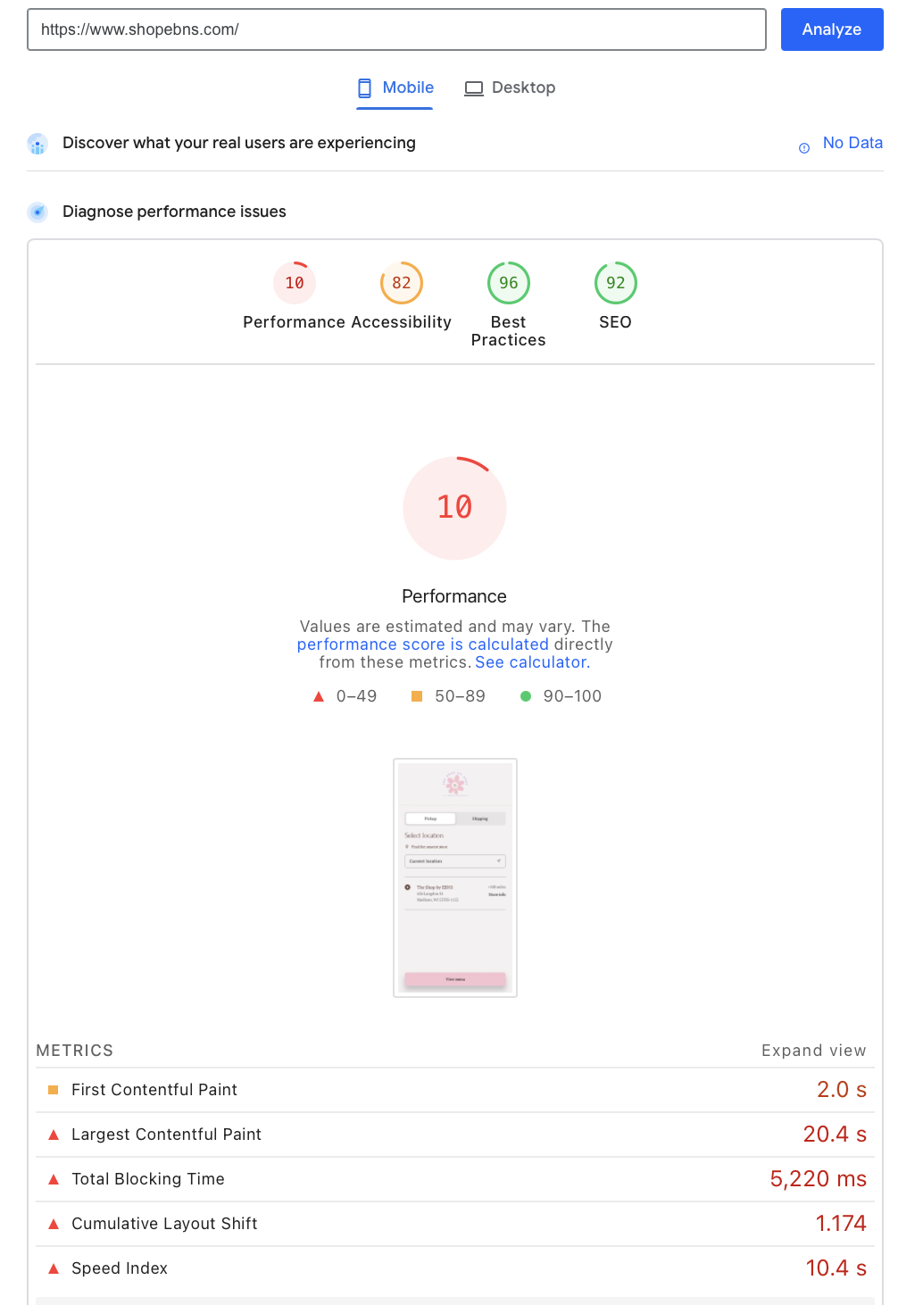
Appendix A: Recommendation #1

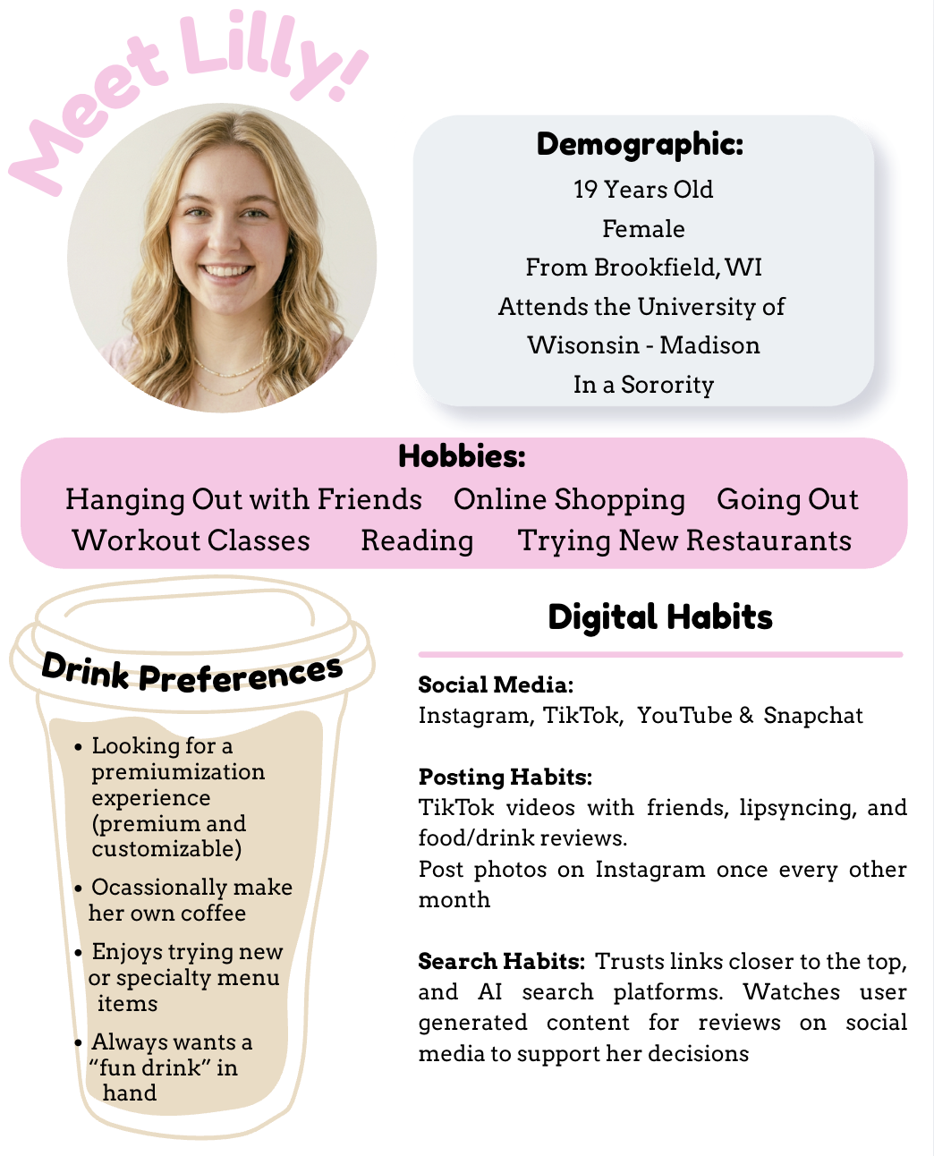
Appendix B: Target Market

Appendix C: Metric Chart on Instagram
Equation for the total: (post’s likes* like point value) + (post’s comment* comment point value) + (post’s reposts or favorites* repost or favorites point value)+ (post’s shares* share point value)
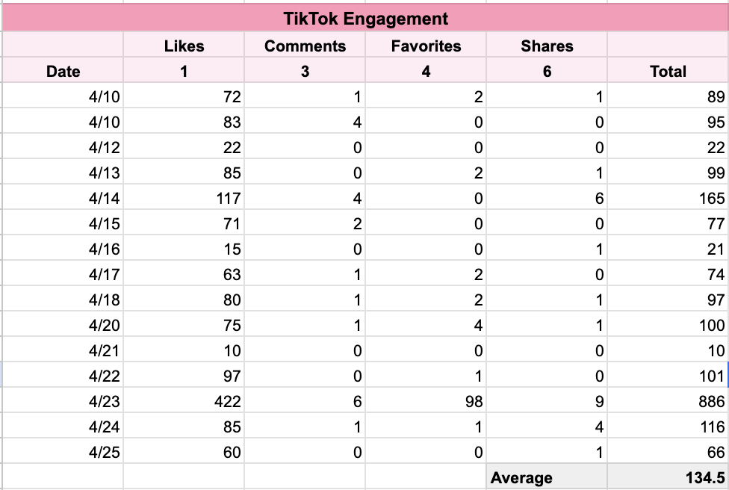
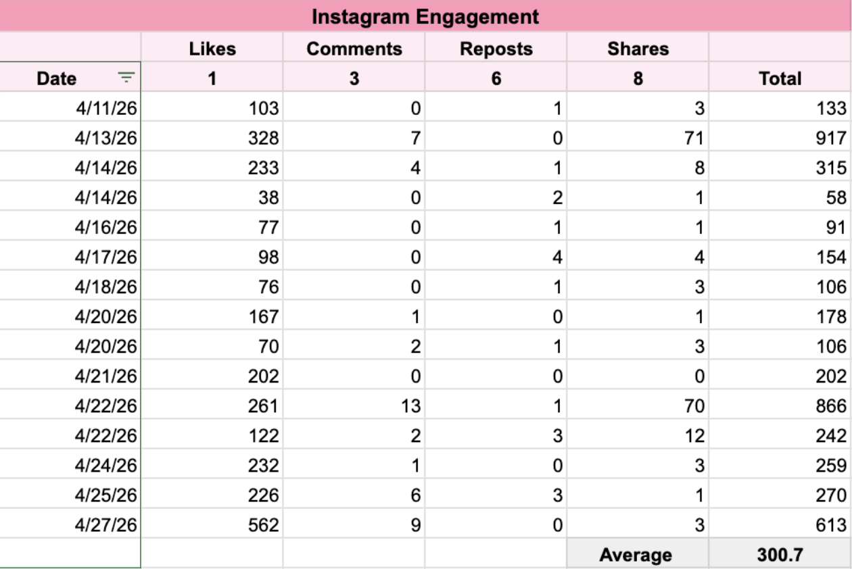

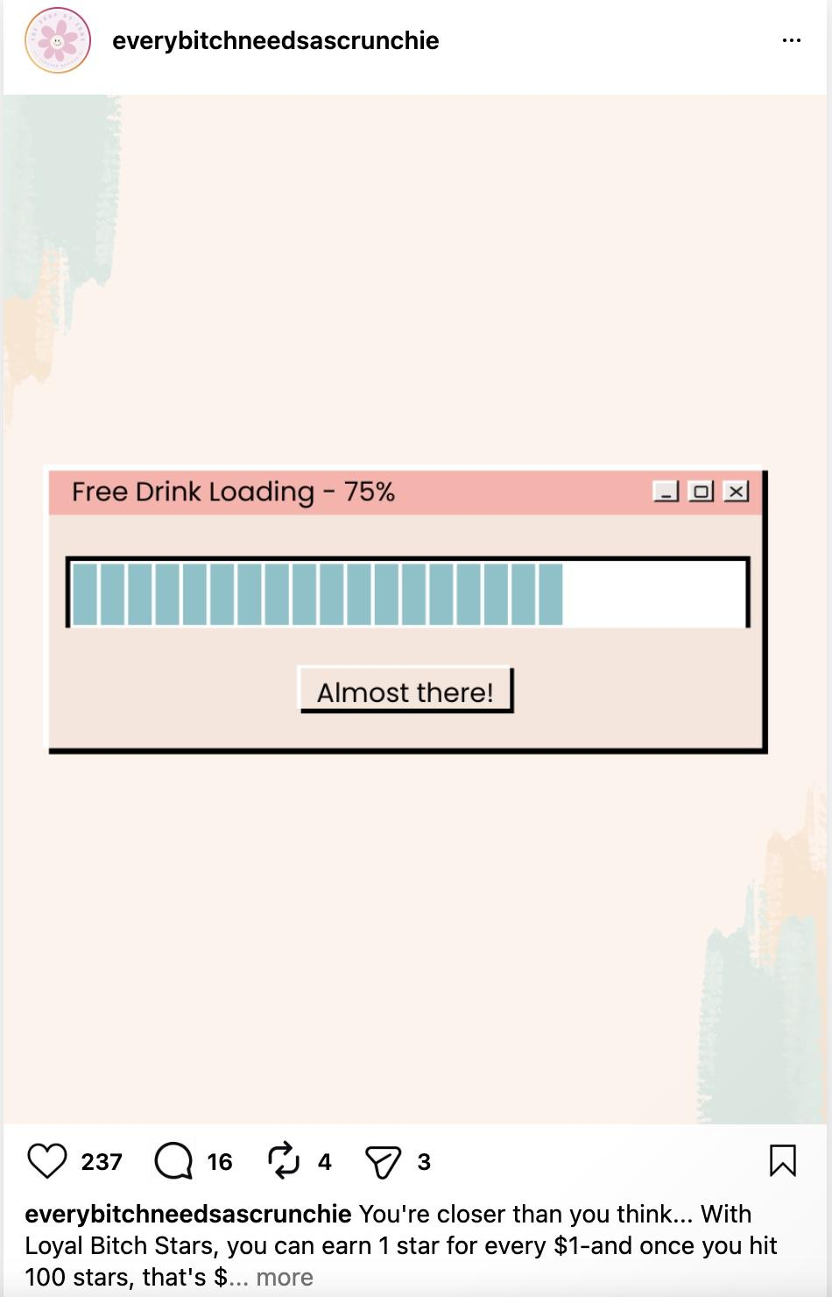
Appendix D: Instagram Post Mockup

Work Cited Page
Gottfried, Jeffrey, and Eugenie Park. “Americans’ Social Media Use 2025.” Pew Research Center, 20 Nov. 2025,
https://www.pewresearch.org/internet/2025/11/20/americans-social-media-use-2025/.

“Digital Marketing Trends for Higher Education (Full).” Encoura, 2026,
https://www.encoura.org/action-plan/digital-marketing-trends-for-higher-education-full/.

“Global Drinks Industry Forecast: Trends, Challenges & Innovations.” Mintel, 16 Apr. 2026,
https://www.mintel.com/insights/food-and-drink/global-drinks-industry-now-and-next/.

“Micro vs. Macro Influencers: Optimize Your Campaign Strategy.” MarketingProfs, 2024,
https://www.marketingprofs.com/articles/2024/51021/micro-vs-macro-influencer-marketing-campaign-strategy.

“PageSpeed Insights.” Web.dev, PageSpeed Insights, 2024, pagespeed.web.dev/analysis/https-www-shopebns-com/8k4f9rtzy3?form_factor=mobile.

“Why Influencer Marketing Is Creating Huge Returns for Businesses.” Convince & Convert, https://www.convinceandconvert.com/influencer-marketing/influencer-marketing-for-businesses/

