Grant Ross

CSIS 252

Dr. Bareiss

28 February 2017

Simon Game

**Problem Summary:**

Simon is a game that asks the user to hit back the buttons that the game shows in order starting at one and incrementing by one each time.

**Problem Requirements:**

* Uses queues to track Simon game
* NXT Robot
* Command line input/output

**System Design:**

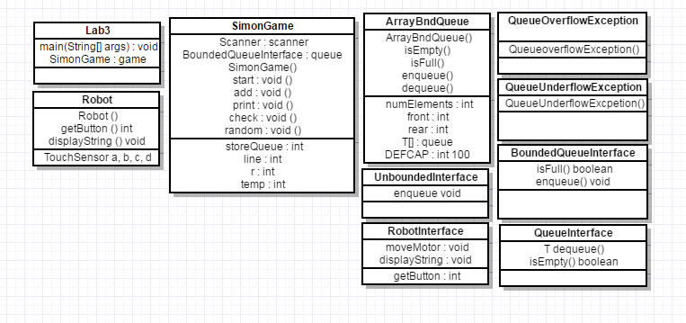

**Testing Report**

These test cases were preformed both inside of JAGRASP and command line.

1. Test Case 1: 2 3 2 1 2

input: 2 3 2 1 2

expected outcome: Correct!

outcome: Correct!

1. Test Case 1: 2 3 2 1 2 1

input: 2 3 2 1 2 3

expected outcome: Wrong!

outcome: Wrong!

1. Test Case 1: 1

input: e

expected outcome: Wrong!

outcome: Exception in thread "main" java.util.InputMismatchException

1. Test Case 1: 1

input: 2

expected outcome: Wrong!

outcome: Wrong!

1. Test Case 1: 4 2 3 4 2 1 4 3 3

input: 4 2 3 4 2 1 4 3 3

expected outcome: Correct!

outcome: Correct!

1. Test Case 1: 2 2 2

input: 2 2 2

expected outcome: Correct!

outcome: Correct!

1. Test Case 1: 4

input: 9

expected outcome: Correct!

outcome: Wrong!

**Testing Instructions**

To run the program, you will need all of the class files in one directory. (Lab3, SimonGame, ArrayBndQueue, BoundedQueueInterface, QueueInterface, QueueOverflowExcpetion, QueueUnderflowException, Robot, RobotInterface, SimonGame, UnboundedQueueInterface) The user can then run by running the Java file “Lab3” in command line or can run the program inside of JGRASP.

**Management Report**

Working on this lab I spent about 2 hours during lab time Wednesday and 1 hour shortly after lab in my dorm. This was mostly spent both wrapping my head around the program and working on an outline for my UML. After getting my UML approved from a TA and showing Dr. Bareiss I started to work on the SDR Saturday evening for another 2 hours. Next I spent 6 hours Tuesday working and finally finishing everything. This is a total of 10-11 hours of work for Simon Lab compared to the estimated time of 4-5 hours. Tuesday took much longer than I thought to finish my Simon game code and I ended up running out of time for the robot.

**Lessons Learned**

I now do I have a deep understanding for queues and how they work, I also realize I need to put in more time even if I think that problem or lab will be easy. I ended up running out of time on something that I thought would only take a couple hours. I should’ve started earlier so I could’ve finished my robot classes.

**Future Improvements**

I will start to get a head start on future labs. To helped me finish on time and finish with a much better quality of work.

**Appendices**

On this lab I used Dr.Bariess classes as well as classes modified from the book for programming class such as ArrayBndQueue, BoundedQueueInterface, QueueInterface, QueueOverflowExcpetion, QueueUnderflowException, Robot, RobotInterface, SimonGame, UnboundedQueueInterface.