Startup screen

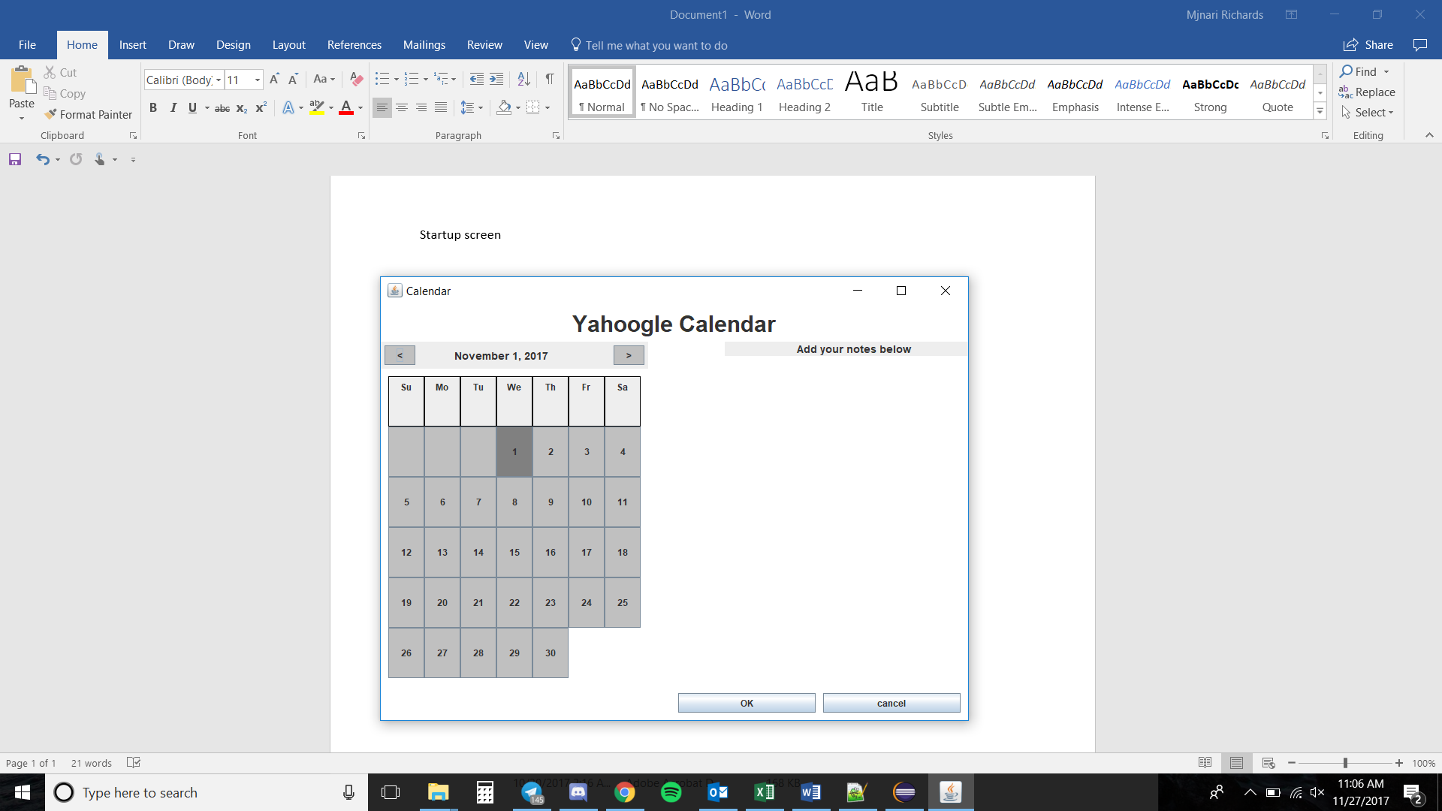

Full Screen

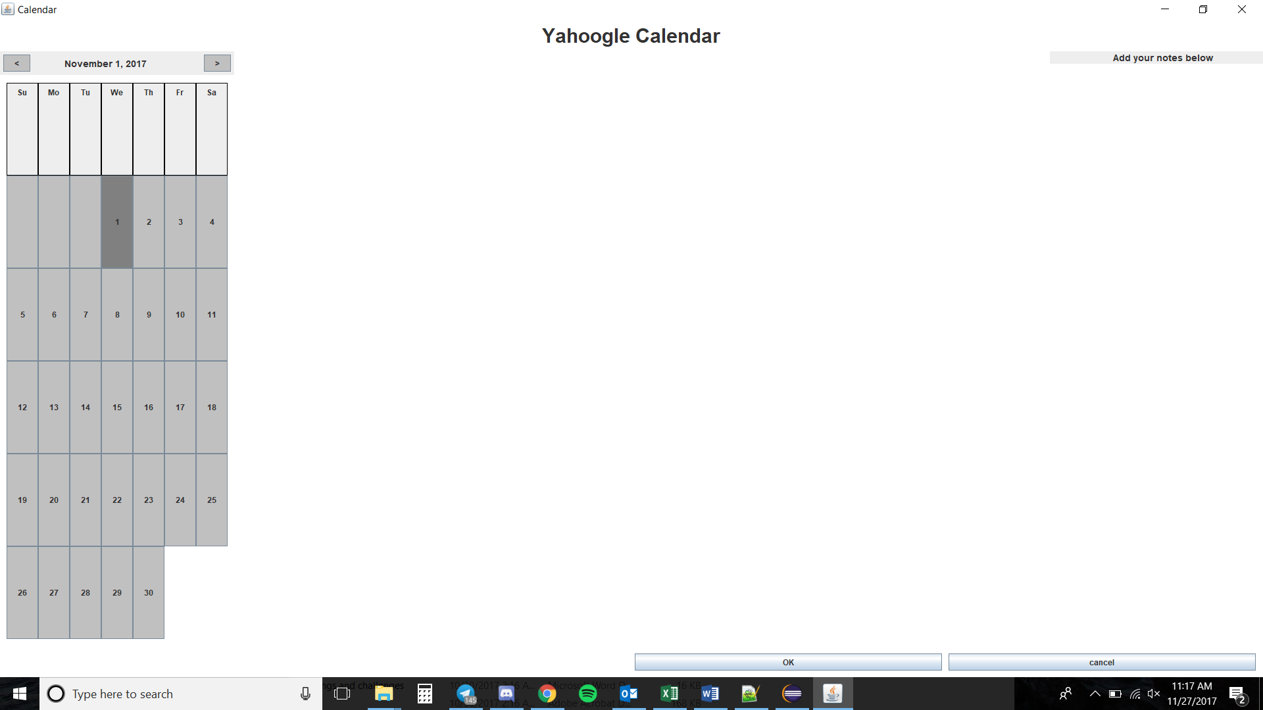

1 Left click

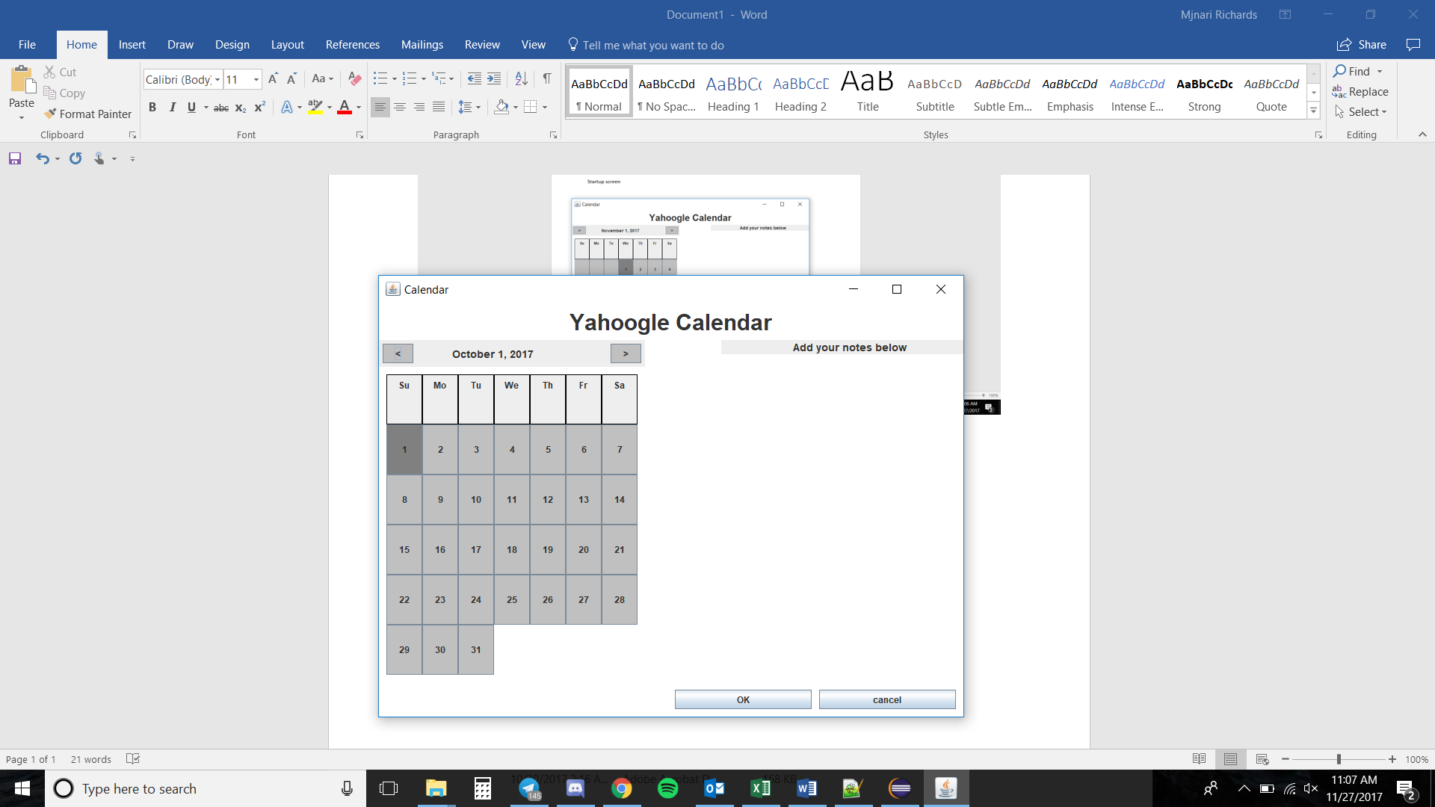

Left click until 2016 February (leap year) (included random right clicks)



Right click to 2018 (with random left clicks)



Same month, select 20

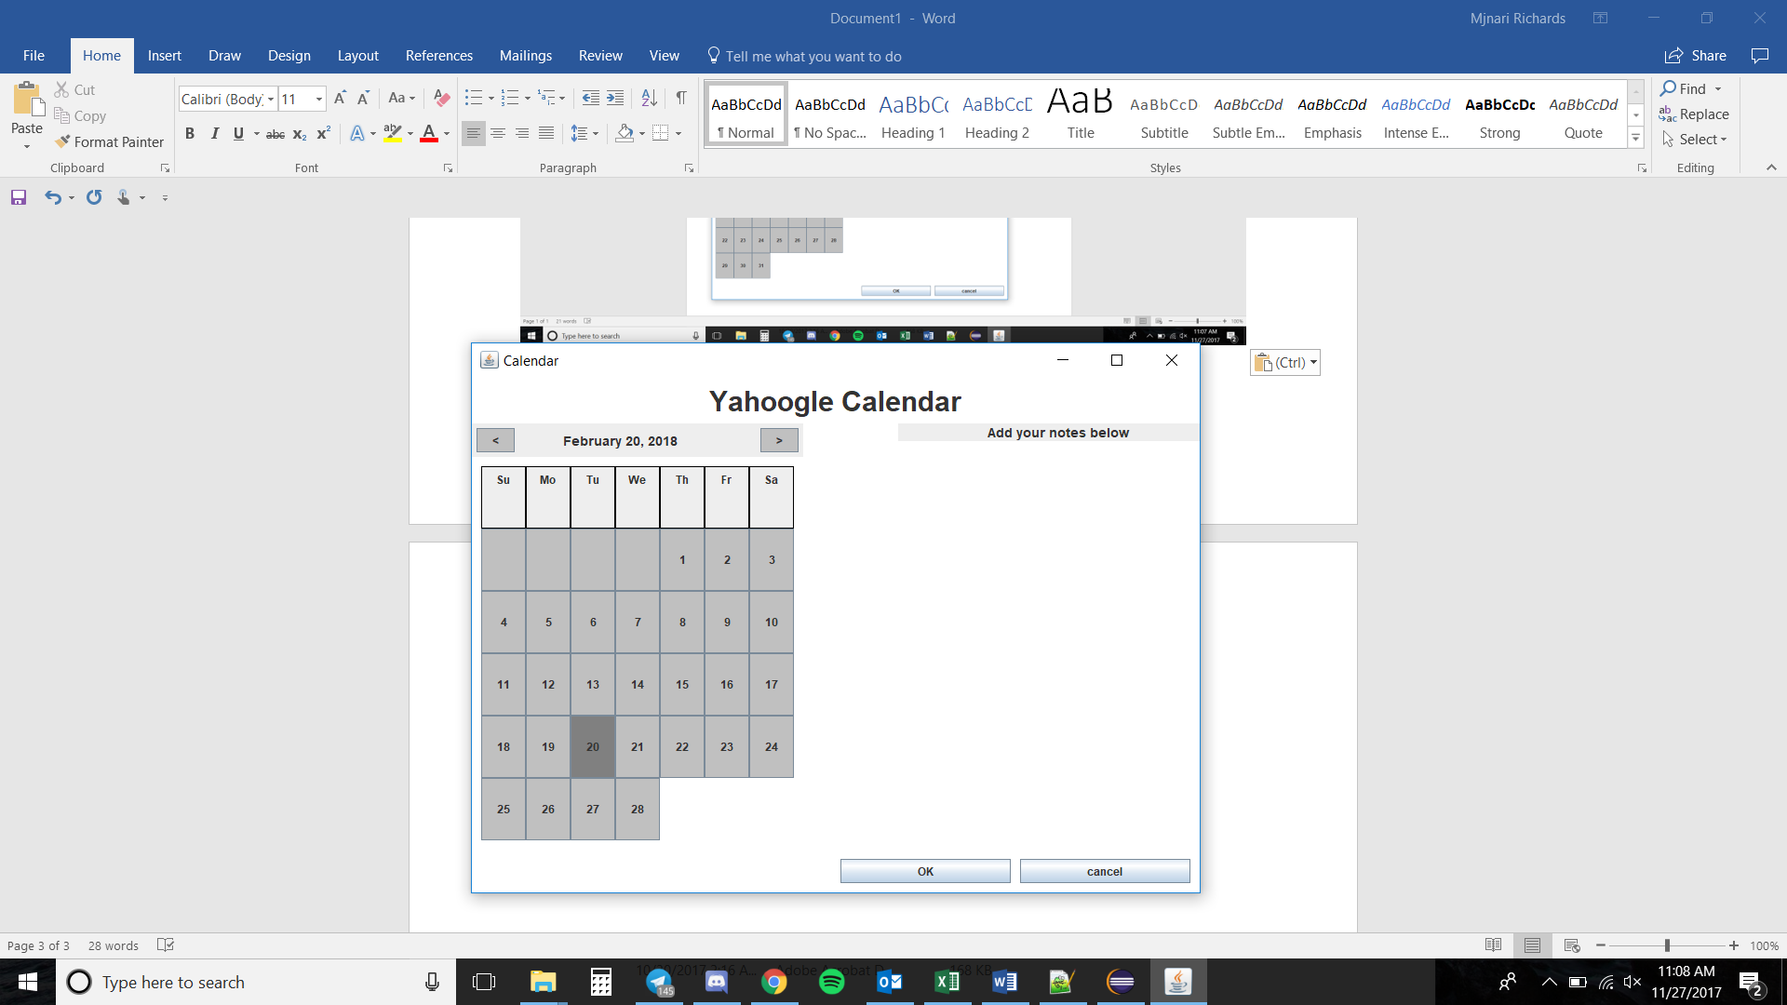

Next month maintains selection

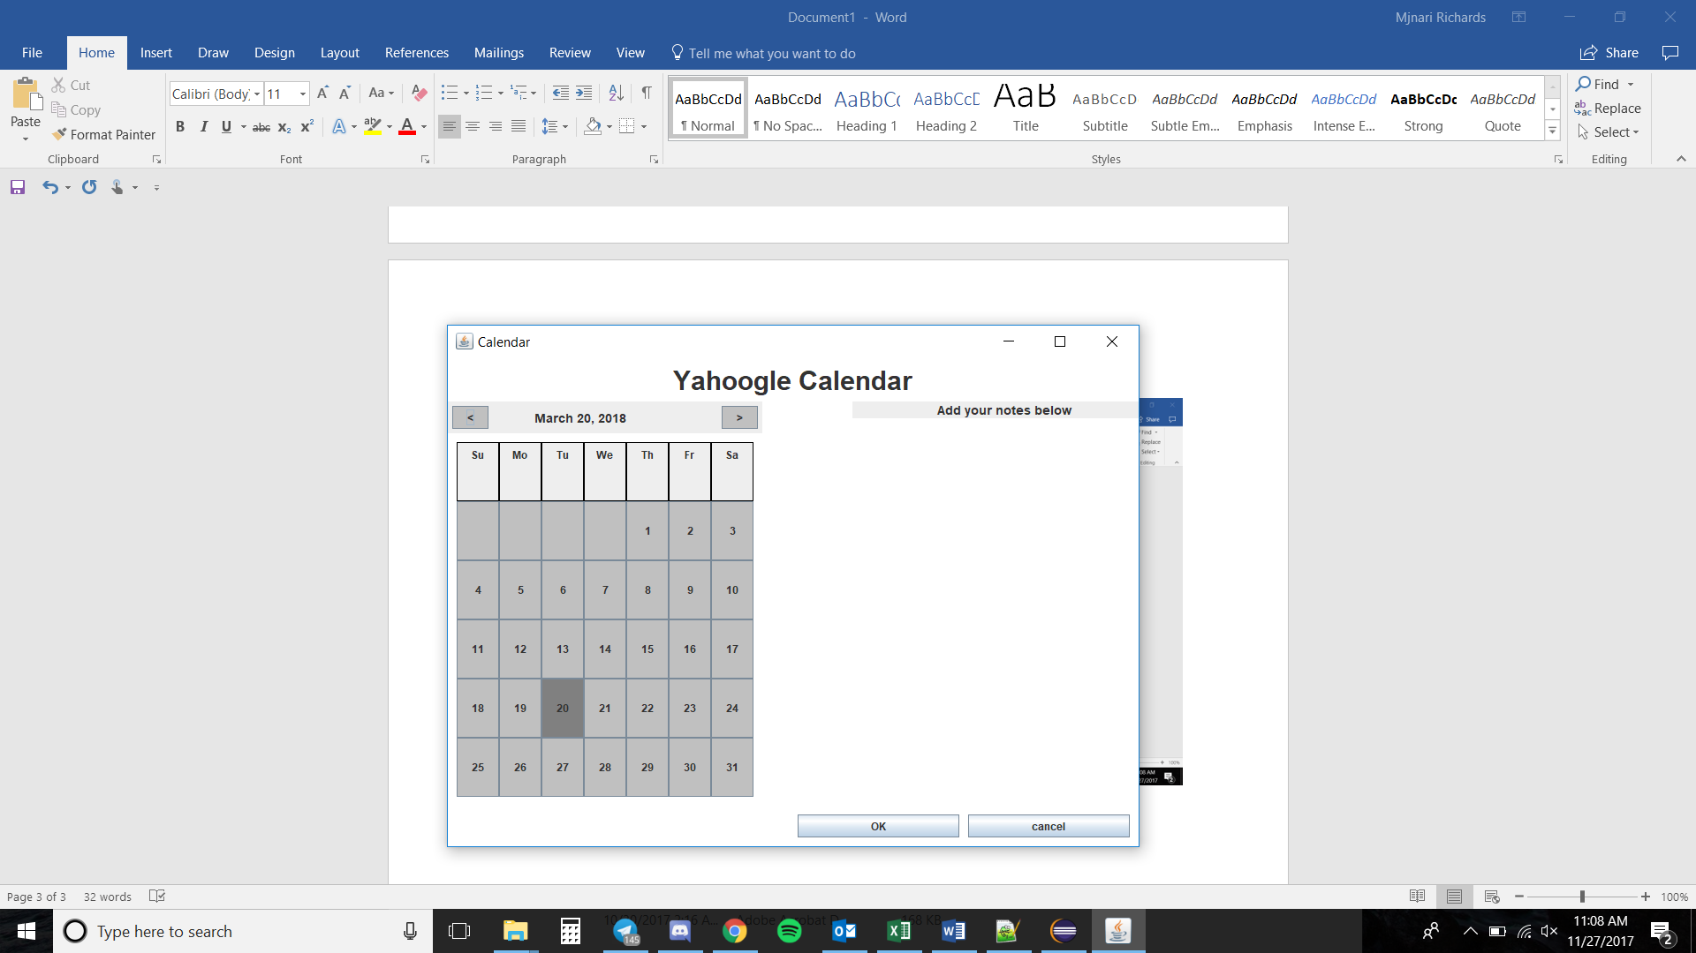

Bug: Select 31, switch to month without 31 days

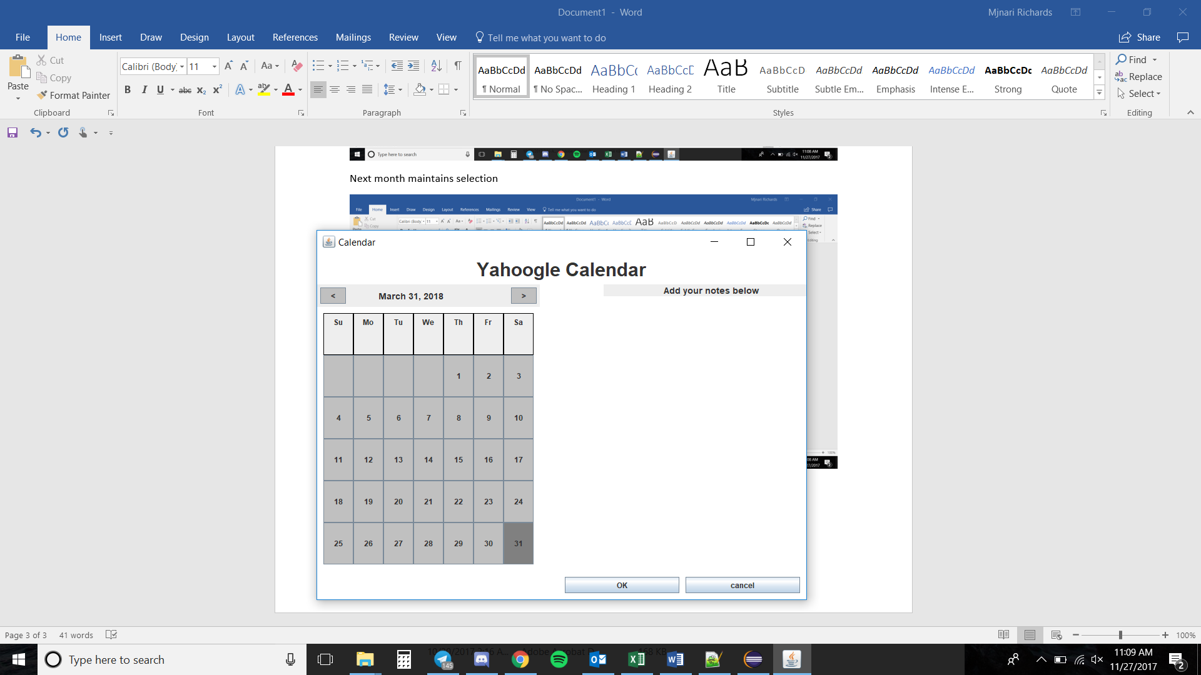

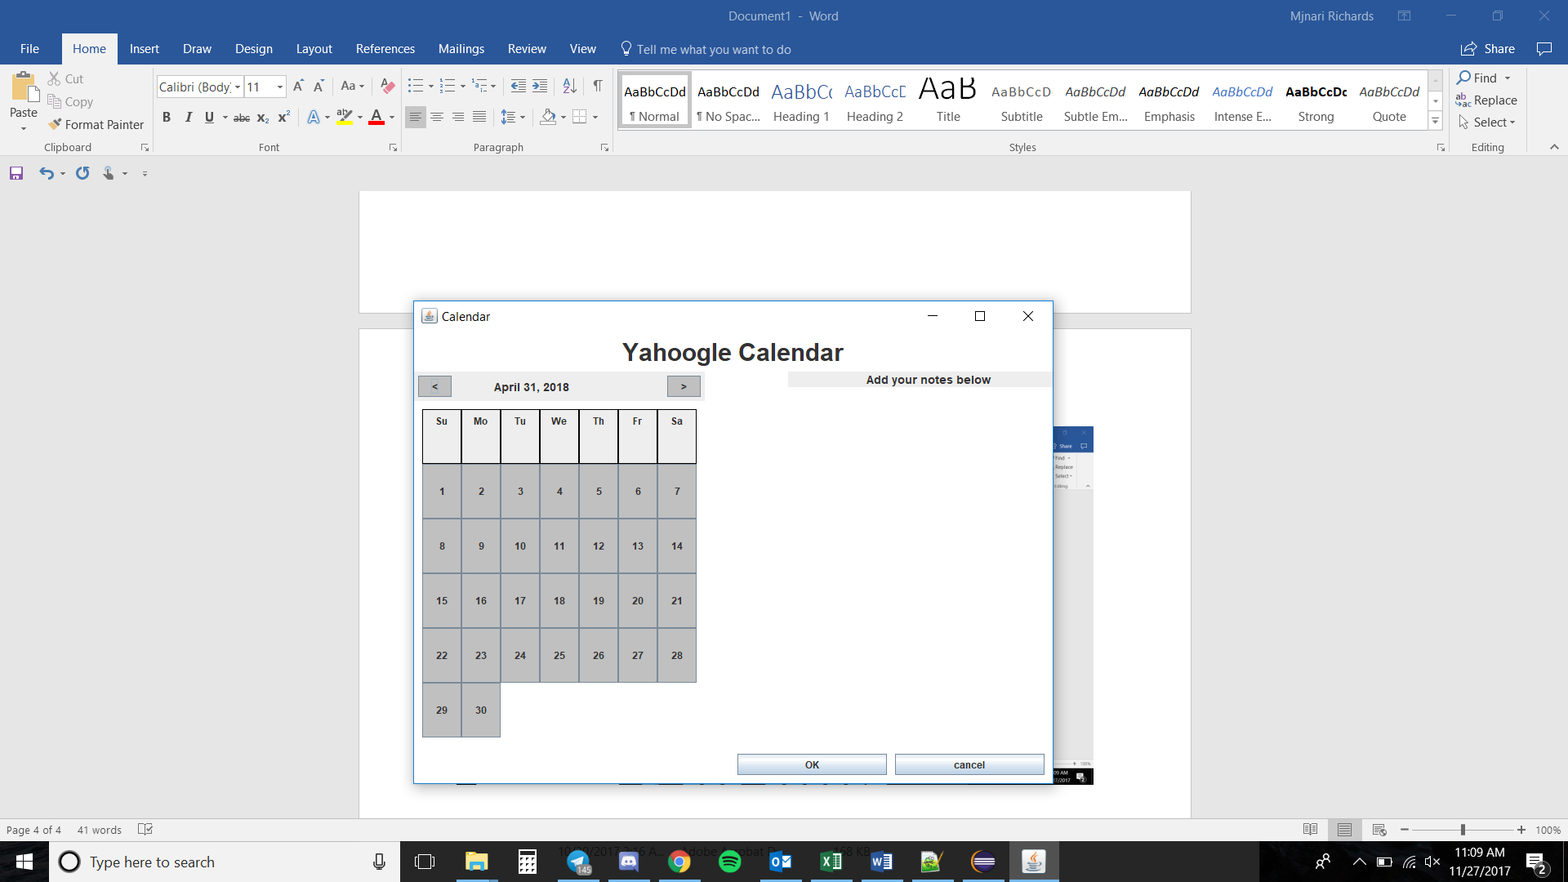

Select 5th, start typing notes

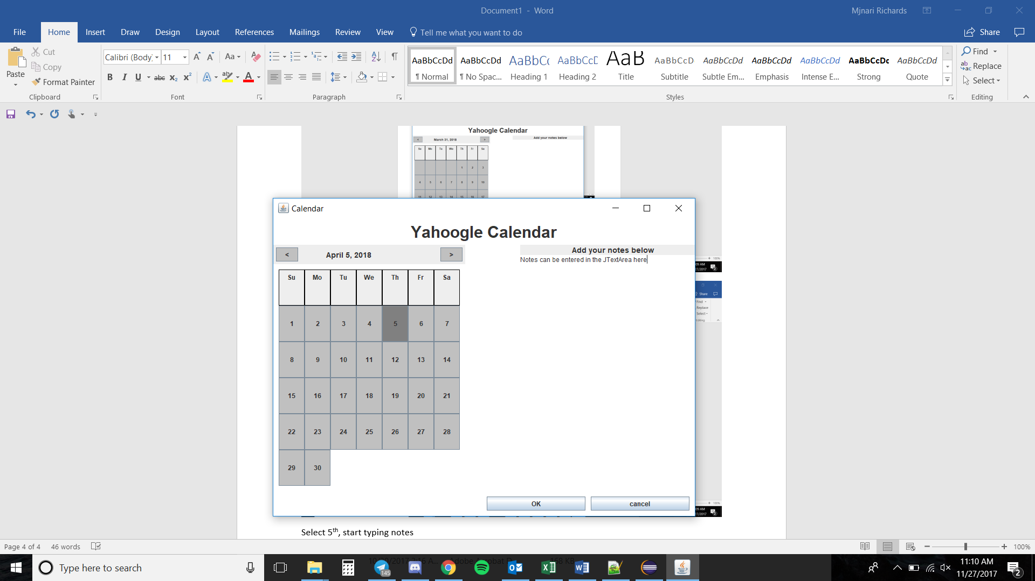

Bug: JTextArea text not saved to dateInfo info correctly, does not properly getId to retrieve the info and does not properly save text for storage

Semi-workaround: Since losing the notes forever would be useless I have designed the JTextArea to not refresh when the date is changed, that way notes can still be helpful

