10 Ways To Improve Your Credit

Boost Your Score

and Enrich Your Life

(And IT’S All Legal!)
By Andrew Wiley

Credit Problems Are Easy To Create

But Hard To Solve

Hello, my name is Andrew Wiley and I’m the owner of Consumers Auto Warehouse in Staunton, Virginia. I am sure you have heard our commercials or know someone who bought a car from us, so you already know we call ourselves the Credit Experts. And this free book will give you the top 10 ways to improve your credit situation.

Yeah, credit problems are easy to create and hard to solve, but that doesn’t mean it is impossible. You can do it, if you follow these easy ways to boost your credit score and get back on track.

#1 – GET INFORMED

Look, we talk to a lot of people with credit issues they never knew they had. Maybe you didn’t get that bill the hospital sent or maybe you just forgot. So the first thing you need to do is find out what the car dealers and banks already know – what is on your credit report?

And the government has finally made something easy for you – they REQUIRE all three credit reporting agencies to provide a free copy once per year.

If you have access to the internet, go to www.annualcreditreport.com. Make sure you don’t go to “freecreditreport.com” – that is a scam to get you to sign up for a monitoring service.

Around here, most lenders use Equifax. The other two credit reporting agencies are Experian and TransUnion. But start with Equifax. You can get a free copy, right online and look at it and print it.

If you don’t have access to the internet you can call and get a copy at 877-322-8228. Or, look in the back of this book at the form provided. It has the address to mail in a request.

#2 - DISPUTE INCORRECT INFORMATION

A story by CBS news in 2004 claimed that almost 80% of all credit reports have mistakes. That is 4 out of 5 folks! And if those mistakes are bad enough, they can keep your score down, make your credit card and loan rates higher or even get you turned down!

So what do you do? If you got your credit report online at www.annualcreditreport.com, you can dispute incorrect information there. If not, submit your dispute in writing to the credit reporting agency that sent you your report.

By law, they must verify the information they are reporting as correct. If the "lender" does not respond within 30 days, the credit reporting agency must remove the item and cannot put it back.

#3 - PAY IT DOWN

If you carry balances that are close to your limit on credit cards or loans, your score suffers. Having a small credit card with a $500 limit and $500 owing on it WILL HURT YOUR SCORE. This is another reason new credit often temporarily hurts your score - you have NEW credit and it is at your limit.

Do everything you can to pay down balances, especially on credit cards. You will save money and improve your score!

#4 - PAY IT OFF

Sometimes it sneaks up on you. You go to Lowe's and get 10% off for opening a new account. Oh, and then you can get a great deal on gas at Exxon, so you add another. Before you realize it you have 8-10 credit cards. Now maybe you use them and maybe you don't, but it doesn't matter to the credit gods. They will ding you score for too many open accounts.

Let's face it; you really don't need 8-10 credit cards. Two cards and maybe one more department store card and close the rest. Get those other accounts paid or transfer the balances to one or two cards. You might get a credit limit increase if you call one of your lower rate cards and tell them you are transferring a big balance.

That doesn’t mean you need to close accounts you don’t use – just limit the number of cards you are actively charging on. If you have cards you don’t use with annual fees – you should close them right away though.

#5 - LIMIT CREDIT CHECKS

Too many inquiries can hurt your score as well. Remember that kiosk at the mall where they were giving away free t-shirts if you signed up for a credit card? Skip it. Don't fill out those offers in the mail. Don't shop 3 or 4 car dealerships (some of those guys will send your application to 10-12 lenders!! -- Can you imagine 40 inquiries on your credit??!). Only apply for credit when you NEED it.

# 6 - PAY ON TIME

Well, this one is a no-brainer. Obviously your credit score will be better if you pay your bills on time. You need to make sure any credit card, sales contract, or loan is paid by its due date. You are usually offered a grace period before any late fees apply. And as long as the lender has their money before 30 days after your due date, it should not show up on your credit report. You should watch out for the following late payment traps your lender might be setting for you –

- Late Fees - These can be as much as $50.00 added to your balance if you are just a few days late. While this does not directly impact your credit report, some lenders will then apply your late payment to the fees first (they are not supposed to do that, but some do). This makes it look like you did not make a full payment and your account will show late.

- Shifting Due Dates - While car loans and mortgages have stable due dates, some credit cards are based on a 28 or 30 day cycle. So that payment you paid on the 9th last month is due on the 7th this month.

- The Check Is In The Mail - Once you mail a check, you can't know for sure when it will get to your lender. And the postmark does not count. If the bank says your check did not get there until after it was due - what are you going to do about it? I strongly recommend paying online when possible or paying in person (for local lenders).

#7 GET RID OF COLLECTION ACCOUNTS

Oh, the dreaded collection accounts! These are those pesky notices you ignored and thought would not impact your score, but THEY DO! Hospital bills, unpaid utilities, cell phone and more. Now, you could do as you have already done, and leave them unpaid, but the will stay on your report for seven years (or more!) if you don’t pay them.

If the collector is willing to delete the account if paid in full, this will have a good impact on your credit. You do have to take a little effort and make some calls to the collection agencies, but you can get them cleared up. Not all agencies will delete reporting but it is worth the time to ask.

- Call your collection agencies and make arrangements to pay off your debt.

- Request in writing the agreement to delete the account upon receipt of payment in full.

- If the company doesn’t delete accounts, paying them off can actually decrease your score due to date of last activity and current date of payment.

#8 DON’T CLOSE PAID ACCOUNTS

A report by MSN Money says that closing accounts can never help your score; it will often hurt it. Shutting down credit accounts will actually lower the total credit available to you. If you choose to close accounts follow these steps which will aid in improving your credit.

- Close only new accounts that have been opened within the last 12-24 months.

- Do not close older accounts. Doing so may shorten the length of your credit history, making you seem less worthy.

- If you plan on applying for NEW credit in the near future, leave all accounts standing.

- Keep balances between 30 and 70% to maintain a healthy score.
#9 LIMIT NEW CREDIT

Although you may think that opening up a new card or store account may help you, it doesn’t; it can actually hurt you. Only open up credit that you need and can use wisely. Limiting new credit is a good way to stay ahead of the game.

- Smartmoney.com notes when you have new inquiries and a number of new credit requests, your score will be lowered.

- Once that new credit line is secured, the average age of your accounts will shorten, which lowers your score.

- Only open accounts that you really need.

#10 FINANCE A VEHICLE

You might think this one is just a setup for the dealership to sell you a car, but you are wrong. Although you should limit new credit when you can, a big ticket item like a mortgage or car loan is absolutely the fastest way to improve your credit score. It shows future lenders that you have the ability to handle a big chunk of credit on a regular basis. There is absolutely NOTHING you can do to improve your credit score faster than financing a vehicle!

WRAPPING IT ALL UP

Well, that is it. No, it is not rocket science and most of this stuff is plain common sense, but with some hard work on your part, a little bit of time and perseverance, you will improve your credit, boost your score and enrich your life.

ABOUT US

Here in Staunton there are over 2,500 residents – your friends and neighbors – who have been enthusiastically happy with the car buying experience they received at Consumers Auto Warehouse.

That’s no coincidence. My team has worked hard to create a car buying experience that is unlike any other. And we are known far and wide as the Credit Experts. Even if you are in the midst of credit issues, if you can answer YES to the following questions, you could be approved today:

- Have you been turned down for credit before?
- Do you earn $250 per week before taxes?
- Are you serious about improving your credit?

That is it – we offer guaranteed financing here through REAL lenders who will help re-establish good credit and restore your good name to creditors everywhere.

FREE OFFER

Mention that you received this book and we will perform a FREE credit analysis for you. See what is on your credit report, learn your score and get some great helpful advice. No pressure, no purchase necessary, just a FREE CREDIT CHECK!

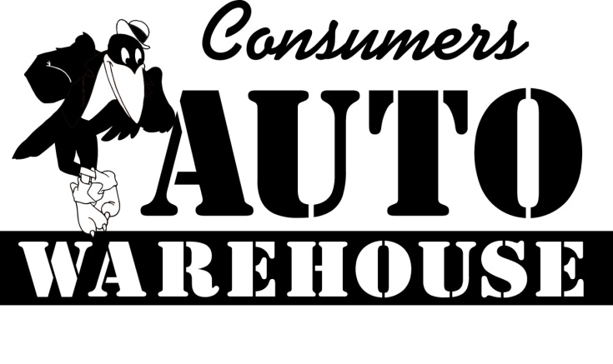

537 Richmond Avenue, Staunton, VA 24401
Toll Free: 877-942-2769
www.cawcawcaw.com
Email us at sales@cawcawcaw.com

Take a look at what some of my customers have had to say:

You guys go above and beyond customer care. No other car dealer around is as GREAT as you all. We will definitely buy our next car from you.

Sheena and Chris Strother – Staunton, VA

If you want a great deal and want to be treated like you are cared about, come to Consumers Auto Warehouse. They treat you like family.

Carol Painter – Staunton, VA

Ok, I came here at 4:25, Feb 13. It is now 6:24. I am leaving with my car and have had the best experience of my life. Am I dreaming here? These people treated me like family. No pressure, no haggling, they made me feel more than welcome, like a close friend. I still am a little in shock at how wonderful this place is.

I cannot wipe the smile off my face. I have my car, the paperwork is done, DMV and everything and I will spread the word from here till forever on what a wonderful experience I had. If you need a car, don’t go anywhere else. This is the place, and I was referred by two co-workers who had the same experience as me – WONDERFUL. Did I tell you I love you guys? He Hee!

Bren Haworth- Staunton, VA February 2008

