Team Name : Grapefruit

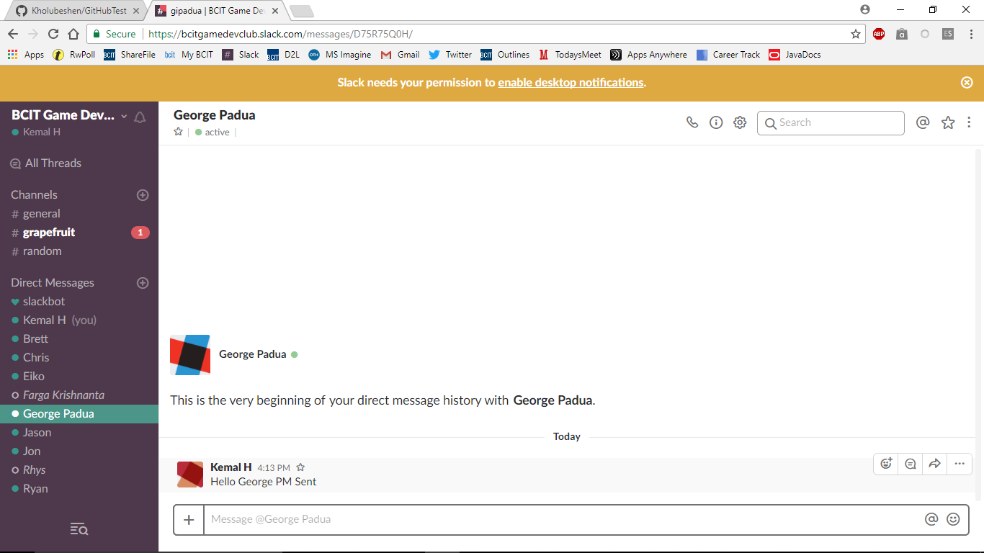

Our idea is to make a game that is a bullet hell.

Kemal

Brett

Garel

John

Connor