# Introduction

Candy has been a fixture of the human diet since the ancient world and has morphed from a luxury to an everyday good (1). There are several forms of candy, but hard candy, which is defined by its composition consisting of mostly crystalline sugar, is an ever-popular form. It comprises approximately one-third of the nearly $5 billion American candy market (2). The characterization of the heat transfer of candy is important as it is only plastic at temperatures above the boiling temperature of water (3).

# The Candy-Making Process

The standard process for sugar confectionary (1) is to boil a saturated sugar solution, often combined with small quantities of glucose syrup or invertase to prevent unwanted crystal formation. For textural reasons, it is not desirable to add large amounts of these additives. Once this mixture reaches the desired temperature, it is formed into the desired shape and cooled. In traditional candy-making, this molding and cooling is done by hand, requiring the use of heat protection or waiting for the sugar to reach a safe temperature to touch. This model aims to characterize the heating and cooling of a molten sugar system to model the temperature over time for a home candy-making process.

# The Simple Model

For the cooling process, a model was created to be solved analytically, which required several assumptions:

The sugar was assumed to be within a vessel that could be simplified to a two-dimensional rectangle. The heat transfer into the vessel itself was neglected, and it was assumed the top and bottom of the sugar were held at a room temperature of 25 ̊C. It was assumed that there was only heat transfer in the y direction.

The sugar was assumed to have a uniform temperature of 140 ̊C at the beginning of the cooling process. The temperature at which a sugar solution will reach above 98% purity is 142 ̊C (3). It was assumed the uniform temperature distribution was due to a brief period of stirring after the heating process ended, which caused a slight lowering of the temperature. It was also assumed that the solution was 100% pure sugar. There are no chemical reactions in the system.

The height of the system was assumed to be 25 cm, which is a medium-sized pot for home use.

Figure Sketch of the simple system model

Simplifying the heat equation

The model determined was then:

With boundary conditions

The values of k, ρ and Cp were assumed to be constant and were found to be (4):

|  |  |  |  |
| --- | --- | --- | --- |
| Constant | K | ρ | Cp |
| Value | 0.145 W/m ̊C | 1435.9 kg/m3 | 1.57842 W/kg |

Table Properties of sugar

## Analytical Solution

The analytical solution was determined to be

For the full analytical solution, see the appendix.

The graph of the analytical solution for n=1 are as follows. It was found that the temperature distribution did not have a maximum in the center for other solutions, and since the system is symmetrical, this means the valid solution is for n=1.

|  |  |  |  |
| --- | --- | --- | --- |
|  |  |  |  |
| t=0+ s[1] | t=100 s | t=1000 s | t=1500 s |

Table Graphs of analytical solution at different times

As seen in the graphs, the time required for steady state of a uniform temperature of 25 ̊C is slightly greater than 1000 seconds but less than 1500 seconds, which is between 16.7 and 22 minutes.

## Numerical Solution

The finite differences method was implemented in Python to confirm the analytical solution numerically. See the attached Python file proj_simple and the appendix for full solution.

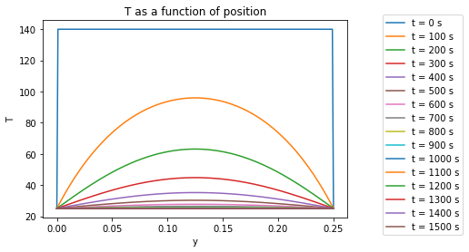

Figure Graph of numerical solution to simple model

The numerical solution is consistent with the analytical solution[2]. It can be seen from the graph of the numerical solution that steady state is reached at approximately 1100 seconds or 18.3 minutes.

# Appendix – Calculations

## Analytical solution

1. Note that for the analytical solution, the graph shows the temperature profile approaching time=0 from the positive direction, while
2. the numerical solution shows the temperature profile at time=0