July 2018 on-peak demand in kW
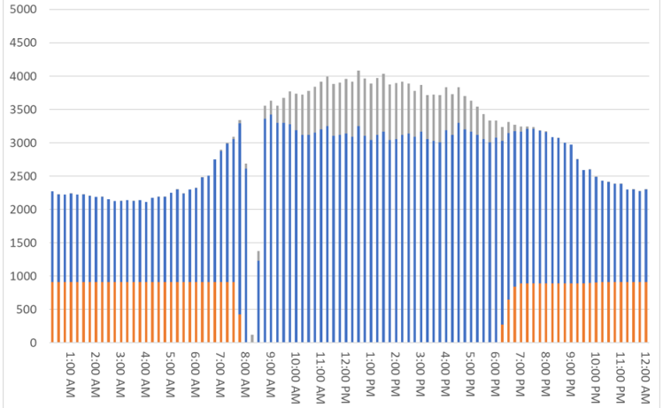

August 2018 on-peak demand in kW
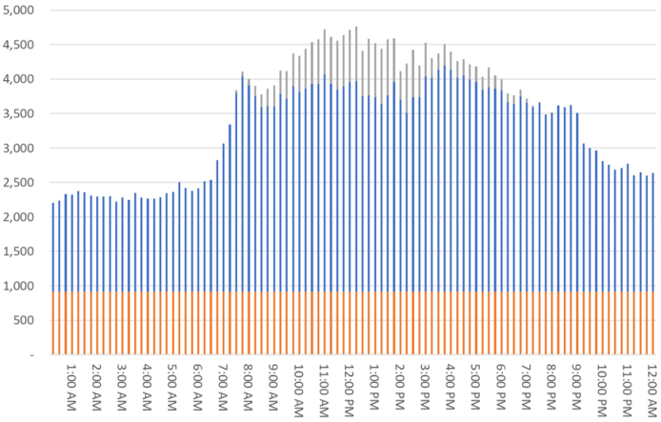

September 2018 on-peak demand in kW
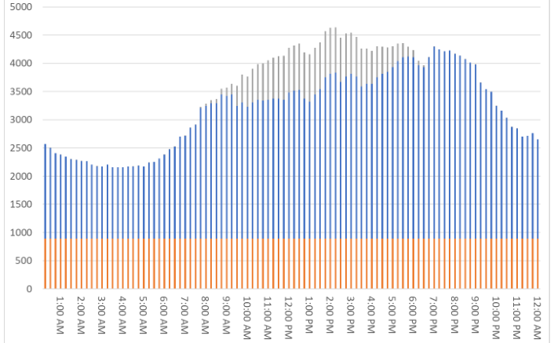

October 2018 on-peak demand in kW
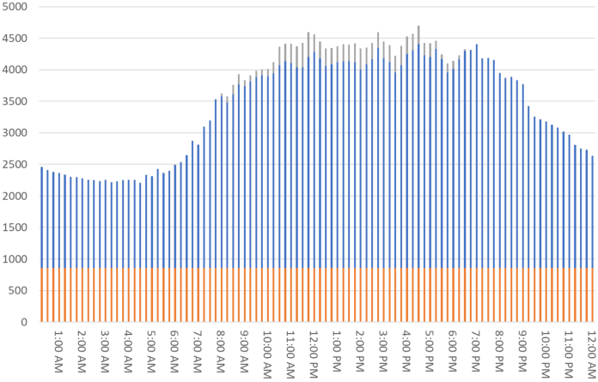

November 2018 on-peak demand in kW
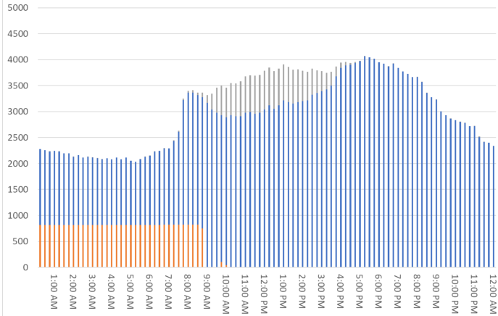

December 2018 on-peak demand in kW
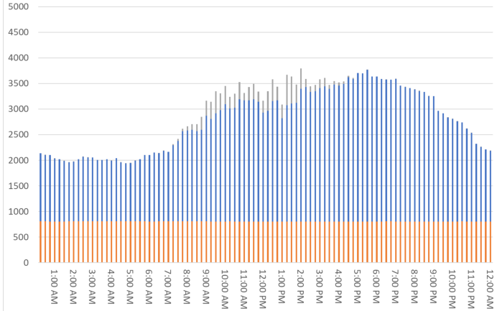

January 2019 on-peak demand in kW
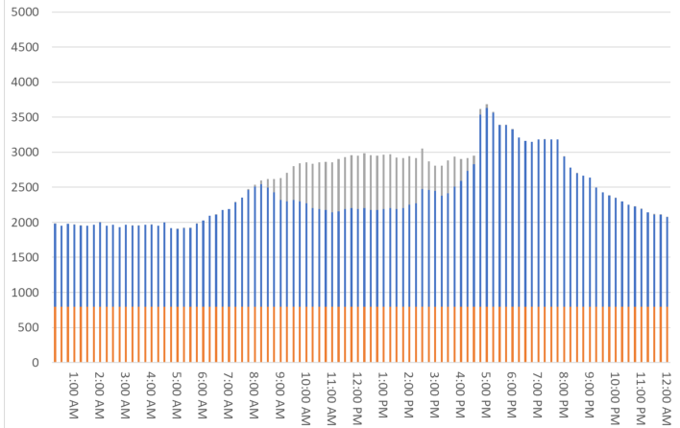

February 2019 on-peak demand in kW
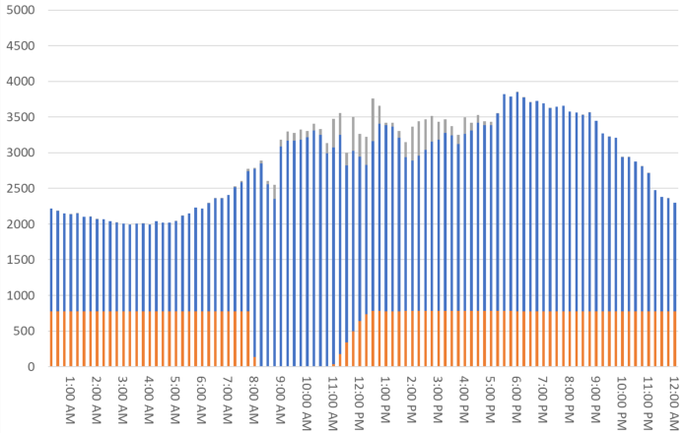

March 2019 on-peak demand in kW
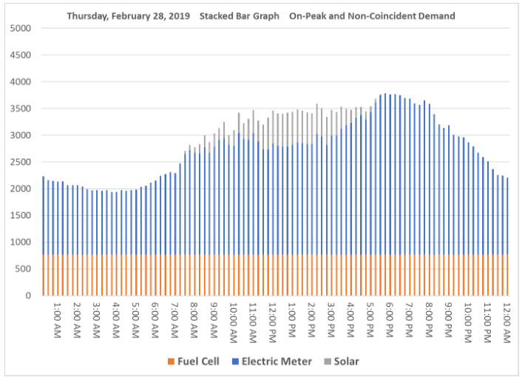
April 2019 on-peak demand in kW
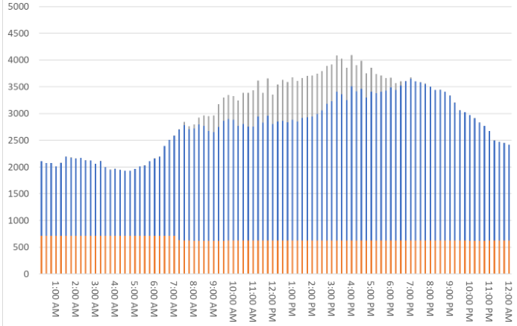

May 2019 on-peak demand in kW
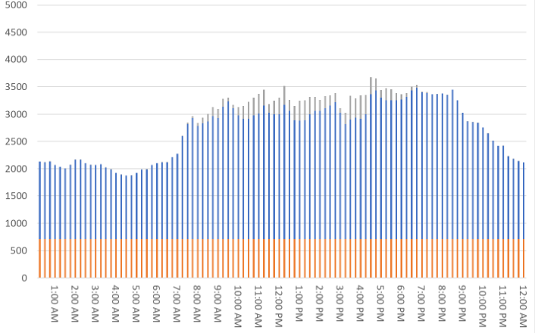

June 2019 on-peak demand in kW
