ZIMBABWE NATIONAL GEOSPATIAL AND SPACE AGENCY (ZINGSA)
In Partnership with: Ministry of Transport & Infrastructural Development
Department of Roads



ROAD CONDITION SURVEY SYSTEM
USER MANUAL

Mobile Application & Web Dashboard

Document Version | v1.0
Issue Date | July 2026
Prepared By | ZINGSA — Zimbabwe National Geospatial and Space Agency
Classification | INTERNAL USE ONLY
Survey Year | 2026

Field Telemetry System v2.0 | Survey Year 2026 | Highways: A1 - A2 - A3 - A4 - A5

TABLE OF CONTENTS
1 | Introduction | 3
2 | System Overview & Architecture | 4
3 | Getting Started | 5
4 | Mobile Application - Field Surveyor Guide | 6
4.1 | Installation & First Launch | 6
4.2 | Home Screen & Navigation | 7
4.3 | Creating a New Survey | 8
4.4 | Asset Categories | 9
4.5 | Survey Form - Common Fields | 11
4.6 | Asset-Specific Survey Forms | 12
4.7 | GPS Coordinate Capture | 20
4.8 | Photo Capture | 21
4.9 | Draft Queue & Offline Storage | 22
4.10 | Synchronising Data to Server | 23
4.11 | Settings & Configuration | 24
5 | Web Dashboard - Administrator Guide | 25
5.1 | Accessing the Dashboard | 25
5.2 | Layout & Navigation | 26
5.3 | Map View | 27
5.4 | Assets Panel | 28
5.5 | Dashboard Module | 29
5.6 | Highways Module | 29
5.7 | Analytics Module | 30
5.8 | Survey Module | 31
5.9 | Database Module | 31
5.10 | Export Module | 32
5.11 | Right-Side Analytics Panel | 33
5.12 | Refreshing Live Data | 33
6 | Data Synchronisation & Offline Operation | 34
7 | System Administration | 35
8 | Troubleshooting | 36
9 | Glossary | 38
Appendix A | Central Database Integration | 40
Appendix B | API Endpoint Reference | 41

1. INTRODUCTION
The Zimbabwe National Geospatial and Space Agency (ZINGSA), in partnership with the Ministry of Transport and Infrastructural Development (MOTID) - Department of Roads, has deployed the Road Condition Survey System to support the national mandate of monitoring, cataloguing, and maintaining Zimbabwe's road network.
This system consists of two integrated components:
- Mobile Application (Android) - Used by field surveyors to collect road asset condition data in the field, including in areas with no internet connectivity.
- Web Dashboard - Used by Roads Department administrators and engineers to view, analyse, and export the collected survey data via an interactive map and reporting interface.

1.1 Purpose of this Document
This User Manual provides step-by-step instructions for both field surveyors operating the Mobile Application and administrators using the Web Dashboard. It covers all features, forms, and workflows required to operate the system effectively.

1.2 Scope
This manual applies to:
- Field surveyors assigned to road condition survey teams
- Roads Department administrators and engineers
- ZINGSA GIS and data management staff
- ICT staff responsible for system maintenance

1.3 Document Conventions
Convention | Meaning
Bold text | Buttons, menu items, and field labels in the application
Italic text | Values to be entered or selected
[Icon label] | Reference to an icon button on screen
NOTE: | Important information the user should be aware of
WARNING: | Action that may result in data loss if not followed correctly

2. SYSTEM OVERVIEW & ARCHITECTURE
The Road Condition Survey System is a full-stack field telemetry platform developed and operated by ZINGSA in support of the MOTID Department of Roads. It comprises three tiers:
Tier | Technology | Purpose
Mobile App (Android) | Capacitor + React (TypeScript) | Field data collection, offline storage, GPS capture, photo attachment, draft queue, one-tap sync
Backend API | Python FastAPI | Receives survey submissions from mobile, proxies data from Central Database, caches records, serves REST API to dashboard
Web Dashboard | Next.js (React) | Interactive Leaflet map, multi-module analytics, data export, live/offline data fallback

2.1 Data Flow
Field Surveyor (Mobile App) --> SYNC --> FastAPI Backend --> FETCH --> Web Dashboard

2.2 Covered Road Asset Categories
Category | Asset Types
Roads | Sealed Roads, Gravel Roads, Earth Roads
Structures | Bridges, Footbridges, Rail Crossings, Tollgates
Amenities | Lay-bys, Bus Stops, Junctions, Road Signs
Drainage | Shelvets, Culverts, Piped Causeways, Drifts, Grids
Traffic | Traffic Lights, Streetlights

3. GETTING STARTED
3.1 System Requirements
Component | Requirement | Notes
Mobile App | Android 8.0 (Oreo) or higher | 1 GB RAM minimum; camera & GPS permissions required
Web Dashboard | Any modern web browser (Chrome, Edge, Firefox) | Internet connection recommended; works with cached data offline
Backend Server | Python 3.9+, FastAPI | Deployed on-premises or cloud server

3.2 Obtaining the Mobile Application
- Step 1: Obtain the file roads.apk from your ZINGSA supervisor or ICT department.
- Step 2: On your Android device, go to Settings > Security > Enable 'Install from Unknown Sources'.
- Step 3: Open the APK file using a file manager and tap Install.
- Step 4: Grant all requested permissions - Camera, Location (GPS), and Storage.
- Step 5: Launch the app. The app icon will appear on your home screen.
NOTE
The application does not require a Google Play Store account or internet connection to install. It is a self-contained enterprise APK distributed by ZINGSA.

4. MOBILE APPLICATION - FIELD SURVEYOR GUIDE
The Mobile Application is the primary data collection tool for field surveyors. It is designed to work in offline environments and syncs data when a network connection becomes available.

4.1 Installation & First Launch
- Tap Allow when prompted for GPS/Location permissions.
- Tap Allow when prompted for Camera permissions.
- Navigate to the Settings tab and enter your Surveyor Name and the Server URL provided by your supervisor.
The app immediately begins warming up the GPS in the background to improve accuracy.

4.2 Home Screen & Navigation
Tab | Description
Home | Welcome screen showing system status and quick-start guide
New Survey | Start a new road asset survey - select asset category and fill in the form
Queue | View and manage saved drafts and queued submissions pending sync
Settings | Configure server URL, default surveyor name, and GPS accuracy settings

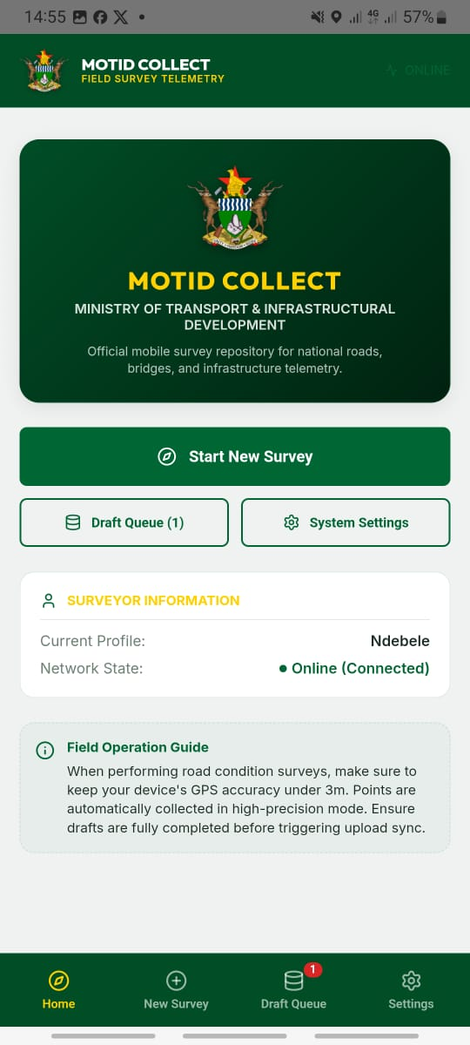
Figure: Mobile Application Home Screen

4.3 Creating a New Survey
- Step 1: Tap the New Survey tab.
- Step 2: Browse the asset category grid (colour-coded by type).
- Step 3: Tap the asset category you wish to survey.
- Step 4: The survey form for that asset type will open.
- Step 5: Fill in all required fields.
- Step 6: Capture GPS coordinates and optionally attach a photo.
- Step 7: Tap Save Draft to save locally, or Submit to queue for upload.
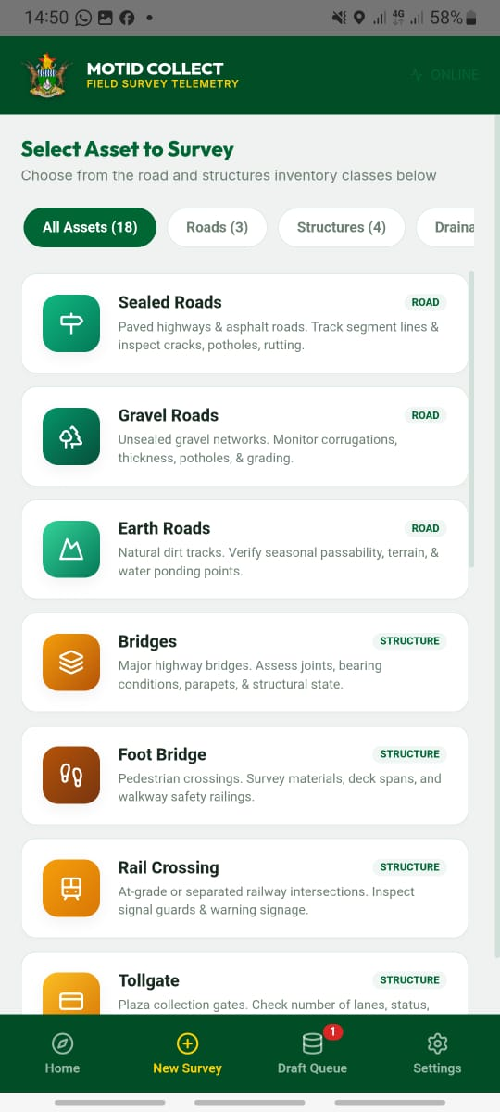
Figure: New Survey Asset Selection Grid

AUTO-SAVE
The app automatically saves your form progress every 400ms as you type. If the app closes unexpectedly, you will be prompted to recover your unsaved work next time you open a form.

4.4 Asset Categories
Asset Type | Category | Description
Sealed Roads | Road | Paved highways & asphalt roads. Track segment lines & inspect cracks, potholes, rutting.
Gravel Roads | Road | Unsealed gravel networks. Monitor corrugations, thickness, potholes & grading.
Earth Roads | Road | Natural dirt tracks. Verify seasonal passability, terrain & water ponding points.
Bridges | Structure | Major highway bridges. Assess joints, bearing conditions, parapets & structural state.
Footbridge | Structure | Pedestrian crossings. Survey materials, deck spans and walkway safety railings.
Rail Crossing | Structure | At-grade or separated railway intersections. Inspect signal guards & warning signage.
Tollgate | Structure | Plaza collection gates. Check number of lanes, status and control mechanism integrity.
Lay-by | Amenity | Roadside rest zones. Check surface type, length and cleanliness state.
Bus Stop | Amenity | Passenger bays & shelters. Record shelter structural status and bay surface conditions.
Junction | Amenity | Main route junctions. Monitor markings quality, warning signs & directional beacons.
Road Sign | Amenity | Speed limits & safety signs. Inspect SADC compliance, poles and reflectivity.
Shelvets | Drainage | Masonry or concrete side drainage. Monitor siltation and crack damage.
Culverts | Drainage | Concrete pipe/box underpasses. Check blocking debris & structural walls.
Piped Causeway | Drainage | Low-level river crossings with pipe channels. Survey serviceability state.
Drift | Drainage | Concrete slab splashways. Inspect water flow depths and slab erosion.
Grid | Drainage | Vehicle cattle grids. Check frame stability, bar spacing & cleanout pit.
Traffic Lights | Traffic | Intersection robot signaling. Check solar/grid power, phases and housing damage.
Streetlights | Traffic | Pole lighting networks. Count active LED fixtures, check cables & battery cabinets.

4.5 Survey Form - Common Fields
Field | Description | Example / Action
Road Name * | The national highway or road route | A4 Highway (Harare-Masvingo-Beitbridge)
Section Name * | Descriptive name for the road section | Masvingo to Beitbridge, km 145
Surveyor Name * | Full name of the field surveyor | John Moyo
Survey Date * | Date the survey was conducted | 2026-07-13
GPS Coordinates* | Latitude/Longitude from device GPS | Tap 'Capture GPS' button
Photo | Optional photo attachment of the asset | Tap 'Take Photo' button
SADC Compliant | Whether the asset meets SADC standards | Yes / No

4.6 Asset-Specific Survey Forms
4.6.1 Sealed Roads
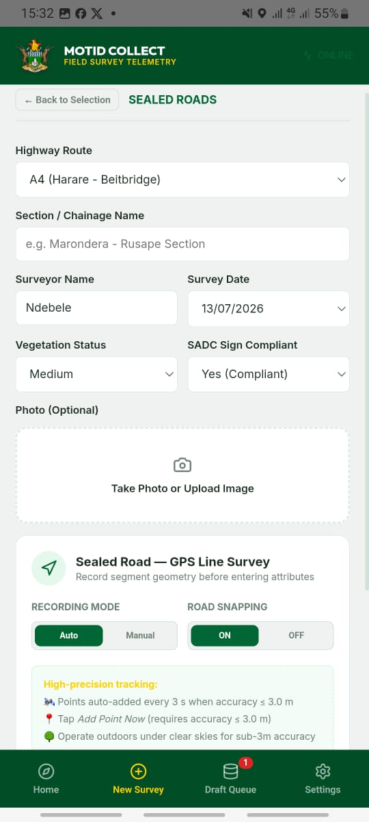
Figure: Sealed Roads Survey Form

Field | Description | Options
Road Class | Classification of the road | Primary / Secondary / Tertiary
Surface Type | Type of sealed surface | Wide Mat SS / Otta Seal / Double Seal
Climate Zone | Climate of the area | Arid / Semi-arid / Moderate / Tropical
Terrain | Topographic terrain type | Flat / Rolling / Mountainous
Road Authority | Managing authority | RDC / DDF / MOTID Central
Length (km) | Segment length in kilometres | e.g. 12.5
Width (m) | Road carriageway width in metres | e.g. 7.0
Drainage Type | Type of road drainage | V-Drain / Kerb & Channel / Table Drain
Narrow Cracks | Hairline/narrow crack condition | No Cracks / <5% / 5-15% / >15%
Wide Cracks | Wide/alligator crack condition | No Cracks / <5% / 5-15% / >15%
Potholes/Patches | Pothole and patching condition | Good / Fair / Poor / Very Poor
Rutting | Wheel track rutting severity | No Rutting / <5mm / 5-20mm / >20mm
Edge Breaks | Road edge break condition | None / <50mm / 50-100mm / >100mm
Drainage Cond. | Overall drainage condition | Good / Fair / Poor / Blocked
Ravelling | Surface ravelling extent | None / Low / Medium / High
Riding Quality | Overall riding quality | Good / Fair / Poor / Very Poor
Road Markings | Presence of road markings | Yes / No
Road Studs | Presence of road studs/cats eyes | Yes / No
Passability | When road is passable | All Year Round / Wet Season Restricted / Dry Season Only
Year Constructed | Year road was built | e.g. 2005

4.6.2 Bridges
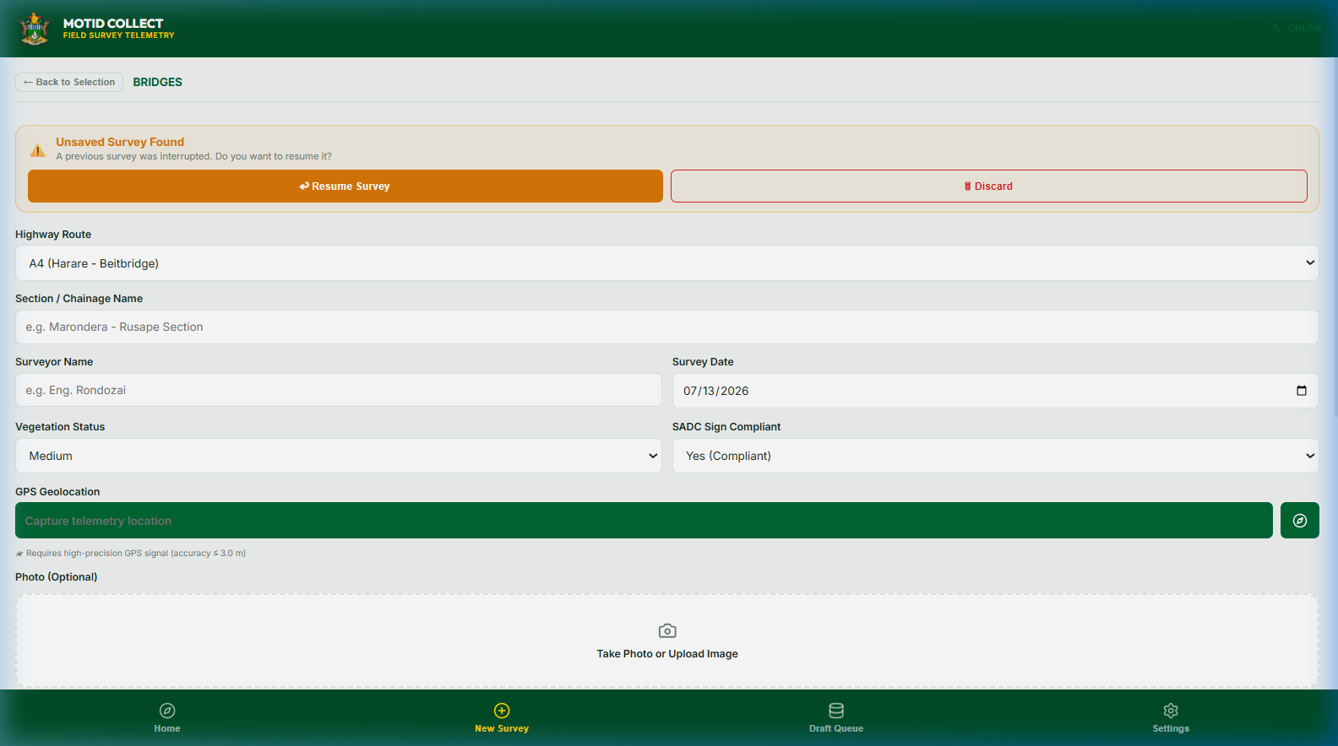
Figure: Bridges Survey Form

Field | Description | Options
Bridge Name | Name or identifier of the bridge | e.g. Runde River Bridge
Crossing Over | What the bridge crosses | River / Railway / Road / Valley
Bridge Type | Structural type | HLDC / Box Culvert / Timber / Steel Truss
Bearing Type | Type of bearing used | Elastomeric / Pot / Roller / Pinned
Expansion Joints | Condition of expansion joints | Good / Fair / Poor / Absent
Bearings State | Condition of bearings | Good / Fair / Poor / Failed
Parapet | Condition of bridge railings/parapets | Undamaged / Minor / Major / Missing
Chemical Effect | Evidence of chemical corrosion | None / Minor / Severe
Vegetation Growth | Vegetation growing on bridge | No / Yes - Minor / Yes - Severe
Drainage | Bridge drainage condition | Good / Blocked / Absent
Overall Condition | Overall structural assessment | Good / Fair / Poor / Critical

4.6.3 Gravel Roads
Field | Description | Options
Road Class | Road classification | Urban Collector / Rural Primary / Feeder Road
Gravel Thickness | Estimated gravel layer thickness | <100mm / 100-150mm / >150mm
Corrugations | Severity of surface corrugations | None / Low / Medium / High
Cross Section | Camber/cross-section shape | Flat / Slightly Cambered / Well Cambered
Potholes | Pothole density | None / Low / Medium / High
Riding Quality | Overall ride quality | Good / Fair / Poor / Very Poor
Passability | Seasonal passability | All Year Round / Wet Season Restricted / Dry Season Only

4.6.4 Culverts & Drainage
Field | Description | Options
Culvert Class | Culvert classification | Pipe Culvert / Box Culvert / Multi-Pipe
Material | Culvert pipe material | Concrete / Steel / HDPE / Corrugated
Serviceability | Overall serviceability state | Good / Fair / Poor / Blocked
Shelvet Type | Type of shelvet structure | Armco / Masonry / Concrete
Drift Passability | When drift is passable | All Year / Dry Season Only

4.6.5 Traffic Assets
Field | Description | Options
Location | Intersection or street name | e.g. Corner Samora Machel / 4th St
Type | Traffic light type | Standard / Solar / Flashing Amber
Phases | Number of signal phases | 3 / 4 / 2-phase pedestrian
Operational | Currently operational? | Yes / No
Condition | Physical condition | Good / Fair / Poor / Vandalized
Power Source | Streetlight power supply | Grid / Solar / Battery Hybrid
Count | Number of streetlight poles surveyed | e.g. 24

4.7 GPS Coordinate Capture
- Tap the Capture GPS button on the survey form.
- The app displays a GPS status indicator showing current accuracy in metres.
- Wait until the accuracy is within your configured GPS Accuracy Limit (default: 3 metres).
- Once the accuracy threshold is met, coordinates are automatically confirmed and locked.
- The Latitude and Longitude fields will be populated automatically.
TIP - GPS Accuracy
For best accuracy, stand in an open area away from buildings and tree cover. Allow 30-60 seconds for the GPS signal to stabilise.

4.8 Photo Capture
- Tap the Take Photo button on the survey form.
- The device camera will open.
- Frame the asset clearly and capture the image.
- Photos are embedded in the draft record and uploaded during sync.

4.9 Draft Queue & Offline Storage
Status | Description | Action
Draft | Surveys saved but not yet ready for submission. Can be edited. | Tap a draft to open and continue editing
Queued | Surveys marked as ready to submit - awaiting network sync. | Will auto-upload when connected
Submitted | Surveys successfully uploaded to the server. | Cannot be edited after upload

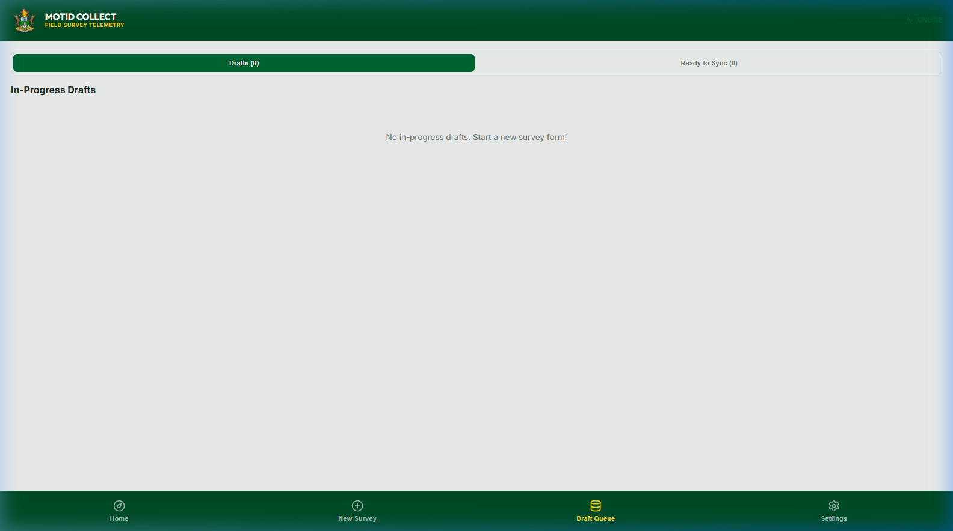
Figure: Draft Queue and Sync Management

4.10 Synchronising Data to Server
- Ensure your device has a WiFi or mobile data connection.
- Navigate to the Queue tab.
- Tap the Sync All button.
- A progress bar displays 'Uploading X of Y records...'
- Successfully uploaded records show a green checkmark.
WARNING
Do not close or lock the app while a sync is in progress. Wait until all records show a green checkmark before closing the app.

4.11 Settings & Configuration
Setting | Description | Example
Server URL | The URL of the backend API server | http://192.168.1.10:3002
Default Surveyor | Your name, pre-filled in new survey forms | e.g. Tendai Chikwanda
GPS Accuracy Limit | Maximum acceptable GPS error in metres | Default: 3.0m
Test Connection | Tap to verify the app can reach the server | Shows Online or Offline

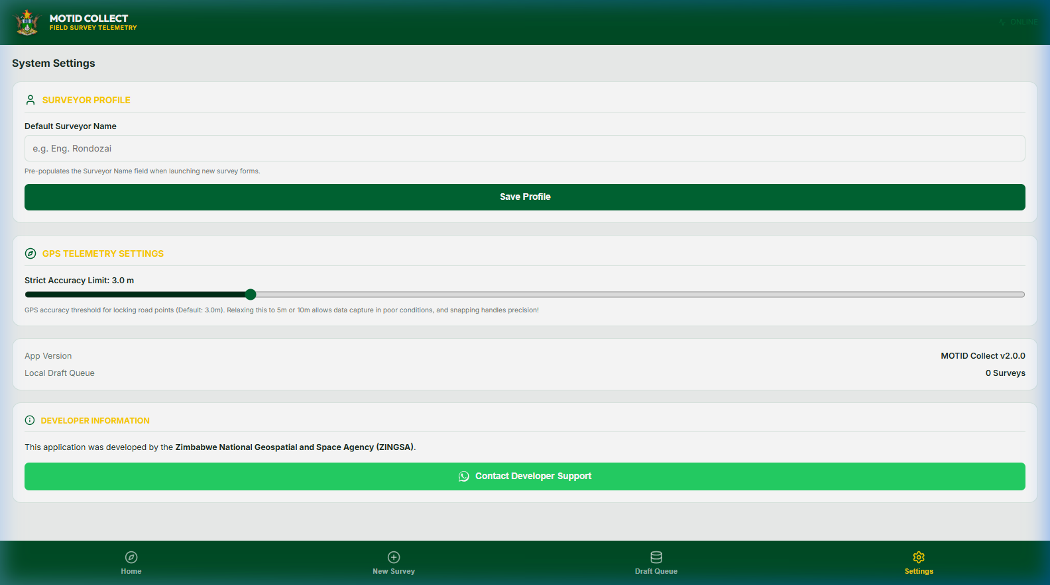
Figure: Application Configuration Settings

5. WEB DASHBOARD - ADMINISTRATOR GUIDE
The Web Dashboard is a browser-based application used by Roads Department administrators, ZINGSA analysts, and engineers to view, query, and export road condition survey data.

5.1 Accessing the Dashboard
- Open Google Chrome, Microsoft Edge, or Mozilla Firefox.
- Navigate to the dashboard URL provided by the ICT department.
- The dashboard loads automatically. No login credentials are required for the default deployment.

5.2 Layout & Navigation
Zone | Description
Header Bar | Top - Ministry/ZINGSA branding, data source, last sync time, Refresh button
Left Navigation Rail | Icon-based vertical navigation for switching between modules
Inner Panel | Left side panel showing filtered asset list. Can be collapsed.
Map Zone | Central Leaflet map showing all surveyed assets as coloured markers
Right Analytics Panel | Right side panel showing charts, statistics, and selected record detail.
Footer Bar | System version, survey year, highway coverage, and record count

5.3 Map View
- Assets displayed as coloured pin markers. Colour indicates asset type.
- Click a marker to select the survey record and view its details in the right panel.
- Use the mouse wheel or track-pad to zoom in and out.
- Use the Road Filter dropdown to filter markers by highway.
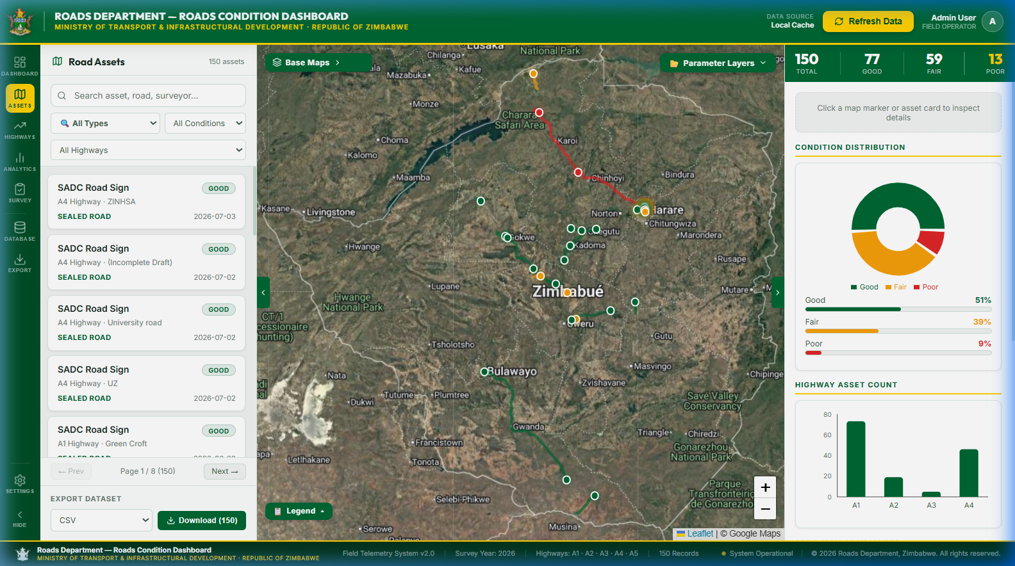
Figure: Web Dashboard Main Map View

5.4 Assets Panel
- Click any record in the list to highlight it on the map and open its details.
- Use the road filter at the top to narrow records by highway (A1-A5 and others).

5.5 Dashboard Module
Provides a high-level overview of survey statistics across all highways - total asset counts, condition distribution charts, and coverage summaries.
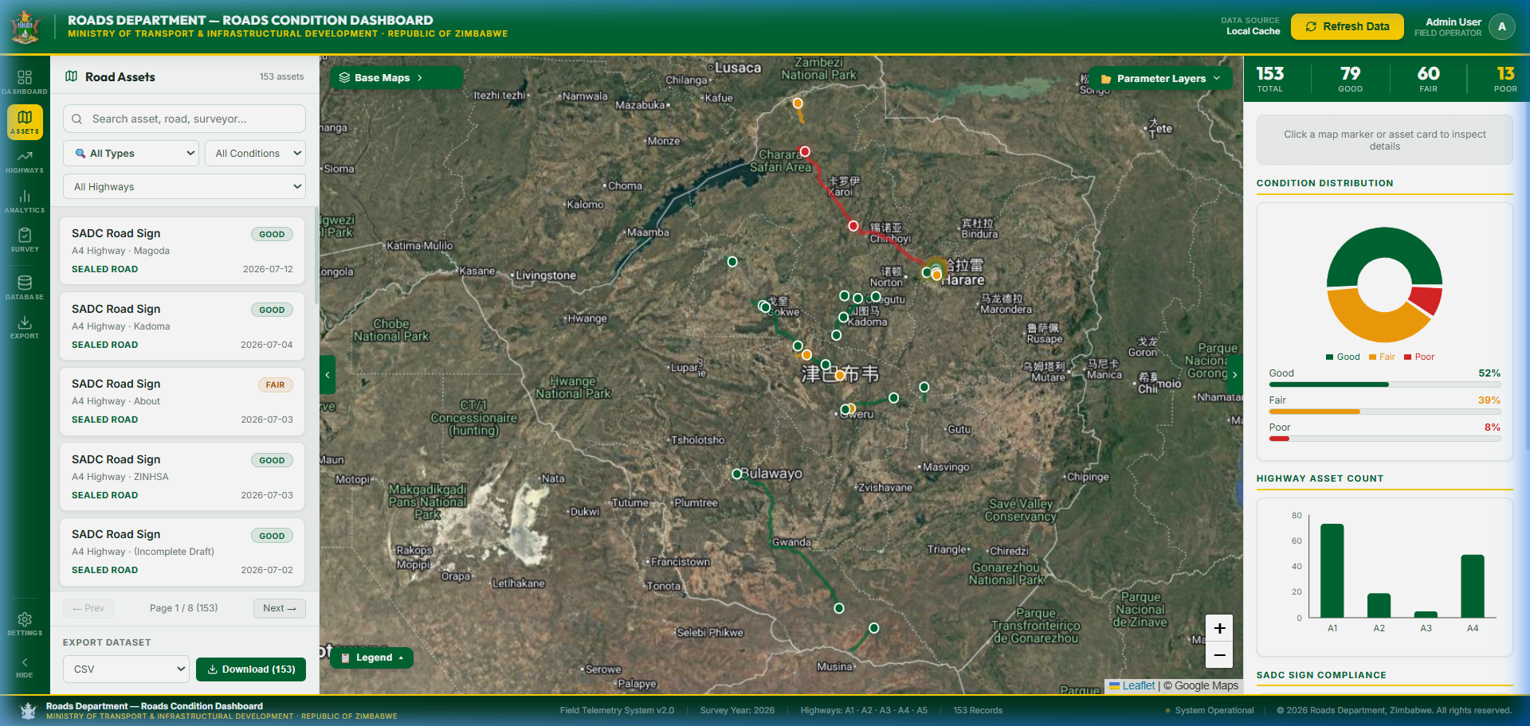
Figure: Web Dashboard Statistics and Charts Module

5.6 Highways Module
Per-highway breakdown of surveyed assets, showing asset count, condition ratings, and survey completion status for each of the surveyed highways: A1, A2, A3, A4, and A5.

5.7 Analytics Module
- Asset condition distribution pie and bar charts
- Road defect frequency analysis (cracks, potholes, rutting)
- Survey activity timeline (records per date)
- Passability analysis by road class

5.8 Survey Module
Structured tabular view of all survey records, filterable by asset type, road, surveyor, and date range.

5.9 Database Module
Raw data view of all survey records for searching, filtering, and individual record inspection.

5.10 Export Module
- CSV - for use in Microsoft Excel or GIS software
- JSON - raw data export for integration with other systems
- PDF Report - formatted condition report for management briefings

5.11 Right-Side Analytics Panel
- Asset type, road name, section, and GPS coordinates
- Survey date and surveyor name
- All condition fields specific to that asset type
- Attached photo (if available)
- Overall condition rating badge (Green=Good, Yellow=Fair, Red=Poor)

5.12 Refreshing Live Data
- Phase 1 - Local Cache: On page load, locally cached data displayed instantly.
- Phase 2 - Server Data: Server queried in background, merged with local records.
- To force a live refresh from Central Database, click the Refresh Data button in the header.

6. DATA SYNCHRONISATION & OFFLINE OPERATION
Layer | Description | Behaviour
Device Storage | Survey drafts stored in browser IndexedDB | Persistent across app restarts
Auto-Save | Form data saved to localStorage every 400ms | Crash recovery protection
Manual Sync | User-initiated batch upload to server | Via Sync All button in Queue tab
Server Cache | Server stores a local JSON cache of Central Database data | Reduces API call latency
Dashboard Cache | roads-data.json served as static fallback | Dashboard loads without server
Conflict Resolution | Server records take precedence; de-duplicated by record ID | Merging on Phase 2 load

7. SYSTEM ADMINISTRATION
7.1 Starting the Backend Server
- Navigate to the backend/ directory on the server.
- Run: python -m uvicorn main:app --reload --port 8000
- API swagger documentation: http://[server-ip]:8000/docs
7.2 Environment Configuration
Variable | Description | Example
DATABASE_URL | Central Database API base URL | https://kf.Central Database.org/api/v2
DATABASE_KEY | Central Database account username | motid_surveyor
DATABASE_PASSWORD | Central Database account password | [secured]
DATABASE_PROJECT_ID | Asset UID of the Roads survey form | a1b2c3d4e5...
OFFLINE_MODE | Serve only cached data without calling Central Database | false

8. TROUBLESHOOTING
Symptom | Solution | Applies To
GPS stuck at 'Waiting for signal' | Move to open area; ensure Location is ON in Android Settings; restart app. | Mobile App
App shows 'Offline' on WiFi | Check Server URL in Settings; tap 'Test Connection'; confirm backend is running. | Mobile App
Sync fails - Network Error | Verify internet; confirm backend server is running; retry after 30 seconds. | Mobile App
Lost draft after app crash | Open any form - yellow recovery banner appears - tap 'Restore Draft'. | Mobile App
Dashboard map is empty | Click 'Refresh Data' in header; verify backend is running and Central Database credentials are correct. | Web Dashboard
Data source shows 'Offline Cache' | Backend server may be down - contact ZINGSA ICT support. | Web Dashboard
Duplicate records on map | Click 'Refresh Data' - system auto-deduplicates on next load. | Web Dashboard
Export not downloading | Check browser download permissions; disable popup blocker for dashboard URL. | Web Dashboard

9. GLOSSARY
Term | Definition
APK | Android Package Kit - the installation file format for Android applications
API | Application Programming Interface - rules for how software systems communicate
Capacitor | A cross-platform runtime that packages web apps into native Android/iOS apps
Culvert | A drainage structure allowing water to flow under a road
Drift | A concrete slab splashway for vehicles to cross a watercourse during low water
FastAPI | A high-performance Python web framework used to build the backend REST API
GIS | Geographic Information System - software for managing and analysing spatial data
GPS | Global Positioning System - satellite technology for geographic coordinates
HLDC | High Load Double Cross - a common precast concrete bridge beam type
Central Database | Online data collection platform used to store and manage survey submissions
Leaflet | An open-source JavaScript mapping library for the interactive map
MOTID | Ministry of Transport and Infrastructural Development
Next.js | A React-based web framework used to build the web dashboard
SADC | Southern African Development Community - standards body for road signs
Shelvet | A side drain channel (masonry or concrete) alongside the road pavement
Sync | Uploading locally stored survey records from the mobile device to the server
ZINGSA | Zimbabwe National Geospatial and Space Agency - the operator of this system

APPENDIX A - Central Database Integration
The backend server fetches survey data from the Central Database API. ZINGSA manages the Central Database organisation account and form assets.
- Survey forms are designed in Central Database and deployed to the field via the mobile app.
- The backend polls the Central Database API using the DATABASE_PROJECT_ID.
- Data is cached server-side to reduce API load and support offline dashboard usage.
Central Database API endpoint: GET https://kf.Central Database.org/api/v2/assets/{ASSET_ID}/data.json

APPENDIX B - API Endpoint Reference
Method | Endpoint | Description
GET | / | Health check - returns server status and version
GET | /api/roads | Returns all road condition survey records
POST | /api/roads/submit | Accepts a new survey record submission from the mobile app
GET | /docs | Interactive Swagger UI API documentation

--------------------------------------------------------------------------------
End of Document
Zimbabwe National Geospatial and Space Agency (ZINGSA)
In Partnership with: MOTID - Department of Roads
Document Version: v1.0 | Issue Date: July 2026 | Classification: INTERNAL USE ONLY

