TITAN PROTECTION

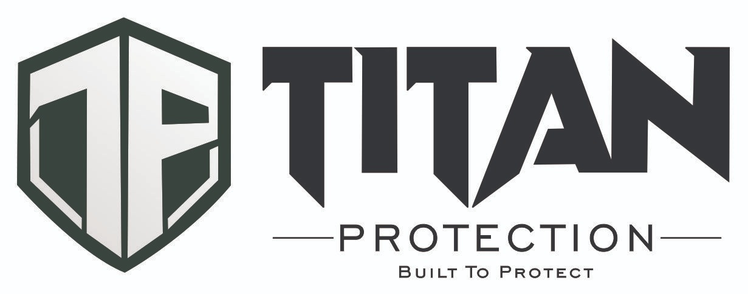

System Manual
Complete Operations Platform Guide
Web Command Portal · Supervisor Portal · Mobile Field Clients

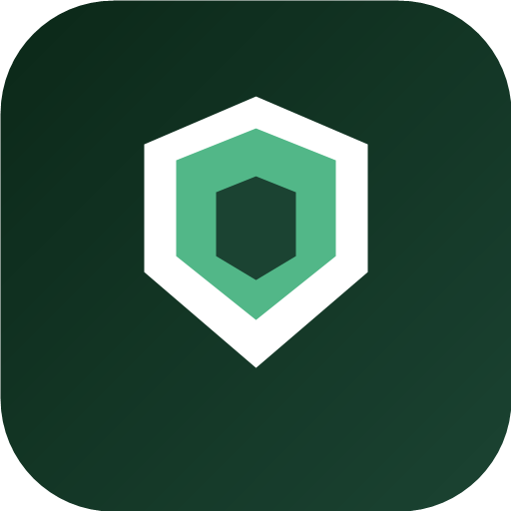

Document | Titan Protection System Manual
Version | 1.0
Date | 20 August 2026
Live system | https://titanprotection.org

Built to Protect
Developed by Arch Luviah Technologies

Table of Contents
Part I — System Introduction
- 1. About Titan Protection
- 2. System Architecture & Components
- 3. User Roles & Access Model
- 4. Data Flow & Synchronisation
Part II — Access & Web Portals
- 5. Signing In
- 6. Master Admin Web Portal
- 7. Supervisor Web Portal
Part III — Mobile Field Clients
- 8. Titan Monitor — Field Operations Client
- 9. Titan Supervisor — Mobile Client
Part IV — Core Operational Modules
- 10. Territory & Supervisor Administration
- 11. Premises & Site Registration
- 12. Personnel & Shift Management
- 13. Command Centre & Real-Time Monitoring
- 14. GIS Operations Map
- 15. Data Explorer & Records Management
Part V — Platform Services
- 16. Communications, PIN Delivery & Alerts
- 17. System Settings & Master Administration
- 18. Mobile App Distribution & Updates
Part VI — Support
- 19. Troubleshooting & FAQ
- Appendix A — Quick Reference
- Appendix B — Glossary

PART I · SYSTEM INTRODUCTION

1. About Titan Protection
Titan Protection is an integrated security operations platform designed for private security companies, corporate protection teams, and institutional guard services. The system unifies command-and-control, field operations, geographic site management, personnel administration, and real-time incident response in a single live ecosystem.
This manual documents the complete Titan Protection system — not a single application or user role, but the full platform: web command portals, supervisor workspaces, Android field clients, shared database, and operational workflows that connect them.

1.1 System Purpose
- Register and geolocate protected premises and patrol points.
- Organise operations by territory with dedicated area supervisors.
- Deploy and monitor field personnel with GPS-verified attendance.
- Track patrol activity, incidents, and compliance in real time.
- Respond to distress (SOS) signals and operational alerts immediately.
- Maintain audit trails through the Occurrence Book and Data Explorer.
- Distribute mobile clients and keep all endpoints synchronised.

1.2 Who Uses This Manual
Audience | Interest
Master Administrators | Full platform setup, configuration, and governance
Operations Managers | Daily monitoring via Command Centre and GIS map
Area Supervisors | Territory-scoped web and mobile supervisor tools
IT / Deployment Teams | APK distribution, login configuration, database sync
Training & Compliance Officers | Workflows, checklists, audit records

2. System Architecture & Components
Titan Protection consists of four client applications sharing one API and database. All components read from and write to the same operational datastore when connected to the live server (Supabase).
Component | Platform | Primary function
Master Admin Web Portal | Browser — / | Full system administration and monitoring
Supervisor Web Portal | Browser — /supervisor | Territory-scoped operations dashboard
Titan Monitor | Android — com.titan.monitor | Field operations client for on-site personnel
Titan Supervisor | Android — com.titan.supervisor | Field client for supervisors — GPS site capture, team view

2.1 Shared Infrastructure
- API layer — /api/state handles reads and operational mutations for all clients.
- Authentication — separate admin (email/password) and supervisor (6-digit PIN) sessions.
- Database — Supabase PostgreSQL; demo mode uses in-memory store when server unreachable.
- Real-time polling — web dashboards refresh every 10 seconds; mobile clients poll on comparable intervals.
- Production URL — https://titanprotection.org (Vercel deployment, web root: web/).

2.2 Recommended Deployment Sequence
- Configure Master Admin credentials and connect to live database.
- Create territories and register supervisors; deliver PINs.
- Register premises with on-site GPS capture (±5 m accuracy).
- Add patrol places at each premises.
- Register field personnel; assign one supervisor and premises per person.
- Schedule shifts and distribute Titan Monitor APK.
- Supervisors install Titan Supervisor APK for field GPS capture.
- Monitor operations in Command Centre and GIS map.

3. User Roles & Access Model
Role | Portal / App | Scope
Master Admin | Web — / | Entire tenant — all territories, settings, data
Area Supervisor | Web — /supervisor + Titan Supervisor app | Assigned territories only
Field Officer | Titan Monitor app | Assigned premises and shifts

3.1 Supervisor Territory Scoping
Supervisors (web and mobile) see only data linked to their assigned territory IDs: premises in those territories, places under those premises, guards assigned to them or their territories, related shifts, attendance, alerts, and occurrence book entries.
Access rule: Supervisors cannot create territories, manage other supervisors, reassign guards to another supervisor, or access Master Admin tools.

4. Data Flow & Synchronisation
Typical operational data flow across the system:
- Admin or supervisor registers a premises with GPS → stored in database → appears on GIS map (green marker).
- Patrol places added at premises → small red markers on map; checkpoint records sync for mobile patrol.
- Field officer clocks in via Titan Monitor → attendance record → Command Centre and map update.
- Incident or SOS logged on mobile → Occurrence Book entry → alert banner on web dashboards.
- Supervisor captures site GPS on Titan Supervisor app → premises/places update via API.
- All web dashboards poll /api/state; changes propagate within seconds on live connection.
Connection indicator: Server Connected / Live = production database. Demo Mode = in-memory only; data may not persist.

PART II · ACCESS & WEB PORTALS

5. Signing In

5.1 Login Chooser — /login
Welcome to Titan Protection — choose your role:
Role card | Description | Action
Master Admin | Full access — supervisors, territories, personnel, premises, settings | Admin sign in →
Supervisor | Area-scoped — command centre, personnel, premises in assigned territories | Supervisor sign in →

Footer: Download Titan Monitor & Supervisor APKs → /downloads

5.2 Master Admin — /admin/login
- Enter email and password configured by your system administrator.
- Click Sign In → redirected to / (Master Admin Dashboard).
- Sign Out from the page header when finished.

5.3 Supervisor — /supervisor/login
- Enter 6-digit PIN on the numeric keypad (same PIN as Titan Supervisor mobile app).
- Redirected to /supervisor (Supervisor Dashboard).
- Forgotten PIN: Master Admin resets from Supervisor & Territories → Reset PIN.

6. Master Admin Web Portal
Full operations hub. Sidebar navigation:
Module | Function
Supervisor & Territories | Territories, supervisor accounts, WhatsApp setup
Guard Management | Personnel profiles, shifts, attendance, alerts, performance
Register Premises | Protected sites, patrol places, GPS capture
GIS Operations Map | Live geographic operations view
Command Centre | Real-time stats, map, Occurrence Book, visitors
Data Explorer | Database collections — search, export, edit
Master Admin | Sync, checklists, audits, data management
Mobile App Downloads | APK distribution page

6.1 System Settings (sidebar)
Setting group | Options
Alerts & Sirens | Siren on critical alerts (SOS, critical guard alerts)
GPS & Geofencing | Geofence radius 5–8 m (default 6 m)
Patrol Monitoring | No-movement threshold 15–90 min (default 45 min)
License Compliance | Expiry warning window 14–90 days (default 60 days)

6.2 Connection & Refresh
Header badge shows Server Connected or Demo Mode Active. Dashboard polls every 10 seconds. Critical alerts may trigger audible siren when enabled.

7. Supervisor Web Portal
Territory-scoped mirror of key admin modules:
Module | Supervisor scope
Register Premises | Premises in assigned territories
Guard Management | Scoped personnel only
GIS Operations Map | Scoped sites, places, events
Command Centre | Scoped live monitoring
Data Explorer | Scoped records; limited edit tables

Not available to supervisors: Supervisor & Territories admin, Master Admin tab, System Settings, Mobile Downloads link, Reset Patrol, cross-territory data.

PART III · MOBILE FIELD CLIENTS

8. Titan Monitor — Field Operations Client
Package: com.titan.monitor · Android APK from /downloads
Purpose: Primary field client for on-site security personnel.

8.1 Sign-In & Profile
- 6-digit PIN login (delivered by email on registration).
- First-login PIN change flow when required.
- Profile photo upload; assigned premises resolved from guard profile and active shift.
- Over-the-air update prompt when newer APK published.

8.2 Main Modules (bottom navigation)
Tab | Function
Patrol | Clock-in/out with GPS geofence verification; patrol point progress; movement tracking
Incidents | Log incidents with photo and voice memo attachments; syncs to Occurrence Book
Checklists | Complete published audit/checklist templates from web admin
Access | Visitor QR scanning and access desk functions
Profile | Guard details, documents, performance summary, sign out

8.3 Key Field Operations
- GPS clock-in — must be within premises geofence radius (system setting, default 6 m).
- Patrol progress — tracks scanned/completed patrol points for assigned site.
- SOS distress — triggers CRITICAL DISTRESS SIGNAL on all web Command Centres.
- No-movement monitoring — server-side alerts if guard stationary beyond threshold.
- Geofence exit alerts — triggered when on-duty guard leaves site boundary.

9. Titan Supervisor — Mobile Client
Package: com.titan.supervisor · Android APK from /downloads
Purpose: Field tool for area supervisors — complements the supervisor web portal.

9.1 Sign-In
Same 6-digit PIN as supervisor web portal. Session scoped to supervisor ID and assigned territories.

9.2 Main Modules
Tab | Function
Home | Dashboard summary — territories, premises, guards, alerts
Sites | Register premises and patrol places with high-accuracy GPS capture (±5 m target)
Team | View and manage scoped guard team
Profile | Supervisor photo, PIN change, app update, sign out

9.3 GPS Capture
Sites panel uses extended GPS warm-up and cluster-median filtering for accurate coordinates. Save is optimised for fast completion after GPS lock. Captured coordinates sync to web GIS map.
PART IV · CORE OPERATIONAL MODULES

10. Territory & Supervisor Administration
Master Admin only — Supervisor & Territories module.

10.1 Territories
- Add Territory → name, city, description, suburbs list.
- Territories scope all premises, supervisors, and filtered data views.
- Delete only after reassigning linked premises and personnel.

10.2 Supervisors
- Add Supervisor → name, role, phone, email, assigned territories.
- System generates 6-digit PIN; delivered via email + WhatsApp manual send.
- Reset PIN, upload photo, edit status (Active / Suspended / Off Duty).

10.3 WhatsApp Integration
Manual WhatsApp model — system opens WhatsApp with pre-filled message; user taps Send. Used for PIN delivery backup, shift notifications, and supervisor-to-guard messaging.

11. Premises & Site Registration
Available on Master Admin and Supervisor web portals (supervisor: scoped territories). Also via Titan Supervisor mobile Sites tab.

11.1 Register Premises
- Premises name, owner/client, address, territory, city, suburb.
- Capture GPS on site — target ±5 m accuracy.
- Share Premises ID with field personnel for Titan Monitor site linking.

11.2 Patrol Places
- Add Place under selected premises — name, type, schedule, description.
- Capture place GPS at physical location.
- Map display: small red P markers. NFC tagging deferred for future release.

11.3 Map Markers (current)
Marker | Colour / size | Meaning
Premises | Green — site initials | Registered protected site centre
Patrol place | Red — small P pin | Important location inside a premises

12. Personnel & Shift Management
Guard Management module — personnel administration (web).
Sub-tab | Purpose
Guard Profiles | Register personnel, documents, bulk supervisor assignment
Shift Roster | Schedule shifts; WhatsApp notification on save
Live Attendance | On-duty status, geofence/movement badges, history
Supervisor Alerts | Movement, geofence, license alerts — dismiss when resolved
Performance | Composite scorecards
Shift Swaps | Approve/reject mobile swap requests
Messaging | Email and WhatsApp configuration and send

12.1 Personnel Registration Rules
- Each field officer assigned to exactly one supervisor (supervisorId).
- Supervisors registering new personnel must assign them to themselves.
- Bulk tools: Assign all to supervisor; Auto-match by territory.
- PIN delivered via email for Titan Monitor login.

13. Command Centre & Real-Time Monitoring
Shared by Master Admin and Supervisor portals (supervisor: scoped data).
Panel | Content
SOS banner | CRITICAL DISTRESS SIGNAL — Dismiss Alarm
Statistics | Compliance rate, taps scanned, active guests, guards on duty
Live map | Compact GIS view of sites and patrol points
Occurrence Book | Chronological field events — status workflow, photo/voice attachments
Visitor registry | Check-in form and live visitor log table

14. GIS Operations Map
Full-screen map (Leaflet) with sidebar in dedicated tab; compact embed in Command Centre.

14.1 Basemaps
- Google Satellite Hybrid (default), Google Streets, Google Terrain, Dark Matter GIS, Esri World Imagery.

14.2 View Presets
Preset | Use case
Operations | Live personnel, geofences, trails, alerts
Patrol | Premises and patrol places only (simplified default)
Emergency | Alerts, heatmap, activity focus
Overview | Sites and places across territories

14.3 Layer Toggles
- Protected premises, patrol places, geofences, GPS accuracy rings, patrol routes.
- Live personnel, movement trails, shift roster, alerts, activity, heatmap, territory zones.
- NFC checkpoint layer hidden until NFC patrol map integration is enabled.

14.4 Map Tools
- Search, zoom, fit all sites, measure distance, copy GPS from popups, fly-to on SOS.

15. Data Explorer & Records Management
Browse all system collections — Core, Geography, People, Operations, Communications, Compliance, Emergency categories.
- Search, paginate (30 rows), copy JSON, export CSV/JSON.
- Inline edit (admin: all editable tables; supervisor: premises, places, guards, shifts, alerts, OB).
- Sensitive fields redacted — PINs, passwords, raw GPS trails, attachments.
PART V · PLATFORM SERVICES

16. Communications, PIN Delivery & Alerts
Event | Email | WhatsApp
New field officer registered | Titan Monitor PIN | Manual send modal
New supervisor registered | Supervisor PIN | Manual send modal
PIN reset | New PIN emailed | WhatsApp opens
Shift scheduled | — | Notification message
SOS triggered | — | Command Centre banner + optional siren

16.1 Alert Types
- SOS panic — highest priority; red banner all dashboards.
- No-movement — field officer stationary beyond threshold.
- Geofence exit — on-duty officer left site boundary.
- License expiry — compliance warning window.
- Shift swap request — pending supervisor action.

17. System Settings & Master Administration

17.1 Master Admin Tab
- Reload from database — sync from Supabase.
- Clear all data — destructive demo reset (production caution).
- Checklist Template Builder — publish audit forms for Titan Monitor.
- Completed Audits — view submitted checklist responses.
- System Configuration summary — read-only settings display.

17.2 Security
- Role-isolated sessions — admin vs supervisor cookies.
- PIN redaction in Data Explorer and supervisor API responses.
- Supervisor mutation guard — server validates territory scope on every action.
- HTTPS enforced in production.

18. Mobile App Distribution & Updates
Public page: /downloads
App | Package | Audience
Titan Monitor | com.titan.monitor | Field operations personnel
Titan Supervisor | com.titan.supervisor | Area supervisors

18.1 Installation
- Download APK from /downloads.
- Allow installation from unknown sources (Android).
- Sign in with PIN.
- Use in-app Update app when newer build published — OTA without manual reinstall.
PART VI · SUPPORT

19. Troubleshooting & FAQ
Issue | Resolution
Demo Mode showing | Verify Supabase connection; Reload from database
Wrong site on Titan Monitor | Verify personnel premises assignment; logout/login after app update
0/0 patrol points | Ensure places exist under premises; checkpoints sync from places
GPS capture fails | Enable location; stand outdoors; wait for ±5 m lock
Blue NFC markers on map | Disable checkpoints layer; NFC map integration deferred
Supervisor PIN failed | Master Admin → Reset PIN
Data not updating | Wait 10 s auto-refresh or use Refresh in Data Explorer

19.1 FAQ
Question | Answer
Is this a guard-only manual? | No — this documents the entire Titan Protection system for all roles.
Can one officer have two supervisors? | No — exactly one supervisor per field officer.
Do supervisors see all company data? | No — only assigned territories.
How many map marker types now? | Two — green premises, red patrol places.
Where are APKs? | /downloads or login page footer link.

Appendix A — Quick Reference
Resource | URL / path
Login chooser | /login
Admin dashboard | /
Supervisor dashboard | /supervisor
Mobile downloads | /downloads
Production | https://titanprotection.org

System Onboarding Checklist
- Connect live database; confirm Server Connected.
- Create territories and supervisors.
- Register premises with GPS.
- Add patrol places.
- Register personnel; assign supervisor and premises.
- Schedule shifts.
- Deploy Titan Monitor and Titan Supervisor APKs.
- Verify Command Centre and GIS map.

Appendix B — Glossary
Term | Definition
Titan Protection System | The complete platform — web portals, mobile apps, API, and database
Premises | A registered protected site with GPS coordinates
Patrol place | Important location inside a premises (red map marker)
Territory | Geographic operating area (city + suburbs)
Command Centre | Real-time web monitoring module
Occurrence Book (OB) | System-wide chronological event log
Titan Monitor | Android field operations client
Titan Supervisor | Android supervisor field client
Geofence | GPS radius for clock-in verification (5–8 m)
Compliance rate | Patrol checkpoint scan completion percentage

Built to Protect
Titan Protection System Manual v1.0 · August 2026
Developed by Arch Luviah Technologies

