TITAN PROTECTION



Phase 2 Implementation Plan
Guard Monitoring Enhancements
Security Operations · Patrol Verification · Real-Time Response

Document | Phase 2 Enhancement & Security Monitoring Plan
Version | 1.0
Date | 21 August 2026
Prepared for | Titan Protection Security
Live system | https://titanprotection.org

Built to Protect

Table of Contents
- 1. Executive Summary
- 2. Current Platform Baseline
- 3. Strategic Objectives
- 4. Enhancement Roadmap Overview
- 5. Phase 1 — Foundation (Prerequisites)
- 6. Phase 2 — Core Guard Monitoring (Detailed)
- 7. Phase 3 — Trust, Reporting & Compliance
- 8. Phase 4 — Advanced Integrations
- 9. System Architecture
- 10. Feature Specifications & Process Flows
- 11. Implementation Timeline
- 12. Success Metrics & KPIs
- 13. Risks & Mitigations
- 14. Appendix — Priority Matrix

1. Executive Summary
This document defines the Phase 2 enhancement plan for the Titan Protection Operations Hub — a integrated platform comprising the web Command Centre, Supervisor Portal, Titan Monitor guard mobile app, and Titan Supervisor mobile app. The plan focuses on strengthening guard monitoring, increasing site security, and providing audit-ready evidence for clients and PSIRA compliance.
Purpose. Transform Titan Protection from a operational tracking platform into a proactive security monitoring system that proves guards are on site, patrolling on schedule, and responding to incidents.

The enhancements are organised into four implementation phases. Phase 1 establishes real-time alerting foundations. Phase 2 (the primary focus of this document) delivers core monitoring capabilities including physical NFC patrol verification, welfare checks, live guard status boards, and structured incident escalation. Phases 3 and 4 extend the platform with client reporting, anti-fraud measures, and advanced integrations.

2. Current Platform Baseline
The following capabilities are already live in production at titanprotection.org:
Module | Current capability
Guard mobile (Titan Monitor) | Clock in/out with geofence · Patrol tap · SOS · Incidents · Checklists · Visitors · Offline queue
Supervisor mobile | Territory-scoped guards · Shift roster · Alert dismiss · SOS clear · Premises registration
Web Command Centre | GIS map · Live attendance · Occurrence Book · Access desk · Checklist builder · Siren alerts
Alerts (live) | Missed clock-in/out (30 min repeat) · No movement · License expiry · Shift swap
Alerts (parked) | Geofence exit (code exists, disabled in settings)
Integrations | Email PIN delivery (Resend) · WhatsApp manual links · HTTP polling (~10s)
Not yet built | Push notifications · Real NFC hardware · Overdue patrol enforcement · Client portal · PDF reports

3. Strategic Objectives
- Prove guard presence — physical and GPS-verified, not honour-system check-ins.
- Enforce patrol schedules — alert when checkpoints are overdue, not just display progress.
- Reduce incident response time — instant push for SOS, geofence exit, and missed clock-in.
- Protect lone guards — welfare checks and dead-man's switch on night shifts.
- Win and retain clients — compliance dashboards and monthly audit reports.
- Meet PSIRA expectations — license tracking, training records, and defensible occurrence logs.

4. Enhancement Roadmap Overview
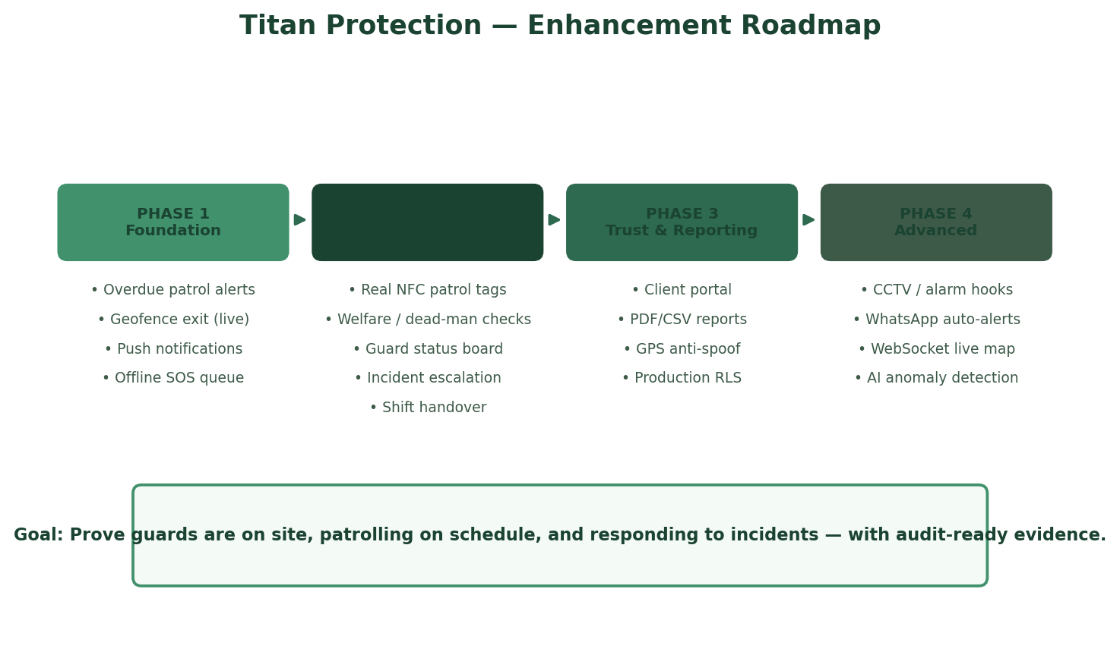
Figure 1 — Four-phase enhancement roadmap from foundation alerts to advanced integrations

5. Phase 1 — Foundation (Prerequisites)
Phase 1 items are prerequisites that should be completed before or in parallel with Phase 2. They address the highest-frequency monitoring gaps using existing code where possible.
Feature | Description | Effort | Security impact
Overdue patrol alerts | Server alert when checkpoint scan exceeds schedule (e.g. Every 2 hrs) + 30 min repeat | Medium | High — proves patrols happened
Geofence exit (live) | Re-enable with grace period to avoid GPS jitter; auto-resolve on re-entry | Low | High — proves guard stayed on site
Push notifications (FCM) | Firebase Cloud Messaging for SOS, critical alerts, missed clock-in | Medium | High — sub-5s response vs 10s poll
Offline SOS queue | Queue panic alert locally; auto-send when connectivity returns | Low | Critical — guard safety in dead zones

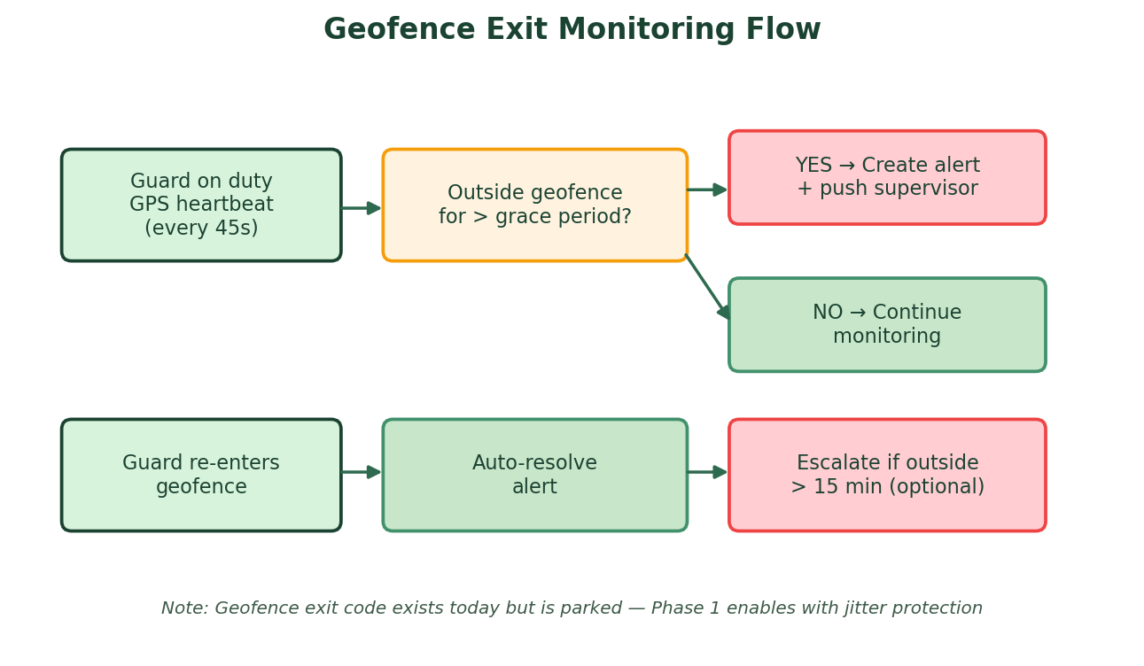
Figure 2 — Geofence exit monitoring with grace period and auto-resolve

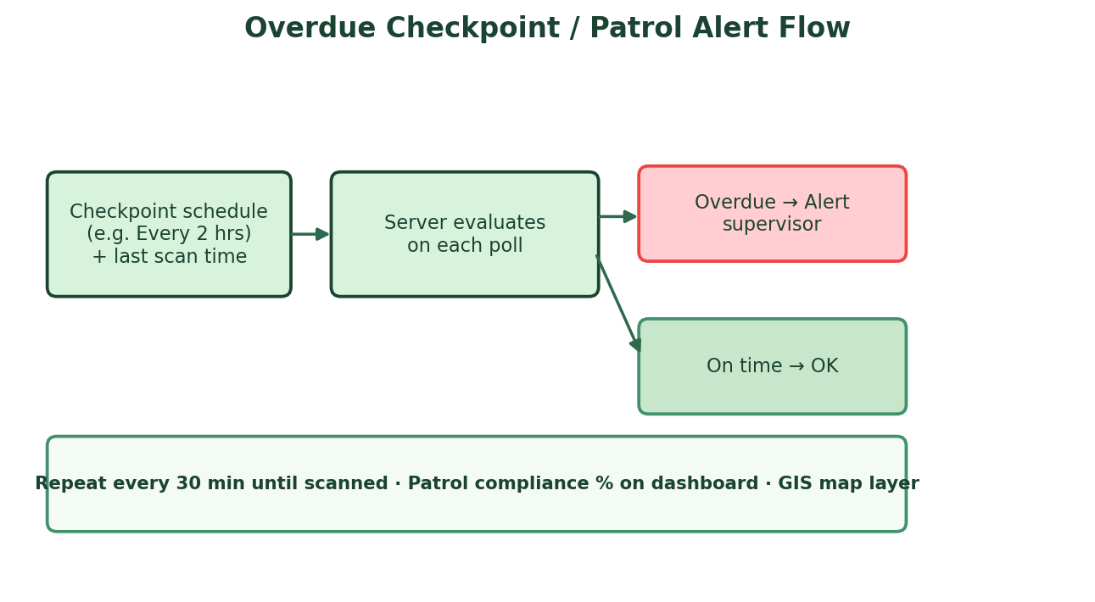
Figure 3 — Overdue checkpoint evaluation and recurring supervisor alerts

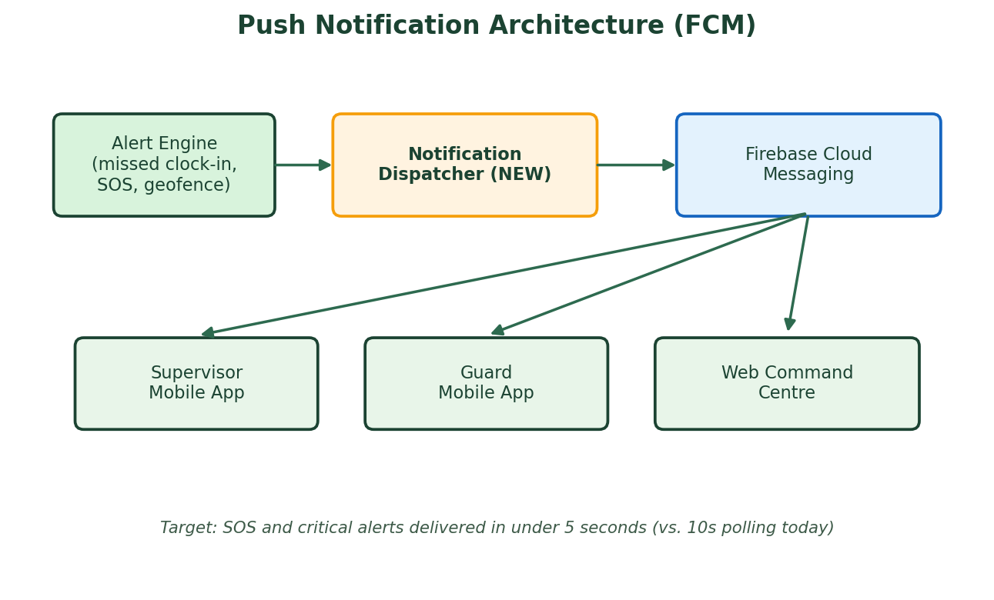
Figure 4 — Push notification architecture replacing poll-only delivery

6. Phase 2 — Core Guard Monitoring (Detailed)
Phase 2 is the primary focus of this implementation plan. These features transform patrol tracking into verifiable security monitoring and give supervisors real-time situational awareness.

6.1 Real NFC Patrol Tag Scanning
Today, patrol checkpoints are confirmed via an in-app button tap. Phase 2 integrates physical NFC tags installed at doors, gates, and patrol points. The guard's phone reads the tag's unique ID, which the server validates against the registered nfc_code on each patrol place.
- Admin registers NFC tag UID when creating or editing a patrol place.
- Guard taps phone on tag — Capacitor NFC plugin reads UID + captures GPS.
- Server validates: tag ID matches · guard is on duty · location within geofence · schedule met.
- Failed validation logged to Occurrence Book with reason (wrong tag, wrong site, etc.).
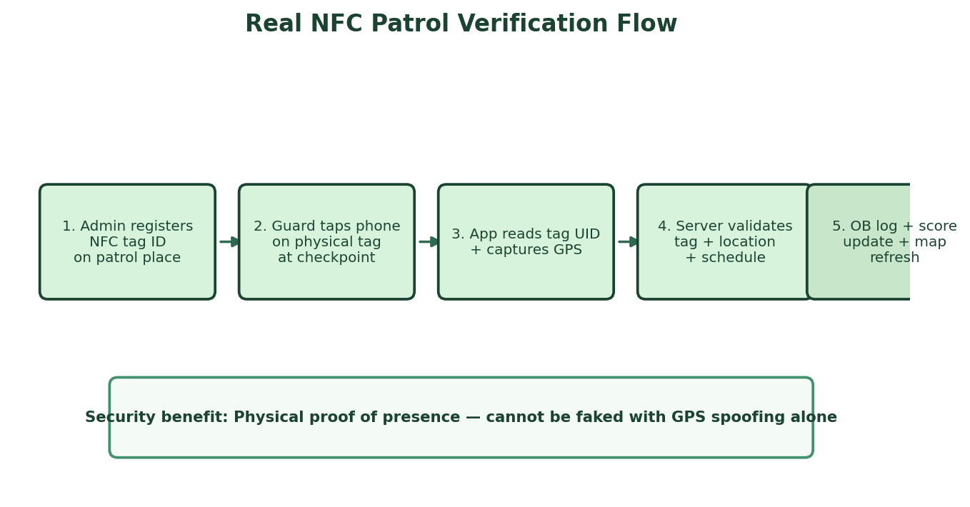
Figure 5 — Real NFC patrol verification end-to-end flow

6.2 Welfare Check / Dead Man's Switch
Extends the existing no-movement alert into a formal welfare protocol for lone guards on night shifts or remote sites. The guard app prompts 'Confirm OK' every 60–90 minutes (configurable per site).
- No response within 5 minutes → supervisor alert + push notification.
- No supervisor acknowledgement within 10 minutes → escalate to Master Admin.
- All welfare checks logged in audit trail with timestamps.
- Can be enabled per-premise (high-risk sites only) or per shift type (night only).
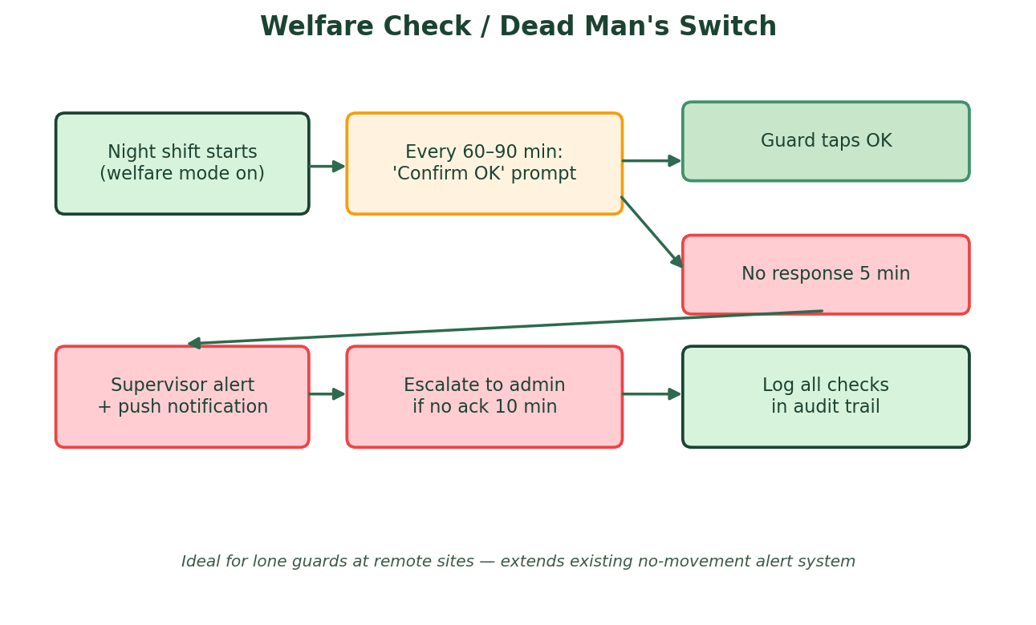
Figure 6 — Welfare check and escalation flow

6.3 Live Guard Status Board
A dedicated Command Centre view showing every on-duty guard as a live status card. Supervisors get at-a-glance situational awareness without opening the GIS map.
Status | Colour | Trigger conditions
GREEN | Normal | On duty · GPS fresh · patrol on schedule · inside geofence
AMBER | Warning | Overdue patrol OR no movement beyond threshold
RED | Critical | Geofence exit OR missed welfare check OR active SOS

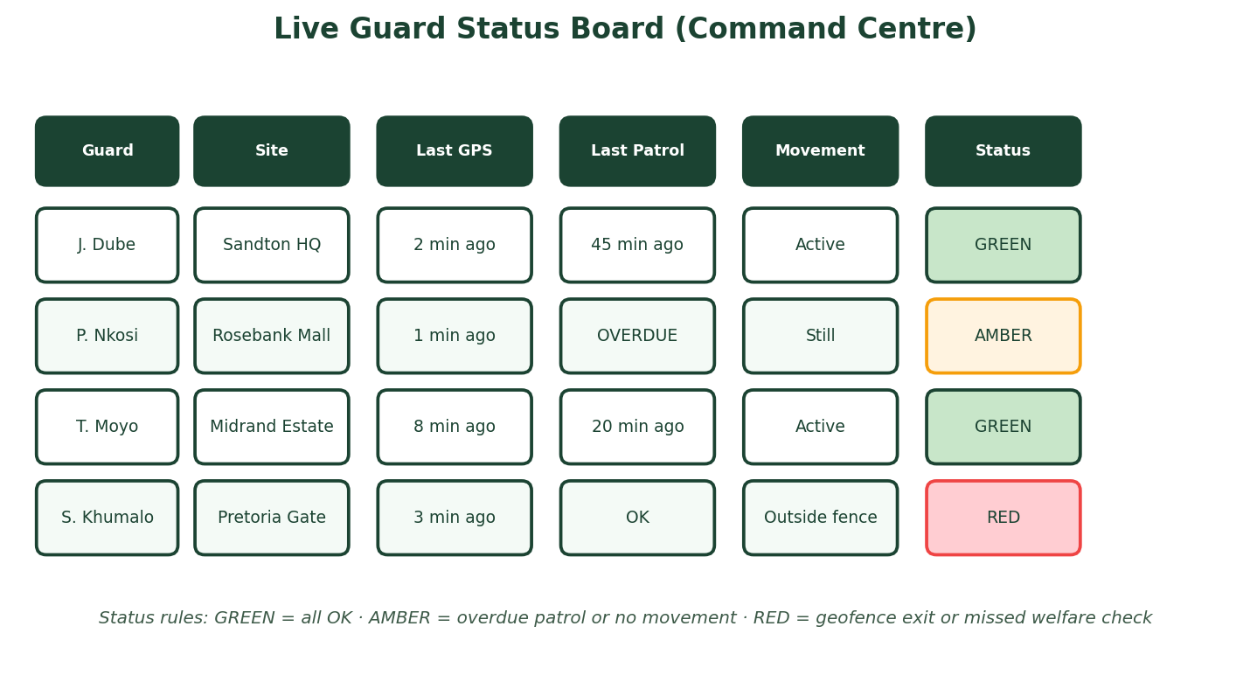
Figure 7 — Live Guard Status Board mock-up for Command Centre

6.4 Shift Handover Verification
Prevents unstaffed gaps between shifts at client sites. Outgoing guard must clock out with handover notes; incoming guard must acknowledge before patrol begins.
- Outgoing guard: clock out + mandatory handover notes (relief guard name, site status, incidents).
- Incoming guard: acknowledge handover within 15 minutes of shift start.
- Gap alert: if no guard on duty for > X minutes between shifts → supervisor notification.
- Handover record stored in Occurrence Book and visible on Guard Status Board.

6.5 Site-Specific Alert Rules
Not every client site has the same risk profile. Phase 2 adds per-premise configuration overrides:
Setting | Example use
Geofence radius override | Large estate: 8m · Small office: 5m
Patrol frequency | High-risk warehouse: every 1 hr · Office park: every 2 hrs
Welfare check interval | Remote gate house: every 60 min · Mall patrol: disabled
Night shift strict mode | Stricter no-movement + mandatory welfare on 18:00–06:00 shifts

6.6 Incident Escalation Workflow
Incidents are logged today but lack structured escalation. Phase 2 adds auto-assignment, SLA timers, and severity-based routing.
- Auto-assign to territory supervisor on incident creation.
- Low severity: status workflow Unassigned → Investigating → Resolved.
- High severity (assault, fire, theft): immediate push to supervisor + admin.
- SLA alert if unassigned > 15 minutes.
- Full photo and voice memo playback on web Occurrence Book.
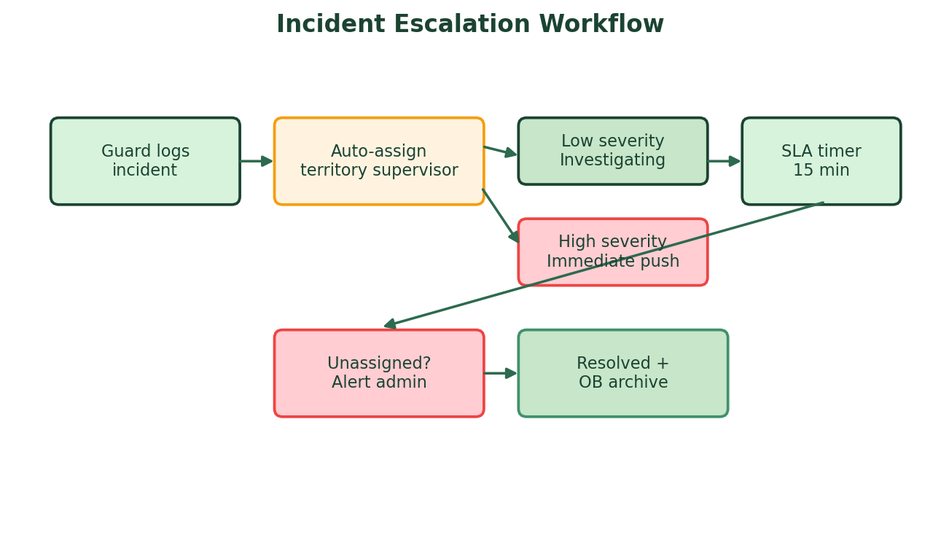
Figure 8 — Incident escalation and SLA workflow

7. Phase 3 — Trust, Reporting & Compliance
Feature | Description | Business value
Client portal (read-only) | Live guards on site · patrol completion · incident summary | Sales differentiator
Automated PDF/CSV reports | Weekly/monthly compliance per client site | Contract retention
GPS anti-spoof detection | Reject mock locations · flag teleport events | Fraud prevention
Production RLS hardening | Tenant isolation · role-based Supabase policies | Go-live requirement
Audit trail module | Who dismissed alerts · export OB + attendance | Legal defensibility
PSIRA compliance dashboard | License + training expiry · site staffing blocks | Regulatory compliance

8. Phase 4 — Advanced Integrations
Feature | Description
CCTV / alarm integration | OB entry when site alarm triggers · map camera to premise
WhatsApp auto-alerts to clients | 'Guard clocked in at your site' using existing WhatsApp infra
WebSocket live map | Sub-second guard positions on GIS for control-room displays
AI patrol anomaly detection | Unusual movement patterns · repeatedly skipped zones
Body-worn camera upload | Incident evidence chain
Multi-language mobile | English · Afrikaans · Zulu for guard UX

9. System Architecture
Phase 2 additions integrate with the existing Next.js / Supabase stack. No platform replacement is required. New components (FCM dispatcher, NFC validation, enhanced alert engine, audit log) extend the current /api/state action model and relational database schema.
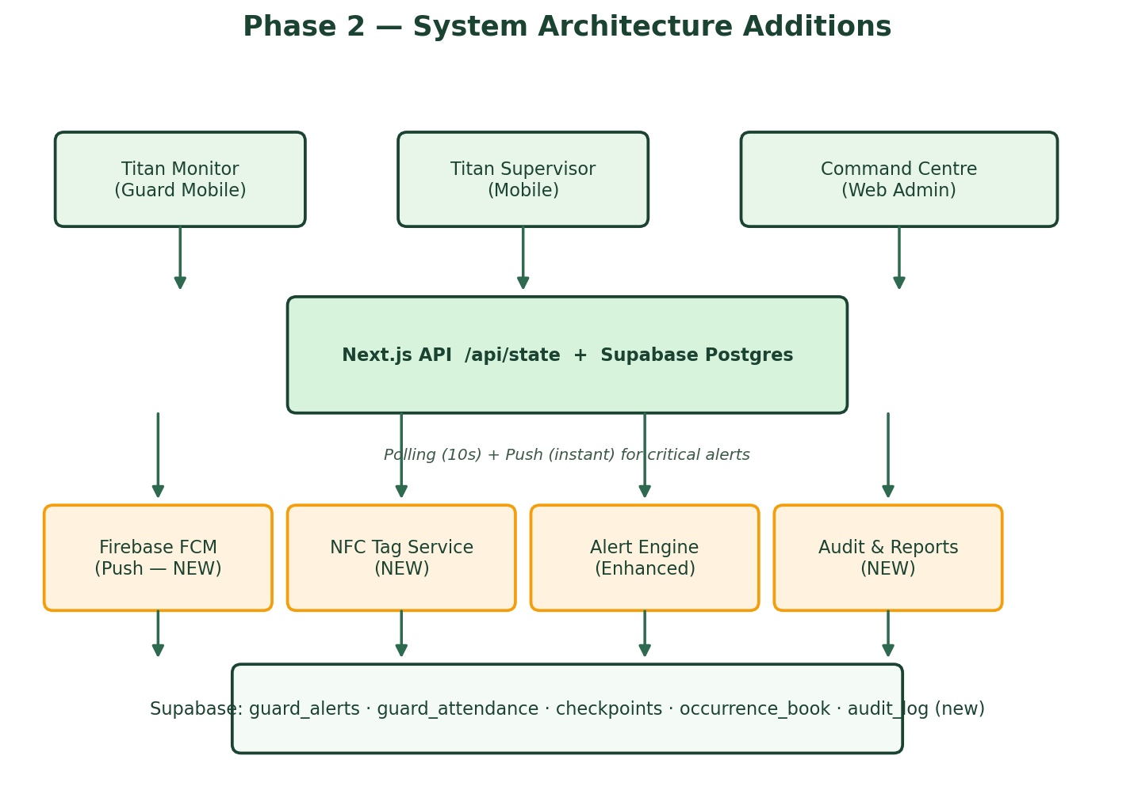
Figure 9 — Phase 2 architecture showing new services alongside existing platform components

10. Feature Specifications & Process Flows
The following table summarises each Phase 2 feature with its primary user, trigger, and expected outcome.
Feature | Primary user | Trigger | Outcome
Real NFC patrol | Guard | Phone tap on physical tag | Verified checkpoint scan in OB + map
Welfare check | Guard / Supervisor | Timer (60–90 min) | OK logged or escalation alert
Status board | Admin / Supervisor | Continuous poll + push | Green/Amber/Red guard cards
Shift handover | Guard / Supervisor | Shift change window | No unstaffed gap at site
Site alert rules | Admin | Per-premise config | Tailored monitoring per client site
Incident escalation | Guard / Supervisor | Incident logged | Auto-assign + SLA + push

11. Implementation Timeline
The suggested timeline assumes one development team working on the existing Titan Protection codebase. Phases can overlap where dependencies allow (e.g. push notifications in Phase 1 unblock Phase 2 welfare alerts).
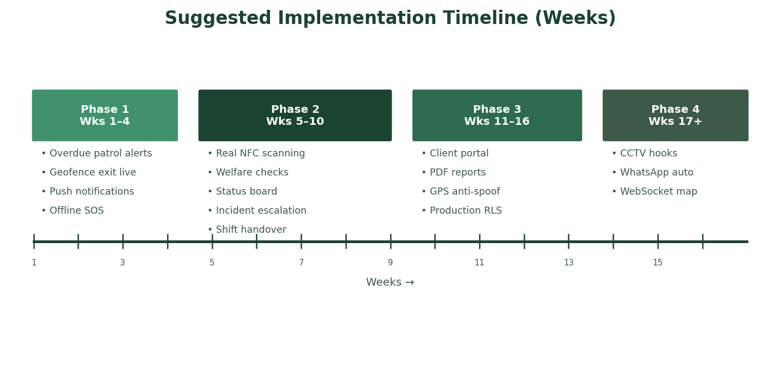
Figure 10 — Suggested 16+ week implementation timeline across all phases

Phase | Duration | Deliverables
Phase 1 — Foundation | Weeks 1–4 | Overdue patrol · Geofence live · FCM push · Offline SOS
Phase 2 — Core Monitoring | Weeks 5–10 | NFC · Welfare · Status board · Handover · Escalation
Phase 3 — Trust & Reporting | Weeks 11–16 | Client portal · Reports · Anti-spoof · RLS · Audit
Phase 4 — Advanced | Week 17+ | CCTV · WhatsApp auto · WebSocket · AI anomaly

12. Success Metrics & KPIs
Metric | Target | Measurement
SOS notification delivery | < 5 seconds | FCM delivery timestamp vs trigger
Patrol compliance rate | > 95% per site | Scans on time / scheduled scans
False geofence alerts | < 2% of shifts | Dismissed geofence / total geofence alerts
Missed clock-in detection | 100% of scheduled shifts | Alerts fired / shifts started
Incident assignment time | < 5 minutes average | Created → Investigating timestamp
Client report delivery | Automated monthly | PDF generated and emailed on schedule
Guard welfare response rate | > 98% | OK taps / welfare prompts

13. Risks & Mitigations
Risk | Impact | Mitigation
GPS inaccuracy indoors | False geofence / patrol alerts | NFC for indoor checkpoints · grace periods · accuracy thresholds
Guard phone battery dies | Monitoring blind spot | Low-battery alert · supervisor notification · status board RED
NFC tag tampering | Fake patrol scans | Tag UID registration · GPS co-validation · audit log
Push notification opt-out | Missed critical alerts | Fallback to polling + SMS for SOS · mandatory FCM for supervisors
Scope creep across phases | Delayed go-live | Strict phase gates · Phase 2 complete before Phase 3 starts
Supabase RLS in production | Data leak between tenants | Phase 3 RLS hardening before multi-client rollout

14. Appendix — Priority Matrix
Features ranked by security impact versus implementation effort. Start with top-right quadrant (high impact, lower effort).
Priority | Feature | Impact | Effort | Phase
1 | Overdue patrol alerts | High | Medium | 1
2 | Geofence exit (live) | High | Low | 1
3 | Push notifications | High | Medium | 1
4 | Real NFC tags | High | Medium | 2
5 | Live status board | High | Medium | 2
6 | Welfare checks | High | Medium | 2
7 | Incident escalation | Medium | Medium | 2
8 | Client portal + reports | Medium | High | 3
9 | GPS anti-spoof | Medium | High | 3
10 | CCTV integration | Medium | Very high | 4

Next step. Review and approve this plan, then begin Phase 1 foundation work while procuring NFC tags for Phase 2 pilot sites. Recommended pilot: one high-traffic site with 4–6 patrol points.

