Assignment 1: CarRental

Interesting links

NOTES:
- Please copy PRC3_assignment1.zip to your Linux environment and unzip it.
- This assignment lets you focus on translating a real application to C++. While translating a C# application you'll run into lots of details. Some of these details are intentionally ignored for now, the details you need now are explained below. You will learn the other details later on, for that we'll be using the same project, so please don't throw your code away when you're done!

This assignment is about getting familiar with C++. You have all studied both C# and C before, so this assignment will focus on what you already know and how to do that in C++.

You probably remember the Car Rental Went Bad example from PRC21. As this example contains a lot of learning goals for that course we use a slightly modified version as a start point for the PRC3 course. Please take a look at the class diagram below:
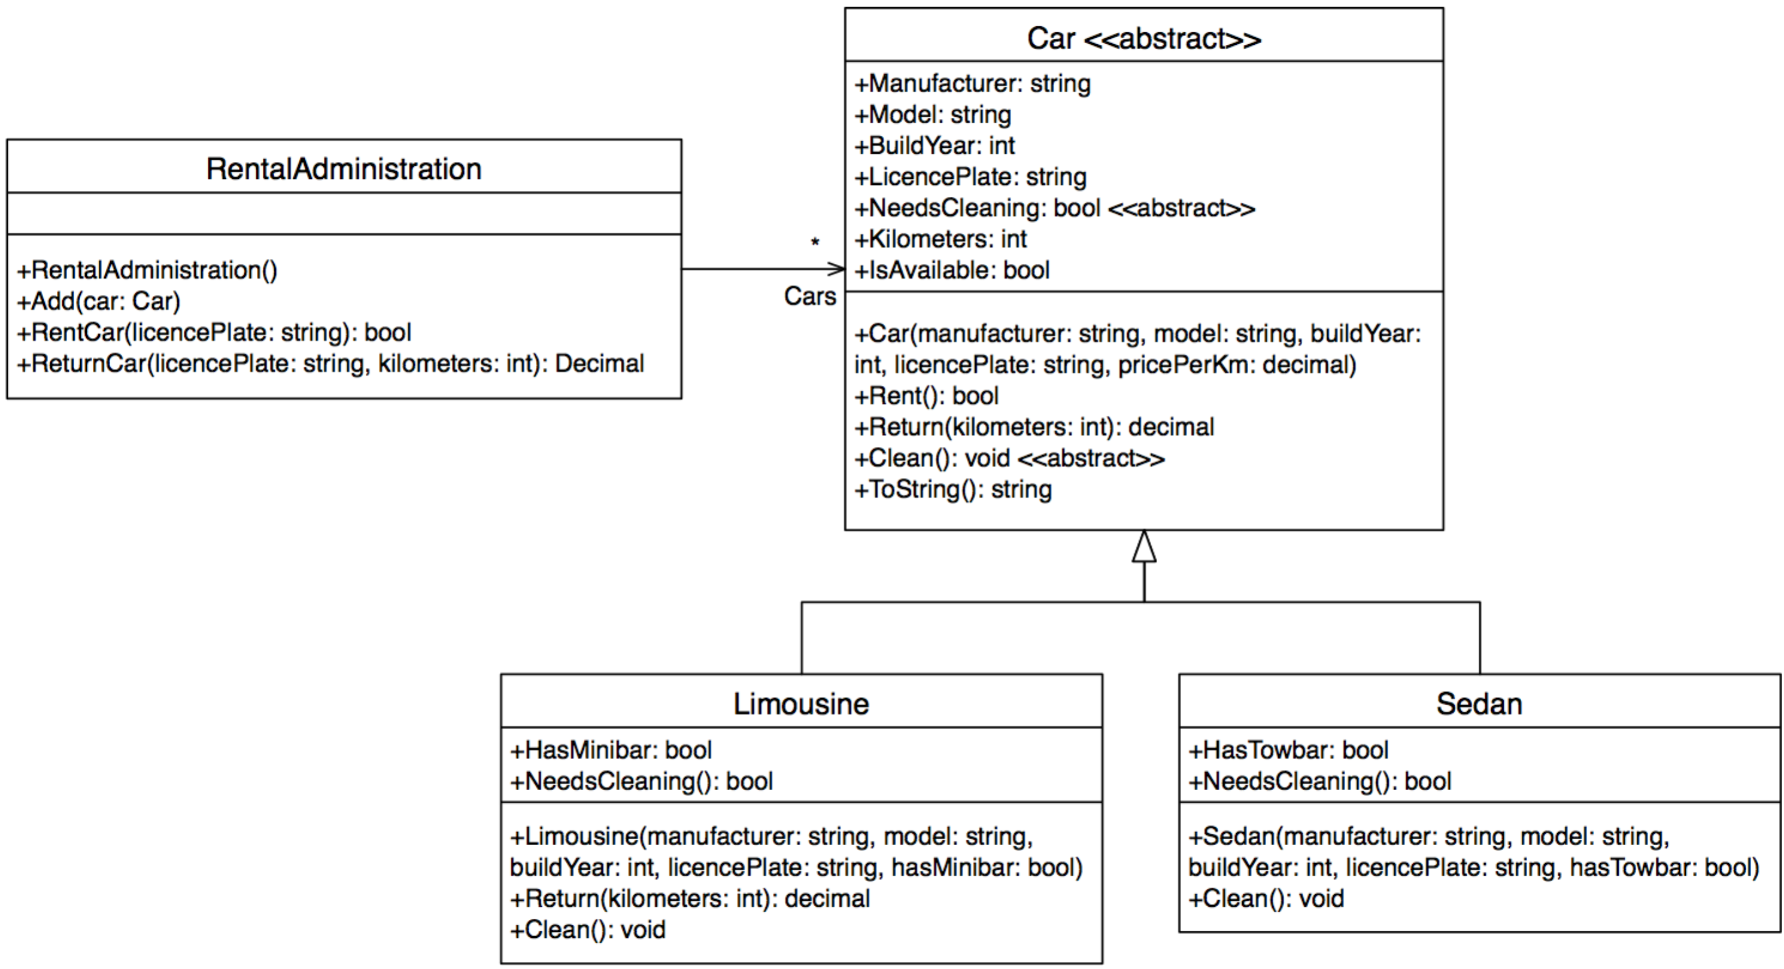

This class diagram is completely implemented in a C# project (in the CarRental_PRC21 folder) that you can use as reference. Please take a look at the code and check if it works properly.

You are now going to implement this project in C++ using the instructions below:

Assignment 1a
Please open Car.cpp and Car.h in the CarRental_cpp/product folder, you will find these files pretty much empty, except for some includes and such. Please open Car.cs as well.
A bit of explanation: Car.h starts with a multiple include protection, which is exactly the same as in C. The next line includes <string>, which looks a bit weird compared to C. C++ include files are included without the .h extension. Be aware though: C++ is mostly backward compatible with C, if you wish to include C header files you do need to use the .h extension. Thus:
#include <string>
versus:
#include <stdio.h>
After the include line you will find a line that says: using namespace std, please ignore that for now. You will learn what this means (and why you don't want to use this) later on. For now just remember that this is a bit of a dirty shortcut.

On to our first challenge: in C# the Car class definition looks like:
public abstract class Car
First problem: C++ has no keyword abstract. For classes this is a bit of an annoyance, as you cannot explicitly make your class abstract (a class is abstract if it contains abstract methods). Another thing you should know is that in C++, classes are always public, so you don't need to specify that (in fact: you can't, it will not compile). When you skip these 2 keywords you are ready to go. Oh, and similar to a C struct, your class definition must end with a semicolon:
class Foo
{
};

So now we have an empty class definition, which we can start to fill. On to the next differences:
- Each class item in C# should tell explicitly if it is public, private or ... In C++ these items are grouped:
class Foo
{
public:
// all public definitions go here
private:
// all private definitions go here
};
- In the C# example, pricePerKm is a Decimal. C++ doesn't have a Decimal type, so please use double instead.
- As you learned in PRC21: any class attribute that starts with a Capital is a property. C++ however doesn't have properties so instead of a Manufacturer property you will make a private manufacturer field and a GetManufacturer() method. If you wanted to make a public set as well you need to implement a SetManufacturer() method as well (hint: you don't need any setters in Car).
As you learned in PRC22: your header file will only contain definitions, so please do not bother with implementation yet. We'll do that later in Car.cpp. Same as with function prototypes in C, each method prototype in a C++ class must end with a semicolon as well.
- Just as in C#, your constructor has the exact same name as your class. It does not have a return type.
- Methods that are virtual in C# must be so in C++ as well: it means the same and is used in the same way.
- Methods that are abstract in C# must be so in C++ as well, however as stated before: C++ lacks an abstract keyword. In C++ an abstract method looks like:
virtual void Clean() = 0;
Abstract functions must always be virtual! Interpret this as: Clean is a function pointer that points to NULL (thus cannot be called!).
- Your ToString method in C# needs the override keyword, as you must tell the compiler that you don't want the implementation that is provided by your parent class (please remember: in C# where all classes inherit from Object). C++ doesn't have an override keyword but in this case you would not need one as in C++ your class doesn't inherit from anything.
- A final note: in C++ it is customary (required even if you program wisely) to make any method that doesn't change your class a const method. A const method prototype looks like:
string GetManufacturer() const;
A const abstract method looks like:
virtual void Clean() const = 0;

Bearing these notes in mind, please try to make your Car class definition. You should end with the following public methods:
- Car (constructor)
- Rent
- Return
- NeedsCleaning
- Clean
- ToString
- GetManufacturer
- GetModel
- GetBuildYear
- GetLicencePlate
- GetKilometers
- IsAvailable

And the following private fields:
- manufacturer
- model
- buildYear
- licencePlate
- kilometers
- isAvailable
- pricePerKm

You should now have a complete Car.h header file so you are now ready to start implementing. Please copy all your function prototypes from Car.h to Car.cpp and:
- Remove all leading spaces (i.e. the spaces at the start of the line)
- Remove all abstract methods (you will not implement them here)
- Remove all semicolons at the end of the line
- Add the class name with a double colon to all methods:
string Car::GetManufacturer() const
- And finally add braces: { and } (no semicolon after the implementation, just like in C).

The first method to implement is the Car constructor. You can implement a constructor basically in 2 ways, the preferred method is:
Car::Car(string manufacturer, string model, int buildYear,
string licencePlate, double pricePerKm)
: manufacturer(manufacturer)
, model(model)
, buildYear(buildYear)
, licencePlate(licencePlate)
, kilometers(0)
, isAvailable(true)
, pricePerKm(pricePerKm)
{
}
Some notes:
- After the colon you can enter a comma separated list of items to initialise. Initialisation of these items is done before the object is completely constructed (which means you cannot use this here!)
Initialisation of items in this list is ALWAYS done in the order in which items are declared in your class definition, so PLEASE do list these items in the exact same order in your constructor. The following is an example of how not to do it:
class Foo
{
public:
Foo();
private:
int length;
string text;
};
Foo::Foo()
: text("Hello World!")
, length(text.length())
{}
In this example: length is first initialised with the length of text (which is not yet declared thus can be anything!) and then text is initialised with "Hello World!". This is a bug that's rather hard to spot!
- In the C# code you'll find exceptions for null references. In C++ however, same as in C, there is no such thing as reference types and value types. Everything is a value type, if you want a reference type you must explicitly make it so using a pointer. As the Car constructor doesn't use pointers, we don't need exceptions for NULL values.
- In the C# code you'll also find exceptions for illegal values. You can throw invalid_argument exceptions in C++: throw invalid_argument ("your description goes here");

All other functions should be rather straightforward, just be aware that const functions must be declared const in both header and implementation:
In your header file:
string GetManufacturer() const;
In your cpp file:
string Car::GetManufacturer() const
{
...
}
If you ever get a compiler error message similar to:
error: assignment of member ‘...’ in read-only object
This means you are trying to change a class member in a const function, which obviously is not allowed. This immediately shows why you should always use the const keyword for functions that are not supposed to change anything: you immediately get an error indicating you made a mistake!

Assignment 1b
Please open Limousine.h, Limousine.cpp and Limousine.cs. The first line of the Limousine class in C# looks like:
public class Limousine: Car
Limousine is a public class that inherits from Car. You've already seen that all classes are public in C++ thus you can leave that out. However: in C++ you can inherit in a public, protected or private way from another class so you do need to state how you want to inherit from Car. For this course, please only use public inheritance, thus your C++ line will be:
class Limousine: public Car

The rest of the Limousine header file should be more of the same in comparison to Car. The cpp file is more of the same as well, except for one thing: calling your base constructor is written down slightly different in C++ compared to C#:
// assuming the following constant: static const double PricePerKm = 2.5;
Limousine::Limousine(string manufacturer, string model, int buildYear,
string licencePlate, bool hasMinibar)
: Car(manufacturer, model, buildYear, licencePlate, PricePerKm)
, ...

You can now implement the Sedan class as well.

Assignment 1c
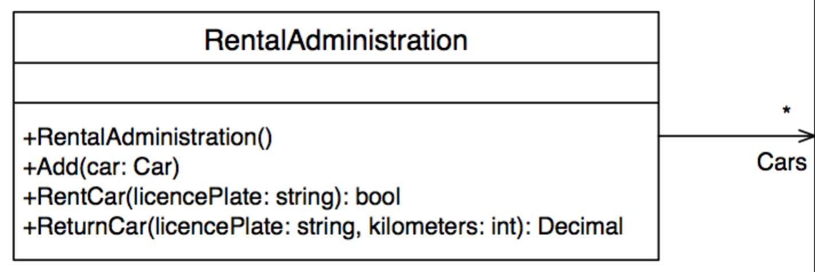

It is now time to implement RentalAdministration. The header file needs a multiple include protection and includes of string and vector. You will also need the using namespace std; line. Inside the class definition we'll start with a place to store Cars, which in C# is a list. The C++ equivalent is vector, so we'll make a vector of Cars. However, the following will not work:
vector<Car> cars;
This is because Car is an abstract class, so we'll have to make a vector of Car pointers. For the same reason why we cannot use a vector of Cars, all methods in RentalAdministration need to work with Car pointers as well. So Add will get a Car pointer as parameter and both Find functions will return a Car pointer. The return type for GetCars is simply vector<Car*>. Similar to all getters in Car, GetCars is a const function as well.

Next step is RentalAdministration.cpp: the constructor can be left empty. The Add method has a pointer parameter, so it needs a check for NULL. As there's no ArgumentNullException in C++ you can best throw an invalid_argument exception here as well. The list Add equivalent in C++'s vector class is push_back.
A note for FindCar: C++ does not have a foreach loop, so you'll have to write a normal for loop. The number of elements in cars is cars.size(). To compare licenceplates, you'll have to check the parameter against something like: cars[i]->GetLicencePlate(): the arrow is needed because cars contains pointers!

Assignment 1d
Ok, so now our complete class diagram is implemented. Only one task left to finish: a user interface. Most of what you need here should be familiar by now, except for printing stuff to the screen and reading user input from the keyboard. In C++ we do not use printf, we use cout instead. Please look at the main function for examples of how to use it. In the main function you will also find how you can read from the keyboard using cin. Please use both lines (cin >> yourVariable and cin.ignore())!

