Computer Vision

Assignment: 4  
Author(s): Rafał Grasman, Bas Woudstra  
Date: 28-09-2018  
Subject: Image Transformations  
Required pre-knowledge: OpenCV, OpenCV documentation, previous assignments (including used code)

Contents

Task 1, 2 and 3 3

Task 4 6

# Task 1, 2 and 3

For task 1, to determine the 4 points of the book the background has been removed by using grabCut function from opencv:

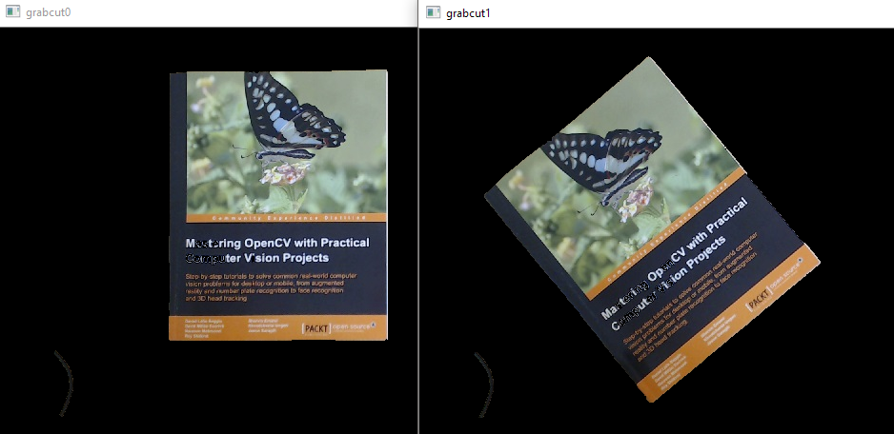

|  |
| --- |
| dst[i] = Mat::zeros(src[i].size(), src[i].type());  Rect rect;  rect.x = ((double)src[0].size().width) * 0.075;  rect.y = ((double)src[0].size().height) * 0.050;  rect.width = ((double)src[0].size().width) * 0.50;  rect.height = ((double)src[0].size().height) * 0.900;  grabCut(src[i], mask, rect, bgdModel, fgdModel, 1, GC_INIT_WITH_RECT); |

Then the image is converted to a binary image:

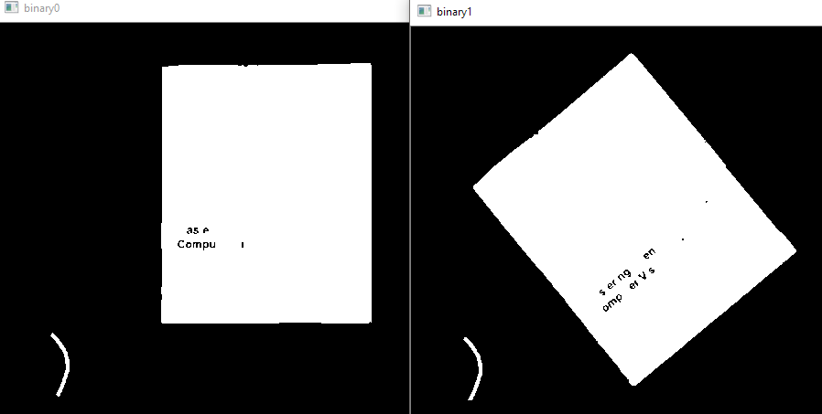

Then it is blurred and canny edge detection is performed:

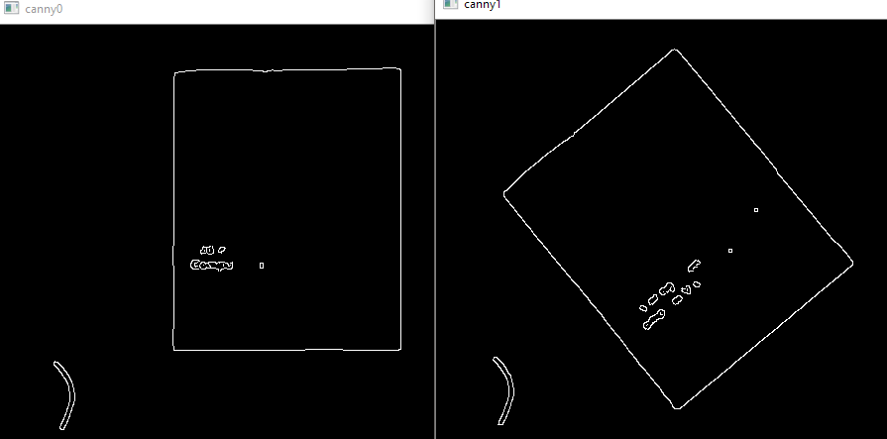

After that the findContours with approxPolyDP functions are used to get the book rectangle per image:

|  |
| --- |
| cv::findContours(canny.clone(), contours, CV_RETR_EXTERNAL, CV_CHAIN_APPROX_SIMPLE);  //(…)  cv::approxPolyDP(cv::Mat(contours[j]), approx, cv::arcLength(cv::Mat(contours[j]), true)*0.02, true);  //(…)  drawContours(dst[i], contours, contours.size() - 1, Scalar(0,255,0)); |

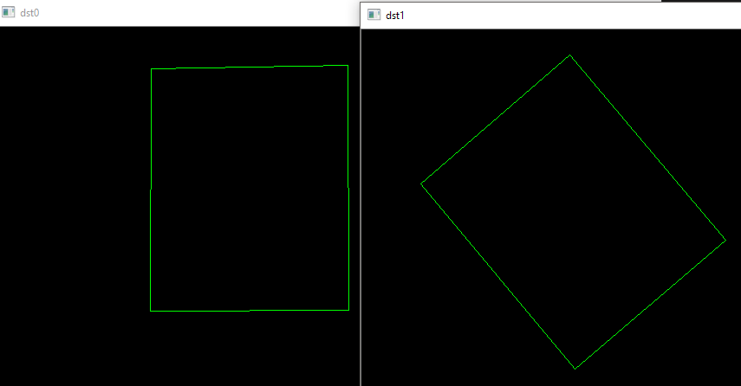

After which the transformation can be calculated from the points:

|  |
| --- |
| Mat transform = getAffineTransform(rectangles[0].data(), rectangles[1].data());  std::cout << transform << std::endl; |

Which yields:

|  |
| --- |
| [**0.7689596576247719, 0.6384605702058028**, *-100.2898860847127*;  **-0.6429605387374916, 0.7619894266473659**, *256.5144439549375*] |

With the rotation, sheer and scaling data being **bold** and translation data being *italic*.

The calculated transformation matrix can be re-applied onto the source image to check if the transformation yields the destination image:

|  |
| --- |
| dst[2] = Mat::zeros(src[0].size(), src[0].type());  dst[3] = Mat::zeros(src[0].size(), src[0].type());  warpAffine(dst[0], dst[2], transform, dst[2].size());  warpAffine(src[0], dst[3], transform, dst[3].size()); |

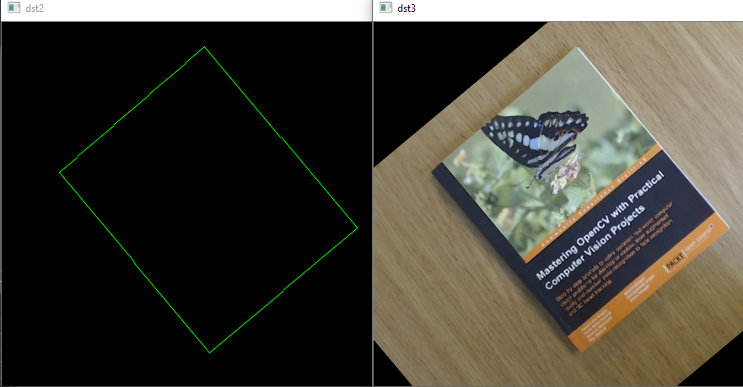

With getPerspectiveTransform all 4 points can be used to get a 3x3 transformation matrix, which will be shown in the next task.

# Task 4

The original images have a dotted line drawn (by mouse selected points) in the order from top-left to top-right and then bottom-right to bottom-left:

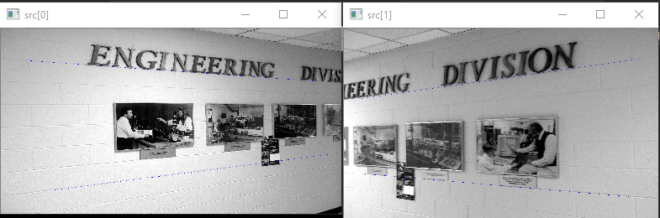

After those points are known they are saved and the transformation matrix is calculated by making the y position of the lines the same (so same height makes the line straight on screen):

|  |
| --- |
| rectangles[i].target.clear();  for (size_t j = 0; j < 4; ++j)  {  Point2f point = rectangles[i].source[j];  if (j % 2 == 1)  {  point.y = rectangles[i].source[j - 1].y;  }  rectangles[i].target.push_back(point);  } |

After that the transformation is calculated:

|  |
| --- |
| Matx33f transform = getPerspectiveTransform(rectangles[i].source.data(), rectangles[i].target.data()); |

And then the image is warped and shown:

|  |
| --- |
| warpPerspective(src[i], dst[i], transform, dst[i].size());  namedWindow("dst" + std::to_string(i), CV_WINDOW_NORMAL);  imshow("dst" + std::to_string(i), dst[i]); |

As can be seen in the following picture the perspective transformation has straightened out the pictures:

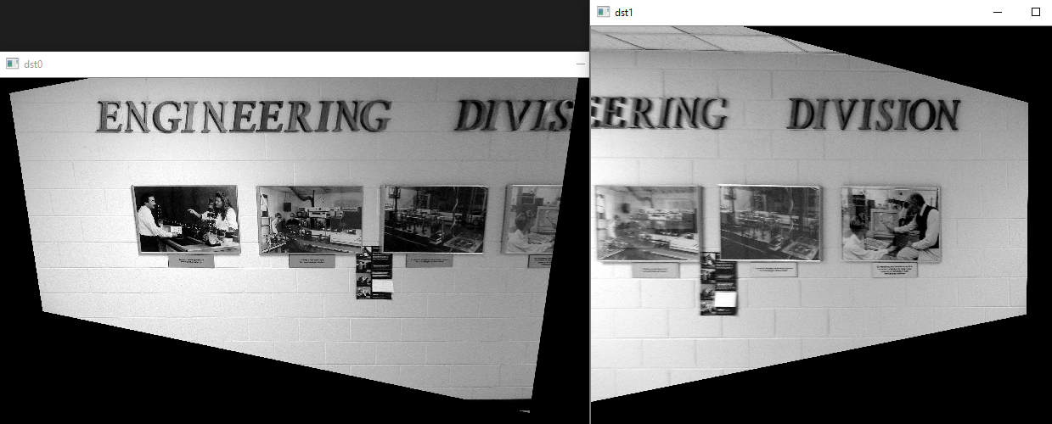

The calculated 3x3 transformation matrixes are:

|  |
| --- |
| transform0:  [0.510548, 0.096822344, 40.219765;  -0.14131102, 0.78065056, 81.195084;  -0.00022838234, 7.5927703e-05, 1]  transform1:  [2.0013189, 0.0007334752, -118.19073;  0.48749441, 1.3977752, -257.98288;  0.00044634411, 5.8678015e-06, 1] |

# Task 5

First the outlines of the banner that needs to be replaced are selected:

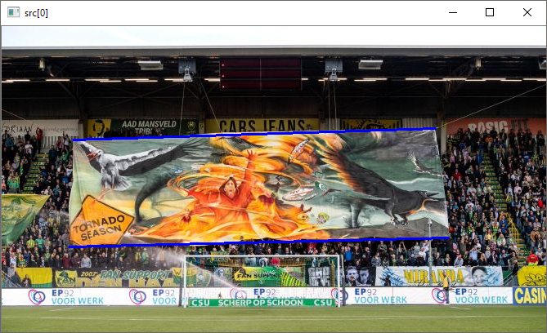

After which the saved points (in order top-left, top-right, bottom-right, bottom-left) are transformed into a straight rectangle:

|  |
| --- |
| std::vector<cv::Point2f> transformfix = rectangles;  transformfix[1].y = transformfix[0].y;  transformfix[3].y = transformfix[2].y;  transformfix[3].x = transformfix[0].x;  transformfix[2].x = transformfix[1].x; |

This is then used to get the perspective transform:

|  |
| --- |
| Matx33f transform = getPerspectiveTransform(rectangles.data(), transformfix.data());  std::cout << "transform:" << std::endl;  std::cout << transform << std::endl; |

|  |
| --- |
| transform:  [1.09539, 0.074461691, -13.501223;  0.042667266, 1.0690696, -5.0879583;  7.5850279e-05, 0.00037821592, 1] |

Then the image is “straightened” out and at the top-left point the new (and resized to the rectangle) banner is inserted:

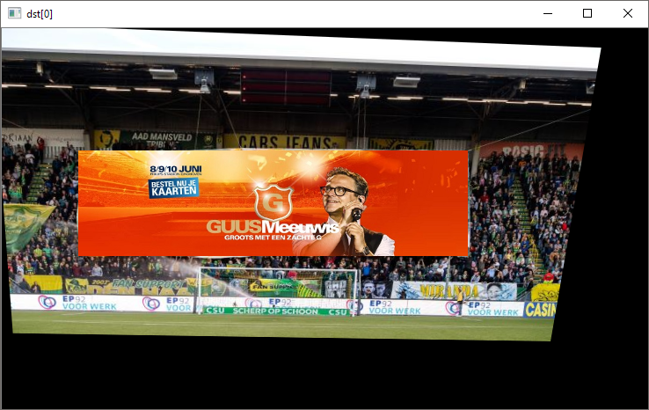

After that the inverse transform is applied to get the original image back with the inserted banner:

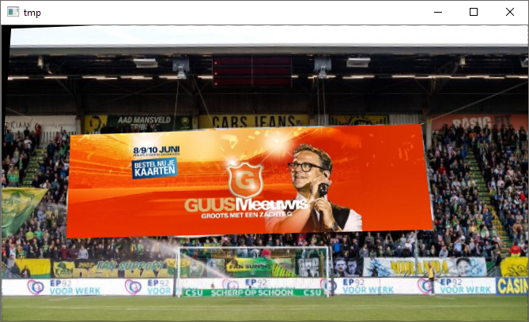

The steps can also be done differently to get rid of the artefact in the top-left corner, for example applying the transform to the banner and putting that onto the image.

The code to perform the above steps:

|  |
| --- |
| dst[1] = Mat::zeros(src[1].size(), src[1].type());  resize(src[1], dst[1], Size(abs(transformfix[1].x - transformfix[0].x), abs(transformfix[3].y - transformfix[0].y)));  namedWindow("dst[1]", CV_WINDOW_AUTOSIZE);  imshow("dst[1]", dst[1]);  dst[1].copyTo(dst[0](cv::Rect(transformfix[0].x, transformfix[0].y, dst[1].cols, dst[1].rows)));  namedWindow("dst[0]", CV_WINDOW_AUTOSIZE);  imshow("dst[0]", dst[0]);  Mat tmp(Mat::zeros(src[0].size(), src[0].type()));  warpPerspective(dst[image], tmp, transform.inv(), tmp.size());  namedWindow("tmp", CV_WINDOW_AUTOSIZE);  imshow("tmp", tmp); |