# Info

Phone model: SM-G996B/DS

Serial R3CRA0LRVBX

IMEI: 351981532065477 / 357213362065474

# Fastboot, recovery, hard reset

To enter boot screen menu:

1. Power off phone
2. Plug in phone
3. Hold PWR + VOL UP until samsung knox logo
4. (bootloader = odin mode)

To force turn device off (HW):

1. Power off phone
2. Plug in phone
3. Hold PWR+VOL DOWN until samsung knox logo

To enter fastboot mode:

1. Power off phone
2. Holde vol up + vol down
3. Plug in phone to computer

# Boot image

<https://xdaforums.com/t/how-to-remove-unlocked-bootloader-warning-for-almost-every-samsung-devices.4323109/>

This bin file contains an image, not a way to skip the screen.

# Kernel

<https://opensource.samsung.com/uploadList>

Search for baseband version: G996BXXU9FWK2 (at the time of writing).

<https://source.android.com/docs/setup/download>

apt install bc texinfo build-essential # may be incomplete, I already have a dev system

mkdir ~/android  
 cd ~/android  
 git clone https://android.googlesource.com/platform/prebuilts/gcc/linux-x86/aarch64/aarch64-linux-android-4.9/ --branch android-platform-11.0.0_r39  
 git clone https://android.googlesource.com/platform/prebuilts/clang/host/linux-x86/ --branch llvm-r383902b # ~30.75GiB, 99k objects

export PATH=~/android/aarch64-linux-android-4.9/bin:$PATH  
 export PATH=~/android/linux-x86/clang-r383902/bin:$PATH

cd ~/android  
 mkdir kernel  
 cd kernel  
 tar -xf Kernel.tar.gz  
  
 cd ~/android  
 mkdir platform  
 cd platform  
 tar -xf Platform.tar.gz  
  
 cd ~/android  
 ln -s platform/system system  
 mv kernel platform/  
  
 cd platform/system/core/liblog/include/log/  
 nano perflog.h # put contents from <https://chromium.googlesource.com/external/webrtc/deps/third_party/winsdk_samples_v71/+/refs/heads/master/Samples/multimedia/directshow/baseclasses/perflog.h>  
  
 cd ~/android  
 mkdir -p platform/kernel/toolchain/gcc/linux-x86/aarch64/   
 ln -s ~/android/aarch64-linux-android-4.9 platform/kernel/toolchain/gcc/linux-x86/aarch64/aarch64-linux-android-4.9  
 mkdir -p platform/kernel/toolchain/clang/host/linux-x86  
 ln -s ~/android/linux-x86/clang-r383902 platform/kernel/toolchain/clang/host/linux-x86/clang-r383902  
  
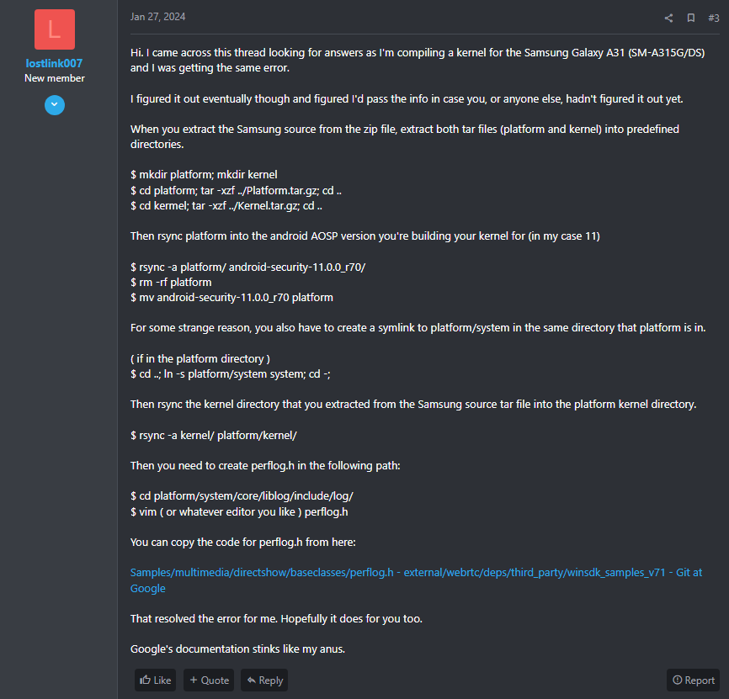

Then compile:

./build_kernel.sh

# KernelSU

curl -LSs "https://raw.githubusercontent.com/tiann/KernelSU/main/kernel/setup.sh" | bash –  
./build_kernel.sh

Flashing

<https://learn.microsoft.com/en-us/windows/wsl/connect-usb>  
<https://github.com/Benjamin-Dobell/Heimdall> (need to add to heimdall/CmakeLists.txt linker directive usb usb-1.0)  
<https://gist.github.com/kevinpapst/2962b66d9528e966ec5b068d2081f6c5>  
<https://github.com/osm0sis/Android-Image-Kitchen/>

Put phone in fastboot mode