Assignment 3: Steganography

You will hand in assignment 3b.

Assignment 3a
- Go to the 3_Stegano_exercise folder in your git repository
- Implement the function makeBitmask so it generates a bitmask with a given width and a given shift (so w=5 and s=1 gives 00111110)
- Implement the function countOnes so it counts the number of 1's in an integer
- Do run the unit tests to make sure everything is properly implemented!

Assignment 3b

IMPORTANT NOTES:
This assignment uses a resource checker program that is located in your Code tree. You need not worry about how it works: it only checks if you free all claimed resources before your program finishes.
To make sure the resource checker can work properly, you do need to:
- include "resource_detector.h" in all your c files
- use the full prototype for main: int main (int argc, char * argv[])
(rather than the shortcut version: int main(void) )
If you forget these points, your project will not compile!

You will hand in:
- bit.c
- bit_test.c
- header.c
- header_test.c
- stegano.c
(it is pretty difficult to create sensible unit tests for stegano.c, so we'll just skip these)

Steganography is the art and science of writing hidden messages in such a way that no one suspects the existence of the message. See also http://en.wikipedia.org/wiki/Steganography .
Steganography means hiding bits in an innocent looking picture, or an innocent sounding mp3-song.

In this assignment, we use bitmap pictures, similar to the pictures of the tree and the cat on the wiki page.
Each pixel is coded in 3 bytes (1 byte each to indicate the intensity of blue, green and red). When we vary the value of the lower bits in such a byte, it will hardly be visible on the screen, so we can use it to hide other information (in our case: another picture).
So the pixel colours of two pixels of two pictures are merged into one byte. That means that we lose quality, but we can live with it.
Example: we take an image of a Trabant and a red Ferrari (see ImageTrabant.bmp and ImageRedFerrari.bmp).
In this assignment, we use bmp image (instead of e.g. jpg images, because all pixels are easily accessible in a bmp file. A specification of the structure of a bmp file can be found at: http://en.wikipedia.org/wiki/BMP_file_format

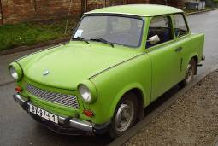

Pixel by pixel, the two images will be merged.
Let's start with the first pixel, the lower left one.
For the Trabant, we find the bytes 58, 5d and 5e (in hexadecimal notation), and for the Ferrari we find d3, d3 and d3.
For this first pixel, we start with the first byte on both sides. The second line in the picture gives the binary representation of the bytes. For the Trabant, we take 5 bits; for the Ferrari, we take 3 bits and merge them together. Please note that the 3 upper bits of the Ferrari are places in the lower bits of the merged byte.
The grey bits will be lost.

Trabant Ferrari
59 | 5d | 5e |  | d3 | d3 | d3

0 | 1 | 0 | 1 | 1 | 0 | 0 | 1 |  | 1 | 1 | 0 | 1 | 0 | 0 | 1 | 1

0 | 1 | 0 | 1 | 1 | 1 | 1 | 0

When this is done for all bytes of all pixels, and stored in a new bmp file, we get the following result:

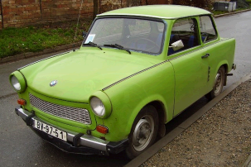

(please note: the Ferrari's front wheel is slightly visible in the Trabant's mudguard).

This operation can also be done with less bits for the Trabant, and more bits for the Ferrari. Results for resp. 4, 3, 2, and 1 bits for the Trabant:

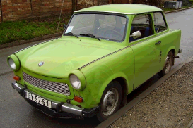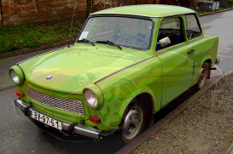

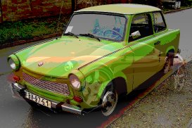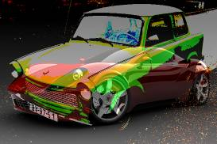

In an opposite way, the Ferrari can be retrieved from the merged picture:

merged picture
0 | 1 | 0 | 1 | 1 | 1 | 1 | 0

0 | 1 | 0 | 1 | 1 | 0 | 0 | 0 |  | 1 | 1 | 0 | 0 | 0 | 0 | 0 | 0

58 | .. | .. |  | c0 | .. | ..
Trabant Ferrari

This has to be done for all bytes for all pixels and stored in a new bmp file. The unmerged images of both cars are:

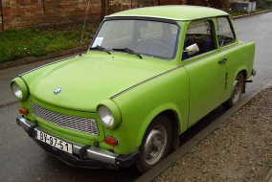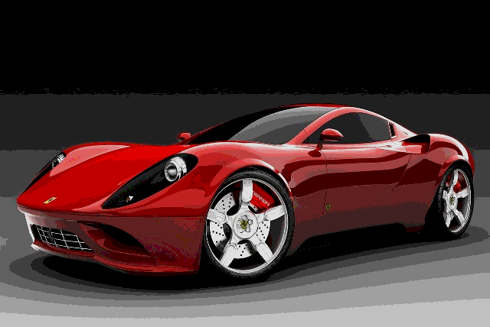

(please note that there is a loss of quality, especially for the Ferrari)

Task 1
It is clear that the retrieving of bits from a byte plays a central role in this application. Therefor it is wise to have a separate function that deals with this. All subsequent tasks of Steganography depend on this function. The following diagram shows de source dependencies in this project:
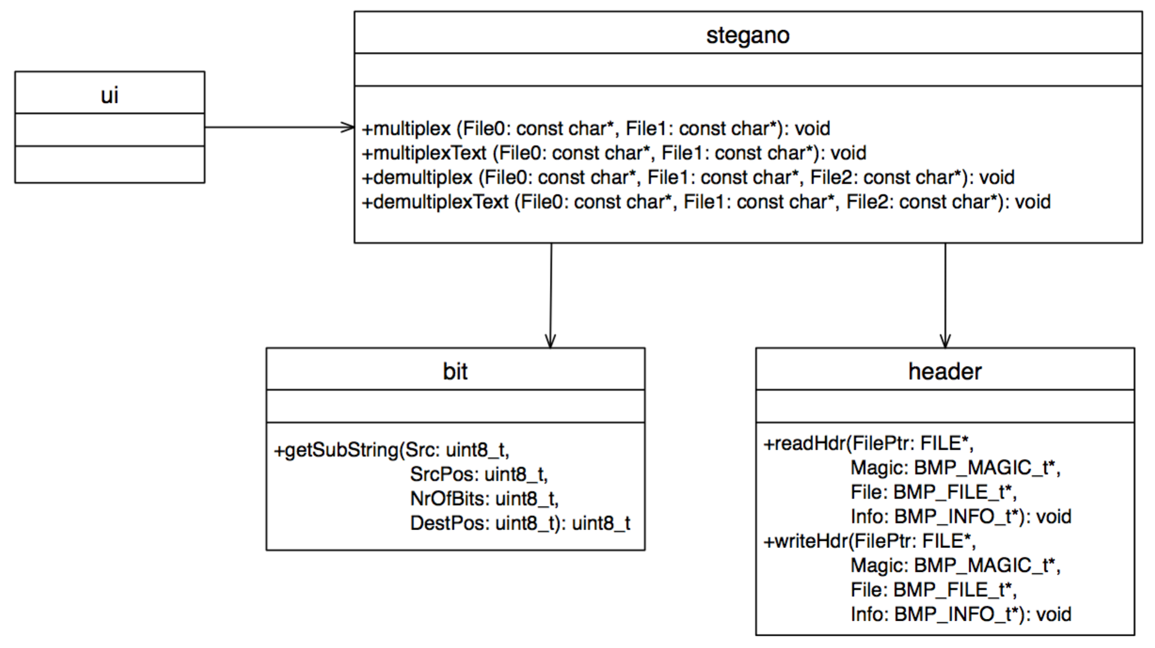

Implement function getSubstring() in bit.c as described below and test it thoroughly by making unit tests in bit_test.c. You can run these unit tests by calling make bittest on the command line. In file bit.h, the following function is prototyped:

uint8_t getSubstring (uint8_t Src, uint8_t SrcPos, uint8_t NrOfBits, uint8_t DestPos)
/* description: get a substring of bits from a uint8_t (i.e. a byte)
*
* example: getSubstring (Src, 3, 4, 1) with Src=ABCDEFGH (bit H is LSB)
* = 000BCDE0
*
* parameters:
* Src: byte to get the substring from
* SrcPos: position of the first bit of the substring (LSB=0)
* NrOfBits: length of the substring
* DestPos: position of the first bits of the destination substring
*
* return:
* substring, starting at DestPos
*/

example: calling getSubstring(0xda, 3, 4, 2) gives 0x2c:

src_pos (=3)

nrof_bits (=4)
src(=0xda)
1 | 1 | 0 | 1 | 1 | 0 | 1 | 0

dest_pos(=2)

return(=0x2c)
0 | 0 | 1 | 0 | 1 | 1 | 0 | 0

Note: this exercise is intended to get knowledge of bit manipulations. Therefore, you should not use if-statements, switch-statements, or arrays with fixed bit values. Instead, you should use the and-, or- and shift-operations.

Task 2:
Some more convenient functions: readHdr() and writeHdr(). You will need them frequently during the subsequent tasks so it is better to have separate functions to read and write the header structs of a bmp file.
The structures have already been defined for you in bmp.h (based on http://en.wikipedia.org/wiki/BMP_file_format)

Implement readHdr() and writeHdr() in header.c and test them thoroughly using unit tests in header_test.c. You can run these unit tests by calling make headertest on the command line.

Task 2a:
Before doing the Stegano bitmanipulations, it is wise to start with a simple application: make a function which copies an existing bmp file to a new file. So it does the following:
- declare variables for two file pointers and the three structs of a bitmap header
- open an existing bmp file for reading
- open a new file for writing
- read the header (using readHdr()) from the existing file
- write the header to the new file (using writeHdr())
- one after another: read a pixel byte and write it to the new file
- close both files

Note: this function has three local variables to store the structs of the header, and it gives their addresses (the pointers) to readHdr() and writeHdr().

Task 3:
Implement function multiplex(), i.e.: merge two bmp images (ImageTrabant.bmp and ImageRedFerrari.bmp) into a new image.
In fact, this function creates 9 images: a picture with 0 bits per byte for the hidden picture, 1 bit per byte,.. until 8 bits per byte.
The function already has an implementation of creating the required filenames.

The rest of the for-loop has to be implemented by you, like: opening the two input files and reading their header structures, opening the output file and writing its header, and then reading+multiplexing+writing all pictures.

In the resulting image, we need to store some information about the multiplexed picture, such that it can be demultiplexed later. For this, the following fields in the header of the new file need to be filled (the rest of the header information can be copied from the original image files):
- struct member creator1 of BMP_FILE_t is set to the width of the hidden picture
- struct member creator2 of BMP_FILE_t is set to the height of the hidden picture
- struct member nimpcolors of BMP_INFO_t is set to the number of bits (in a byte) of the hidden picture

Please note that both image files have an equal height and width.

It can be tested with e.g. the files ImageTrabant.bmp and ImageRedFerrari.bmp.
They can be multiplexed (option 1) into mux_ImageTrabant.bmp_red_ferrari_3.bmp (this name is generated automatically).

Task 4:
Implement function demultiplex(), i.e.: the opposite of multiplex(). One image file (with a merged Trabant and Ferrari) is given, and two new image files have to be created (one for the Trabant, and one for the Ferrari).
This function works for any number of bits for the multiplexing; the actual value can be retrieved from struct member nimpcolors of BMP_INFO_t (see previous task)

In the new image files, the struct members with dedicated multiplex information have to be set to zero:
- struct member creator1 of BMP_FILE_t
- struct member creator2 of BMP_FILE_t
- struct member nimpcolors of BMP_INFO_t

It can be tested with menu option 3 (after building the main application).

Task 5:
Implement function multiplexText()and demultiplexText(), to hide text into an image.
Text can be hidden very well, by multiplexing one text bit in each 8-bit pixel color.
For example, the character 'M' (0x4d) in bit notation can be stored in 8 pixel bytes: (in this document only the first three bytes are shown because of the limited paper width)

character 'M':
0 | 1 | 0 | 0 | 1 | 1 | 0 | 1

1 | 0 | 1 | 1 | 0 | 1 | 1 | 0 |  | 0 | 1 | 1 | 0 | 1 | 1 | 0 | 1 |  | 0 | 0 | 1 | 1 | 1 | 0 | 1 | 0 |  | etc.

The MSB (http://en.wikipedia.org/wiki/Most_significant_bit ) (here: a zero) must be in the first byte, the LSB (here: a one) must be in the eighth byte.

(please note that it doesn't matter in which color-byte (red, green or blue) the character-bit will be placed; the pixels and their colors are simply regarded as one gigantic array of bytes)

In the multiplexed image, we need to store some information about the multiplexed text, such that it can be demultiplexed later. For this, the following field in the new file's header needs to be filled:
- struct member creator1 of BMP_FILE_t is set to number of bytes of the hidden text

It can be tested with e.g. the files ImageCitroen2Cv.bmp and TextFontys.txt.
They can be multiplexed (option 2) into mux_ImageCitroen2Cv.bmp_TextFontys.txt.bmp (this name is generated automatically).
Afterwards, they can be demultiplexed (menu option 4) into demux_ImageCitroen2Cv.bmp and demux_TextFontys.txt (those names can be chosen by yourself).
Files TextFontys.txt and demux_TextFontys.txt.should be exactly the same.
Files ImageCitroen2Cv.bmp and demux_ImageCitroen2Cv.bmp will differ, because we lost the least significant bits for storing the text characters.

After you have finished task 5, please run make scripttest on the command line, this will run the bash script test.sh in the test directory, which performs an integration test of everything you've written so far.

Task 6 (for bonus points):
Enhance function multiplex()such that it can merge two bmp images with different sizes (like ImageYellowFerrari.bmp and ImageCitroen2Cv.bmp). The smaller (hidden) image appears in the lower left corner of the multiplexed image.
To solve this task, you need to study how the pixels are stored in the bitmap file (it's a kind of a two dimensional array).

One of the multiplexed images:
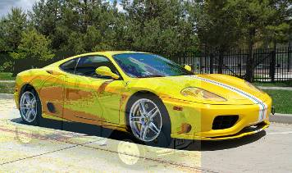

Task 7 (for bonus points):
Enhance function demultiplex()as well.

Please make sure to run make scripttest on the command line again after implementing tasks 6 and 7, it should still test without errors!

General:
Please note that we have used some restrictions to make our live easier. This means that the following items are given and you don't need to check this:
- we only use 24-bit colormap
- a bitmap file always contains the three structs (and no more) as listed in bmp.h (according to the specifications, bmp's may contain more structs, but they are not used in this assignment)
- we only use pictures where the pixel width is a multiple of 4 (to avoid row padding)
- when merging pictures, the first image always has a larger width and height than the second image

