Private Firewall using amazon NetworkFirewall in
AWS

- Objective :
  - How to create private Firewall using Amazon NetworkFirewall in AWS.
- Scope / Definition :
  - This guide will walk you through to configure the architecture
- Instructions :
Open VPC page and go to Amazon NetworkFirewall (console)
    - Sign in to the AWS Management Console and open the Amazon NetworkFirewall at https://eu-west-1.console.aws.amazon.com/vpc/home?region=eu-west-1
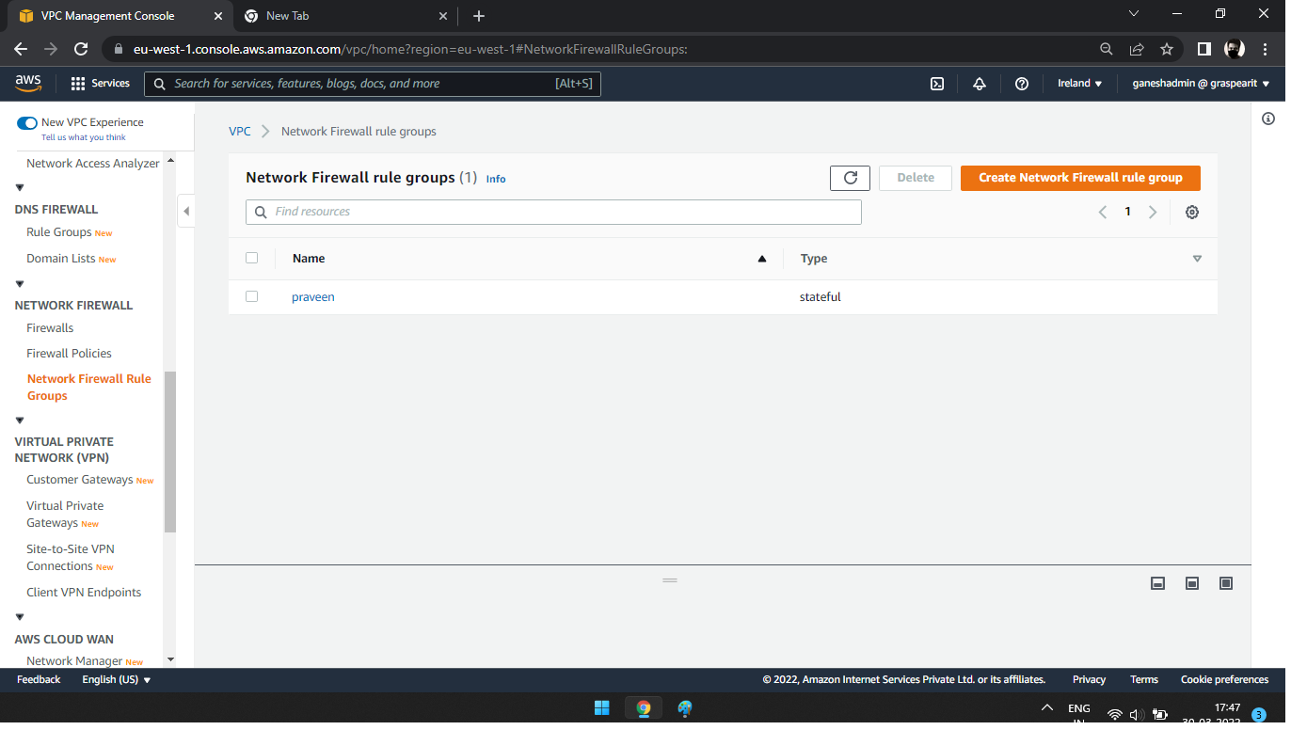

    - First create a network firewall role group. Once enter console create a new group. You get two options. One stateful role group another one stateless. Use stateful rule groups to inspect packets within the context of the traffic flow. Use stateless rule groups to inspect individual packets on their own, without the context of the traffic flow.
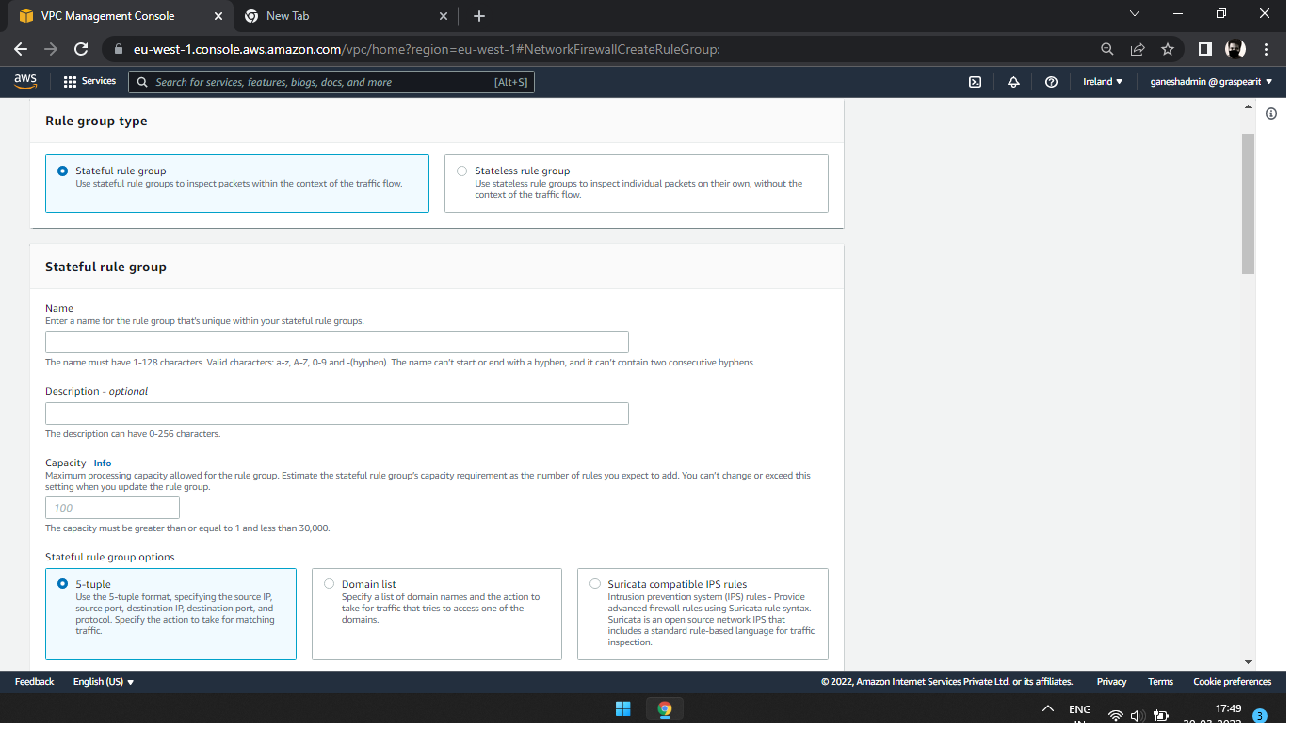
    - Then fill name and descriptions. The capacity is how many IP you have use for it. Next options. There are three types select what you want.

- If you select 5 tuple option, Choose any protocol. select Source, source port, destination, destination port. Finally Review and enter. 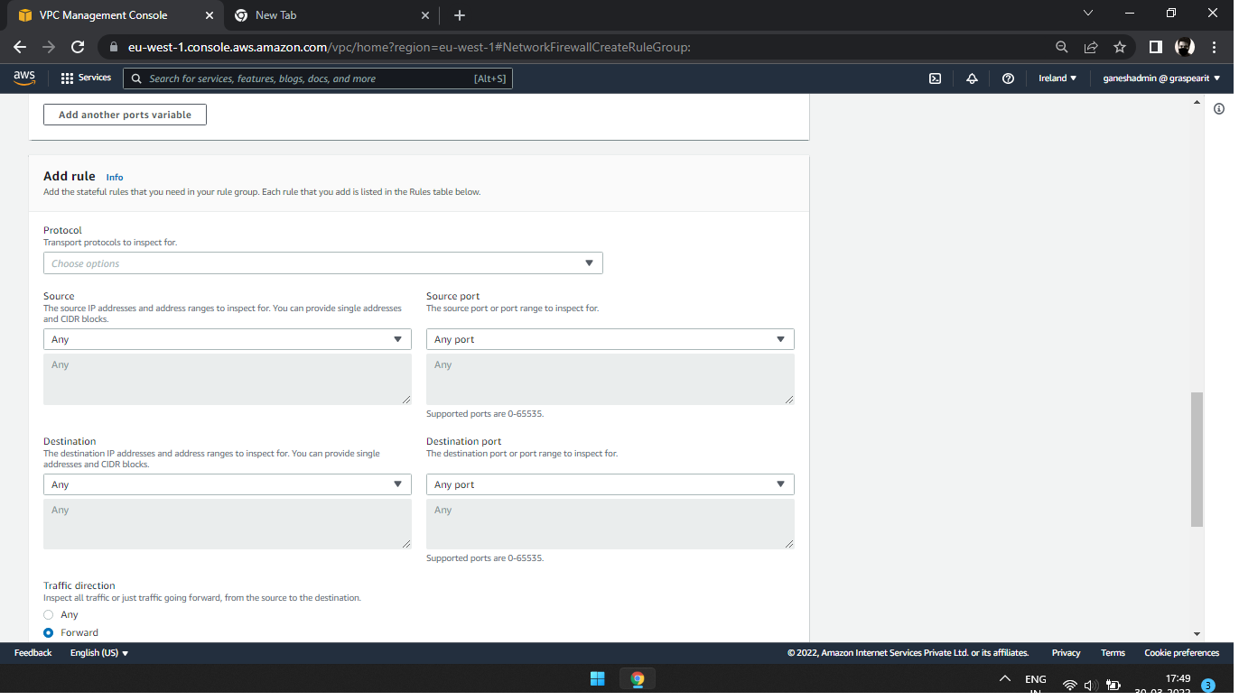
- We have a network firewall role group. So next create a firewall policy. First fill name and description. 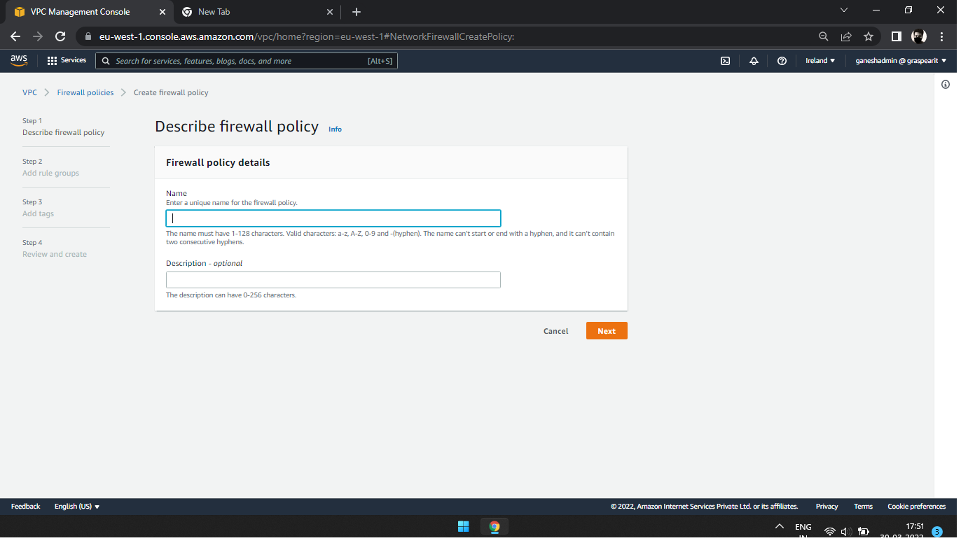
- Add rule groups stateful section

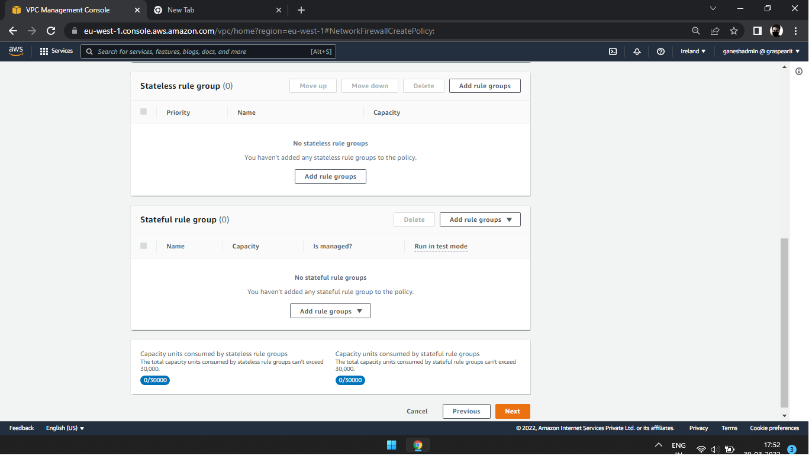

- Then we need a VPC. So, create a separate VPC. 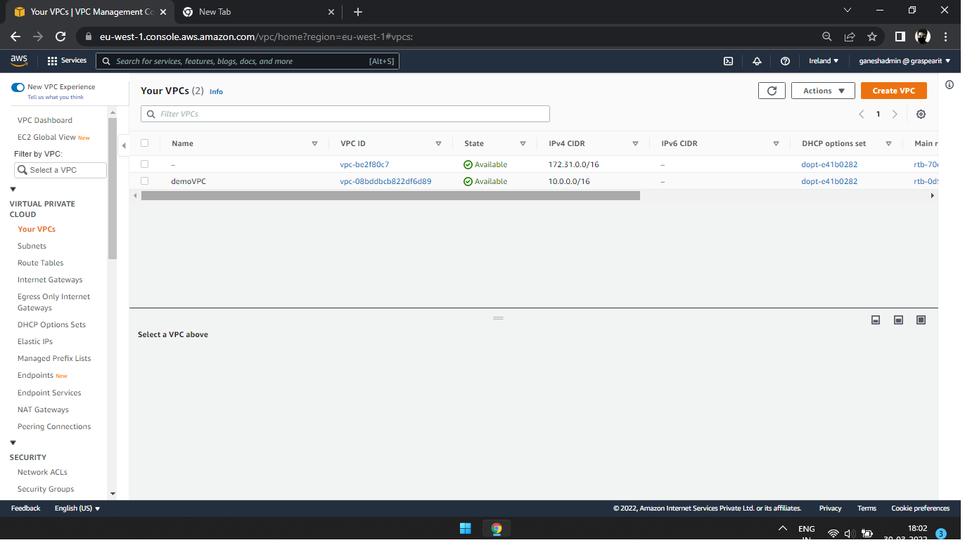
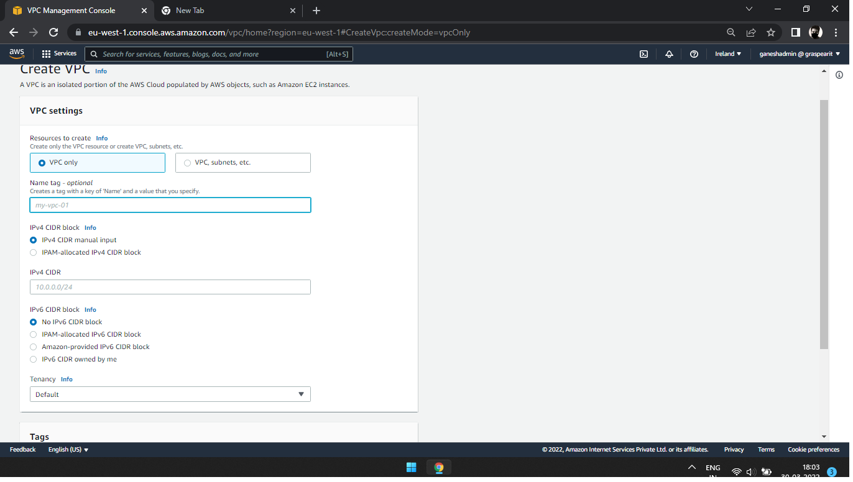
- At the same time you create a Subnet. Create a subnet for two different names. One Firewall and another one Clint. 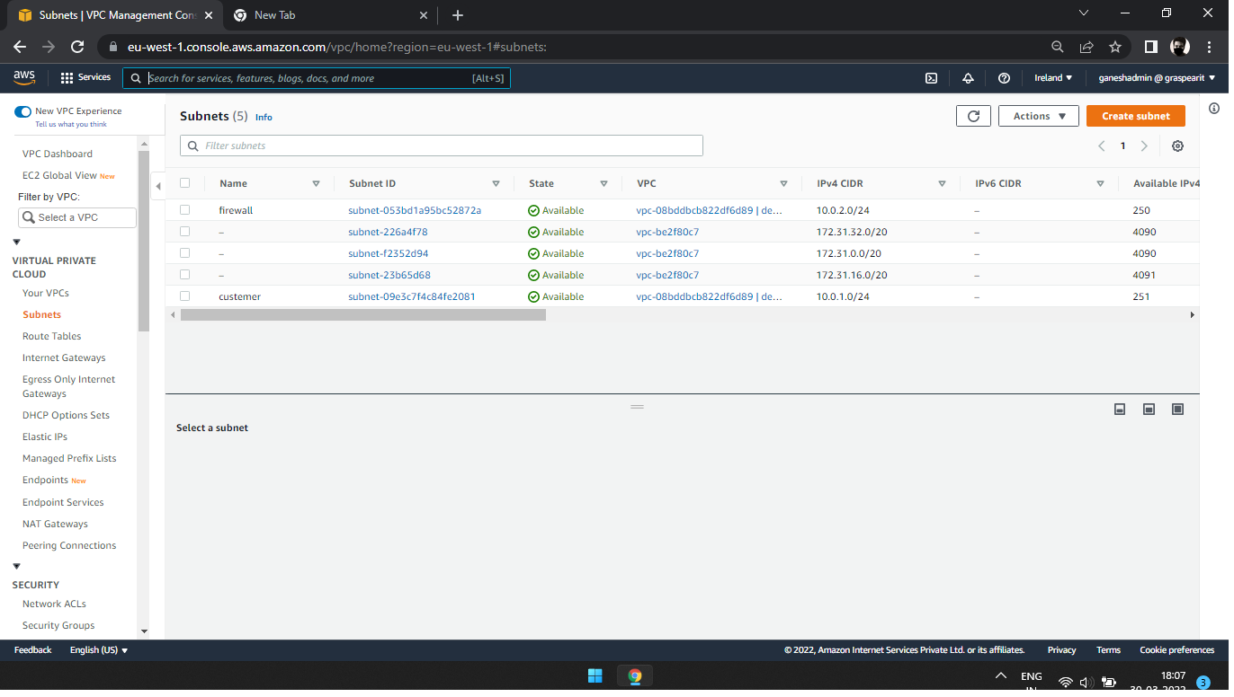
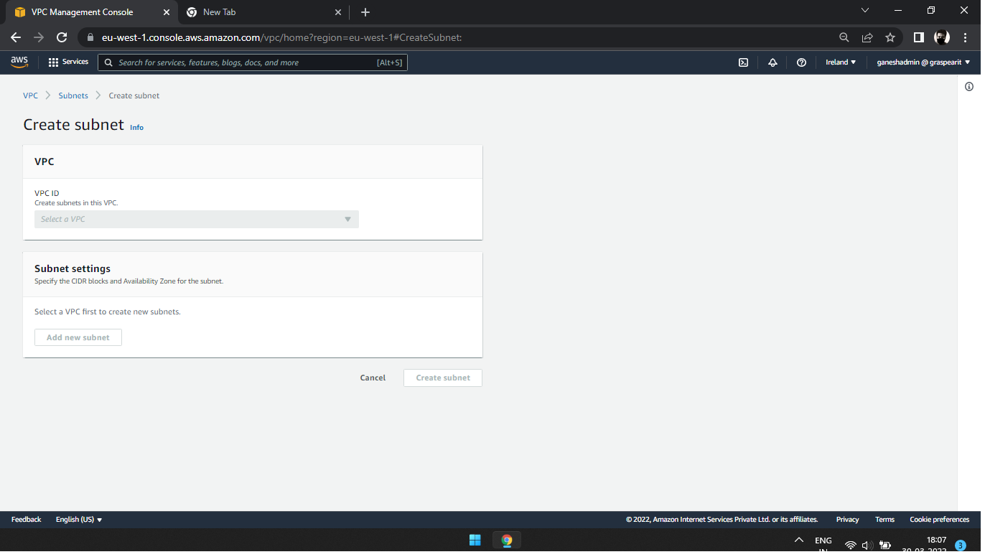

9 Next create a Rout table. Create same type of subnet name like Firewall and Clint.
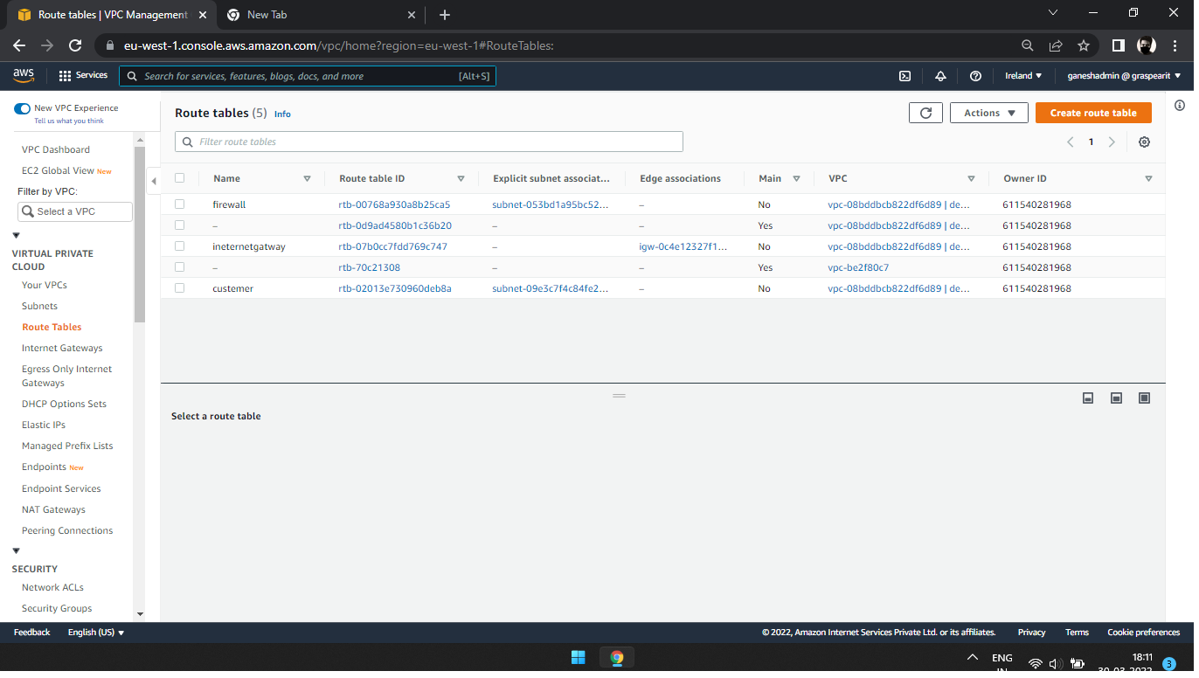

10 Then enter the clint route table and set Subnet associations.
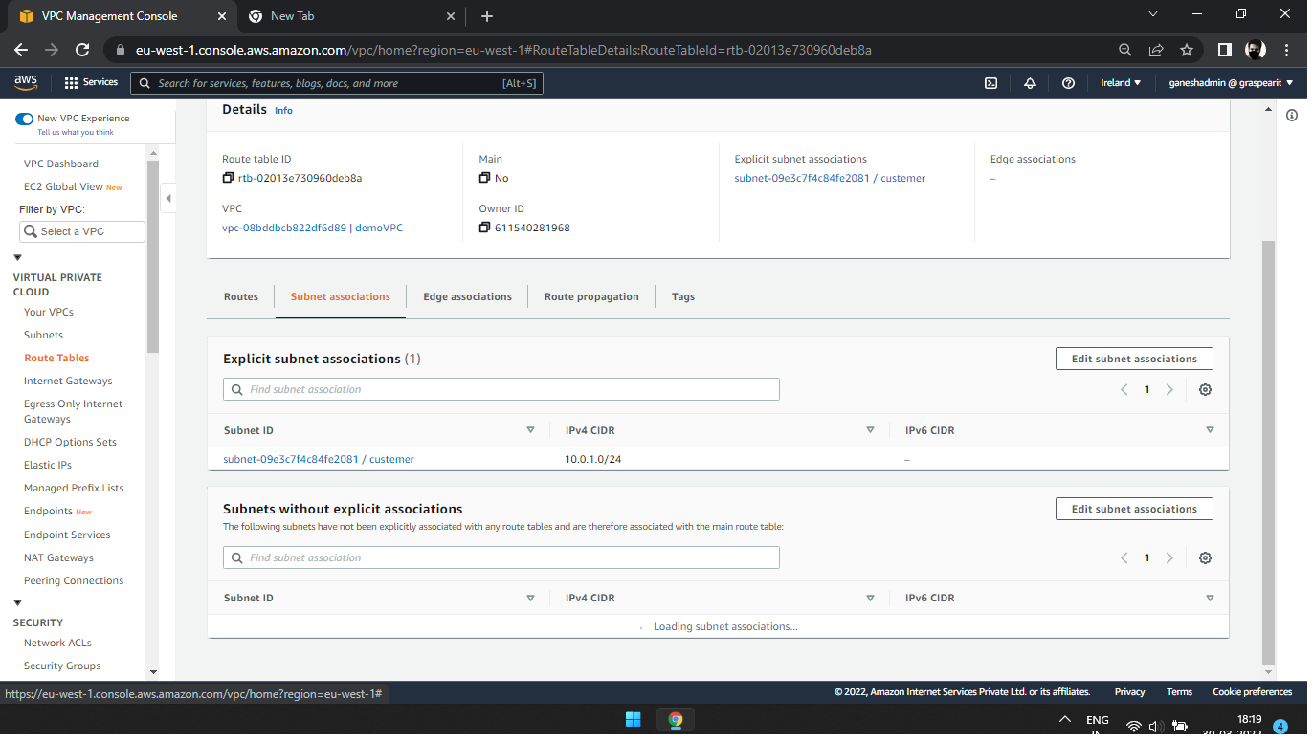
11 Then add a Route for clint id. Edit it.
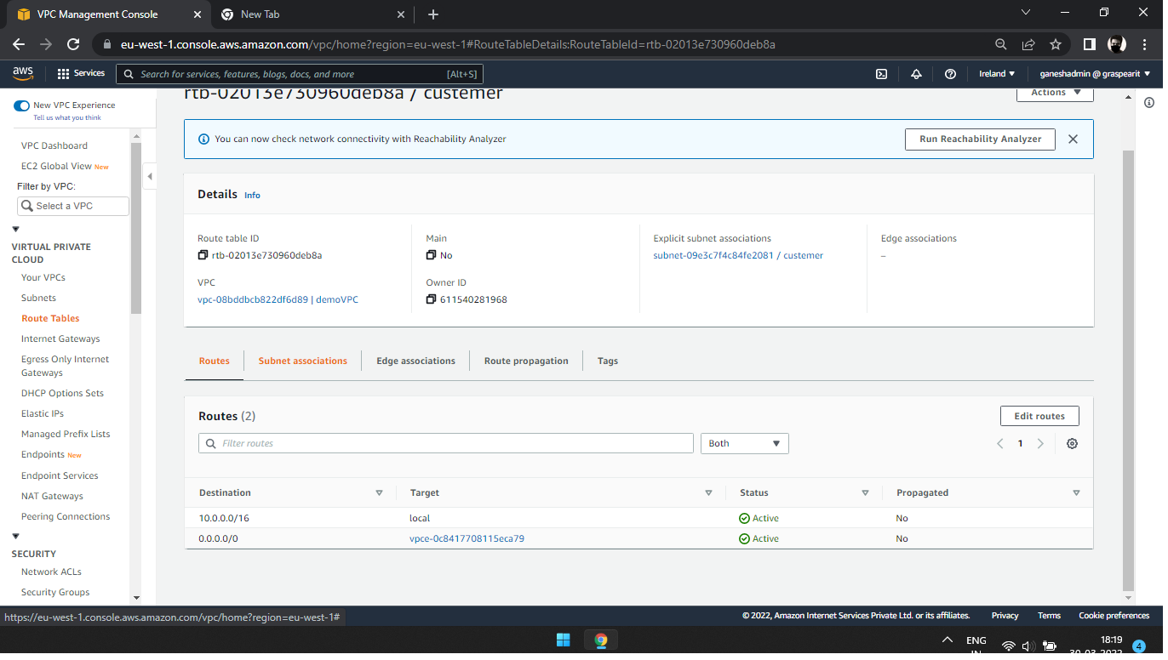

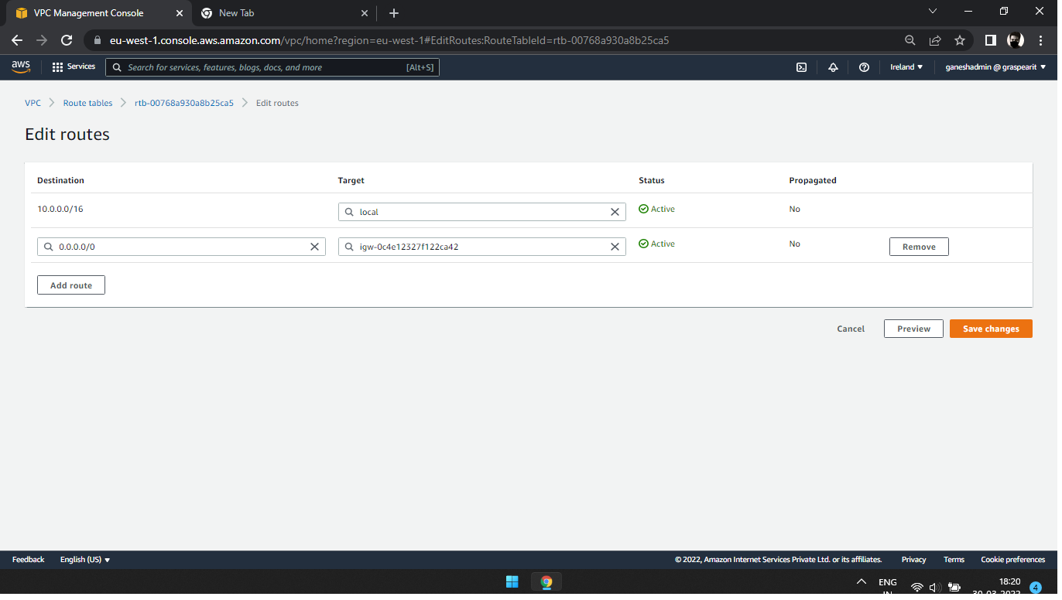
13 At the same type apply firewall route table.
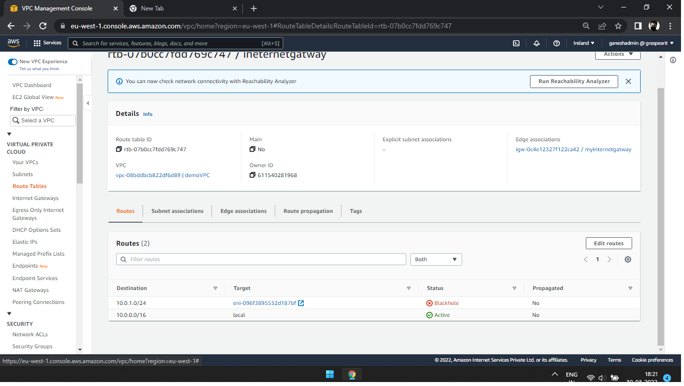
- Finally, we come on Firewall page. Here enter firewall name and descriptions and VPC and also subnet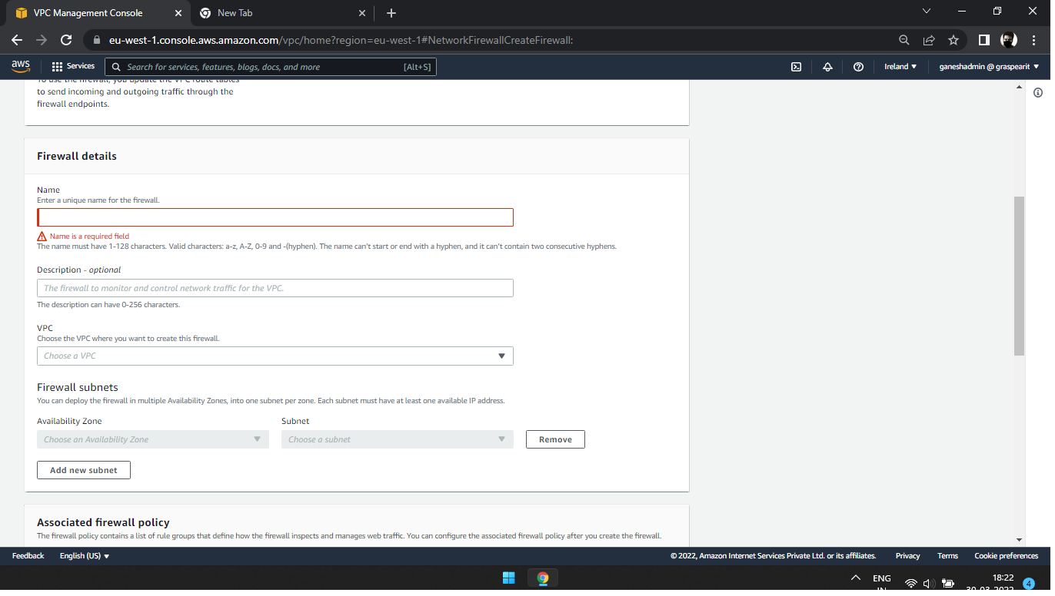
- Then create a instance for this Ip and subnet.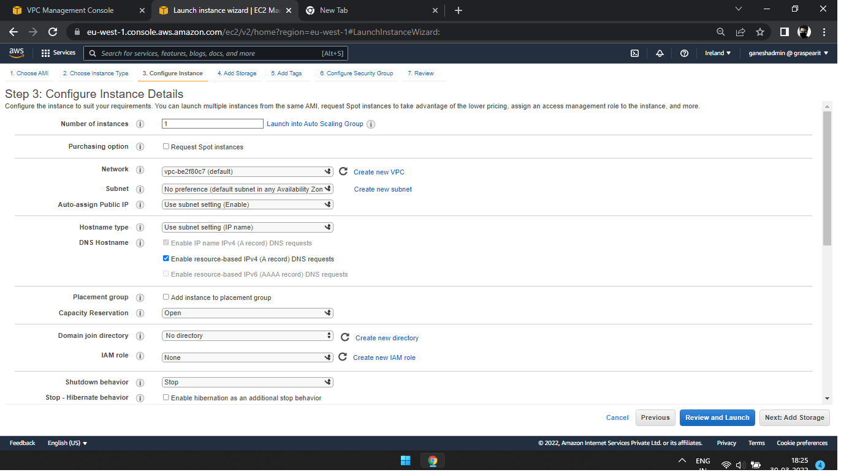
- Reference
  - Instance name: praveen

Version number | Version Date | Prepared By | Reviewed By | Review Date
0.1 | 28-feb-2022 | Praveen clement raj | Raj Kumar

