A

PROJECT REPORT

ON

**“ Voice Assistant ”**

Towards partial fulfilment of the requirement in

**4th Semester BCA (2022 – 2023)**

**Submitted by:**

Hitesh Vaishnav (210510106033)

Roshan Gupta (210510104024)

Omkar Dharkar (210510110009)

**Submitted To:-**



**Parul Institute of Computer Application,**

**Parul University.**

Under the guidance of

Assistant Professor

**Prof. Hardik Parmar.**

**Acknowledgement**

*The success and final outcome of this project required a lot of guidance and assistance from many people and we are extremely privileged to have got this all along the completion of our project. All that we have done is only due to such supervision and assistance and we would not forget to thank them.*

*We respect and thank Dr Priya Swaminarayan, Dean, FITCS for providing us an opportunity to do the project work in BCA and giving us all support and guidance, which made us complete the project duly. We are extremely thankful to Mam for providing her support and guidance, although she had busy schedule managing the academic affairs.*

*We would not forget to remember Prof. Hina Chokshi, HOD, BCA department for her encouragement and more over for her timely support and guidance till the completion of our project work.*

*We owe our deep gratitude to our project guide Prof. Hardik Parmar, who took keen interest on our project work and guided us all along, till the completion of our project work by providing all the necessary information for developing a good system.*

*We are thankful to and fortunate enough to get constant encouragement, support and guidance from our Parents, all Teaching staffs of BCA Department which helped us in successfully completing our project work. Also, we would like to extend our sincere esteems to all staff in laboratory for their timely support.*

***Hitesh Vaishnav : 210510106033***

***Roshan Gupta : 210510104024***

***Omkar Dharkar : 210510110009***



PARUL INSTITUTE OF COMPUTER APPLICATION

**CERTIFICATE**

This is to certify that **Hitesh Vaishnav, Roshan Gupta, Omkar Dharkar**, the student(s) of Parul Institute of Computer Application, has/have satisfactorily completed the project entitled “**Voice Assistant***”* as a part of course curriculum in BCA / IMCA semester-V for the academic year 2021-2022 under guidance of**Hardik Parmar*.***

Enrollment Number: ***210510106033***

Enrollment Number: ***210510104024***

Enrollment Number: ***210510110009***

|  |  |  |
| --- | --- | --- |
| **Quality of work** | **Grade** | **Sign of Internal guide** |
| **Poor / Average / Good /**  **Excellent** | **B /B+ / A / A+** |  |

Date of submission:

HOD, Principal,

**Prof. Hina Chokshi** **Dr Priya Swaminarayan**

**INDEX**

|  |  |
| --- | --- |
| **Content** | **Page No.** |
| 1. Research |  |
| 1. Feasibility Studies |  |
| * 1. Technical Feasibility |  |
| * 1. Economic Feasibility |  |
| * 1. Operational Feasibility |  |
| 1. System Requirement Specification |  |
| * 1. Introduction to SRS |  |
| * 1. Abstract |  |
| * 1. System Users |  |
| * 1. Modules |  |
| * 1. Modules Description |  |
| * 1. Hardware / Software Requirement |  |
| * 1. Flow Chart |  |
| * 1. TimeLine Chart |  |
| 1. Technology Description |  |
| * 1. Features and Limitations of New System |  |
| 1. Data Flow Diagram |  |
| * 1. Context Level DFD’s |  |
| * 1. Level 1 DFD’s |  |
| * 1. Level 2 DFD’s |  |
| * 1. Level 3 DFD’s |  |
| 1. Use Case Diagram |  |
| 1. Class Diagram |  |
| 1. Activity Diagram |  |
| * 1. Description of Activity Diagram |  |
| 1. E-R Diagram |  |
| * 1. E-R Diagram Description |  |
| 1. Data Dictionary |  |
| * 1. Description of Data Dictionary |  |
| 1. Form Design (Screenshots Phase 1, 2, 3, 4 and Validation’s Screenshots) |  |
| 1. What is Testing? |  |
| * 1. Importance and Types of Testing |  |
| 1. Future Enhancement |  |
| 1. References and Bibliography |  |

1. **Research**
   1. **What is research?**

Voice assistant is a Virtual assistant, that uses speech recognition, natural language, processing and speech synthesis to take action to help its users. This assistant have evolved quick and can perform several complex task. Read over comprehensive guide on voice assistant here.

1. **Feasibility Studies**

**What is Feasibility?**

Feasibility study can help you determine whether or not you should proceed with

your project. It is essential to evaluate cost and benefit. It is essential to evaluate cost and

benefit of the proposed system

Feasibility study can help you determine whether or not you should proceed with

your project. It is essential to evaluate cost and benefit. It is essential to evaluate cost and

benefit of the proposed system

Feasibility study can help you determine whether or not you should proceed with

your project. It is essential to evaluate cost and benefit. It is essential to evaluate cost and

benefit of the proposed system

Feasibility study can help you determine whether or not you should proceed with

your project. It is essential to evaluate cost and benefit. It is essential to evaluate cost and

benefit of the proposed system

Feasibility study can help you determine whether or not you should proceed with

your project. It is essential to evaluate cost and benefit. It is essential to evaluate cost and

benefit of the proposed system

Feasibility study can help you determine whether or not you should proceed with

your project. It is essential to evaluate cost and benefit. It is essential to evaluate cost and

benefit of the proposed system

Feasibility study can help you determine whether or not you should proceed with

your project. It is essential to evaluate cost and benefit. It is essential to evaluate cost and

benefit of the proposed system

Feasibility study can help you determine whether or not should proceed with your project. It is essential to evaluate cost and benefits of the proposed system.

* 1. **Technical Feasibility**

It includes finding out technologies for The Project, both hardware and software. For virtual assistant user must have microphone to convey their message and a speaker to listen when system speaks. These are very cheap nowadays and everyone generally possess them.

* 1. **Economic Feasibility**

Hear, we find the total cost and benefit of the proposed system over current system.

* 1. **Operational Feasibility**

It is easy and simple city of operations of proposed system. System does not require any special skill set for user to operate it. In fact, it is designed to be used by almost every on. Kids who still don’t know to write keno reader, problem for system and get answer.

1. **System Requirement Specification**
   1. **Introduction To SRS**
      1. **What is SRS?**

A software requirements specification (SRS) is a description of a software system to be developed. It lays out functional and non-functional requirements, and may include a set of use cases that describe user interactions that the software must provide.

* + 1. **Need of SRS**

In order to fully understand one’s project, it is very important that they come up with a SRS listing out their requirements, how are they going to meet it and how will they complete the project. It helps the team to save upon their time as they are able to comprehend how are going to go about the project. Doing this also enables the team to find out about the limitations and risks early on.

* 1. **Abstract**

A virtual assistant is a *technology based on artificial intelligence.* The software uses a device’s microphone to receive voice requests while the voice output takes place at the speaker. But the most exciting thing happens between these two actions.

It is a combination of several different technology: voice recognition, voice analysis and language processing.

It is completely developed using one of the most powerful language pythons.

* 1. **System Users**
     1. **Description of User Role**

There is user who can use it with command system will respond according to query in voice command. User can give single or more it will work on their voice command.

* 1. **Modules**
* Hot word dictation
* Google search
* YouTube search
* Web Browser Access
* Play Any music
* Weathercasting
* News
* Read News
* Take Screenshots
* Temperature
* Set Alarm
* Keyboard automation
  1. **Modules Description**

**3.5.1 Hot word dictation**

This will be in work after using some hard words. These word will wake up it and sleep it.

**3.5.2 Google search**

We can use Google chat voice command you can search anything

**3.5.3 You tube search**

You can use YouTube by giving a single command “ Open YouTube search on tube ”. This feature will give most satisfied output as you want.

**3.5.4 Web Browser Access**

This future will provide to accessing Web by using single command. You can search any website and much more.

**3.5.5 Play Any music**

You can play any music, It can be online and off-line also it will play song on single command

**3.5.6 Weathercasting**

humidity This future will provide you temperature of real-time. It will show and speak, real-time temperature and of your city.

**3.5.7 Set Alarm**

This will set real-time alarm on your device by using voice command, and also remind at the set time.

* 1. **Hardware Requirements**

|  |  |
| --- | --- |
| **Name of Components** | **Specification** |
| Processor | Higher processor |
| RAM | 64 MB (or) Higher |
| Hard Disk | 32 MB (or) Higher |

**3.6. Software Requirements**

|  |  |
| --- | --- |
| **Name of Components** | **Specification** |
| Operating System | Microsoft Windows/Linux/android |
| Software development Kit | Voice Development Kit |
| Tools & languages | Python, |

* 1. **Flow Chart**

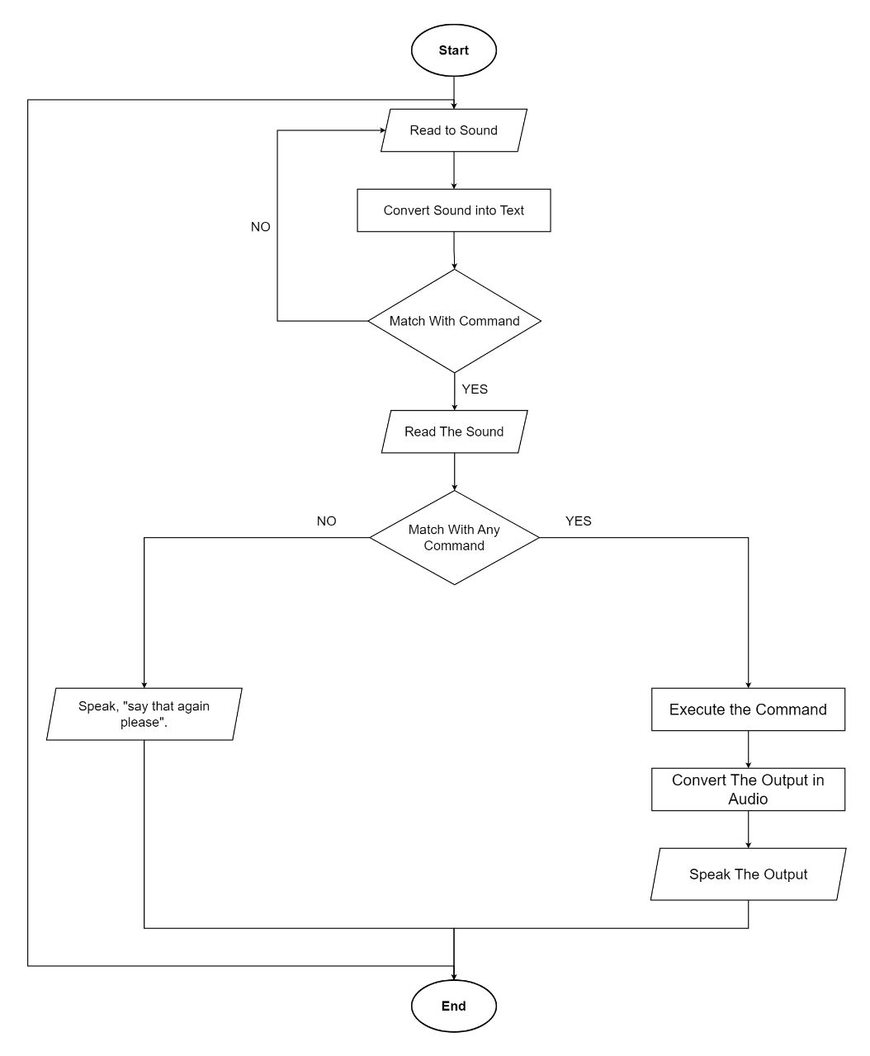

* 1. **Time Line Chart**

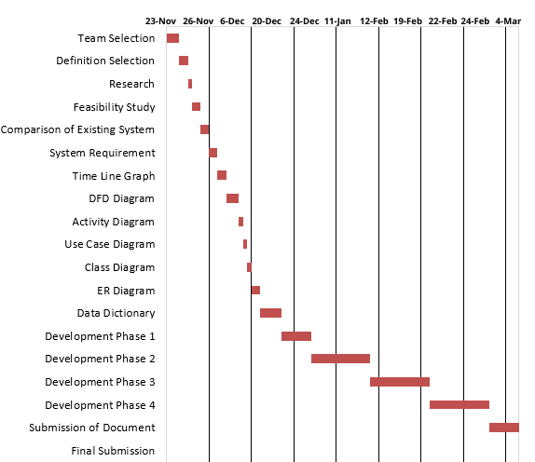

Figure 3.7.1. Time Line Chart

1. **Technology Description**
   1. **Features and Limitations of New System**

|  |  |
| --- | --- |
| **Existing System** | **New System** |
| They were not perform specific task | They were perform specific task |
| There are normal voice assistant | There are advance voice assistant |

1. **Data Flow Diagram**
   1. **Context Level DFD’s**

Figure 5.1.1. Context Level DFD: 0 Level

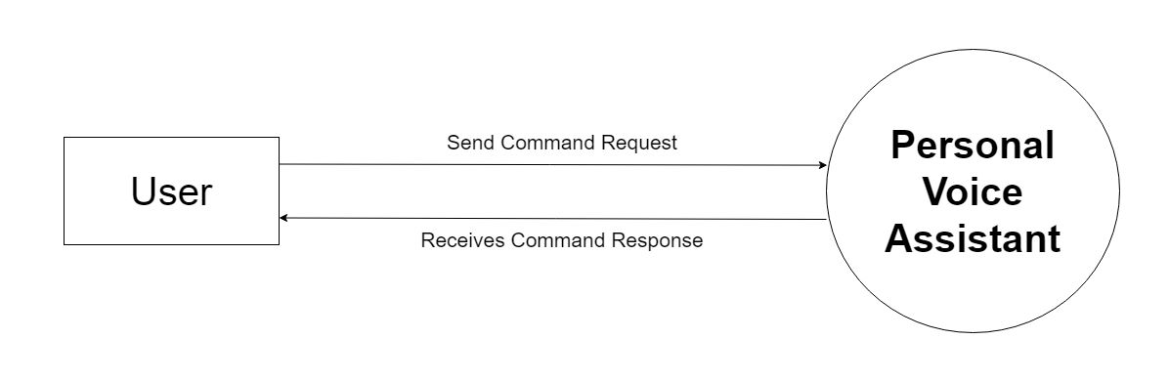

* 1. **Level 1 DFD’s:**

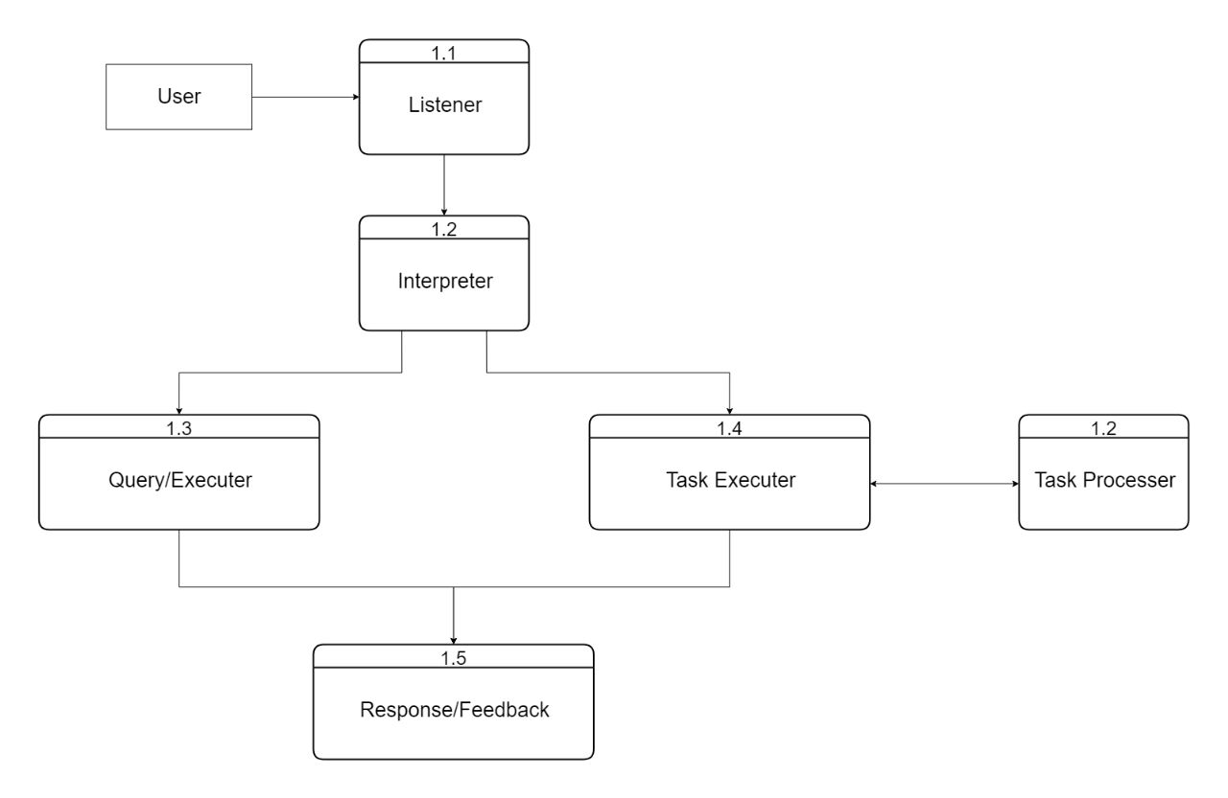

* 1. **Level 3 DFD’s:**

1. **Use Case Diagram**

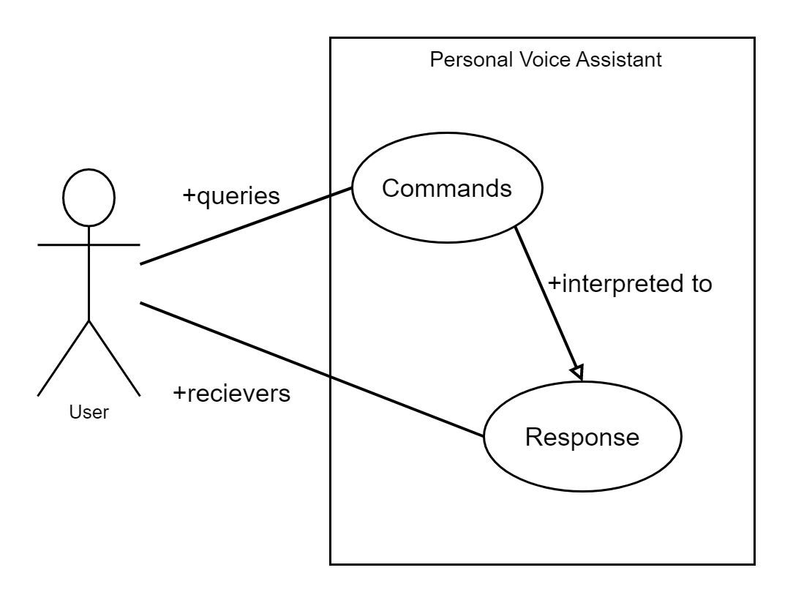

1. **System Flow diagram**



1. **Form Design (Screenshots Phase 1 ,2,3,4 & validation’s screenshots)**
   1. **Development Phase -1**

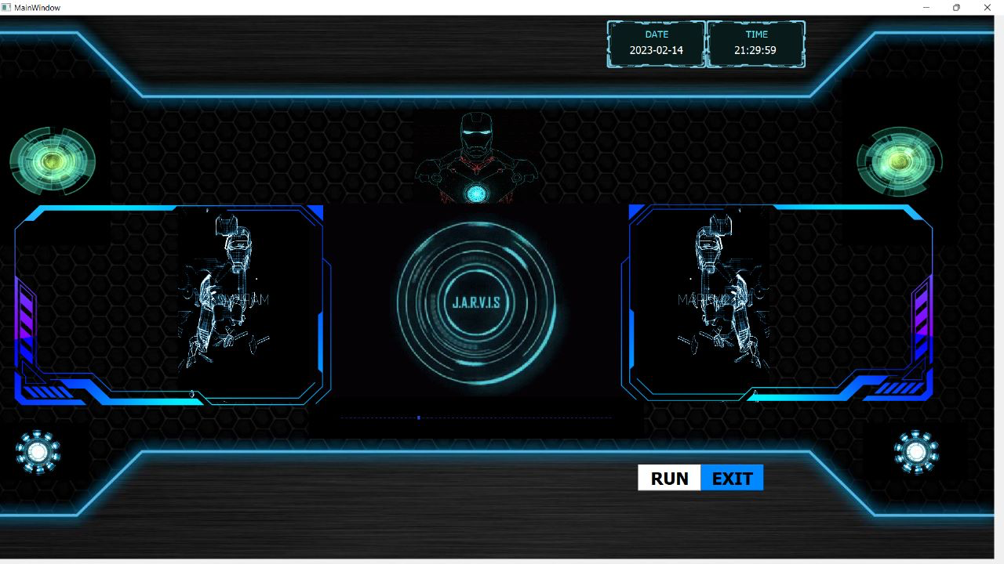

* 1. **Development Phase -2**

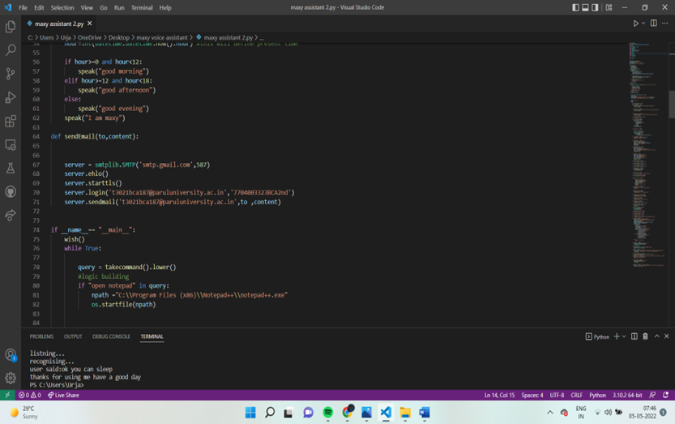

* 1. **Development Phase -3**

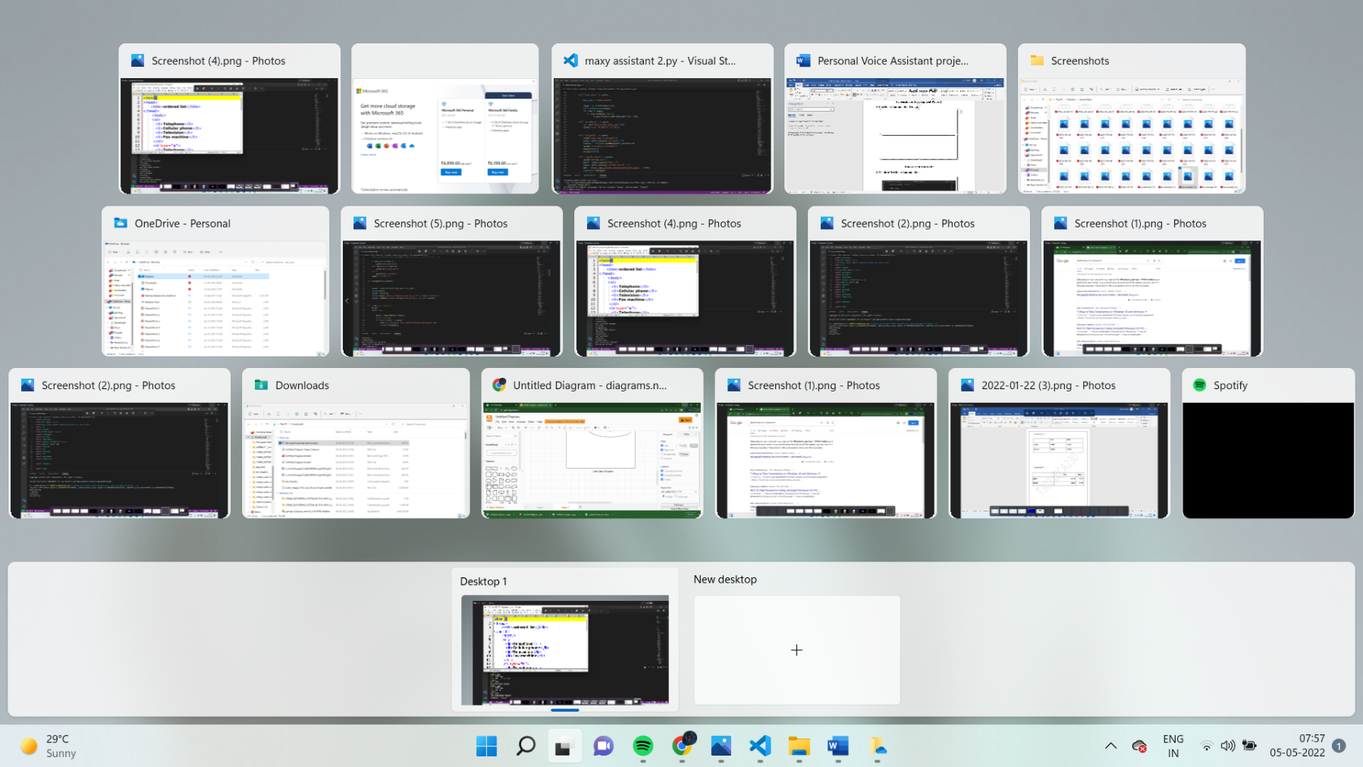

* 1. **Development Phase -4**

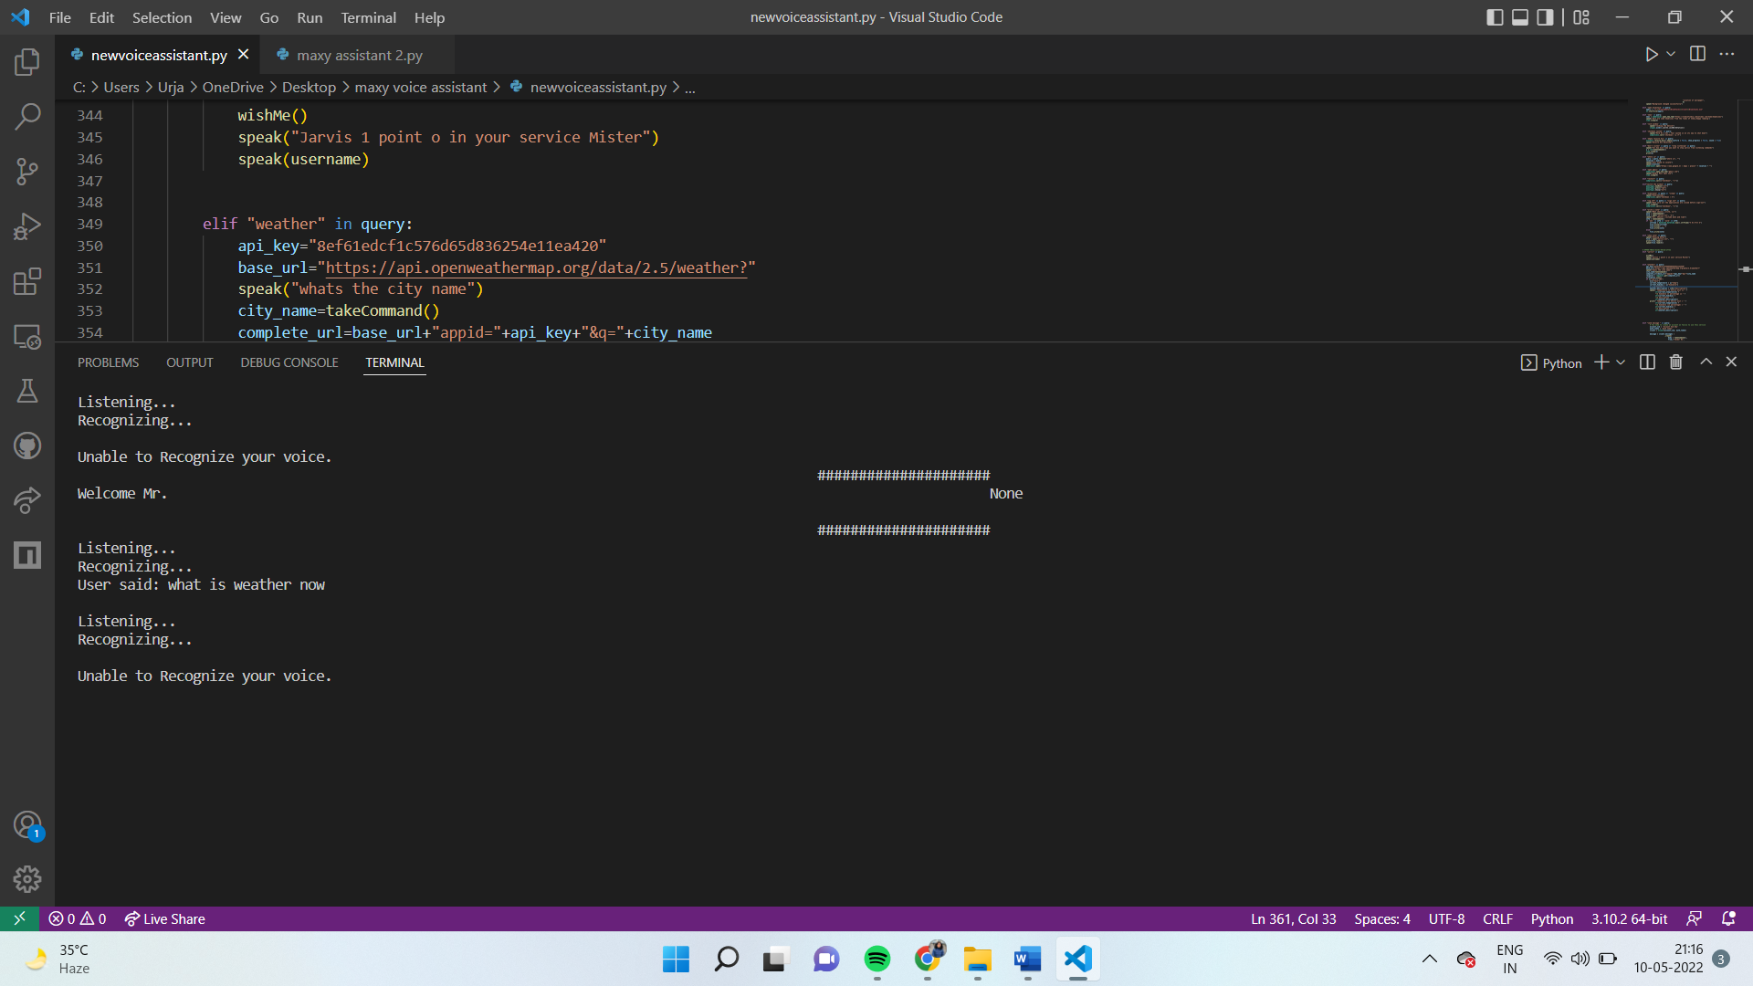

**12. What is testing?**

**12.1. Importance and types of testing**

Software testing is the act of examining the artifacts and the behaviour of the software under test by validation and verification. Software testing can also provide an objective, independent view of the software to allow the business to appreciate and understand the risks of software implementation.

**Importance:**

Identifies defects early.

Improves product quality.

Increases customer trust and satisfaction.

Detects security vulnerabilities.

Helps with scalability.

Saves money.

**Types:**

Integration Testing.

Unit Testing.

Functional Testing.

Security Testing.

Performance Testing.

Regression Testing.

Stress Testing.

Acceptance Testing.

**13. Future Enhancement**

* Change In Behaviors Of Searching.
* Voice In Gaming Industry
* Individualized Experiences
* Voice-Tech in Healthcare
* Voice Cloning
* Way of Sharing Technology

**14. References & Bibliography**

**Website referred:**

[**www.stackoverflow.com**](http://www.stackoverflow.com)

[**www.pythonprogramming.net**](http://www.pythonprogramming.net)

[**www.codecedemy.com**](http://www.codecedemy.com)

**Books referred:**

Python Programming – Kiran Gurbani

Learning Python – Mark Lutz

**Resources: -**

1. YouTube
2. Google

THANK YOU ………