Creating a project
If this is your first time using Django, you’ll have to take care of some initial setup. Namely, you’ll need to auto-generate some code that establishes a Django project – a collection of settings for an instance of Django, including database configuration, Django-specific options and application-specific settings.

$ django-admin startproject mysite
This will create a mysite directory in your current directory.

Note
You’ll need to avoid naming projects after built-in Python or Django components. In particular, this means you should avoid using names like django (which will conflict with Django itself) or test (which conflicts with a built-in Python package).

Where should this code live?
If your background is in plain old PHP (with no use of modern frameworks), you’re probably used to putting code under the Web server’s document root (in a place such as /var/www). With Django, you don’t do that. It’s not a good idea to put any of this Python code within your Web server’s document root, because it risks the possibility that people may be able to view your code over the Web. That’s not good for security.
Put your code in some directory outside of the document root, such as /home/mycode.

Let’s look at what startproject created:
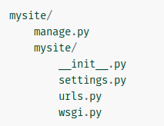

These files are:
- The outer mysite/ root directory is just a container for your project. Its name doesn’t matter to Django; you can rename it to anything you like.
- manage.py: A command-line utility that lets you interact with this Django project in various ways. You can read all the details about manage.py in django-admin and manage.py.
- The inner mysite/ directory is the actual Python package for your project. Its name is the Python package name you’ll need to use to import anything inside it (e.g. mysite.urls).
- mysite/__init__.py: An empty file that tells Python that this directory should be considered a Python package. If you’re a Python beginner, read more about packages in the official Python docs.
- mysite/settings.py: Settings/configuration for this Django project. Django settings will tell you all about how settings work.
- mysite/urls.py: The URL declarations for this Django project; a “table of contents” of your Django-powered site. You can read more about URLs in URL dispatcher.
- mysite/wsgi.py: An entry-point for WSGI-compatible web servers to serve your project. See How to deploy with WSGI for more details.

The development server
Let’s verify your Django project works. Change into the outer mysite directory, if you haven’t already, and run the following commands:

$ python manage.py runserver
You’ll see the following output on the command line:
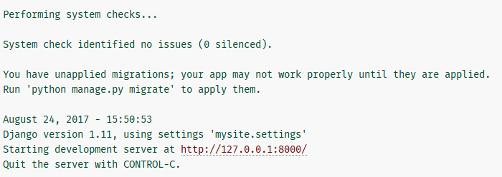
Note
Ignore the warning about unapplied database migrations for now; we’ll deal with the database shortly.

You’ve started the Django development server, a lightweight Web server written purely in Python. We’ve included this with Django so you can develop things rapidly, without having to deal with configuring a production server – such as Apache – until you’re ready for production.

Now’s a good time to note: don’t use this server in anything resembling a production environment. It’s intended only for use while developing. (We’re in the business of making Web frameworks, not Web servers.)

Now that the server’s running, visit http://127.0.0.1:8000/ with your Web browser. You’ll see a “Welcome to Django” page, in pleasant, light-blue pastel. It worked!

