Now that your environment – a “project” – is set up, you’re set to start doing work.

Each application you write in Django consists of a Python package that follows a certain convention. Django comes with a utility that automatically generates the basic directory structure of an app, so you can focus on writing code rather than creating directories.

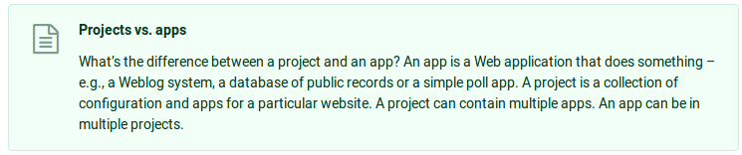
Your apps can live anywhere on your PYTHONPATH. In this tutorial, we’ll create our poll app right next to your manage.py file so that it can be imported as its own top-level module, rather than a submodule of mysite.

To create your first app, make sure you’re in the same directory as manage.py and type this command:

$ python3.6 manage.py startapp webapp

That’ll create directory webapp, which is laid out like this:
./webapp:
admin.py
apps.py
__init__.py
migrations/
__init__.py
models.py
tests.py
views.py

This directory structure will house the webapp application.

So, typical multi app structure, looks like,

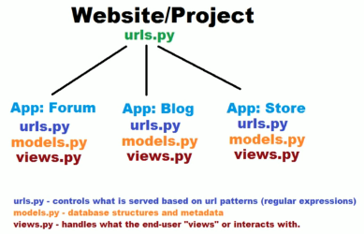

Such design helps us perform the following,
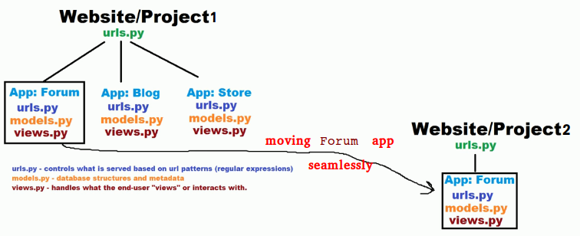

Goto ../mysite/mysite/settings, add your webapp entry, to install your app in the project:

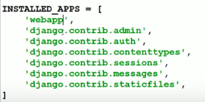

let us update views.py, as shown below:

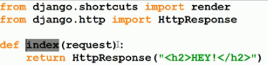

This is the simplest view possible in Django. To call the view, we need to map it to a URL - and for this we need a URLconf.
To create a URLconf in the webapp directory, create a file called urls.py. Your app directory(webapp) should now look like:

webapp/
__init__.py
admin.py
apps.py
migrations/
__init__.py
models.py
tests.py
urls.py
views.py

In the webapp/urls.py file, include the following code:
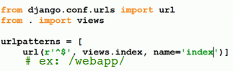

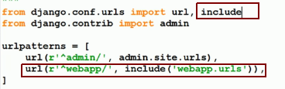
The next step is to point the root URLconf at the webapp.urls module. In mysite/urls.py, add an import for django.conf.urls.include and insert an include() in the urlpatterns list, so you have:

The include() function allows referencing other URLconfs. Note that the regular expressions for the include() function doesn’t have a $ (end-of-string match character) but rather a trailing slash. Whenever Django encounters include(), it chops off whatever part of the URL matched up to that point and sends the remaining string to the included URLconf for further processing.

The idea behind include() is to make it easy to plug-and-play URLs.

For example: If the request url is /webapp/something/something. and your root urlconf has url('r'^webapp/', include('webapp.urls')') , then the something/something will be passed to webapp/urls.py to resolve.

After starting the webserver:
$ python3.6 manage.py runserver

Launching the browser client,
