The Django admin application can use your models to automatically build a site area that you can use to create, view, update, and delete records. This can save you a lot of time during development, making it very easy to test your models and get a feel for whether you have the right data. The admin application can also be useful for managing data in production, depending on the type of website. The Django project recommends it only for internal data management (i.e. just for use by admins, or people internal to your organization), as the model-centric approach is not necessarily the best possible interface for all users, and exposes a lot of unnecessary detail about the models.

All the configuration required to include the admin application in your website was done automatically when you created the skeleton project. As a result, all you must do to add your models to the admin application is to register them.

Before registering the models to admin app (django.contrib.admin), below procedure shows, how to create a new "superuser" and login to the site.

Create a superuser,
mysite$ python3.6 manage.py createsuperuser
Username (leave blank to use 'mohet01'): admin
Email address: sham.ibmgs@gmail.com
Password:
Password (again):
Superuser created successfully.
mysite$
and then start server

Now launch admin url with http://localhost:8000/admin, displays below page

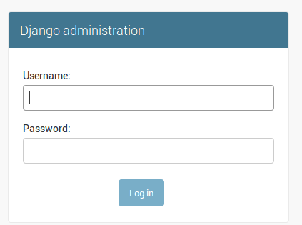

Enter user name and password:

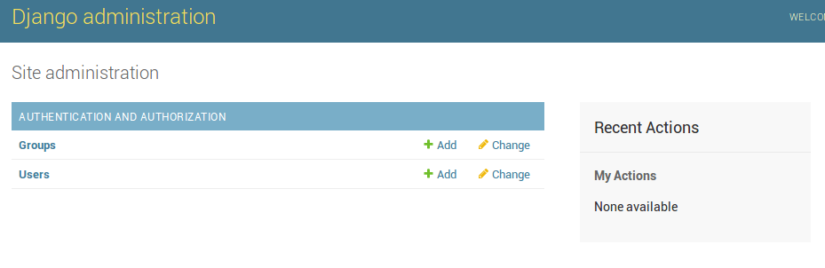

We'll use the Django admin site to add some real data.

Registering models to admin app
First we'll show you how to register the models with the admin site,

../mysite/blog/admin.py
from django.contrib import admin
from blog.model import Post

# Imports the models and then calls admin.site.register to register each of them.
admin.site.register(Post)

fd

