When you click each blog,

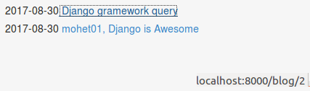

Corresponding Url does not have its template and view, as shown below.

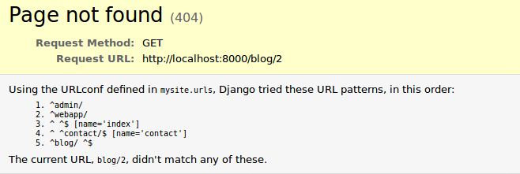
Let us complete that.

For url pattern, we use named group regular expression, for this. Read more.

Blog/urls.py

urlpatterns = [
url(r'^$', ListView.as_view(
queryset=Post.objects.all().order_by("-date")[:25],
template_name="blog/blog.html",
)
),
url(r'^(?P<pk>\d+)$', DetailView.as_view(
model=Post,
template_name='blog/post.html'
)
)
]

with post.html as

{% extends "personal/header.html" %}

{% block content %}
<h3>{{post.title}}</h3>
<h6>on {{post.date}}</h6>
{{post.body|safe|linebreaks}}
{% endblock %}

safe is required, if post body includes something like <h1>This is body<h1>
safe will interpret that headers as well instead of displaying it literally

