1)
Obtained a Ubuntu virtual private server from Digital ocean cloud
Server: mohet01-ubuntu
512 MB / 20 GB Disk / TOR1 - Ubuntu 16.04.3 x64
IP address: 159.203.35.199
root passwd: interOP@123
mohet01 passwd: interOP@123

2)
Followed initial server setup details, given here. About sudoers.

Topics

Introduction: Just the README and a stub directory for SSH keys
Servers: Fabric fabfile.py in the prod subdirectory
Operating systems: Start of the Ansible playbook
Web-servers: Builds the Nginx configuration into the Ansible playbook
Source-control: Adds Git repository cloning to the playbook
Databases: Sets up PostgreSQL and Redis
Application-dependencies: Installs Python packages into a virtualenv, establishes environment variables and syncs the app to the database
Wsgi-servers: Configures Supervisor to run the app with Green Unicorn
Task-queues: Adds to the Supervisor configuration for Celery and Redis
Continuous-integration: Modifies the Ansible playbook so it does not prompt for the sudo password on the CI server

Chapter 1 - Introduction

Services and Code We'll Use
We use several services to get our environment up and running.
The services are:
DigitalOcean / Linode: Hosts our virtual private production server - a single 1 gigabyte RAM virtual private server costs $10 / month
GitHub: handles source control in the deployment - a free account works well
Twilio: automates deployment alerts - either a free trial account or an upgraded account is fine
GitHub and Twilio can be used with the free trial account for our purposes.

We also need several free open source projects to handle the deployment, including:
Fabric: provides a convenient way to script SSH commands with Python code
Ansible: an easy to use but powerful configuration management automation tool
Nginx: the second most common web server currently deployed that is also popular with the Python community
Green Unicorn: a Web Server Gateway Interface (WSGI) server that will execute our Python code so we can run our web application

A local Linux or Mac OS X environment is required to perform the deployment.

Our web application uses the Django web framework and follows the Python Web Server Gateway Interface (WSGI) standard defined by the Python community in PEP 3333 for deploying web applications to web application servers.

PEP 3333 specifies that WSGI frameworks such as Django, Flask and Pyramid can be interchangeably deployed to WSGI servers such as gunicorn, mod_wsgi and uWSGI.

Chapter 2 - Server

Your web application must run somewhere other than your development environment on your desktop or laptop. That location is a separate server (or cluster of servers) known as a "production environment". For simplicity, we will use a single virtual private server for our application's production environment deployment.

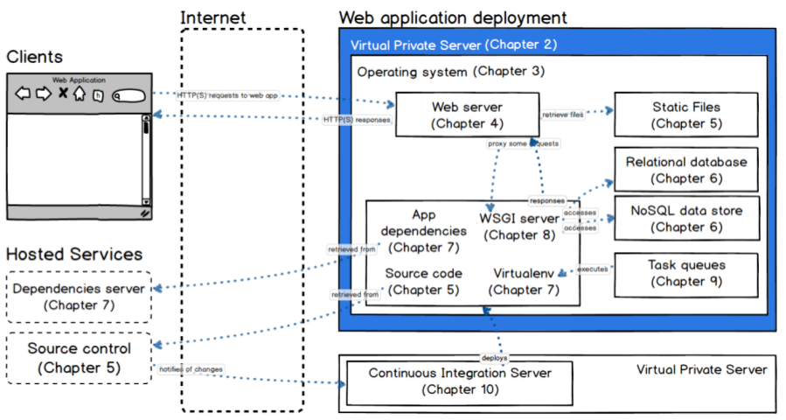
Obtain a virtual private server to use as our production environment, boot up the server and
secure it against unauthorized access attempts. Below is the Ubuntu virtual private server obtained from Digital ocean cloud.

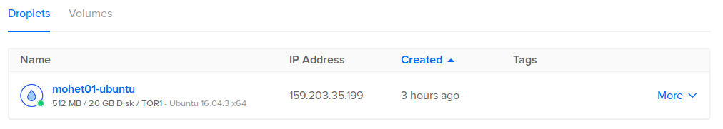
Let's consider our hosting options before diving into the deployment on the Digitalocean virtual private server.

Hosting Options
There are four general options for deploying and hosting a web application:
"Bare metal" servers: physical hardware; vendor examples: Dell, Lenovo
Virtual private servers: shared rented portions of servers, examples: Linode, Digital Ocean
Infrastructure-as-a-service (IaaS): virtualized abstractions of resources, examples: Amazon Web Services & Microsoft Azure
Platform-as-a-service (PaaS): abstracted execution environments such as Heroku, Python Anywhere or Amazon Elastic Beanstalk

Bare metal server Vs Virtual private server, read more.

Bare metal servers and virtual private servers are similar. A base operating system such as Linux is installed with root access and the ability to configure (or totally screw up!) the system. System packages, a web server, WSGI server, database and the Python environment can be installed with the
customer preferences necessary for the deployment. The application code can be pulled from a source controlled repository and deployed so the application can run within the Python environment.

we will deploy our web application on a virtual private server (VPS). There are plenty of VPS hosting options. I have used Digital ocean, as of now. You typically get what you pay for in the VPS hosting
industry.

What are Virtualized Servers?
Virtual private servers (VPSs) are sandboxed slices of hardware run with a hypervisor running on top of a physical server. Virtualization software such as Xen and VMWare allow a providers' customers to use fractions of a full server that appear as their own independent instances. For example, a server with an 8-core processor and 16 gigabytes of memory can be roughly virtualized into 8 pieces with the equivalent of 1-core and 2 gigabytes of memory. The primary disadvantage of virtualized servers is that there is resource overhead in the virtualization process. But for our web application deployment, a single well-configured virtual private server provides more than enough performance and represents a huge cost savings over purchasing dedicated hardware.

Create public and private keys
We need to create a public-private key pair that will be used to harden our new server against unauthorized login attempts.
Before we boot up our newly-provisioned server we need to create a public-private key pair on our local machine. Then we can upload the locally-created public key to our remote server.
Once we are using the key pair we can disable password logins for greatly increased server security. In addition, we will not have to type in a password each time we want to log into the server via SSH, which is way more convenient.

On your local computer (not the server you created on Linode), open a new terminal window.
Create a directory with the following commands to store our key pair.
$ mkdir ssh_keys
$ cd ssh_keys/
$
Execute the following ssh-keygen command to create the public-private key pair.
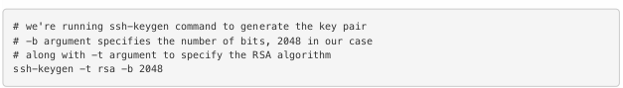
When prompted for a file in which to save the keys do not use the default. Instead, enter the following directory and file into the prompt.
$ ssh-keygen -t rsa -b 2048
Generating public/private rsa key pair.
Enter file in which to save the key (/home/mohet01/.ssh/id_rsa): ./prod_key
Enter passphrase (empty for no passphrase):
Enter same passphrase again:
Your identification has been saved in ./prod_key.
Your public key has been saved in ./prod_key.pub.
The key fingerprint is:
SHA256:sHWpThf0Q/mQQmyo4K6IN/2ooNvJyooc+BBwNLHT5sQ mohet01@mohet01-ubuntu
The key's randomart image is:
+---[RSA 2048]----+
| +. +o .o |
| . =. ..+++ |
|. +.E.....+.oo |
|.. =. .+ o . .. |
|. .. . S . |
|.. . o . |
|=o o . |
|B*=... |
|B**o... |
+----[SHA256]-----+
$
Press enter twice when prompted for a passphrase. We will not use a passphrase for the deployer user's keys.

After entering a blank passphrase twice, the key pair is generated by the ssh-keygen program. Now you have two new files: a private key prod_key and a public key prod_key.pub. The private key should never be shared with anyone as it will allow access your server once it is configured. The public key can be shared with anyone and does not need to be kept private.

Execute the following command to copy the newly-created public key to a separate file that holds authorized keys.
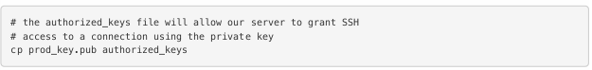
$ cp prod_key.pub authorized_keys
$ ls
authorized_keys prod_key prod_key.pub
$
You now have the required public and private key files as well as an authorized_keys file. Keep backups of these files in a safe place since once the server is locked down you'll need them to log in.
With our new key files we can now fire up the server and set up our security configuration.
Boot and Secure the Server
When we boot up the server we need to ensure it is locked down against unauthorized access attempts. There are scores of malicious bots that search for servers across the IPv4 address range. The Internet is a dangerous place for unsecured servers.

Fortunately, with a few steps we can mitigate the most glaring security weaknesses of a newly-provisioned server.
When you are ready to begin the initial lock down steps we can start our machine up.

SSH into your server with ssh root@{ip.address.here} where {ip.address.here} is your server's IP address, which can be found on the Digital ocean’s dashboard.
$ ssh root@159.203.35.199
root@159.203.35.199's password: ******
$ pwd
/root
$
You'll likely receive a prompt like the following warning. This prompt states that you've never connected to this server before and it asks if you are sure that this host's signature matches the server on which you intend to connect. Enter yes then enter the root password you created during the earlier Digital ocean server provisioning step.

Ensure the system packages cache is up to date.

Next upgrade all out of date packages.
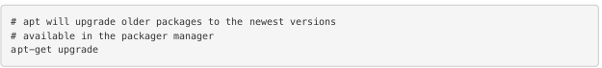
Install fail2ban with its sensible default settings.
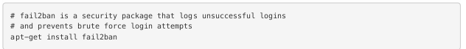
Next we need to modify the SSH configuration so a connection cannot directly log into the root user account. Only someone using the exact private key, we created earlier can connect to this server.

Open the /etc/ssh/sshd_config file in the text editor of your choice. For example use emacs /etc/ssh/sshd_config to open the file in Emacs. You should see the following lines of the file in your editor. Edit the following highlighted lines in the configuration file to match what is
shown below.

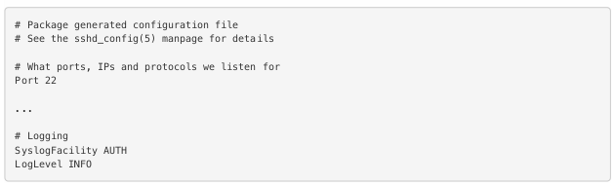
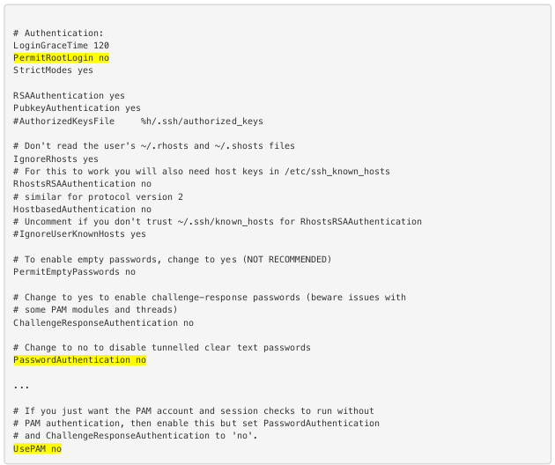

Above, you changed PasswordAuthentication to no because passwords are not necessary for logging in with the private key.
UsePAM is set to no because we are using a key pair so password authentication should be disabled for this server.
Set no for #PermitRootLogin so that we can lock down the root account and only access the server with a user account that will be created in a moment.
Save the file.
We need to create a non-root group before we can create a new non-root user to put into the non-root group. Execute the following commands on the remote server. You can change "deployers" to another group name if you want but you have to be consistent in future steps.

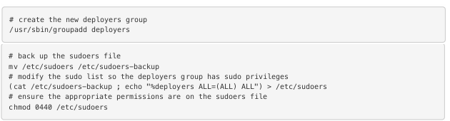
Now add a non-root user with the non-root group we just created. Replace the name Ethashamuddin Mohammed with your name (but leave the quotes around the name). You will be prompted to enter the same new password twice for this account.

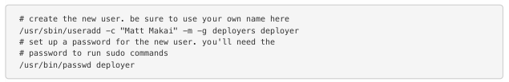
Create a directory for the new deployer user to store our public and private keys.

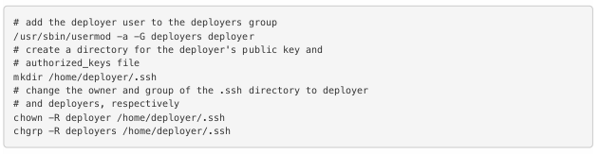
Don't log out of root just yet. We need to upload the public and private keys for the deployer user so we can log in with that account.

Upload Public SSH Key
In order to authenticate with our new deployer user, we need to upload the prod_key.pub and authorized_keys files.
Keep the root SSH connection open. We'll need that in a minute.
Go back to the command prompt on your local machine where the SSH keys we created earlier in this chapter are stored.
Upload the prod_key.pub and authorized_keys files to our server for the new deployer user. Again, make sure to replace the IP address with your server's IP address.

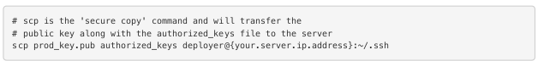
When prompted by the scp command enter the deployer's password that was created in the previous section.

Restart SSH Service
We need to ensure that we can SSH into the new deployer user after we reload
our SSH configuration on the remote server.
In the terminal where root is logged into your virtual private server, run the
following command. Do not yet log off of root!
Now try to SSH in with the new deployer user in the other terminal window. Again, replace the IP address in this command with the IP address of your server.
If you get a command prompt on the server, success! We can now close out our root connection. You won't be able to log directly into root anymore, but only into the deployer user. That's a really good thing because automated malicious bots often try to log into the root user with their attacks.

Automate Server Configuration
Clearly we don't want to have to manually type in all these steps every time we create a new VPS instance. Fortunately the Fabric library makes these instructions easy to automate. Let's take a look at a short script that runs every step we just performed above.

On your local machine, create a new directory named prod under your project. prod will store files for handling deployments to our production server for our application.

Within prod create a new file named fabfile.py with the following contents.

import os

from fabric.api import *
from fabric.contrib.files import sed

"""
Fabric file to upload public/private keys to remote servers
and set up non-root users. Also prevents SSH-ing in with the
root user. Fill in the following blank fields then run this
Fabric script with "fab bootstrap".
"""
# run the bootstrap process as root before it is locked down
env.user = 'root'

# the remote server's root password
env.password = 'interOP@123'

# all IP address or hostnames of the servers you want to put
# your SSH keys and authorized_host files on, ex: 192.168.1.1
env.hosts = ['159.203.35.199']

# your full name for the new non-root user
env.new_user_full_name = 'Ethashamuddin Mohammed'

# username for the new non-root user to be created
env.new_user = 'deployer' # ex: deployer

# group name for the new non-root user to be created
env.new_user_grp = 'deployers' # ex: deployers

# local filesystem directory where your prod_key.pub and
# authorized_keys files are located (they will be scp'd
# to target hosts) don't include a trailing slash
# note: the tilde resolves to your home directory
env.ssh_key_dir = '~/git/Projects/Deployment/ssh_keys'

"""
The following functions should not need to be modified to
complete the bootstrap process.
"""
def bootstrap():
env.ssh_key_filepath = os.path.join(env.ssh_key_dir, env.host_string + "_prod_key")
local('ssh-keygen -t rsa -b 2048 -f {}'.format(env.ssh_key_filepath))
local('cp {} {}/authorized_keys'.format(env.ssh_key_filepath + ".pub", env.ssh_key_dir))

sed('/etc/ssh/sshd_config', '^UsePAM yes', 'UsePAM no')
sed('/etc/ssh/sshd_config', '^PermitRootLogin yes', 'PermitRootLogin no')
sed('/etc/ssh/sshd_config', '^#PasswordAuthentication yes',
'PasswordAuthentication no')
_create_privileged_group()
_create_privileged_user()
_upload_keys(env.new_user)
run('service ssh reload')

def _create_privileged_group():
run('/usr/sbin/groupadd ' + env.new_user_grp)
run('mv /etc/sudoers /etc/sudoers-backup')
run('(cat /etc/sudoers-backup ; echo "%' + env.new_user_grp \
+ ' ALL=(ALL) ALL") > /etc/sudoers')
run('chmod 440 /etc/sudoers')

def _create_privileged_user():
run('/usr/sbin/useradd -c "%s" -m -g %s %s' % \
(env.new_user_full_name, env.new_user_grp, env.new_user))
run('/usr/bin/passwd %s' % env.new_user)
run('/usr/sbin/usermod -a -G ' + env.new_user_grp + ' ' + \
env.new_user)
run('mkdir /home/%s/.ssh' % env.new_user)
run('chown -R %s /home/%s/.ssh' % (env.new_user,
env.new_user))
run('chgrp -R %s /home/%s/.ssh' % (env.new_user_grp,
env.new_user))

def _upload_keys(username):
scp_command = "scp {} {}/authorized_keys {}@{}:~/.ssh".format(
env.ssh_key_filepath + ".pub",
env.ssh_key_dir,
username,
env.host_string
)
local(scp_command)

Within fabfile.py, edit the line that begins with env.password so it has your root password entered while creating your DigitalOcean server.

Next edit the line that begins with env.hosts so it has your VPS' IP address. The IP address can be found on the your DigitalOcean account dashboard.

Modify line 24 with your full name for the non-root user. Change the value under
env.ssh_key_dir = '~/fsp-deployment-guide/ssh_keys' to the directory where you created your prod_key and prod_key.pub files.

Run Fabric Script (if required)
fabric relies on Python having the fabric library installed. We'll use virtualenv, a Python tool for isolating packages, to create a separate Python installation that keeps our Fabric package dependency separate from other existing Python packages.

Chapter 3 Operating systems

An operating system runs on a server and controls access to computing resources that our web application will use to run.

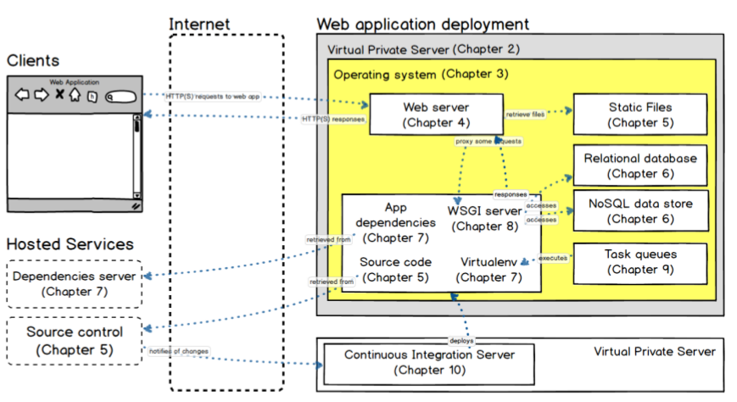
An operating system makes many of the computing tasks we take for granted easy. For example, the operating system enables writing to files, communicating over a network and running multiple programs at once. Otherwise you'd need to control the CPU, memory, network, graphics card
and many other components with your own low-level implementation.
In this chapter we set up and configure our operating system, Ubuntu Linux 16.04 Long Term Support (LTS), on our DigitalOcean virtual private server.

Ubuntu includes a package manager for installing necessary system libraries that we need to run our Python web application. We will also lock down the operating system against unauthorized access attempts.

Ubuntu
Ubuntu is a Linux distribution packaged by the Canonical Ltd company. For desktop versions of Ubuntu, GNOME (until the 11.04 release) or Unity (11.10 through current) is bundled with the distribution to provide a user interface.
Ubuntu Long Term Support (LTS) releases are the recommended versions to use for deployments. LTS versions receive five years of post-release updates from Canonical. Every two years, Canonical creates a new LTS release, which allows for an easy upgrade path as well as flexibility in skipping every other
LTS release if necessary. As of March 2016, 14.04 Trusty Tahr is the latest LTS release.
Mac OS X, and to a lesser extent Windows, are fine for developing your Python application. However,
Windows and Mac OS X are not appropriate for our production deployment.

Install System Packages
Ubuntu uses the Debian distribution as a base for packages, including the apt package manager. There are several required apt packages found on Linux servers running a Python stack. These packages are:
python-dev for header files and static libraries for Python development
python-virtualenv for creating and managing Python virtualenvs to isolate library dependencies
git-core for the Git version control system
nginx is a web server that will answer our incoming HTTP requests
supervisor controls the state of our WSGI server and task queue

Let's install these packages needed for our deployment.
$ sudo apt-get update
Ensure the package manager's local cache is up to date.
$ sudo apt-get install fail2ban python-virtualenv python-dev
It will take a little while for the packages to get installed since apt is downloading everything from the central Ubuntu package repositories.
When it's done you'll see something like the following line and you will be back at the command prompt.
Processing triggers for libc-bin (2.19-0ubuntu6) ...
With these packages in place we now have the basic system dependencies to get our Python environment running. However, our system still needs a firewall to lock down ports other than 22 (ssh), 80 (HTTP) and 443 (HTTPS).

Enable Firewall
Ubuntu has a handy tool named Uncomplicated Firewall ( ufw ). Run these commands with ufw on our server to stop Internet traffic against ports we do not intend to expose to the outside world.

$ ufw allow 22
$ ufw allow 80
$ ufw allow 443

The first three above commands tell our operating system to only allow incoming network connections to go through to ports 22, 80 and 443. We now need to enable the firewall with the following command:

$ sudo ufw enable
Command may disrupt existing ssh connections. Proceed with operation (y|n)? y
Firewall is active and enabled on system startup
$
Our firewall is in place, but it was a pain to manually run all the above commands. Next we will take a look at the configuration management tool Ansible, which helps us automate our deployment process.

Ansible
Ansible is an open source configuration management tool written in Python that will allow us to automate the steps we previously performed manually. Throughout thise exercise, we will also build on the Ansible scripts, which are called "playbooks" in Ansible terminology.
Ansible has hundreds of built-in modules to execute tasks for setting up and running servers. The source code for every module is freely available on Ansible's core and extras Git repositories.

In the last chapter we created a prod directory for our fabfile.py Fabric script. Now we can add our Ansible files within the same directory. This can either be under your project or a separate source control repository.
Remember to keep your confidential information such as usernames and passwords private!

YAML syntax, which is how Ansible playbooks (our configuration management language) are expressed.

We use YAML because it is easier for humans to read and write than other common data formats like XML or JSON. Further, there are libraries available in most programming languages for working with YAML.

Playbooks are expressed in YAML format and have a minimum of syntax, which intentionally tries to not be a programming language or script, but rather a model of a configuration or a process.

Each playbook is composed of one or more ‘plays’ in a list.

$ cd prod
$ touch deploy.yml hosts
$ mkdir roles group_vars

We just created a new file for the main YAML playbook named deploy.yml, which will coordinate our deployment's various roles. We also created a hosts file that will tell Ansible what server IP addresses to deploy our application.

Fill in the prod/deploy.yml file with the following text.

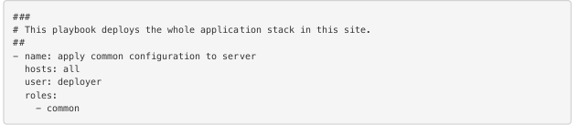
1. Fill in the hosts file with the following text.

