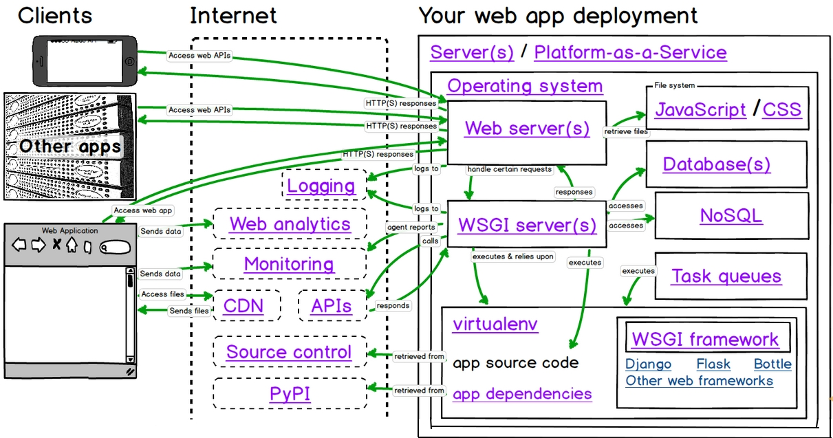
How things work together?

Django is one example of web application framework. Below is the common work performed by a framework,
- Request/Response abstraction
- Session state
- User authentication and authorization
- Page templating
- URL mapping
- Database access
- Security
- Caching
Deploying Django with Apache and WSGI server is a tried and tested way to get Django into production.
mod_wsgi is one of the WSGI server which can host any Python WSGI application, including Django. Django will work with any version of Apache which supports mod_wsgi.

