Hw 3 40243118S 王擎天

1. 設計電路說明(20%):

此線路圖是一個簡單的3個input和6個output組成,中間由一個finite state machine組成,它會在每一clock cycle更新內部的數值,並由input的兩個訊號S1,S2來調控更新的狀態,並由狀態來決定六個output的值.

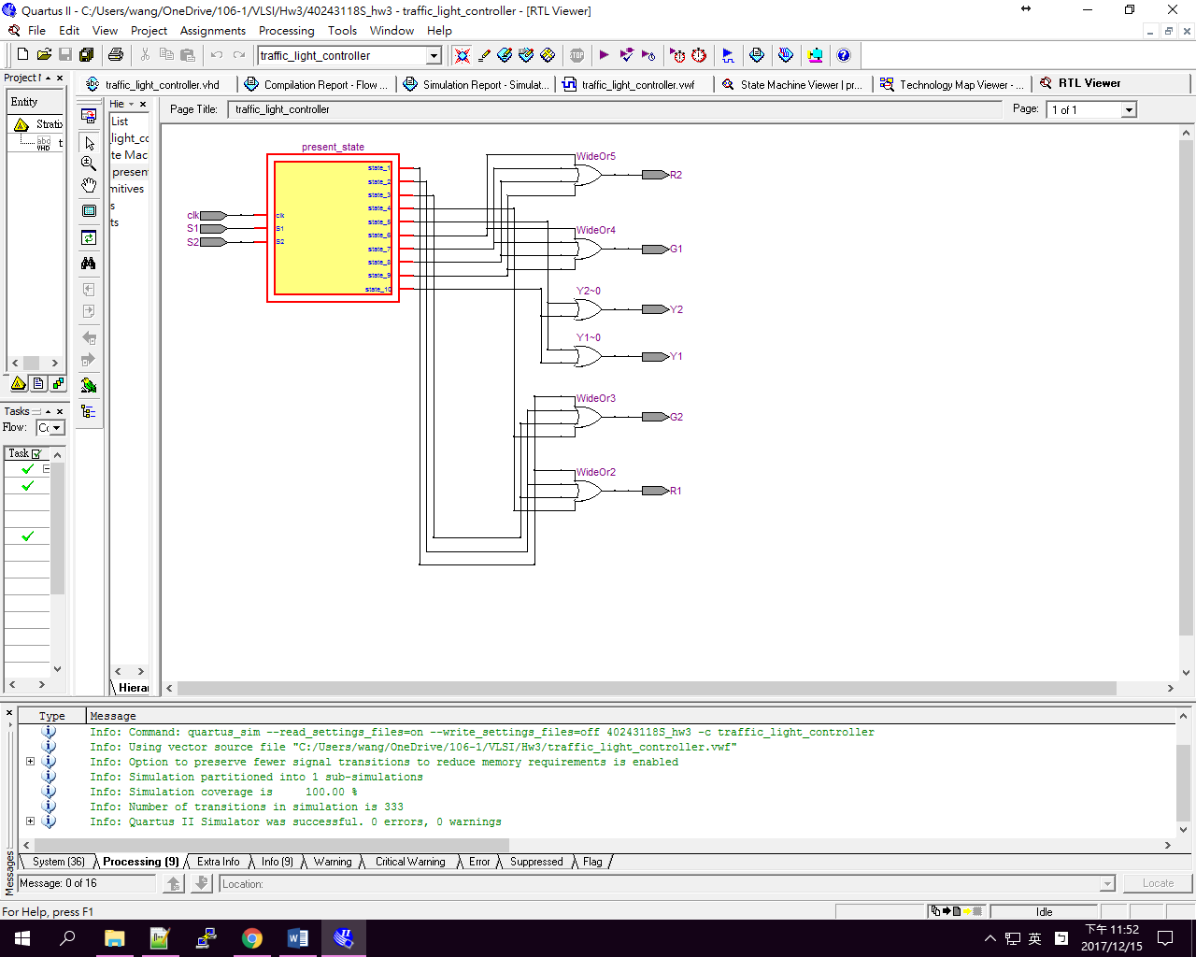

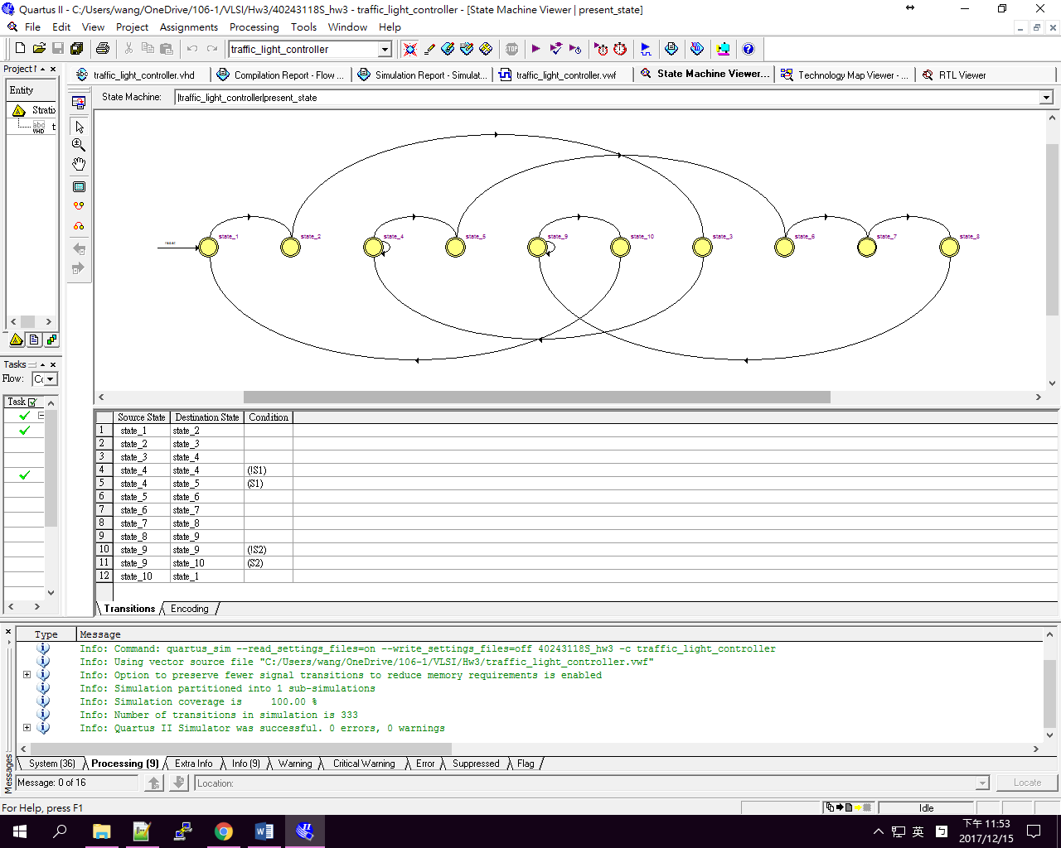

2. 程式碼說明(30%):

此程式由先宣告status_type,並設定10種state組成,又創造兩個signal,一個存現在的狀態(present_state),一個存將來的狀態(next_state).每次clock rising edge發生時,就會更新六個output的狀態(R1,Y1,G1,R2,Y2,G2),並且用next_state存下一步的數值,再用它跟改present_state.其中,S1,S2可以用來調控state machine更新到下一步的狀態.

|  |
| --- |
| entity traffic_light_controller is  port(  S1,S2,clk:in bit;  R1,Y1,G1,R2,Y2,G2:out bit  );  end entity;  architecture arch_traffic_light_controller of traffic_light_controller is  type state_status is (state_1,state_2,state_3,state_4,state_5,state_6,state_7,state_8,state_9,state_10);  signal present_state,next_state: state_status;  begin  process(present_state,S1,S2)  begin  R1<='0';  G1<='0';  Y1<='0';  G2<='0';  R2<='0';  Y2<='0';  case present_state is  when state_1=>  next_state<=state_2;  R1<='1';  G2<='1';  when state_2=>  next_state<=state_3;  R1<='1';  G2<='1';  when state_3=>  next_state<=state_4;  R1<='1';  G2<='1';  when state_4=>  if (S1='1') then  next_state<=state_5;  else  next_state<=state_4;  end if;  R1<='1';  G2<='1';  when state_5=>  next_state<=state_6;  Y1<='1';  Y2<='1';  when state_6=>  next_state<=state_7;  G1<='1';  R2<='1';  when state_7=>  next_state<=state_8;  G1<='1';  R2<='1';  when state_8=>  next_state<=state_9;  G1<='1';  R2<='1';  when state_9=>  if(S2='1') then  next_state<=state_10;  else  next_state<=state_9;  end if;  G1<='1';  R2<='1';  when state_10=>  next_state<=state_1;  Y1<='1';  Y2<='1';  end case;  end process;  process(clk)  begin  if( clk'EVENT and clk = '1') then  present_state <=next_state;  end if;  end process;  end architecture; end if;  G1<='1';  R2<='1';  when state_10=>  next_state<=state_1;  Y1<='1';  Y2<='1';  end case;  end process;  process(clk,reset)  begin  if(reset='1') then  present_state<=state_1;  elsif( clk'EVENT and clk = '1') then  present_state <=next_state;  end if;  end process;  end architecture; |

3. 模擬結果說明(30%):

此圖呈現state從state 1開始隨著clock cycle跟新狀態的現象

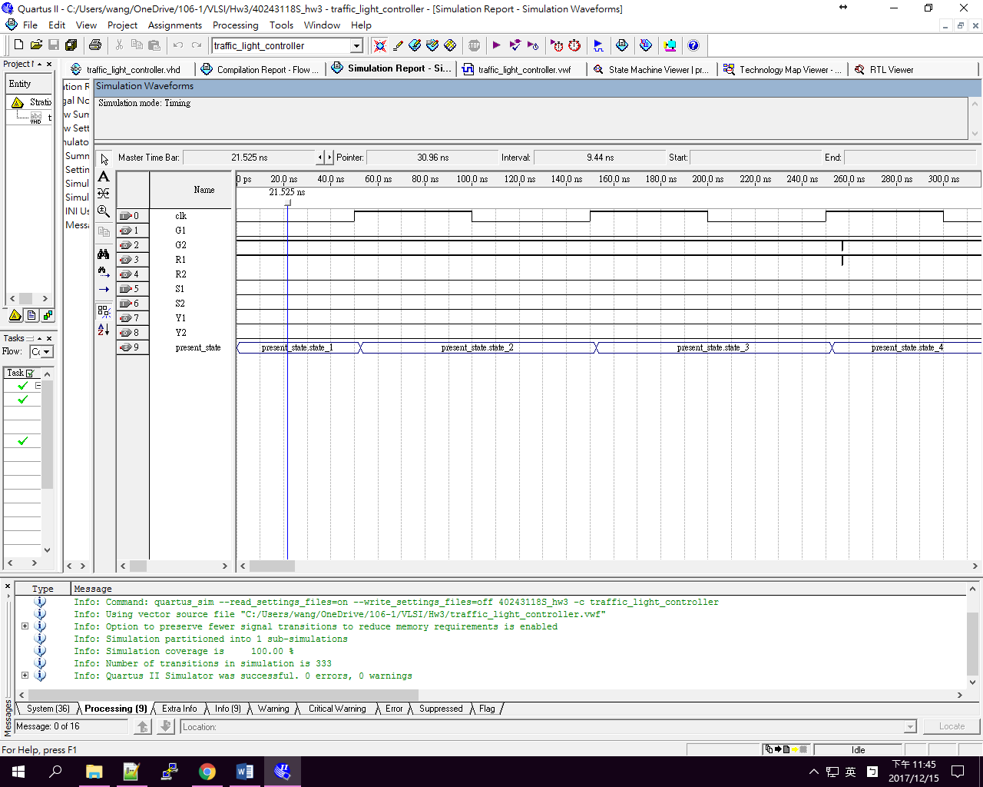

此圖呈現state 4只有在S1為一的狀態下才會更新到state 5,否則停留在state 4

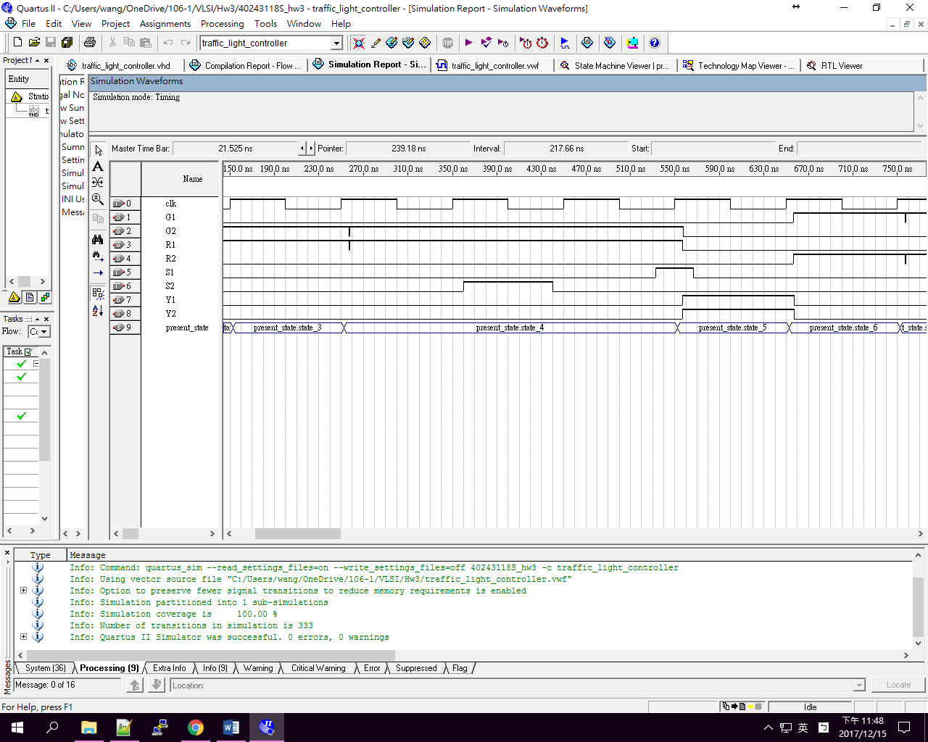

此圖呈現state隨著clock cycle跟新狀態的現象

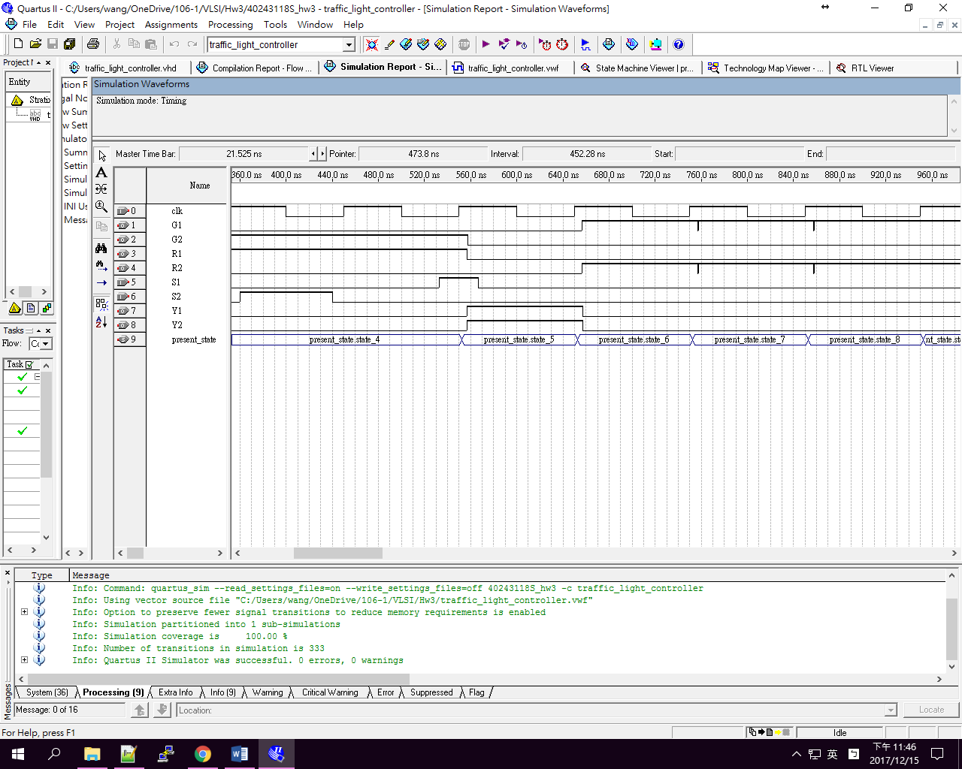

此圖呈現state 9只有在S2為一的狀態下才會更新到state 10,否則停留在state 9

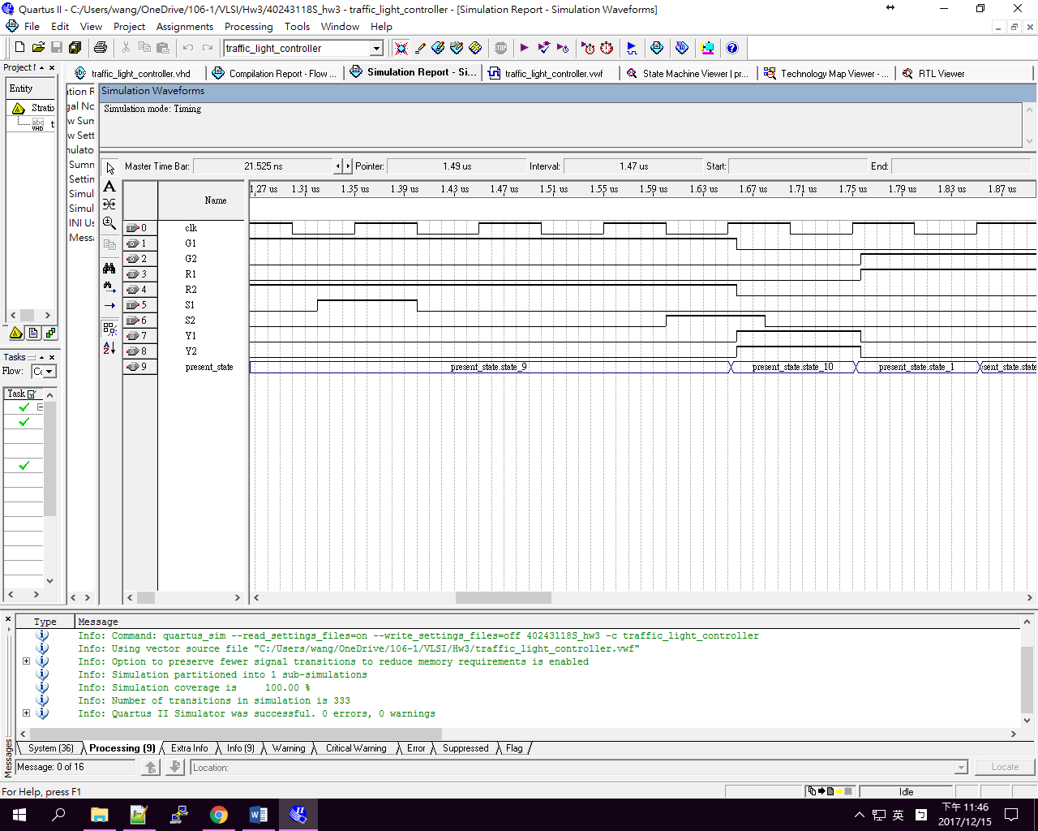

此圖呈現state 10後回到state 1,並開始一個新循環

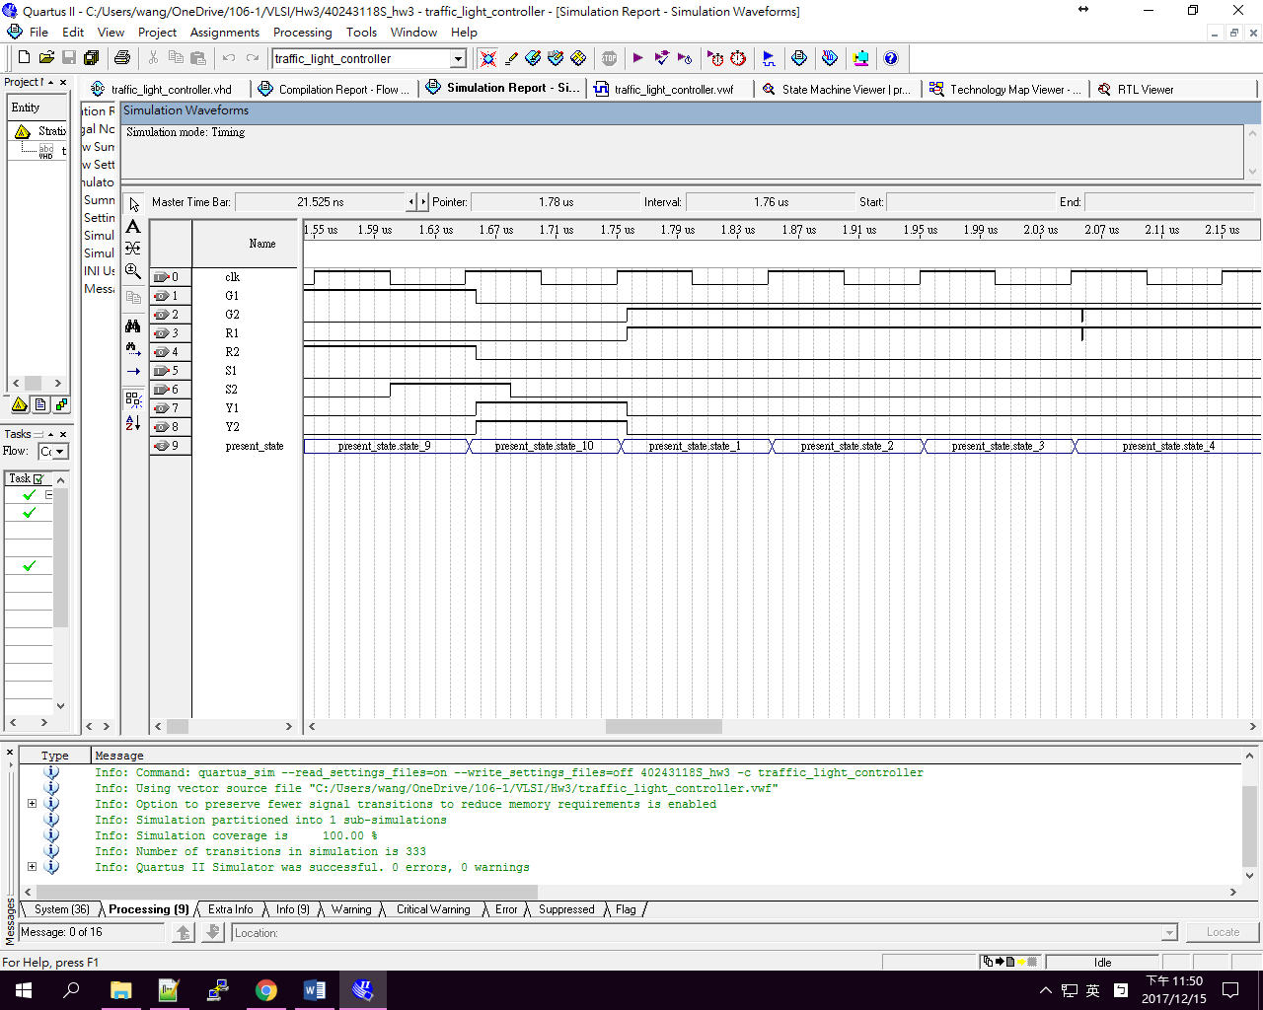

4. 結論及心得(20%):

透過上圖的state machine viewer和模擬圖和模擬圖的所呈現每個state的狀態得知,此程式有正常運作和編寫.透過這次的練習我可以使用VHDL所提供的便利性產生出state machine的線路,並透過quartus看出state machine運作的機制.