HW#3 (Due 12/15)
- Consider the following simple traffic light controller. It controls two sets of traffic lights {R1, Y1, G1} and {R2, Y2, G2}. There are two sensors S1 and S2 for switching the traffic lights.
S1
S2
{R1,Y1, G1}
{R2,Y2,G2}
Traffic
Light
Controller
clk
The ASM chart of the controller is shown below.
R1 G2
R1 G2
R1 G2
R1 G2
Y1 Y2
R2 G1
R2 G1
R2 G1
R2 G1
Y1 Y2
S1
S2
No
Yes
Yes
No
State1
State2
State3
State4
State5
State6
State7
State8
State9
State10
Write a VHDL code to implement the system using Quartus II. Your project report should include the following items.
- the Quartus II project file containing the VHDL code of the system,
- the ppt or word files containing the simulation results and the corresponding discussions.
參考實驗結果:present_state與reset只是為了讓同學方便瞭解實驗結果，並不需要顯示出來。
State1 | State2 | State4 | State5 | State9 | State10 | State3 | State6 | State7 | State8
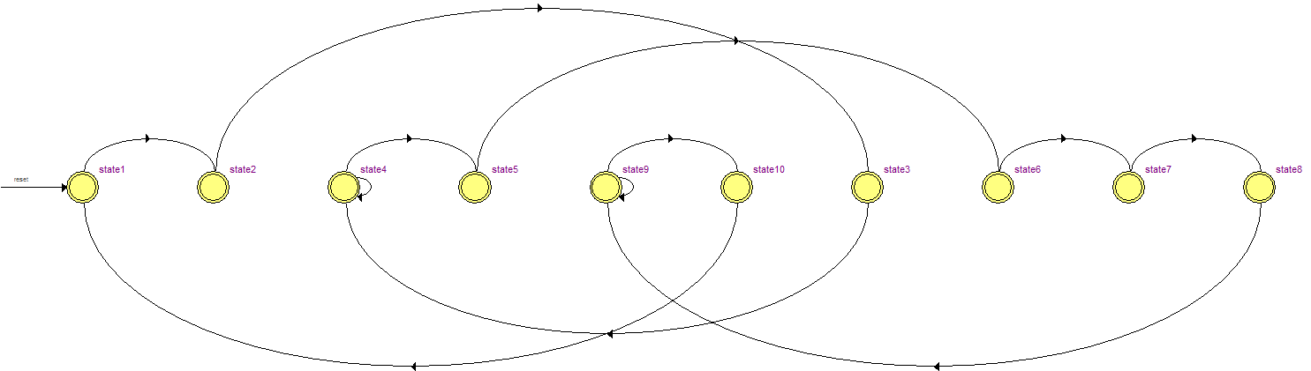
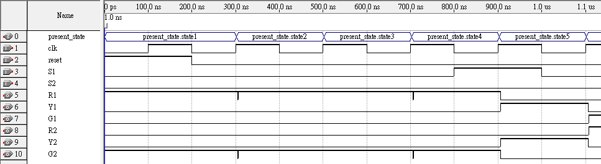
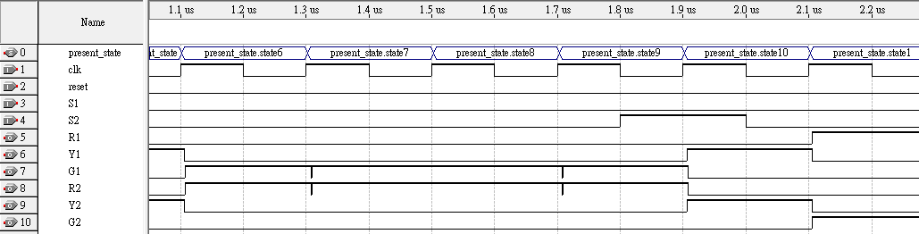
手動輸入S1,S2的值
State Machine Viewer

