Tracking Computations
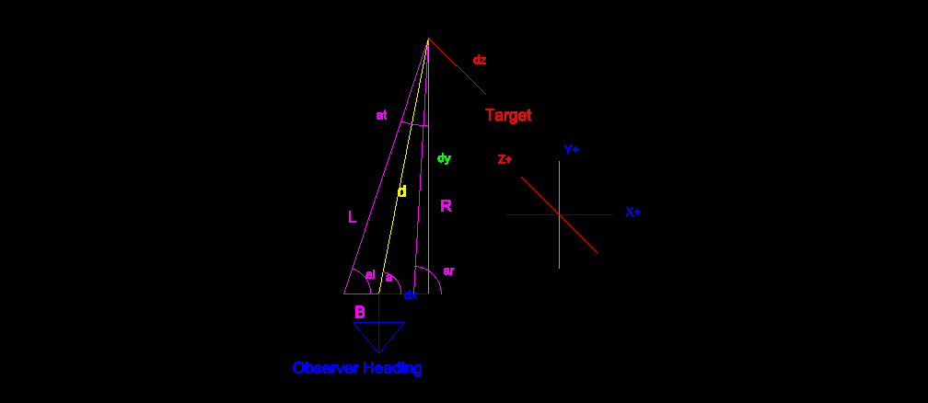
Given inputs:
- AngleR and AngleL, AngleH:
the angles through which the target appears to the Right and Left Pixies,
- constant B:
the separation of the 2 pixies
Compute Outputs:
- dx,dy,dz:
relative offsets of the target with the Observer taken to be the origin.
Y+ is the direction from the observer to the target,
X+ is the direction from the observer to the right,
Z+ is the direction from the observer upwards
Note: the observer drone will be flying in the Y- direction since it will always be ahead of the target.

Angles:

Sin Law:

Cos Law:

Projecting on (x,y,z), first we need angle “a”:

Sin Law:

The height angle “ah” is measured such that:
- ah > 0 when observer is below target, dz > 0
- ah = 0 when observer is at same level as target, dz = 0
- ah < 0 when observer is above target, dz < 0

Likewise:
- dy is always >= 0 since we do not know what to do if the observer is passed over/under
and
- dx <0 if the target is observed to the left of the centerline, when looking towards the target from the observer
- dx = 0 when target and observer are aligned
- dx >0 when target is to the right of the observer when looking towards the target from the observer

Then we can find dy and dx and dz:

Pixie Pixel to Angle Computation & Simulation Computations
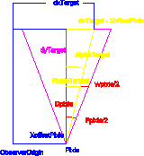

Pixie Pixel to Angle computations:
The Pixie cameras provide target coordinates in pixels (px,py). It is assumed that the origin of the field of view is lower left.
To compute the Pixie angles in terms of the flown the X-axis and Z-axis, we must do some computation.
Pixie Constants:
- Field of view Angles (fx,fy): values 75° in Pixie X-axis, 47° in Pixie Y-Axis
- Pixel Ranges (rx,ry): values are (640,400)
- Pixie fictive PD: calculated based on the Angles and Pixel ranges.

Inputs:
- Pixie pixel coordinates of target: (px,py)
- Note: it is assumed that the Pixie measures (0,0) from the lower left corner of its field of view, thus if the target were “dead ahead” the pixie would return (320,200)
- Target dy (Tdy) : distance from Pixie to the target projected onto flown Y-axis
Outputs:
- angle in flown X-axis (a): either 'al' or 'ar' depending on which Pixie
- angle in flown Z-axis (ah)
Computations:
We note that there are similar triangles, so:

And this can then be used to compute the angles:

and thus we can deduce the required angles from Pixie's ouput!

This maps: Pixie(px,py) → Pixie(a, ah)

Simulation Computations:

In the simulation we know the absolute position of the target and the observer. From that we must compute the data that the Pixies would send to the navigation system.

This means that we must determine the pixel coordinates of the target as seen by each pixie.

The inputs:
Pixie constants:
- x-offset: this is the distance in the x-axis that the Pixie is offset from the Observer origin, i.e. B/2 from previous section

Simulation Values:
- Target (x,y,z)
- Observer (x,y,z)
The outputs:
For each Pixie:
- Target(px,py): i.e. the pixel values for the coordinates of the target.

From the above computations we can simply factor in the offset of the Pixies, which is in the X-axis and we are golden:

Then combining with the previous results:

We have our simulator mapping: T(x,y,z), Obs(x,y,z) → Pixie(px,py) for each Pixie:

(don't forget to round and cast as integers since pixel values are ints!!!)

Flight controls:

