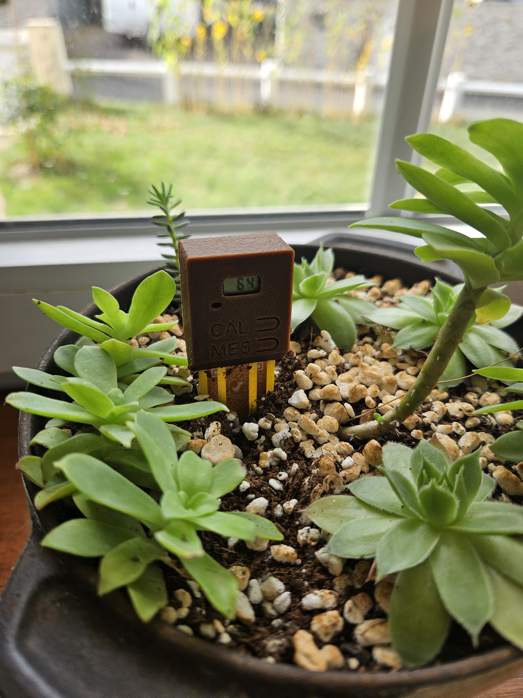
Moisture sensor
User Manual

- Introduction
The purpose of this document is to explain how to use the moisture sensor.

This device is designed to show the humidity level of a flower pot. After user calibration the moisture-sensor will show the humidity level of a flower pot and if the level is under 20% a red led will blink to indicate low humidity level.
Table of content
Introduction 2
System Overview 4
Functional Description 4
Power on 4
How to use 6
Autotune 6
Reflow 6

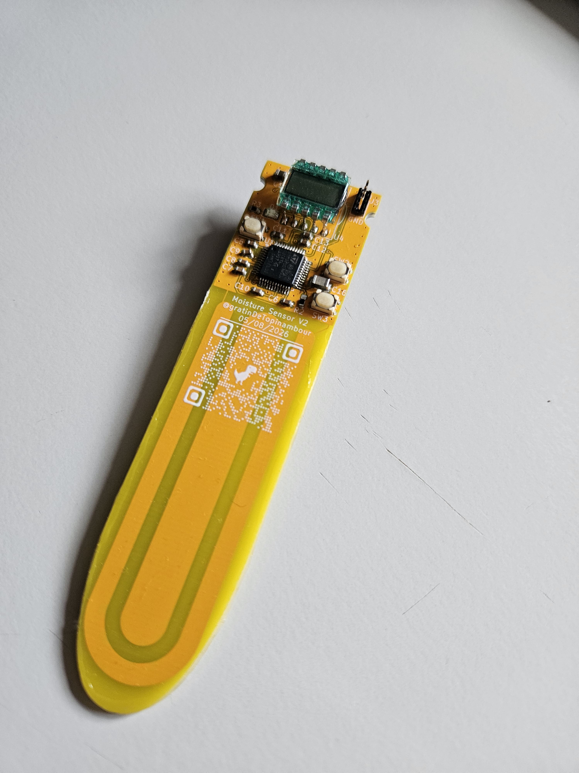

System Overview

Functional Description
The moisture sensor operates with 3 push button and one LCD screen
LCD screen: show the humidity level in %
LCD screen

ST-LINK

Reset

Calibration

Measure

Capacitive probe
ST-LINK: port used for communication, mainly use for debug and programming
Reset: Button used to reset the board, mainly use for debug and programming
Calibration: Button used for calibration
Measure: Button used for measuring humidity level
Capacitive probe: need to be in the dirt

Initialisation:
Place any CR2032 battery cell in the back slot then press the reset button.
Program the board with an st-link and the program available on Git-Hub
Put the 3D print cover available on Git-Hub
The moisture probe is now fully fonctionnal

How to use

Calibration
Prepare two pot. One with dry soil and the other with wet soil.
Place the probe inside the dry soil and press the calibration button.
Once you see the « SEC » message on the screen press the calibration button a second time.
The probe will calibrate in a few seconde
Once you see the « EAU » message on the screen place the probe in the wet soil and press calibration button
The probe will calibrate in a few seconde
once everything is done press the measure button to check if the humidity level is OK

Usage
Once the calibration is done.
Place the probe in the flower pot.
Press Measure button to update the humidity level.
The humidity level will update every 30min or when you press the MES button
If the humidity level goes under 20% the probe will blink

