# Risk appendix

Construction projects inevitably involve a host of cost risks. The objective of risk management is to minimise the costs of these risks. This involves:

1. Risk minimisation
   1. Identifying and mitigating avoidable risks
   2. Reducing estimation error as appropriate
2. Risk measurement
   1. Measuring the remaining risk
3. Ongoing risk monitoring
   1. Accounting for this risk in investment decisions
   2. Managing the remaining risk in a cost efficient manner

There are upwards of fifty sets of guidelines outlining required approaches to risk management across Australian jurisdictions. In general, these documents are very detailed and well written. However, there are substantial blind spots in the guidance provided in each jurisdiction. This has resulted in risk management guidance that varies in quality across the components of risk management.

Figure XX provides a high level summary of the quality of risk guidance across Australian jurisdictions. It identifies that the provided guidance regarding risk minimisation is generally of a far higher standard than that of risk measurement and ongoing risk monitoring. This is aligned with the nature of Australia’s problem with cost overruns: most projects finish on budget, but the huge costs of uncommon events are poorly anticipated and accounted for.

In this appendix we review the current practices of each state for each of these components of risk management, and highlight the opportunities for improvement. Full details of the Australian risk management guidelines analysed in this appendix are provided in appendix XX.

**Figure XX: The quality of risk management guidance varies**Guidance quality by jurisdiction and topic ranked as sufficient, incomplete and poor by green, yellow and red, respectively.  
*Sources: Australian risk management guidelines, Grattan analysis*

|  |  |  |  |  |  |  |  |
| --- | --- | --- | --- | --- | --- | --- | --- |
|  | **Risk minimisation** | | **Risk measurement** | | | **Ongoing risk monitoring** | |
| **C’wlth** |  | | | | | | |
| **NSW** |
| **VIC** |
| **QLD** |
| **WA** |
| **SA** |
| **Activity** | Mitigate avoidable risks | Reduce estimation error | | Measure the remaining risk | Account for risk in investment decisions | | Manage risk throughout construction |
|  |  | | | | | | |

## Risk minimisation

The most critical component of risk management is reducing project risks where possible. This can be achieved by identifying and mitigating avoidable risks and reducing estimation error, as far as it is financially worthwhile to do so.

While there is scope to improve estimation error in many jurisdictions, the general quality of guidance provided on risk minimisation on transport infrastructure projects is high. This is a necessary component of a high quality risk management process, but risk minimisation alone is not sufficient.

This section provides a conceptual overview of Australia’s risk minimisation practices with the objective of identifying both what risk minimisation can achieve, and highlighting the risk management tasks that remain after risks have effectively been minimised.

### Identify and mitigate avoidable risks

Consistent use of risk matrices or like tools to identify and mitigate avoidable risks on construction projects is extremely important. This is because active mitigation of cost risks can reduce the frequency with which large cost overruns occur, as illustrated in figure XX.

**Figure XX: Some avoidable risks can be mitigated**Stylized representation of the probability of cost overruns of each size, per cent

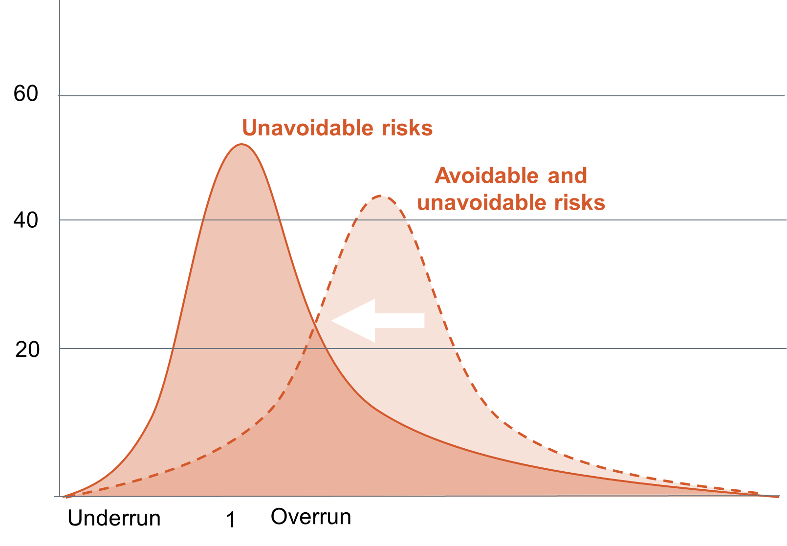  
*Notes: The distribution of unavoidable risks depicted is a stylized representation of the distribution of cost overruns observed in the Investment Monitor; see appendix xx for details. The distribution of avoidable and unavoidable risks has been inferred by assuming that cost overruns would be larger if no effort was made to mitigate avoidable risks. This graph’s illustrative purpose is to graphically present the common wisdom that cost risks can be reduced, but not eliminated, by mitigating avoidable risks.  
Sources: Deloitte Investment Monitor, Grattan analysis.*

At least one set of risk management guidelines in each of Australia’s state and Commonwealth government jurisdictions recommends the use of risk matrices and provides high level advice on how to mitigate common risks[1]. For this reason, the guidance on risk identification and mitigation provided in every jurisdiction appears to be adequate.

### Reduce estimation error

Some states also provide comprehensive guidance on the level of detail required for risk estimation at each stage of a projects’ development.

For example, the South Australian Department of Planning Transport and Infrastructure Estimating Manual sets out:

* the detail with which costs should be estimated, in terms of whether global benchmark, unit rate or first principles approaches should be used to price project inputs;
* the detail with which projects should be broken down into their components, defined relative to the Work Breakdown Schedule; and
* the size of the contingency margin which should be added to estimates at each stage.

It is important that every jurisdiction provides this level of guidance for two reasons. Firstly, the expense of arriving at more detailed cost estimates means that, where there are not clear requirements regarding the appropriate level of detail, incentives to produce insufficiently detailed cost estimates prevail.

Secondly, the different margins of error associated with different cost estimation methodologies mean that cost estimates derived using different estimation methodologies are not directly comparable.

Providing detailed guidance on how project costs should be estimated for each level of project maturity allows governments to increase their confidence that projects will come in on budget, as illustrated in figure XX. Such increased cost certainty should be pursued insofar as the benefits outweigh the costs.

**Figure XX: More projects finish on budget when estimation error is low,** Probability of cost overruns of each size, per cent

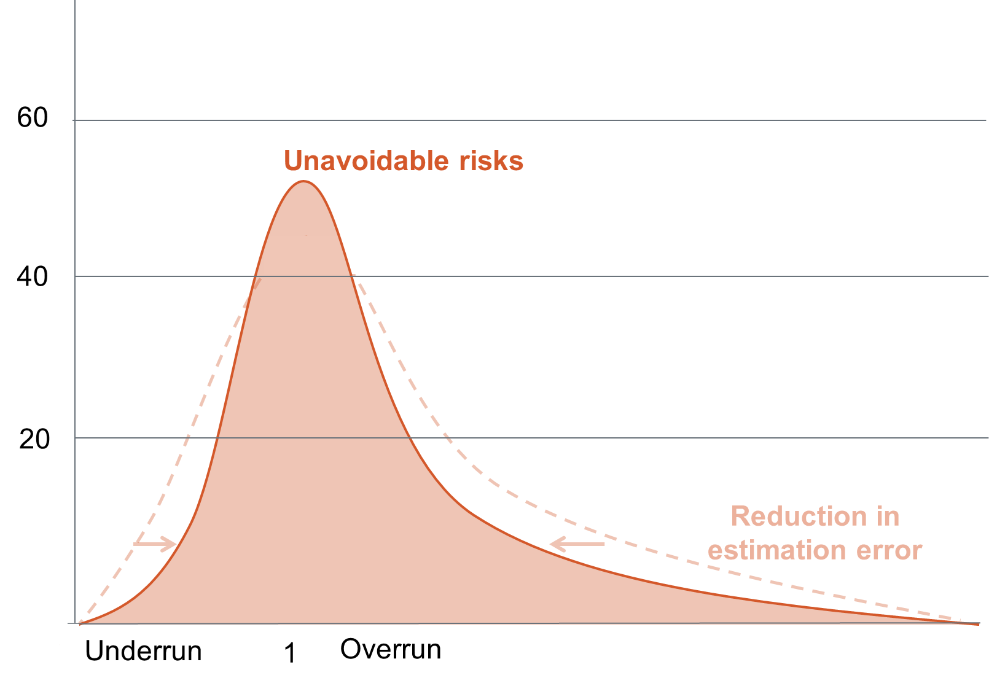

*Notes: The distribution of unavoidable risks depicted is a stylized representation of the distribution of cost overruns observed in the Investment Monitor; see appendix xx for details. The narrowing of the distribution of unavoidable risks associated with a reduction in estimation error has been inferred by assuming that extreme outcomes would be more common if the margin of error on cost estimates was wider. This graph’s illustrative purpose is to graphically present the common wisdom that cost risks can be reduced, but not eliminated, by reducing estimation error.   
Sources: Deloitte Investment Monitor, Grattan analysis.*

## Risk measurement

Australia’s guidance on risk minimisation is generally of a high standard. However, this guidance is not sufficient, as it is inevitable that some cost risks will be impossible, or prohibitively expensive, to eliminate. These remaining risks need to be accurately measured, so that they can be factored into investment decisions and efficiently managed throughout a project’s life.

As discussed in chapter XX, the critical shortcoming of risk management on Australia’s transport infrastructure projects is that the guidance regarding how to measure unavoidable project risks is uniformly poor. This is because the guidance on how to quantify project risks is:

* inconsistent within and across jurisdictions,
* incomplete, as most guidance does not provide advice on how to assess unknown risks or extreme and unlikely events, and
* often contains insufficient information for the recommended risk measurement methodologies to be properly implemented.

This section reviews each of these shortcomings in detail and provides state-specific examples of opportunities for improvement.

### Guidance is inconsistent

Guidelines which apply to the same jurisdiction often recommend different approaches to risk measurement. For instance,

* Probability pricing is required for federal funding, yet only half the risk measurement guidance provided at the federal level discusses probability pricing[2].
* In Victoria, three key guidelines on risk measurement each recommend only part of the toolkit, and a different part in each case:
  + ___’s Technical Guidelines on Economic Evaluation of Business Cases require only sensitivity analysis,
  + the Victorian Insurance Management Authority requires only the calculation of the expected value of project risks, and
  + the Department of Treasury and Finance’s Business Case Template and Gateway Review Process only requires reference class forecasting.

Such inconsistencies within jurisdictions obfuscate proper process and make the conceptual dependencies between tools unclear.

Risk measurement guidance should also be consistent across jurisdictions. This is because each state must comply with both its own guidelines and the Commonwealth’s whenever it seeks project funding from the Commonwealth to supplement its own funding of a project. Where state and commonwealth guidance differs, multiple versions of the same analysis are required.

For example, Victoria’s business case on the Western Distributor has two sets of benefit cost ratios in order to conform to different guidance of the two levels of government.[3] Neither of these benefit cost ratios is more correct than the other. Rather, they are two imperfect estimates of the same concept. As both estimates would have come at a significant financial cost, Australia’s project appraisal processes could be made more cost efficient by aligning the analysis required across each jurisdiction.

As it stands, risk measurement guidance is very inconsistent between each state and the Commonwealth. Table XX shows that the expected value approach to estimating risks’ costs is the only approach that is recommended consistently across all jurisdictions.

|  |  |  |  |  |
| --- | --- | --- | --- | --- |
|  | **Expected value** | **Sensitivity analysis** | **Probability pricing** | **Reference class forecasting** |
| C’wlth |  |  |  |  |
|  |  |  |  |  |
| NSW |  |  |  |  |
| VIC |  |  |  |  |
| QLD |  |  |  |  |
| WA |  |  |  |  |
| SA |  |  |  |  |

**Figure XX: No state provides high quality risk measurement guidance,**Green = recommended  
Yellow = recommended, but with insufficient information to be properly implemented  
Red = not recommended

*Sources: Australian risk management guidelines, Grattan analysis*

The inconsistencies observed across Australian risk measurement guidelines could be resolved by removing old guidance when new processes are implemented, consolidating existing guidelines and writing new guidance so that replaces, rather than augments, older guidance.   
  
For example, many of the inconsistencies within guidance that applies to all states were addressed through the 2016 release of the Australian Transport Assessment and Planning (ATAP) Guidelines[4]. These guidelines replaced Austroads’ Guide to Project Evaluation and the National Guidelines for Transport System Management in Australia, and were written to be aligned with the guidance provided Infrastructure Australia’s guidelines, The COAG-agreed National Guidance on Public Private Partnership Projects and the National Charter of Integrated Land Use and Transport Planning. A similar exercise should be undertaken within each of the states.

Where different institutions within jurisdictions require different amounts of risk analysis, guidance should be comprehensively reviewed so that the hierarchy relating guidance documents is clear and, where possible, analytical requirements are aligned. Page 11 of Transport NSW’s Principles and Guidelines for Economic Appraisal of Transport Initiatives provides a useful example of how this can be done.

### Guidance is incomplete

Even if project proponents were to follow the guidance on risk measurement to the book, cost overruns would be underestimated. This is because the recommended approaches to risk measurement are incomplete.

There’s no single “right” way to measure risk, but for an approach to risk measurement to be considered complete, it must be both reliable and comprehensive. Assessments of project risks can be considered:

* **reliable** if expert opinion is used to tailor risk estimates to projects’ specific characteristics, and objective information is used to counter the challenges of optimism bias and strategic misrepresentation; and
* **comprehensive** if known, unknown, moderate and extreme risks are all accounted for.

As no single risk management tool achieves all these objectives, a combination of tools is required. Table XX summarises how each risk measurement tool can, if used properly, contribute to a complete approach to risk measurement.

|  |  |  |  |  |  |  |  |  |  |  |  |  |
| --- | --- | --- | --- | --- | --- | --- | --- | --- | --- | --- | --- | --- |
| **Table 1: Complete approaches to risk measurement satisfy all the conditions for reliability and comprehensiveness by using a combination of tools** Attributes of each risk management tool, where **✓**  indicates that a tool can be used satisfy the criteria, **✓** indicates that a tool can be used to get part way towards the criteria and **🗶**  indicates that a tool cannot be used to achieve the criteria. | | | | | | | | | | | | |
|  | | | | **Reliable** | |  | | **Comprehensive** | | | |  |
|  | |  | **Tailored** | | **Objective** | | **Moderate** | | **Extreme** | **Known** | **Unknown** | |
| **Expert judgement** | Expected value | | **✓** | | **🗶** | | **✓** | | **✓** | **✓** | **🗶** | |
| Probability pricing Moderate (eg: P50) | | **✓** | | **🗶** | | **✓** | | **🗶** | **✓** | **🗶** | |
| High (eg: P90) | | **✓** | | **🗶** | | **🗶** | | **✓** | **✓** | **🗶** | |
| Sensitivity analysis | | **✓** | | **✓** | | **🗶** | | **🗶** | **✓** | **🗶** | |
| **Monte Carlo simulation** | Expected value | | **✓** | | **✓** | | **✓** | | **✓** | **✓** | **✓** | |
| Probability pricing Moderate (eg: P50) | | **✓** | | **✓** | | **✓** | | **🗶** | **✓** | **✓** | |
| High (eg: P90) | | **✓** | | **✓** | | **🗶** | | **✓** | **✓** | **✓** | |
| Value at Risk | | **✓** | | **✓** | | **🗶** | | **✓** | **✓** | **✓** | |
| **Reference class forecasting** | Probability pricing Moderate (eg: P50) | | **🗶** | | **✓** | | **✓** | | **🗶** | **✓** | **✓** | |
| High (eg: P90) | | **🗶** | | **✓** | | **🗶** | | **✓** | **✓** | **✓** | |
| Value at Risk | | **🗶** | | **✓** | | **🗶** | | **✓** | **✓** | **✓** | |
| **Characteristics of complete risk measurement** | | | **✓** | | **✓** | | **✓** | | **✓** | **✓** | **✓** | |

*Sources: Australian risk management guidelines, Grattan analysis*

### Insufficient information is provided

Perhaps the most troubling shortcoming of Australia’s current risk measurement guidelines is that they commonly do not provide sufficient information to realise the advantages of the methodologies that they recommend.

For example, **sensitivity analysis** is a valuable tool for understanding the external drivers of cost uncertainty. However, only 43 per cent of guidelines which recommend sensitivity analysis specify variables should be subjected to sensitivity analysis and the range of values these variables regularly take. In the absence of this information, there is opportunity for project proponents to retrofit their choices of variables and ranges of variation in order to achieve an acceptable level of cost uncertainty. Because of this, more guidelines should suggest ranges for sensitivity analysis, or recommend that the Austroad sensitivity ranges are used[5].

Even more egregious is that some guidelines recommend that **reference class forecasting** be employed, but do not provide data or key statistics on any reference classes. Reference class forecasting is the practice of incorporating the rate of cost overruns observed historically on like projects into a project’s cost estimate. Consequently, reference class forecasting cannot be implemented to any degree without high quality data on historical cost outcomes.

Yet this is what some of Australia’s risk management guidelines demand of project proponents. For example,

the cost benefit analysis guidelines of Queensland Treasury’s Project Assessment Framework recommend that cost estimates are adjusted for optimism bias using empirical evidence that is relevant to the project’s type (2006, p.25). However, they do not provide any such evidence and, to the best of our knowledge, such empirical evidence is not readily available.

Similarly, the Commonwealth’s Best Practice Cost Estimation Standard for Publicly Funded Road and Rail Construction identify that reference class forecasting should be used to counteract optimism bias, and refer to

the United Kingdom’s reference class forecasting uplift rates (appendix 11). However, these uplift rates are not appropriate for use on Australian cost estimates, because they are designed to offset the average magnitude of cost overruns observed on British projects, relative to British cost estimation practices.

A similar circumstance befalls **probability pricing**. Probability pricing is the practice of identifying the cost under which a project is expected to be completed with a given probability. Accordingly, probability pricing requires knowledge of the distribution of a project’s cost risks. Probability pricing can be conducted either:

* “probabilistically”, which involves estimating the distribution of risks on a specific project from estimates of its component parts[6], or
* “deterministically” which involves applying standard uplift rates that are – like reference class forecasting – derived from historical analysis of completed projects[7].

More than 80% of guidelines on probability pricing recommend that the probabilistic approach to probability pricing is employed, as the validity of the deterministic approach under active debated[8]. However, there appears little grounds to claim that the probabilistic approach, as currently practiced, is any more scientific.

This is because only two guidelines[9] provide any guidance to project proponents on the expected distribution of project risks, and both of these guidelines overlook the most critical characteristic of the distribution of cost risk on transport infrastructure projects: that cost overruns are more likely and larger on average than cost underruns.

The observed distributions of construction project risks are actively being researched in academic circles[10]. This research is important, as the specific probability prices estimated through Monte Carlo simulation are only as reliable as the assumptions on which they are based. In order to obtain reliable probability prices using a probabilistic methodology, the distributions of key, or overarching, project risks need to be reliably estimated and clearly communicated in probability pricing guidelines.

## Risk management

While Australian jurisdictions appear to have good guidance on risk mitigation and ample, though flawed, guidance on risk measurement, there is a dearth of guidance on how remaining risks should be managed. This is problematic because the consequences of cost overruns can be moderated through good cost risk management.

The following sections contrast the existing guidance and best practice on how to include risk when making investment decisions and how to manage contingencies.

### Account for the remaining risk in investment decisions

Cost overruns are most problematic when they result in projects with benefits less than the costs being built at the expense of projects which promise higher returns.

It is true that project costs, and hence projects’ returns on their investments, will always be uncertain. However, when project risks are not priced into benefit cost ratios, returns on investments will routinely be lower than expected. This increases the probability that cost overruns will distort project selection.

The impact of cost overruns on project selection can be minimised by including the expected value of project risks in the cost estimates used for cost benefit analysis (ref: BITRE, 2005). While benefit cost ratios will still be more uncertain for risky projects than routine projects after this adjustment is made, the benefit cost ratios of risky projects will no longer be systematically biased in a way that makes projects appear more lucrative than they really are. For this reason, it is critical that the costs used in cost benefit analyses include the *expected value* of project risks.

Only the Commonwealth and NSW’s risk management guidelines clearly recommend that the expected value of projects risks should be incorporated into the costs estimates used for benefit cost analysis[11].

It is not reasonable to assume that incorporation of the expected value of risks into cost estimates is implicitly expected by guidelines which do not comment on the type of costs that should be employed in cost benefit analysis. This is because previous Australian research regarding the treatment of risk in cost benefit analysis has found that there is substantial confusion on this matter (BITRE, 2005).

The various guidance documents provided on cost benefit analysis for transport infrastructure projects in Australia should be amended to clearly recommend that the expected value of project risks be included in the costs employed in cost benefit analysis.

### Manage project risks in a cost efficient manner

Cost overruns are also problematic when they inflict unanticipated shocks on government budgets. In order to protect against this, it is routinely advised that project budgets are accompanied by contingency funds.

However, this important component of risk management appears to be largely governed by rules of thumb. This conclusion is supported by the observations that the recommended size of contingencies varies widely across guidelines (Figure xx), and the data underpinning guidelines’ recommended contingency ranges is not routinely cited.

**Figure XX: The recommended size of contingency funds varies substantially across guidelines**Recommended contingency sizes at early and late stages of project development as a proportion of project costs, per cent

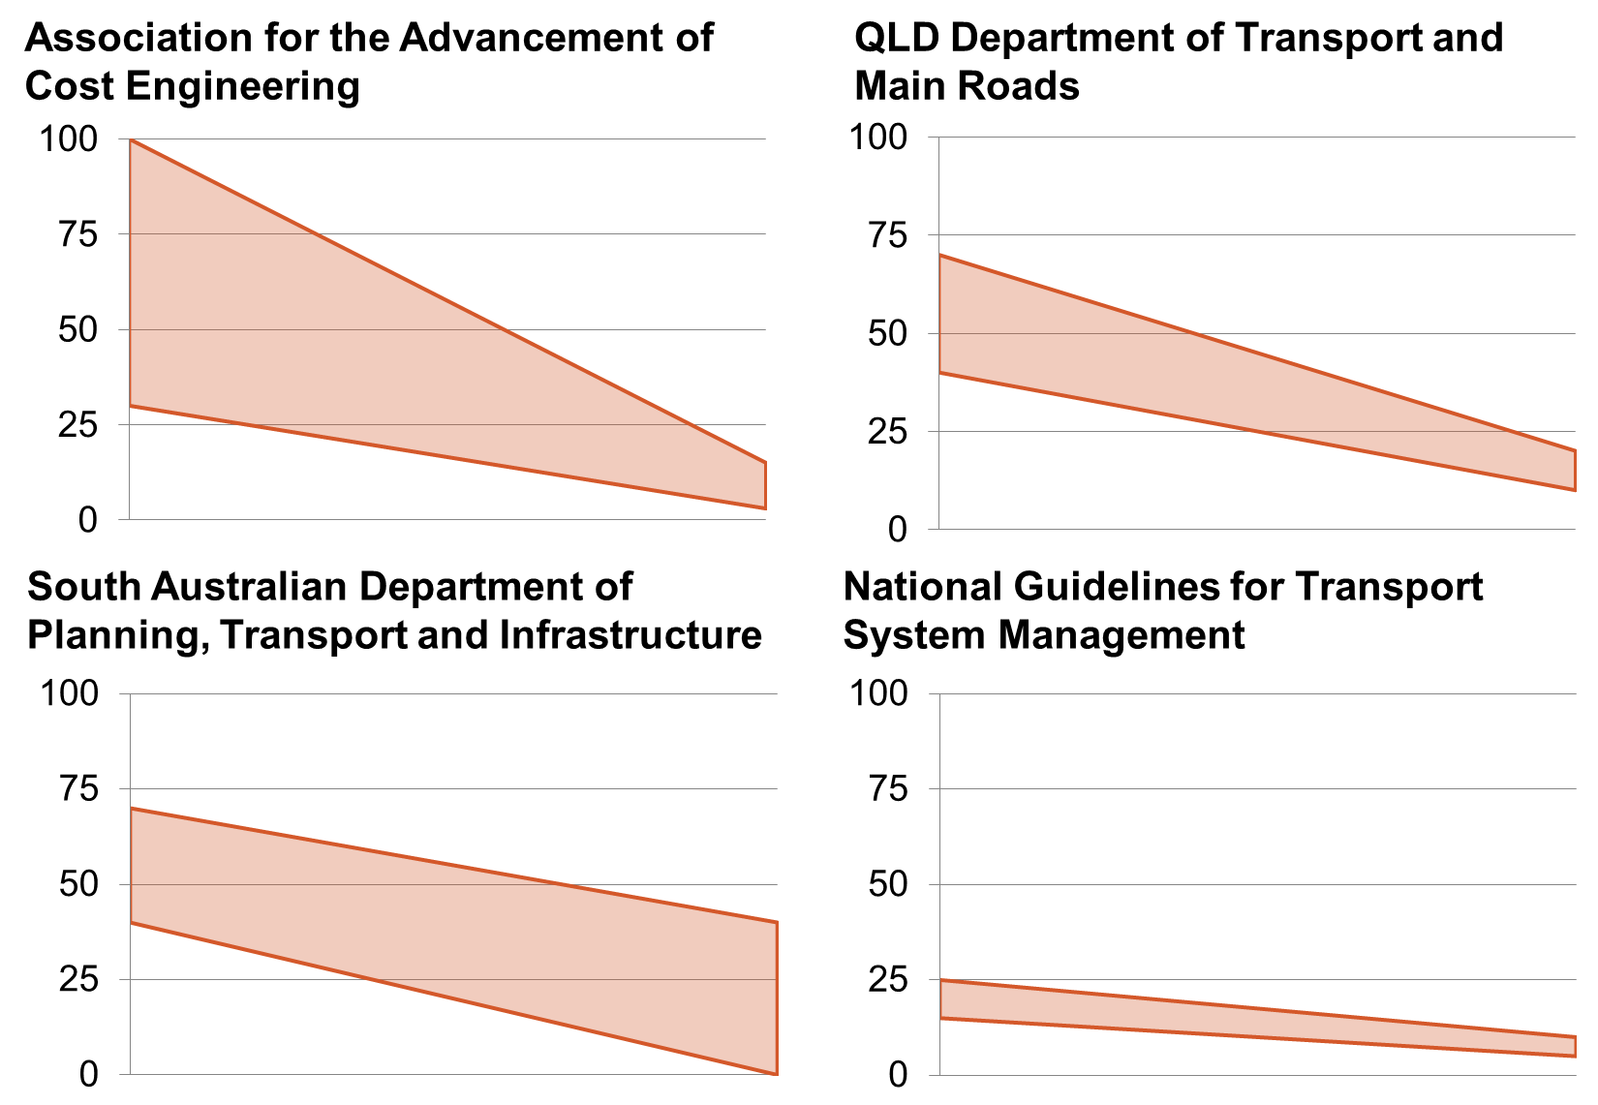  
*Notes: The contingency ranges cited in the National Guidelines for Transport System Management refer specifically to road projects specifically, and are anticipated to be too conservative for projects which are one-off in nature.   
Sources:*

Even more problematic is the frequent absence of strict requirements for contingency funds to be held at the portfolio level. New South Wales is the only jurisdiction which provides clear, strategic advice on how contingency funds should be managed[12], and Queensland appears to be the only state where there is a strict requirement for contingency funds to be managed at the portfolio level[13].

It should be noted that in the absence of such protocol, there are clear incentives for contingencies to be managed at the project level. This is because changes to project budgets that involve state treasuries increasing projects’ budget allocations are open to more public scrutiny. Consequently, project management teams are subject to lower reputational risk when contingency funds are included within initial budget allocations and managed at the project level.

Chapter XX identified that contingency funds can be XX times more cost effective when managed at the portfolio level. For this reason, it would be desirable for all states to adopt a stringent practice of managing contingency funds at the portfolio.

# Methodological appendix

The conclusions drawn in this report are founded on thorough statistical analysis of transport projects completed in Australia since 2001. This appendix provides the supporting details of the report’s data sources and analysis.

## Data

The analysis contained in the cost overruns report is based on two unique datasets: a time series dataset built from the archives of the Deloitte Access Investment Monitor which tracks the evolution of project costs over time for all Australian transport infrastructure projects constructed since 2000, and a smaller but far more detailed dataset which investigates the circumstances surrounding the cost overruns on 51 of these projects.

### Inflation adjustment

Both of these datasets are based on publically available information such as government budgets, announcements by private companies and media sources. As these data sources report project budgets in terms of nominal outturn dollars, so do both the Investment Monitor and smaller Grattan datasets. We assume that the distribution of project costs across time is the same for all projects and inflate nominal outturn costs to 2016 dollars from the central year of each project’s construction period. While only approximate, this approach is sufficient for controlling for the effect of inflation at the aggregate level under the assumption that the distribution of project costs over the construction period does not vary with time.

### Cost definitions

We define cost overruns as the percentage change in project costs over a given period, as a proportion of a project’s initial cost. Project costs are defined as the total cost of designing and constructing a given asset to the public sector, and so include public sector project management costs outside of the project contract and exclude any costs incurred beyond the contract price by the contractor.

We consider overruns on these costs in relation to three project stages: from announcement with a cost estimate but prior to a budget commitment, between a formal budget commitment by an Australian government and the start of construction, and during construction. .

These project stages correspond to the descriptions of projects’ maturity associated with each cost estimate in the Investment Monitor dataset.

### Comparison of the two datasets

The key differences between the Investment Monitor and smaller Grattan dataset are the size and quality of the datasets. In order to monitor all transport projects from conception to completion, Deloitte Access Economics has employed a routine data collection methodology which involves scanning government budgets and media sources for mentions of the projects of interest. This approach is efficient, but is arguably prone to errors as the details and history of each project cannot be examined in detail every time a data point is added.

Seeking to ascertain the quality of the Investment Monitor’s cost estimates, we compared the cost estimates recorded in this dataset against the small sample of carefully investigated transport infrastructure projects that make up the Grattan dataset.

Figure XX compares the Investment Monitor and Grattan datasets’ estimates of the total value of the projects included in the Grattan dataset. Although the Grattan dataset only covers a limited number of projects, the high level of similarity between the value of the Investment Monitor and Grattan datasets’ portfolios at each project stage provides assurance that the Investment monitor dataset is unbiased. The comparability of the Grattan and Deloitte datasets also holds at the individual project level, as there is no statistically significant difference between the average cost change on individual projects observed across the Grattan and Investment Monitor datasets[14].

Figure XX: Cost estimates contained within the Investment Monitor data appear reliable overall

Total value of the portfolio of projects contained within the Grattan dataset by project stage, $billion

Source: Deloitte-Access Investment Monitor; Grattan dataset; Grattan analysis.

Despite this similarity, we expect the average magnitude of cost overruns observed in the Investment Monitor will be substantially lower than observed in the Grattan dataset. This is because the Investment Monitor considers all projects valued over $20 million, the Grattan dataset only considers projects valued above $100 million and project size has been found in the literature to be a consistent predictor of the size of cost overruns (Flyvbjerg et al., 2004, Koushki et al., 2005, Anastasopoulos et al., 2012).

In line with this expectation, we observe far higher cost overruns across the Grattan dataset than the Investment Monitor dataset.

Figure : Cost overrun by project stage in Investment Monitor and Grattan datasets



Notes: Cost overruns are defined as the percentage change over the period of interest as a proportion of the project’s initial cost estimate.  
Source: Deloitte-Access Investment Monitor; Grattan dataset; Grattan analysis.

### Outliers

The Investment Monitor dataset contains a number of extreme observations. The quality of these observations is difficult to ascertain because not all of the sources underpinning the Investment Monitor dataset are still accessible, and the search cost associated with finding the sources for these data points is high. For this reason, we take a conservative approach and exclude the XX projects with overruns that are greater than the largest overrun observed in the Grattan dataset, and the XX projects with underruns that are less than XX per cent of the smallest underrun observed in the Grattan dataset.

### Missing data

A second notable characteristic of the Deloitte Investment Monitor is that projects enter the monitor at different levels of maturity, ranging from “possible” to “under construction”. This results in some projects missing cost estimates for the early project stages. Where this is the case, we assume that no cost overrun occurred prior to the project’s first appearance in our dataset.

|  |  |
| --- | --- |
| **Project stage** | **Percentage of completed projects with a cost estimate** |
| Prior to a budget commitment | 19 per cent |
| Prior to construction | 57 per cent |
| During construction | 100 per cent |

As discussed in section XX, a manual check of the history of 19 such projects with missing data indicated that this is assumption is quite conservative – 37 per cent of these projects did experience public overruns during the unobserved period – a proportion only marginally lower than the 46.5 per cent of projects with early cost estimates recorded that experienced early cost overruns.

**FigureXX: Cost overruns are likely to be higher than reported**Average cost overrun rates as a proportion of initial costs, by project stage

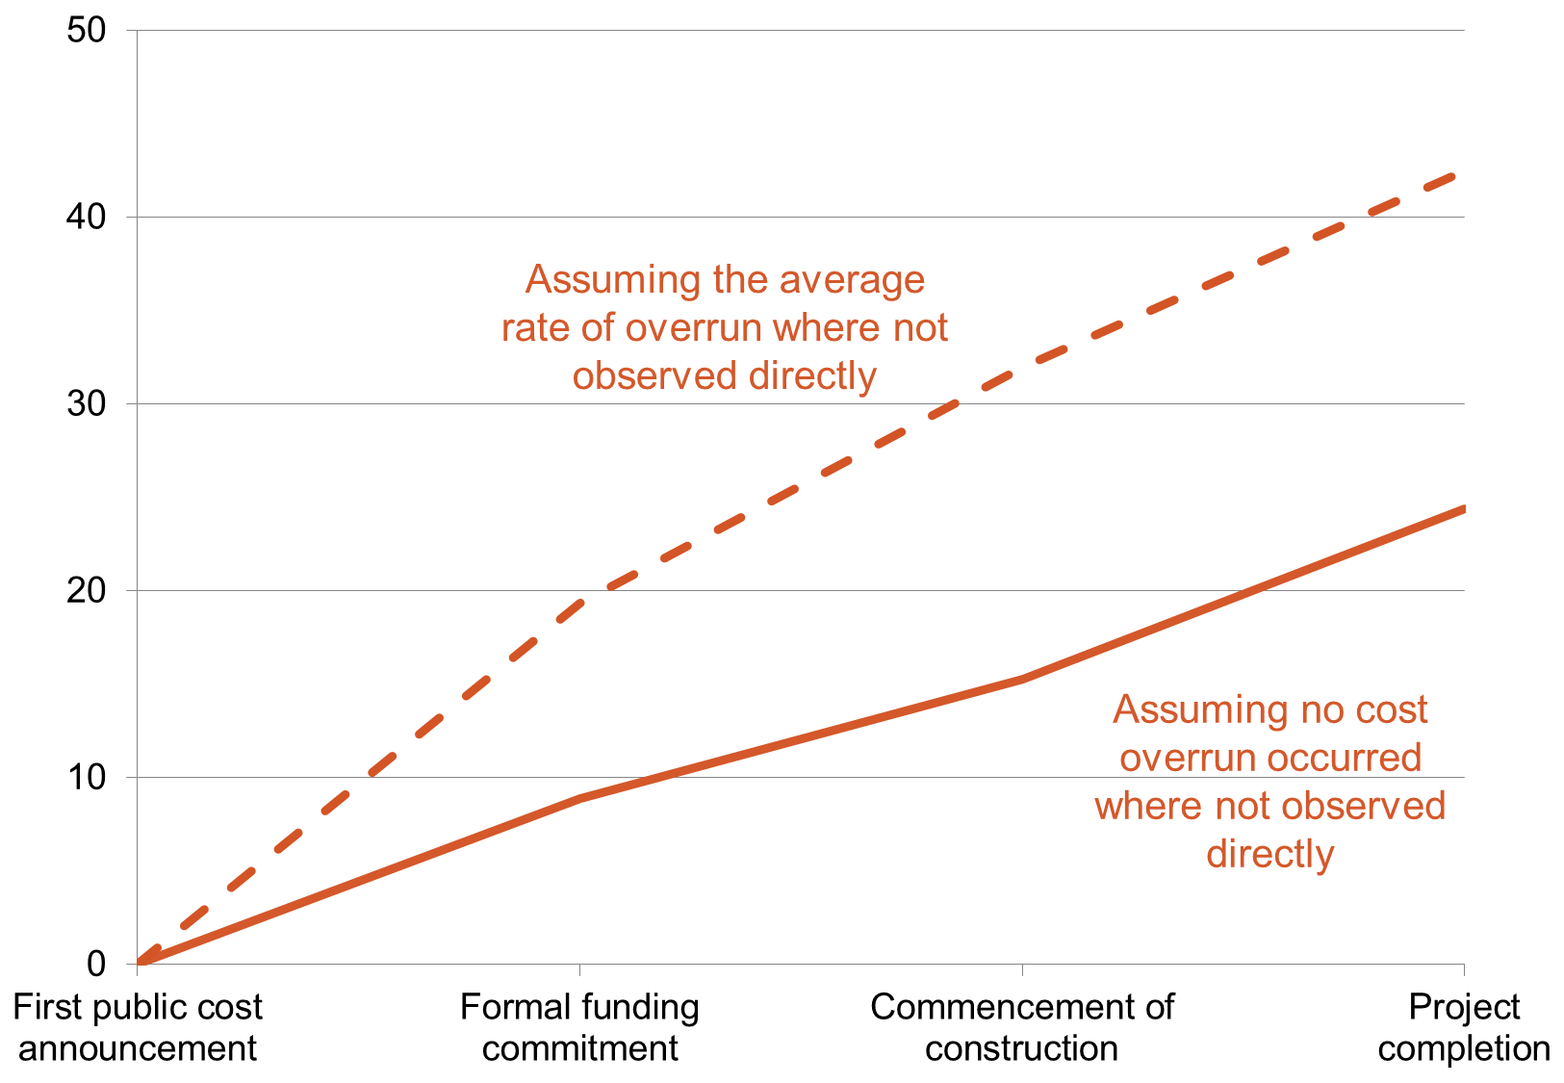

Notes: Australian transport projects completed between 2001 and 2015  
Source: Deloitte Investment Monitor, Grattan analysis.

This indicates that the missing data in the Investment Monitor dataset is associated with unobserved cost changes in some cases, as well as the absence of early cost estimates in others. Consequently, cost overruns may indeed be closer to the upper bound than the lower bound presented in figure XX. As this report’s analysis assumes that no cost overrun occurred where not observed directly, we note that its conclusions are conservative.

## Analysis

The key questions that we use these datasets to answer are how big cost overruns are in Australia, at what period in the project lifecycle cost overruns occur and what factors are associated with larger overruns and project cancellation.

### Magnitude of cost overruns

We measure the average magnitude of cost overruns using a weighted arithmetic mean size of cost overruns, where the weights are defined as $w_{i}=\frac{C1_{i}}{{\sum_{i∈N}{C1}}_{i}}$ and C1 denotes the initial project cost. This weighting scheme places greater weight on projects that make up a greater share of the overall infrastructure budget.

The key advantage of this approach is that it allows our cost overrun indices to be interpreted as the percentage increase in expected infrastructure expenditure incurred across the portfolio between two project stages, as $CO_{12} =\frac{1}{N}\sum_{i∈N}{\frac{C2-C1}{C1}}×\frac{C1_{i}}{\sum_{i∈N}{C1}}=\frac{\sum_{i∈N}{\left(C2_{i}-C1_{i}\right)}}{\sum_{i∈N}{C1_{i}}}$.

However, it should be noted that the estimates obtained through a weighted arithmetic mean of this kind and the unweighted arithmetic mean commonly used elsewhere in the literature is trivial – only XX per cent.

Weighted arithmetic means:

|  |  |
| --- | --- |
| $$CO_{12} =\frac{1}{N}\sum_{i∈N}{\frac{C2_{i}-C1_{i}}{C1_{i}}}w_{i}$$ $$CO_{23} =\frac{1}{N}\sum_{i∈N}{\frac{C3_{i}-C2_{i}}{C1_{i}}}w_{i}$$ | $$CO_{34} =\frac{1}{N}\sum_{i∈N}{\frac{C4_{i}-C3_{i}}{C1_{i}}}w_{i}$$ $$CO_{14} =\frac{1}{N}\sum_{i∈N}{\frac{C4_{i}-C1_{i}}{C1_{i}}}w_{i}$$ $=CO12+CO23+CO34$ |

Where:

$C1_{i}$: First cost when project $i$ is classified as “possible or under consideration” $C2_{i}$ 
: First cost when project $i$ is classified as “committed” $C3_{i}$ 
: First cost when project $i$ is classified as “under construction” $C4_{i}$ 
: First cost when project $i$ is classified as “completed” $$w_{i}=\frac{C1_{i}}{{\sum_{i∈N}{C1}}_{i}}$$

### Dependence between cost overruns over time

We partner this aggregate summary of cost overruns with analysis of the linear dependence between cost overruns over time. To do so, we estimate the Pearson coefficient between the indices CO12 and CO23, and CO23 and CO34, and ascertain the significance of these correlations at the XX per cent level of confidence through comparison to Chi-Squared critical values.

This allows us to draw conclusions regarding whether individual projects are more or less likely to experience an overruns in a given period if it experienced an overrun in the previous period. We complete this analysis separately for each cohort, as defined by the project’s maturity when the first cost estimate is announced.

Pearson coefficients:

$$ρ_{t, t+1} =\frac{\sum_{i∈N}{\left[\left(CO_{t}-\frac{1}{N}\sum_{i∈N}{CO_{t}}\right)\left(CO_{t+1}-\frac{1}{N}\sum_{i∈N}{CO_{t+1}}\right)\right]}}{\sqrt{\sum_{i∈N}{{\left(CO_{t}-\frac{1}{N}\sum_{i∈N}{CO_{t}}\right)}^{2}} }\sqrt{\sum_{i∈N}{{\left(CO_{t+1}-\frac{1}{N}\sum_{i∈N}{CO_{t+1}}\right)}^{2}} }}$$

Where $CO_{t}$ 
 and $CO_{t+1}$ refer to cost overruns incurred over the consecutive project stages $t$ 
 = “possible or under consideration” – “committed”, “committed” – “under construction”, “under construction – completed”.

### Causes of cost overruns

We also investigate the relationship between cost overruns at each project stage and independent variables that describe the characteristics of each project and its appraisal process using regression analysis. This analysis is completed in two stages. First, we use a logit model to examine the correlation between our independent variables and the probability that a project experiences a cost overrun of any size. Following this, we model the magnitude of cost overruns where a cost overrun occurred using a log-normal model.

Logit model of the probability of cost overruns occurring:

$$\operatorname{logit}\left(l({CO}_{t}>0)\right)=β_{0}+β_{1}X_{1}+…+β_{K}X_{K}+ε$$

Log-normal model of the magnitude of cost overruns, if they occur

$$\log\left(\frac{Cost_{t+1}-Cost_{t}}{Cost_{1}}|Cost_{t+1}>Cost_{t}\right)=β_{0}+β_{1}X_{1}+…+β_{K}X_{K}+ε$$

Where:

$\{X_{1}, …, X_{K}\}$: independent variables $ε$ 
: zero-meaned random error term $t$ 
 = “possible or under consideration” – “committed”, “committed” – “under construction”, “under construction – completed”.

[Regression results]

Cost overruns are also expected to be partially attributable to scope changes. We assessed the contribution of this cause by thoroughly investigating publically available evidence of scope changes on the 51 projects contained within the Grattan dataset. We defined scope changes as substantive changes to an asset’s functionality. This definition excludes quality improvements because project benefits cannot be assumed to increase alongside costs to the same extent as with functional improvements.

The average proportion of cost overruns attributable to scope changes was estimated by the average cost of scope changes as a percentage of cost overruns on projects which experienced scope changes, multiplied by the percentage of projects which experienced scope changes. The cost of scope changes was drawn from publically available estimates of the value of scope changes where possible.

Where this information was not available, other information was employed to approximate the value of scope changes. Where scope changes were expressed as a proportion of the total asset – such as road being made “20 per cent longer”, the value of scope changes were estimated by the corresponding proportion of the project costs prior to the scope change. Where the timing of scope changes was made explicit, the value of cost overruns was estimated by the value of all cost overruns incurred during the project stage when the scope change was reported to have occurred. We found that publically available information was consistently of sufficient quality to benchmark the contribution of scope changes to cost overruns in one of the aforementioned ways.

### Survival analysis

In addition to examining the size, timing and causes of cost overruns, we investigated the frequency with which projects were cancelled and the relationship between cost overruns and project cancellation.

Project cancellation rates for each stage were calculated as the percentage of the projects which entered a project stage which also exited that project stage.

We also estimated the appropriate overall rate of cancellation, by calculating the proportion of the 39 business cases for transport infrastructure published by Infrastructure Australia by the 12th of Feburary 2016 which would have benefit cost ratios less than 1 if project costs increased by the average amount observed across the Deloitte Investment Monitor projects.

The overall cancellation rate of XX per cent observed across the Deloitte Investment Monitor projects was approximately equal to our estimate of 24 per cent for the appropriate overall rate of cancellation. From this comparison, we conclude that there are not enough projects being cancelled. This is because a greater proportion of projects should have been cancelled than were cancelled if the average benefit cost ratio observed across the Infrastructure Australia business cases is overestimated by as little as 2 per cent of the average benefit cost ratio of 2.95, and there are numerous reasons to suspect that this is the case.

For instance, the benefit cost ratios of cancelled projects are likely to be worse than the 39 projects that had undergone an advanced level of planning and voluntarily submitted their business cases for publishing. It is also reasonable to suspect that benefit cost ratios are overestimated by more than 2 per cent on average, as numerous studies have found that estimates of project benefits are routinely optimistic[15]. Finally, the business case for completing projects with benefit cost ratios that are only very marginally above one is contentious, given the existence of competing budget objectives and the marginal excess burden of raising taxes to fund infrastructure projects[16].

We also investigate the relationship between cost overruns and project survival through a logit model of the probability of a project being cancelled at each stage, given the magnitude of cost overruns as incurred up to that point.

$\operatorname{logit}\left({Survival}_{t}\right)=β_{0}+β_{1}CO_{1t}+ε$

Where:

${Survival}_{t}$ = 0 if a project is cancelled in period t, 1 otherwise $$CO_{1t} =\frac{C_{t}-C1}{C1}$$

We find that the value of cost overruns incurred to date, expressed as a percentage of projects’ initial value, does not have a statistically significant effect on the probability of a project being cancelled at any stage in a project’s development.

[Table of results]

### Distributional analysis

Box XX in chapter XX features a stylized representation of the distribution of cost overruns. This stylized distribution, presented as figure XX below, is also employed in figures XX, XX and XX of appendix 1.

The stylized representations of distribution of cost overruns feature a much smaller kurtosis that the observed distribution of cost overruns. This modification was made so that the diagrams were easier to label clearly and a key characteristic of the distribution - the heaviness of its right tail – was more visible.

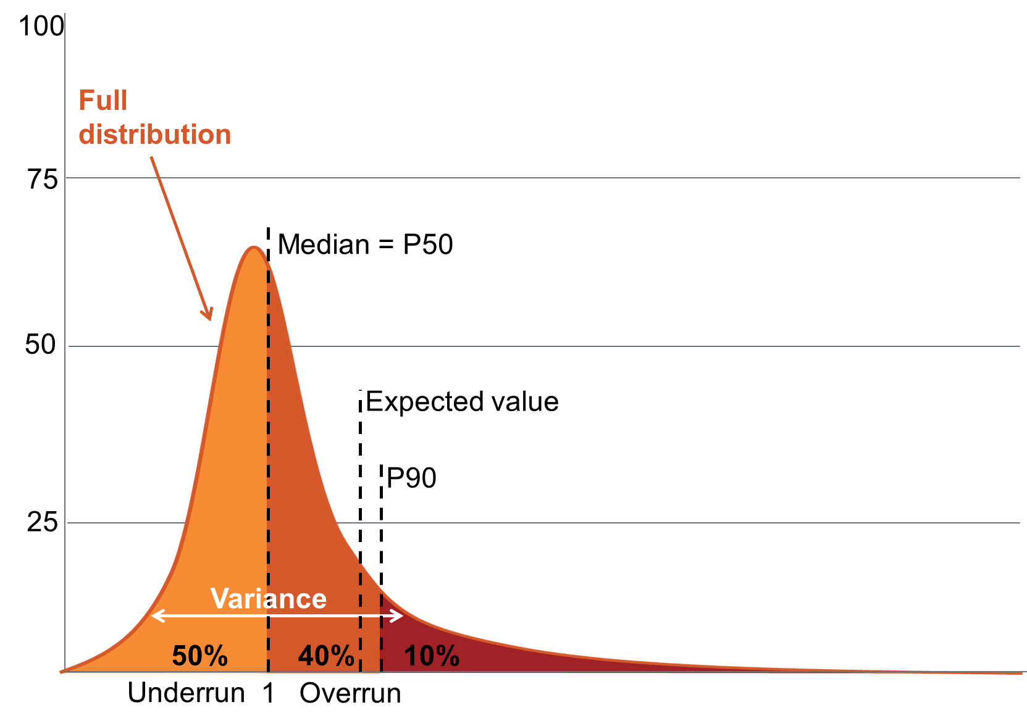

Figure XX confirms that stylized distribution employed is a fair representation of the underlying data. As emphasised in Box XX, the expected value of cost overruns falls far closer to the distribution’s 90th percentile than its median.

Though less immediately visible, the heaviness right tail of the observed distribution is also notably: XX percent of projects experienced cost overruns greater than the smallest cost underrun. In these ways, the stylized distribution of cost overruns provides a fair representation of the underlying data.

[Insert an updated and annotated version of the observed distribution]

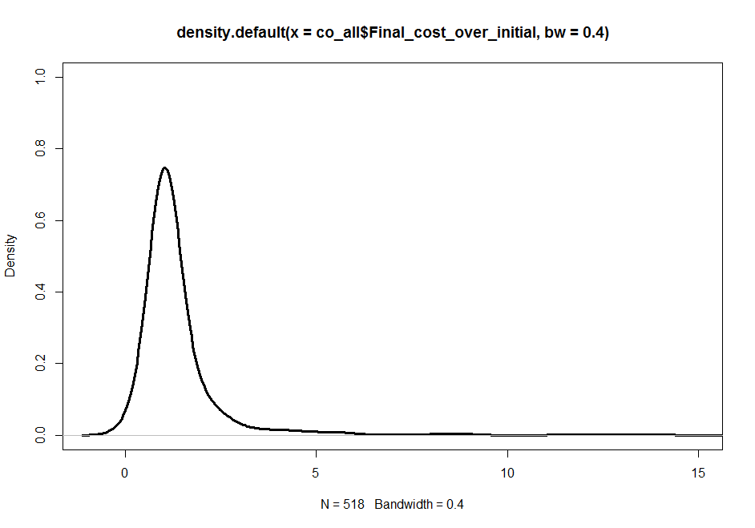

### Contingency analysis

Figure 1 in chapter 5.2.2 presents the financial advantages of managing cost risk at the portfolio level relative to the project level.

The value of contingencies required to provide assurance that 90 per cent of projects will finish within budget has been estimated as the 90th quantile of the observed distribution of cost outcomes, using the median-unbiased sample quantile estimator[17].

To estimate the necessary size of a contingency fund to achieve this level of confidence at the project level, this analysis was conducted on the distribution of project’s cost outcomes observed through the investment monitor.

To estimate the necessary size of a contingency fund to achieve this level of confidence across the portfolio of infrastructure projects, this analysis was conducted on a simulated distribution of average portfolio cost outcomes.

This simulated distribution was constructed by bootstrapping 1000 sample means with replacement from the observed distribution of project outcomes.

Check:

* What bootstrapping algorithm R used
* How many observations were assumed to form each sample

Intuitive description:

This analysis estimates how large a contingency would have to be in order to be sufficient to cover the net cost overrun incurred across a portfolio of 1000 projects in 90 per cent of cases.

### Expected difference between P50 and P90 costs

We use projects’ first cost estimates when classified as “committed” in the Deloitte Investment Monitor to analyse the accuracy of the current probability pricing practices.

We pick this point in the Investment Monitor because it corresponds to the point that projects are first awarded a budget commitment, and this is the earliest point for which there is a clear requirement that probability pricing is employed.

The guidance regarding what type of probability price should be used in budget statements is inconsistent. Mostly, it is requested that P90 cost estimates are used as budget estimates. However, in some cases budget estimates are P75 costs. To allow for this variation in practices, we make the conservative assumption that budget estimates are all P75 estimates. Under the less conservative assumption that budgets contain P90 cost estimates, probability prices would be downwardly biased by an additional 15 percent.

Table XX reports the percentage of projects observed to have cost overruns greater than each estimated probability price. This comparison is founded on the assumption that budgeted costs are P75 cost estimates, which we know to be exceeded by 34 per cent of projects. This means that cost estimates that have been defined to be P75 costs should, on average, be P66 costs.

|  |  |  |
| --- | --- | --- |
| Estimated probability price | Per cent of projects with cost overruns greater than each probability price | Difference, as a per cent of budget commitment project costs, between the P50 and other estimated probability prices |
| P50 | 59 per cent | 0 per cent |
| P75 | 34 per cent | 0 per cent |
| P87 | 22 per cent | 21 per cent |
| P90 | 19 per cent | XX per cent |
| P99 | 10 per cent | 69 per cent |

To identify the estimated probability prices for different levels of risk tolerance, we assumed that all probability price estimates are biased by the same amount, in the same direction[18].

That is, we know the P75 probability price estimate is downwardly biased by 9 percentage points because it is exceeded by 34 per cent, rather than 25 per cent, of observations. We invoke the assumption that this bias is consistent across the distribution implies, which implies that P50 estimates will be exceeded by 59 per cent of observations, rather than 50 per cent of observations, for example.

The final column of table XX reports the the difference, as percentage of budget commitment project costs, between the P50 and other estimated probability prices. These figures have been calculated as the difference between the 90th and 50th quantiles of the observed distribution of final costs over budgeted costs, using the median-unbiased estimator of sample quantiles[19].

We draw two conclusions from this analysis. The first conclusion is that expected value of cost overruns after budget commitments have been made is closer to a P90 cost estimate than a P50 cost estimates. This is based off the observation that the expected value of cost overruns after a budget commitment has been made is 21 per cent, and under the current probability price estimation methodology, a 21 per cent cost uplift is equivalent to a P87 cost estimate.

Building off this finding, we also conclude that the average difference between P50 and P90 cost estimates as a percentage of budgeted project costs is approximately 21 per cent, under the current probability price estimation methodology. This is because, as budgeted cost estimates could also be interpreted as P50 cost estimates[20], the 21 per cent cost uplift required to convert a budget commitment cost estimate to a P90 cost estimate is also the appropriate uplift rate for converting a P50 cost estimate to a P90 cost estimate.

The uplift required to convert a P50 cost estimate to a P90 cost estimate may actually be far higher than this. Under an accurate probability pricing methodology, this difference could actually be as large as 69 per cent. We refrain from making this claim so as to only interpret observed outcomes in relation to the probability price estimates that prevailed when the cost outcomes were generated. This is because switching to an accurate probability price estimation methodology could change cost behaviour.

**Raw copy of this graph:**

**Figure XX: The quality of risk management guidance varies**Guidance quality by jurisdiction and topic ranked as sufficient, incomplete and poor by green, yellow and red, respectively.

**Turn this into chevrons?**

|  |  |  |  |  |  |
| --- | --- | --- | --- | --- | --- |
|  | **Risk minimisation** | | **Risk measurement** | **Risk management** | |
|  | **Mitigate avoidable risks** | **Reduce estimation error** | **Measure remaining risk** | **Account for risk in investment decisions** | **Manage risk throughout construction** |
| **C’wlth** |  | | | | |
| **NSW** |
| **VIC** |
| **QLD** |
| **WA** |
| **SA** |

*Sources: The XX publically available guidelines of the institutions listed in ____ as of October 2016, Grattan analysis.*

1. Should I list each of these guidelines?
2. The *National Partnerships Agreement on Land Transport Infrastructure Projects*, Australian Transport Council’s *National Guidelines for Transport System Management in Australia*, Infrastructure Australia’s *Business Case Template*, the *Best Practice Cost Estimation Standard for Publicly Funded Road and Rail Constructio*n and BITRE’s *Overview of Project Appraisal for Land Transpor*t require or discuss probability pricing. However, Infrastructure Australia’s *Assessment Framework*, the *HB 158:2010 Handbook on delivering assurance based on ISO 31000:2009* and BITRE’s *Risk in Benefit Cost Analysis*  paper do not.
3. <http://economicdevelopment.vic.gov.au/__data/assets/pdf_file/0003/1237269/Western-Distributor-Business-Case-Redacted.pdf>, p190.
4. http://austroads.com.au.tmp.anchor.net.au/images/stories/ngtsm_revision_project_summary.pdf
5. Austroads 1996. p28: 2005. p27. These are old, but referenced in docs like p.32 of http://www.tmr.qld.gov.au/-/media/busind/techstdpubs/Project-delivery-and-maintenance/Cost-benefit-analysis-manual/Costbenefitanalysismanualroadprojects.pdf?la=en
6. For example. [Reference Peter Love’s papers].
7. For example, [Reference eg SA guidelines]
8. Currently, institutions like Infrastructure Australia (year, page)and Queensland’s Department of Main Roads (year, page) assert that deterministic approaches to probability pricing are “invalid” and “inaccurate” while others still recommend its practice. (p.36, <http://infrastructureaustralia.gov.au/projects/files/Assessment_Framework_Detailed_Technical_Guidance.pdf>; QLD Cost Estimation Manual, page 79; For example, South Australian Department of Planning, Transport and Infrastructure’s Estimating Manual)
9. QLD and fed notes on administration
10. For example. [Reference Peter Love’s papers].
11. Reference Australian Transport Assessment and Planning Guidelines and Transport for NSW Principles and Guidelines for Economic Appraisal of Transport Investment Initiatives, and others that DON’T.
12. Infrastructure NSW Contingency Management Guidebook
13. <https://www.treasury.qld.gov.au/publications-resources/project-assessment-framework/paf-policy-overview.pdf> and Financial and Performance Management Standard 2009
14. The t-distribution critical statistic of the difference between the two means is 0.35, far lower than the threshold of 1.68 required for statistical significance at the 90 per cent level of confidence with a sample of this size.
15. FLYVBJERG, B. 2016b. The fallacy of beneficial ignorance: A test of hirschman’s hiding hand. World Development, 84, 176-189.
16. TERRILL, M., EMSLIE, O. & COATES, B. 2016. Roads to riches: better transport investment. Grattan Institute.
17. Hyndman and Fan, 1996
18. This is the most forgiving assumption that could be invoked regarding the average distance between each probability price under the current estimation methodology, as it is equivalent to assuming that the estimated probability prices were based off a probability distribution which takes the exact shape of the observed data.

    It is also the most conservative assumption that could be invoked for this purpose. The guidelines that recommend specific distributions all recommend symmetric distributions, which would cause the error in estimated probability prices to increase with each probability price above the median. By assuming that probability price estimates have been based off a correctly shaped probability distribution, we only claim probability prices are downwardly biased by the lower bound of the of bias implied by the cost estimation guidelines.
19. Hyndman and Fan, 1996
20. 34 per cent of projects finish above their budget commitment costs, but 91 per cent of projects finish on or above their budget commitment costs. This means that P9-P66 cost estimates should all be set equal to budget commitment costs.