## 

knitr::purl("GST_costing.Rmd")  
source("GST_costing.R", echo=FALSE)  
file.remove("GST_costing.R")  
knitr::opts_chunk$set(warning = FALSE,  
 message = FALSE,   
 echo=TRUE,  
 fig.height=8, fig.width=13)

hes10hh %<>%  
 mutate(disposable_income = Total_current_weekly_HH_income_from_all_sources - Household_weekly_expenditure_on_income_tax_HES_only,  
 disposable_income_annual = 52 * disposable_income,  
 disposable_income_group = floor(disposable_income_annual/25000) * 25000)  
  
disposable.income.quintiles <-   
 svydesign(data = hes10hh, ids = ~Unique_household_number, weights = ~Weight_HH_HES) %>%  
 svyquantile(~disposable_income, design = ., quantiles = (0:5)/5)  
  
create_qiles <- function(x, breaks){  
 as.numeric(factor(cut(x, breaks = breaks, include.lowest=TRUE)))  
}  
  
savings.by.quintile <-   
 hes10hh %>%  
 mutate(  
 quintiles = create_qiles(disposable_income, disposable.income.quintiles)   
 ) %>%  
 mutate(savings = disposable_income - Total_goods_and_services_expenditure_HES_only) %>%  
 group_by(quintiles) %>%  
 summarise(avg_savings = weighted.mean(savings, Weight_HH_HES))

savings.by.quintile %>%  
 grplot(aes(x = quintiles, y = avg_savings)) +   
 geom_bar(stat = "identity") +   
 scale_y_continuous("Weekly household savings", label=grattan_dollar) +   
 theme(axis.title.y = element_text(angle = 90))

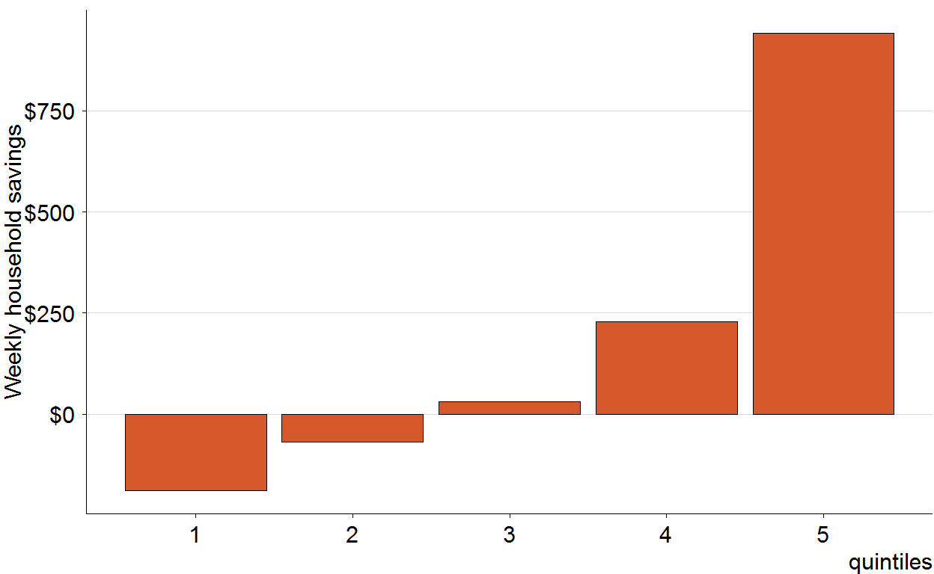

savings.by.quintile_prop <-   
 hes10hh %>%  
 mutate(  
 quintiles = create_qiles(disposable_income, disposable.income.quintiles)  
 ) %>%  
 mutate(savings = disposable_income - Total_goods_and_services_expenditure_HES_only) %>%  
 group_by(quintiles) %>%  
 summarise(avg_savings = weighted.mean(savings, Weight_HH_HES)/weighted.mean(disposable_income, Weight_HH_HES))  
  
savings.by.quintile_prop %>%  
 grplot(aes(x = quintiles, y = avg_savings)) +   
 geom_bar(stat = "identity") +   
 scale_y_continuous("Prop household savings", label=percent) +   
 xlab("disposable income") +  
 theme(axis.title.y = element_text(angle = 90))

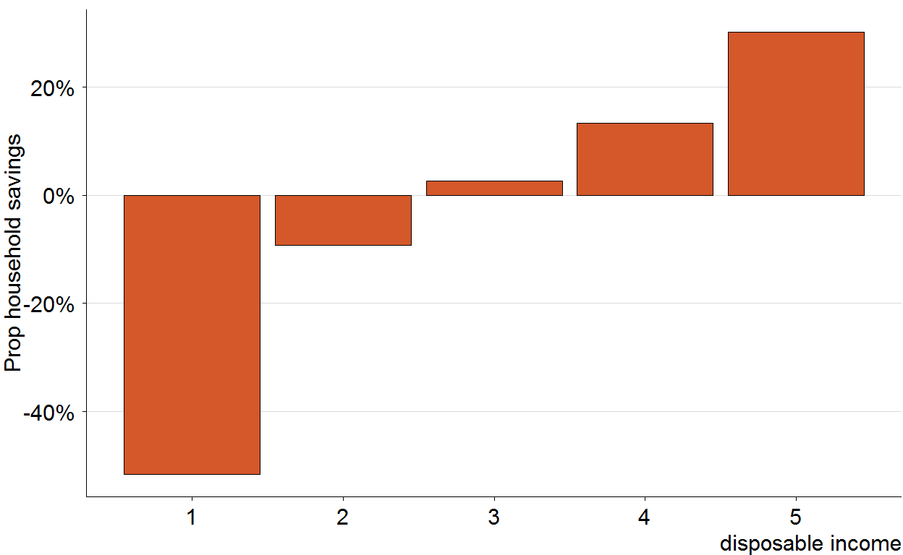

hes10hh %<>%  
 mutate(private_income_weekly = Total_current_weekly_HH_income_from_all_sources - Current_weekly_HH_income_from_government_pensions_and_allowances_basis,  
 private_income = private_income_weekly * 52,  
 private_income_group = floor(private_income/25000) * 25000,  
 prop_gst_by_disp_inc = Weekly_household_GST_on_all_goods_and_services_FIS / disposable_income,  
 prop_gst_by_exp = Weekly_household_GST_on_all_goods_and_services_FIS / Total_goods_and_services_expenditure_HES_only)  
  
hes10hh %>%  
 filter(private_income < 250e3) %>%  
 grplot(aes(x = factor(private_income_group),  
 y = prop_gst_by_disp_inc,  
 weight = Weight_HH_HES)) +   
 geom_boxplot() +   
 ggtitle("GST / disposable income") + xlab("private income") +  
 scale_y_continuous(label=percent, limits = c(0,0.3))

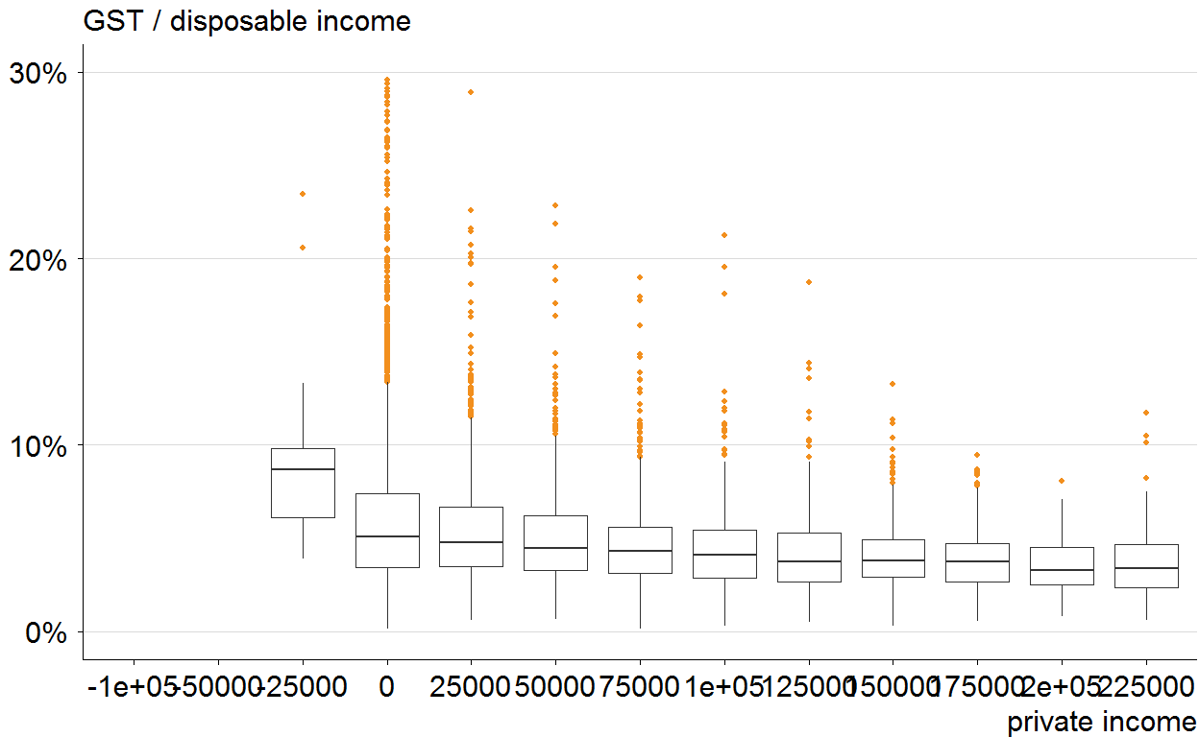

private.income.quintiles <-   
 svydesign(data = hes10hh, ids = ~Unique_household_number, weights = ~Weight_HH_HES) %>%  
 svyquantile(~private_income, design = ., quantiles = (0:5)/5)  
  
savings.by.private.quintile_prop <-   
 hes10hh %>%  
 mutate(  
 quintiles = create_qiles(private_income, private.income.quintiles)  
 ) %>%  
 mutate(savings = disposable_income - Total_goods_and_services_expenditure_HES_only) %>%  
 group_by(quintiles) %>%  
 summarise(prop_savings = weighted.mean(savings, Weight_HH_HES)/weighted.mean(private_income, Weight_HH_HES))  
  
savings.by.private.quintile_prop %>%  
 grplot(aes(x = quintiles, y = prop_savings)) +   
 geom_bar(stat = "identity") +   
 scale_y_continuous("Weekly household savings / private income", label=percent) +   
 xlab("private income quintiles") +   
 theme(axis.title.y = element_text(angle = 90))

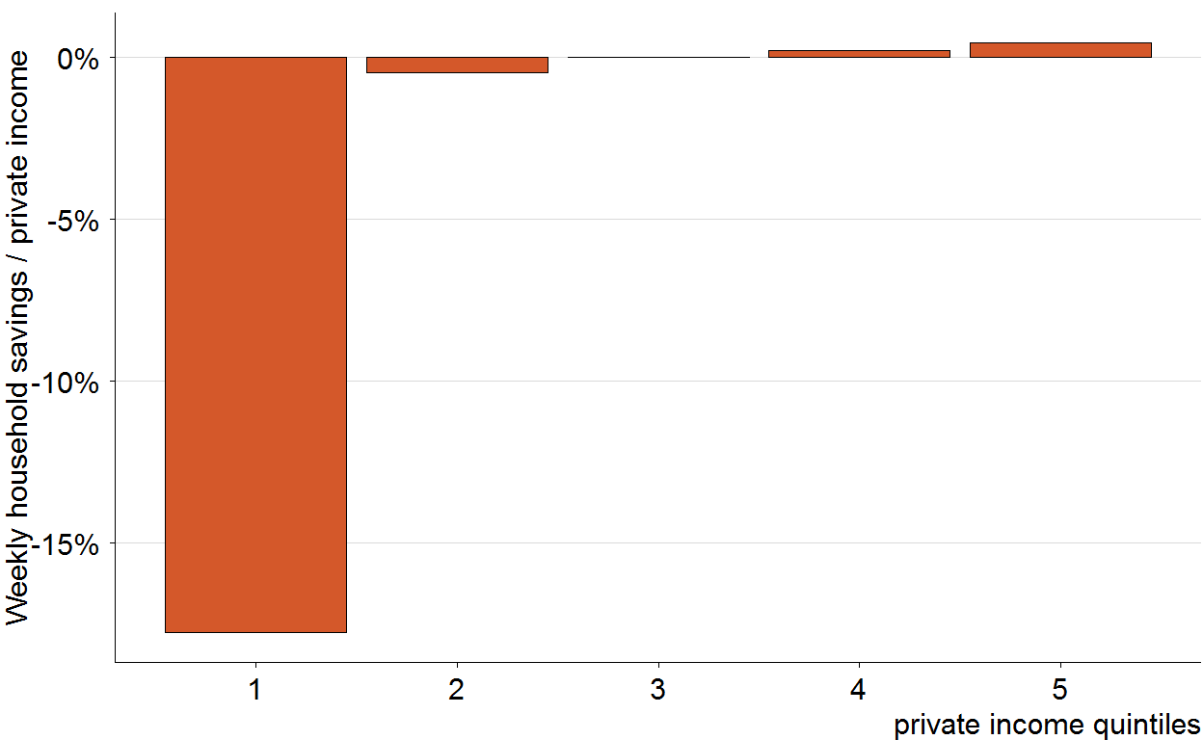

hes10hh %>%  
 filter(private_income < 250e3) %>%  
 grplot(aes(x = factor(disposable_income_group),  
 y = prop_gst_by_disp_inc,  
 weight = Weight_HH_HES)) +   
 geom_boxplot() +   
 ggtitle("% GST / disposable income") + xlab("Disposable income") +   
 scale_y_continuous(label=percent, limits = c(0,0.3))

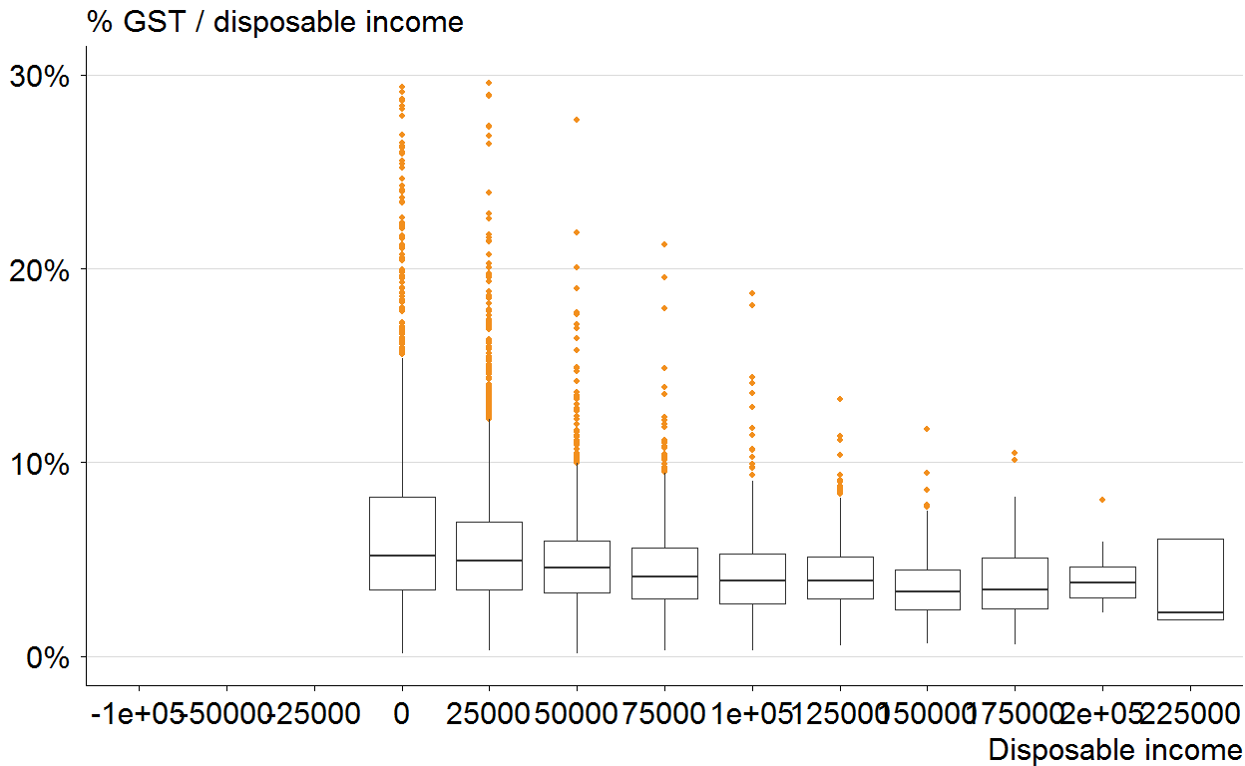

hes10hh %>%  
 filter(private_income < 250e3) %>%  
 grplot(aes(x = factor(private_income_group),  
 y = prop_gst_by_exp,  
 weight = Weight_HH_HES)) +   
 geom_boxplot() +   
 ggtitle("% GST / expenditure") + xlab("Private income") +   
 scale_y_continuous(label=percent, limits = c(0,0.3))

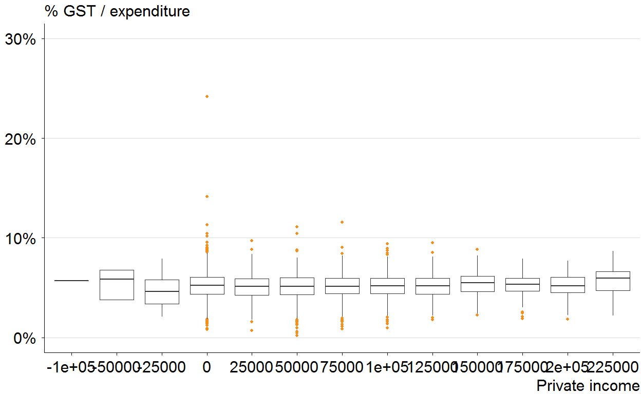

hes10hh %>%  
 filter(private_income < 250e3) %>%  
 grplot(aes(x = factor(disposable_income_group),  
 y = prop_gst_by_exp,  
 weight = Weight_HH_HES)) +   
 geom_boxplot() +   
 ggtitle("% GST / expenditure") + xlab("Disposable income") +   
 scale_y_continuous(label=percent, limits = c(0,0.3))

