**BIOEN 585 Project Proposal Samantha Sun, Spring 2019**

**Title:** Simulating stimulation-induced network plasticity in ‘rich clubs’ by measuring changes in local-field potentials from modeled single-unit simple neurons

**Shorter title:** Modeling network plasticity from single-unit simple neurons

**Consultants:** Jonathan Mischler (jmishler@uw.edu) – 2nd year graduate student in Fetz lab

Larry Shupe (lshupe@uw.edt) – Senior Researcher in Fetz lab

**Importance:** With advances in neural recording technologies, it is now possible to simultaneously perform single-site recordings and local field potential (LFP) recordings. However, there are still questions regarding the relationship between individual neuron spiking and the overall LFP shape and whether we can learn about the behavior of the network of neurons from the LFP it generates.

Of particular interest to this proposal is whether we can model stimulation-induced plasticity between networks of single-unit neurons, which will allow us to predict how neural networks may change with different stimulation inputs and inform future stimulation methods to modulate network plasticity in the brain.

**Previous knowledge:** There are many computational models of neurons that exist, most notably the Hodgkin-Huxley model that relates a neuron to an electrical circuit. Other models range from simple integrate-and-fire to complex neural network models. Each model has its benefits and drawbacks, and it’s important to consider what question is trying to be answered when deciding which model to use. Since this project involves scaling up to model a network of neurons, we decided on a simple neuron model developed by Izhikevich, which is an ODE model that is able to mimic the behavior of the 20 most fundamental electrical waveforms of neurons1. When considering how neural connections change with plasticity, the prominent theory is spike-timing dependent plasticity (STDP), which states that if one neuron fires just before another neuron repeatedly, then the strength of their connection increases. Research that explores how external stimulation changes plasticity has validated STDP, and our goal in this project is to computationally model stimulation to determine whether the network change matches STDP rules.

**Questions to be addressed**: Can we modify the simple neuron model to accurately replicate physiological data? How do single neurons contribute to the overall network LFP? How does external stimulation change the behavior between two networks of neurons?

**Modeling approach:** The plan is to take the simple neuron model developed by Izhikevich to create two classes of neurons: tonic and bursting phasic. I chose these two because I have previously collected neural recording from a cockroach leg that exhibited behaviors that can be explained with these two neuron types.

The first aim of this project would be to implement this simple neuron model and create a small group of neurons (not connected) that matches the behavior I recorded. This will allow us to find out the physiologically relevant parameters and time scales we should be using.

The second aim of the project is to scale up to a network-level so that we could measure a “local field potential (LFP)” or simply a signal that represents the summed activity of all the neurons in the network. LFPs are very commonly used to record neural activity and there are a lot of data that exists on what LFPs should look like. The main aspect in this aim is figure out how to connect the neurons and how many neurons to use. To determine how the network is connected, we will reference literature to see how the brain is typically connected. Previous research using network modeling has identified the brain having “small-world” properties, where there are densely connected groups or “rich clubs” of neurons that are sparsely connected to other densely connected groups2. We can optionally determine how much spontaneous firing (stochastic modeling) affects the overall network behavior. For this aim, we will ensure that our network is densely connected along with other network properties that we find in literature. We will validate this by comparing our modeled LFPs to experimentally recorded LFPs from literature.

The third aim of this project (if there is time) would be to see how the network changes when introducing stimulation. For this, we will create two “rich clubs” of neurons and introduce a Dirac function that acts as external stimulation. We will explore what types of stimulation protocols to use, including common ones such as repetitive single-site stimulation and paired pulse stimulation. We will measure the LFPs and how they change before and after stimulation. We expect our model to follow STDP plasticity rules as explained in literature.

**References**:

1. Izhikevich EM. Simple model of spiking neurons. *IEEE Trans Neural Networks*. 2003;14(6):1569-1572. doi:10.1109/TNN.2003.820440

2. Bullmore E, Sporns O. Complex brain networks: Graph theoretical analysis of structural and functional systems. *Nat Rev Neurosci*. 2009;10(3):186-198. doi:10.1038/nrn2575

**Recommended reads**:

1. <https://www.izhikevich.org/publications/dsn.pdf>

Book that has a really good description of the different neuron models and basic introduction to neurons if you need a refresher. Recommend reading pages 8-15, 20, 267-277 for model information and chapter 1 if you need a neuron refresher.

1. <https://www.annualreviews.org/doi/full/10.1146/annurev.neuro.31.060407.125639>

<https://www.sciencedirect.com/science/article/pii/S0896627312007039?via%3Dihub>

Papers that explains the different plasticity rules (STDP, Hebb rule, plasticity models). Only need to read the introduction for the first paper. For the second paper, take a look at Figure 2 and make sure you understand what that means. We will be referencing the Hebbian STDP model.

1. <https://www.researchgate.net/publication/317579637_Spiking_Neuron_Models_A_Review>

Paper on different neuron models. Mostly for reference, don’t actually read it unless you’re really interested because it’s super dense and I won’t read it lol.

Paper that’s tried to relate single spiking with LFPs in visual recognition task: <https://www.ncbi.nlm.nih.gov/pmc/articles/PMC3963414/#app2>

Papers for reference:

* A paper on STDP, hebb rule, plasticity models – just need to understand the basic principle of plasticity, no need to go into different types other than the Hebbian STDP
  + <https://www.annualreviews.org/doi/full/10.1146/annurev.neuro.31.060407.125639>
  + Read only intro
  + <https://www.sciencedirect.com/science/article/pii/S0896627312007039?via%3Dihub>
* Neuron models that we’re going to use:
  + Reading: pg 8-15, 20, 267-277 in izhikevich book, ch1 if you need a refresher of what a neuron is
  + <https://www.izhikevich.org/publications/dsn.pdf>
* Paper on different neuron models (mostly for reference, don’t actually read because I wont read it lol)
  + <https://www.researchgate.net/publication/317579637_Spiking_Neuron_Models_A_Review>

Modeling approach

My plan is to take the simple neuron model developed by Izhikevich (ODE model) to create two classes of neurons: tonic and bursting phasic. I chose these two because I have previously collected neural recording from a cockroach leg that exhibited behaviors that can be explained with these two neuron types.

The first aim of this project would be to implement this simple neuron model and create a small group of neurons (not connected) that matches the behavior I recorded. This will allow us to find out what are physiologically relevant parameters and time scales we should be using.

The second aim of the project is to scale up to a network-level so that we could measure a “local field potential (LFP)” or simply a signal that represents the summed activity of all the neurons in the network. LFPs are very commonly used to record neural activity and there’s a lot of data that exists on what LFPs should look like. The main aspect in this aim is figure out how to connect the neurons and how many neurons to use. Another researcher in the Fetz lab has been successful when using 30 neurons, so I’m thinking something in that degree of scale. To determine how the network is connected, we will reference literature to see how the brain is typically connected. Off the top of my head, I know that there are “small-world” properties, where there are densely connected groups or “rich clubs” of neurons that are sparsely connected to other densely connected groups. We can optionally determine how much spontaneous firing (stochastic modeling) affects the overall network behavior. For this aim, we will ensure that our network is densely connected along with other network properties that we find in literature. We will validate this by comparing our modeled LFPs to experimentally recorded LFPs from literature.

The third aim of this project (if there is time) would be to see how the network changes when introducing stimulation. For this, we will create two “rich clubs” of neurons and introduce a dirac function that acts as external stimulation. We will explore what types of stimulation protocols to use, including common ones such as repetitive single-site stimulation and paired pulse stimulation. We will measure the LFPs and how they change before and after stimulation. We expect our model to follow plasticity rules as explained in literature.

* Aim 1: Pick the most common neurons (tonic + phasic) and look at the summed behavior of a small combination of them + match parameters with cockroach data (tonic + phasic spikes, deflection ramp up)
* Aim 2: scale up network so that you can model LFPs as a sum from single spiking neurons – random connections that exhibit small-world properties (check lit for other network properties, maybe just very densely connected)
* Aim 3: make 2 networks with small world properties and do paired pulse stim to see how network connectivity changes (apply dirac to one site + measure LPF in other site) – can compare with literature results or models of network plasticity (if larry sends his papers, if not then reference the ones above)

Brainstorming for ideas:

What exists already:

* Neuron models
  + Hodgkin-Huxley model (biologically relevant to squid neurons)
  + Larry’s integrate + fire model (used in context of stimulation + saw matching results)
  + Izhikevich neuron – best of both worlds
  + Hopfield model – binary neuron model, simplest + computationally cheap
  + Review of a lot of models - <https://link.springer.com/content/pdf/10.1007%2Fs00422-006-0068-6.pdf>
    - Talks about shortcomings of integrate + fire neurons
* Plasticity models
  + Hebbian
  + STDP - <https://www.ncbi.nlm.nih.gov/pmc/articles/PMC2799003/> (ALL THE MODELS – really complex)
  + Spike-response model (pretty complicated) <https://www.mitpressjournals.org/doi/pdf/10.1162/089976600300015844>

Do I have access to some nice datasets/experimental data that I could use for comparison?

* Emailed Larry for datasets but can probably find
* Paired stimulation increases EP amplitude (Seeman + Fetz 2017, nhp)
* Single site repetitive stim caused changes in EvP amplitudes (increase + decrease) (Keller 2018)
* Wait I have data from bioen466 –
  + Spontaneous neural data from leech Retzius neuron

Need:

* Single site stim
* Paired pulse stim
  + Stdp at 10ms vs 100ms

Reading: pg 8-15, 20, 267-277 in izhikevich book, ch1 if you need a refresher of what a neuron is

* Hi this gives the matlab code for the simple neuron LOL
* Could potentially use this to model behavior seen in cochroach leg model – some spine had tonic/phasic/both, would just need to equate physical perturbation to current input, also did a 20hz sine wave which would be awesome to model
* Also have stepwise spiking which can easily be interpreted as increasing current amp over time
* Also have 20 – 100 hz in 10 hz increments of perturbation frequency
* Aim 1: Pick the most common neurons (tonic + phasic) and look at the summed behavior of a small combination of them + match parameters with cockroach data (tonic + phasic spikes, deflection ramp up)
* Aim 2: scale up network so that you can model LFPs as a sum from single spiking neurons – random connections that exhibit small-world properties (check lit for other network properties, maybe just very densely connected)
* Aim 3: make 2 networks with small world properties and do paired pulse stim to see how network connectivity changes (apply dirac to one site + measure LPF in other site) – can compare with literature results or models of network plasticity (if larry sends his papers, if not then reference the ones above)
* Importance:
  + can computationally model how a population of neurons can contribute to LFP signal
  + can ask questions about relationship between neuron population + LFP, sometimes we can only record LFP and need to infer what neural behavior is, having this model will allow us to work backwards and given the stimulation input and LFP we may be able to determine single unit neural behavior
  + with single unit recording on the horizon it’s possible to apply this model to learn more about relationship between single unit recordings and LPFs

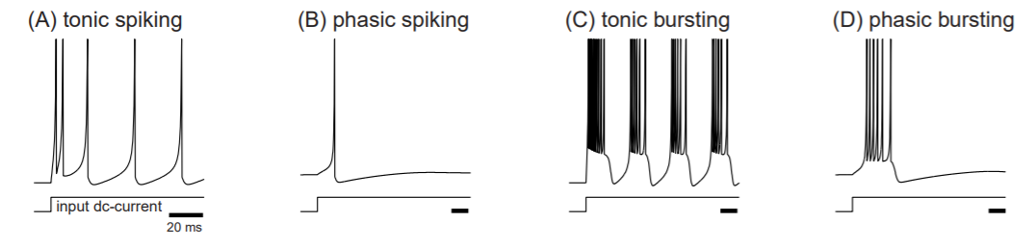

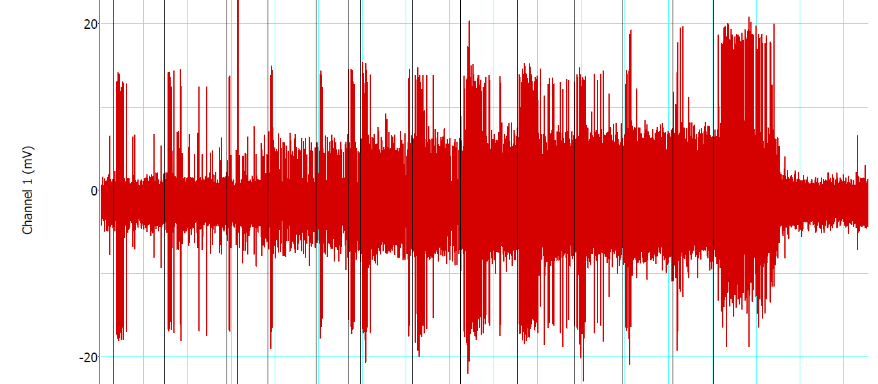

“responsetostepwise_step_b_v2” (don’t have raw data for this)

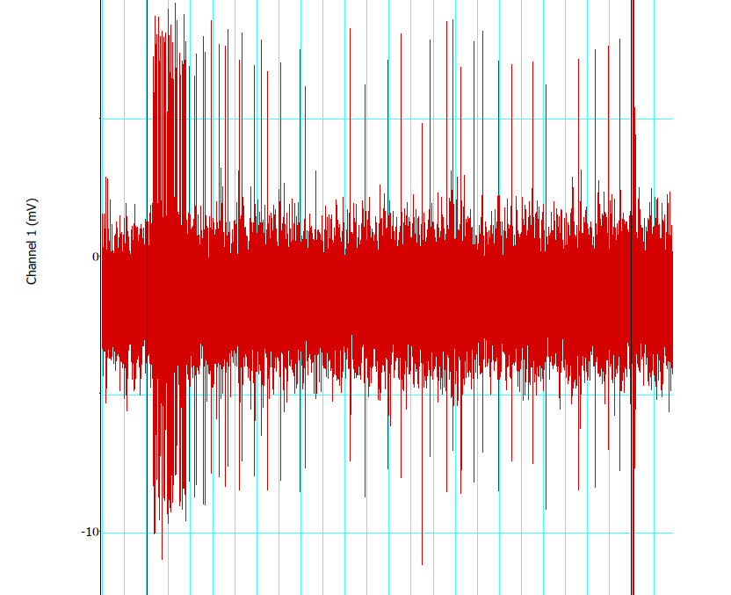

“evokedactivity_step_g_v3”

Looks like there’s 1 phasic bursting and 1-2 tonic neurons here

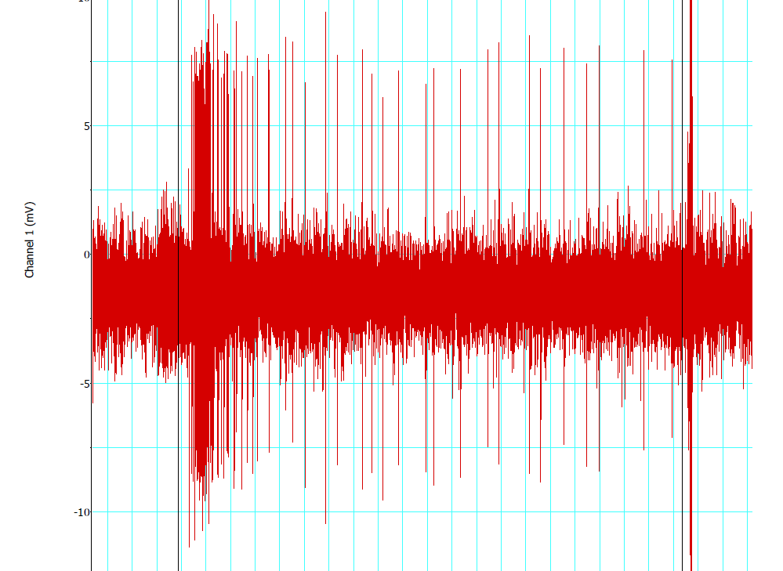

“evokedactivity_step_g_v4”

I think this is the cleanest one yet

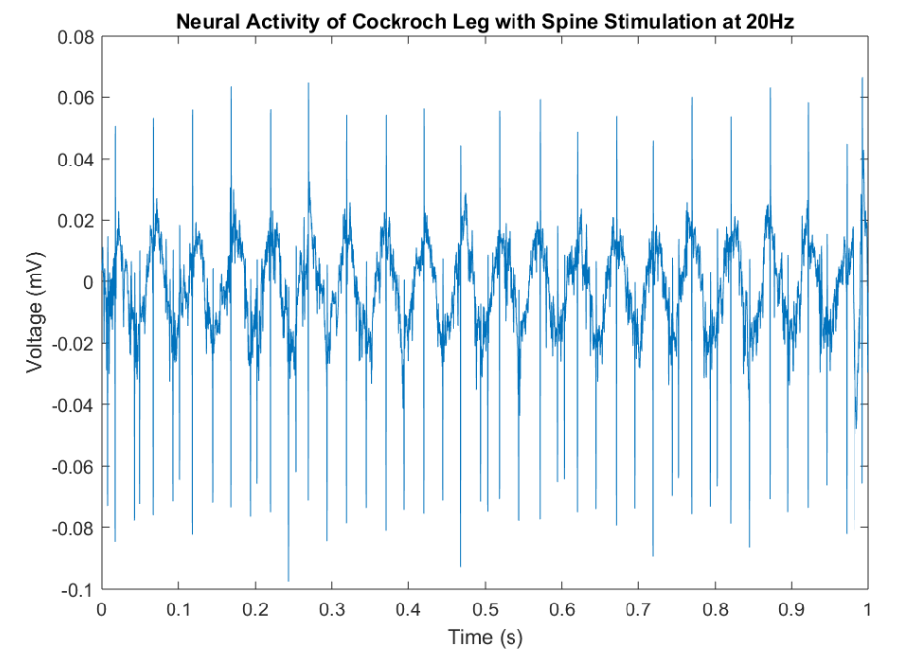

“fig5”

Question session:

* How to model the network
* How much of the network will we stimulate to see the overall behavior? For