Gravitybox Schedule.NET

Step-by-Step Overview

Gravitybox Software
Gravitybox Software
PO Box 2462
Alpharetta, GA 30023 USA
Voice mail & Fax : (+1) 866.GRAVBOX
Email : feedback@gravitybox.com
Website : http://www.gravitybox.com

Copyright Warning
This document is protected by copyright law. Unauthorized reproduction or distribution of this program, or any portion of it, may result in severe civil and criminal penalties and will be prosecuted to the maximum extent possible under law.

Contact Information
For inquiries about redistribution of this document or the GbSchedule.NET component please contact Gravitybox Software.

Gravitybox Software
PO Box 2462
Alpharetta, GA 30023

Voice-Mail and FAX (Toll-Free in the US):
866.GRAVBOX (866.472.8269)

Website:
http://www.gravitybox.com

Email:
Please send questions, comments, or bugs to feedback@gravitybox.com

Downloads
The Gravitybox Schedule ActiveX component and other Gravitybox products can be downloaded from the Gravitybox website at http://www.gravitybox.com.

The direct download URL for GbSchedule.NET is http://www.gravitybox.com/download/Schedule.NET.msi.

Source Code Note
You may notice that the examples of this book are not complete. The relevant code has been listed for discussion; however it is not necessary to list thousands of lines of code that you are never going to read. Only the relevant code snippets have been included. I hope that other writers in the future take this same methodology.
The Schedule.NET component is easy to use, general-purpose schedule component. This document will outline how to quickly start using it in your VS.NET application.

Add to Toolbox
The first thing that you need to do is add it to your toolbox, which can be accomplished following these steps.
- Right-click in the toolbox to show a pop-up menu
- Click “Add/Remove Items” to see the following dialog

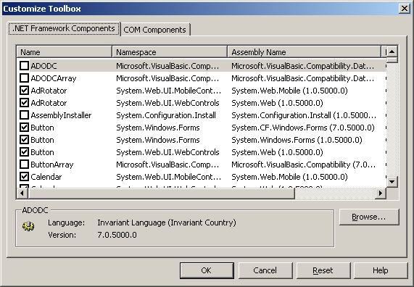

- Click the “Browse” button to show the “Open” dialog
- Navigate to the installation folder and find the “bin” directory
- Choose the file “Gravitybox.Schedule.dll” and press the “Open” button
- Afterwards you should see the following UserControls highlighted

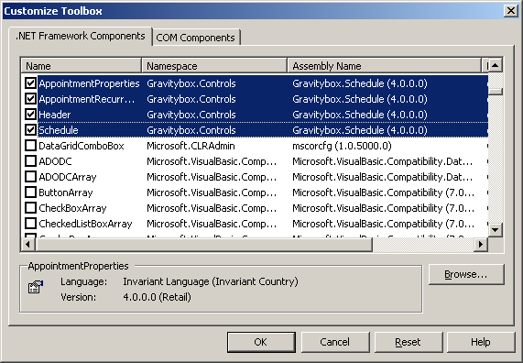

- Press the “OK” button to add these to the Toolbox

When you add Gravitybox controls to the toolbox you will notice there are a few more UserControls than just the schedule. The others can be used to add additional functionality but for now we will concentrate on the schedule component.

Now that the Schedue.NET component is in the toolbox you can click and drag it to a form.

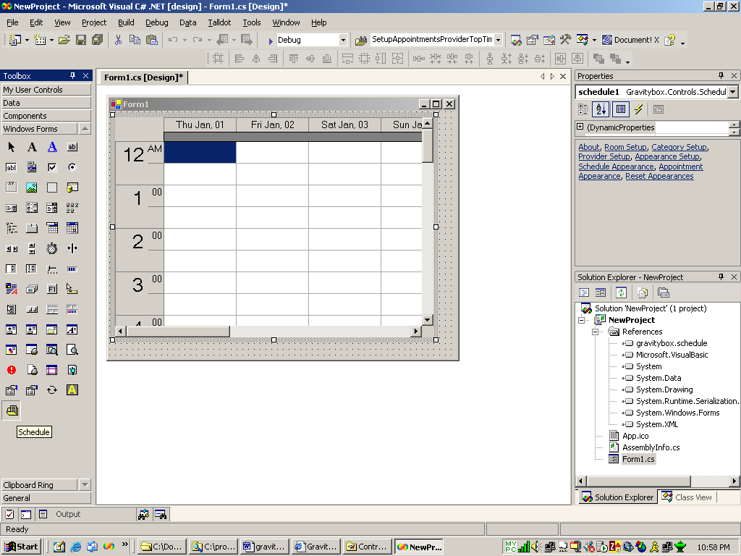

Your new application will run as it is now. When you run the application, you will be able to create appointments by double-clicking the background. Afterwards the default dialog will appear to allow you to edit the appointment’s properties.

Object Setup
You can actually start adding objects at design-time in the properties window. Looking at the property window below, you will notice that there are many links you can click. Many actually add objects that will appear at run-time. For example the links Room Setup, Category Setup, and Provider Setup allow you to fill a collection with each of these objects.

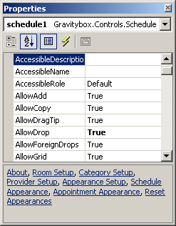

As an example of this lets explore the Room Setup link. When clicked it will display the dialog below.

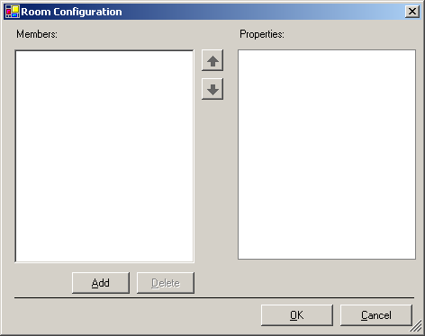

The dialog shows an empty room collection. You can add rooms by pressing the Add button. Upon pressing it, a new object will appear in the collection.

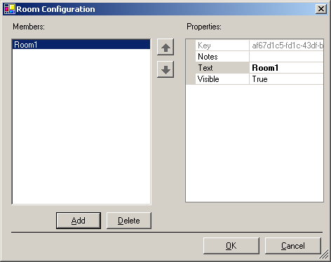

Notice that it has the default name of “Room1”. You can change this to any text you wish. You can also remove items with the delete button, of course. Rooms are using to display appointments in viewmodes with room information. For example, if the schedule’s viewmode were set to RoomTopTimeLeft then the room objects would be across the top margin and time would be displayed across the left margin. Each appointment may have exactly zero or one room. You can think of this as a location. An appointment can only be in one place.

The Category and Provider setup screen are very similar. Providers can also be viewed on the schedule in the top or left margin. However Category objects are not displayed as a viewmode. They are used only to classify appointments. An appointment may have zero or more Providers or Categories.

Add Appointments
You can easily add appointments immediately. The following code sets the bounds of schedule to the month of January 2006. It also bounds the time displayed from 8am to 6pm (8:00-18:00).

C#
//Setup Schedule
DateTime startDate = new DateTime(2006, 1, 1, 8, 0, 0);
DateTime endDate = new DateTime(2006, 1, 31);
schedule1.ViewMode =
Gravitybox.Controls.Schedule.ViewModeConstants.DayTopTimeLeft;
schedule1.SetMinMaxDate(startDate, endDate);
schedule1.StartTime = startDate;
schedule1.DayLength = 10;

//Add appointments
Gravitybox.Objects.Appointment appointment = null;
appointment = schedule1.AppointmentCollection.Add("",
startDate, startDate, 60);
appointment.Subject = "My Appointment";
appointment.Appearance.BackColor = Color.LightBlue;

VB.NET
'Setup Schedule
Schedule1.ViewMode = _
Gravitybox.Controls.Schedule.ViewModeConstants.DayTopTimeLeft
Schedule1.SetMinMaxDate(#1/1/2006#, #1/31/2006#)
Schedule1.StartTime = #8:00:00 AM#
Schedule1.DayLength = 10

'Add appointments
Dim appointment As Gravitybox.Objects.Appointment
appointment = Schedule1.AppointmentCollection.Add("", _
#1/1/2006#, #8:00:00 AM#, 60)
appointment.Subject = "My Appointment"
appointment.Appearance.BackColor = Color.LightBlue

The code above creates the screen below. The appointment has been created for one hour at the schedule’s start date and time. Also its back color has been set to light blue and subject set to “My Appointment”.

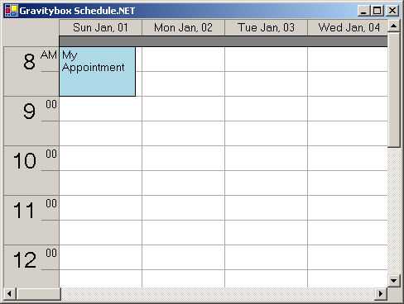

The appointments can be as fancy as you wish them to be by setting header, borders, fonts, colors, etc.

Notice when the add method of the AppointmentCollection was called that the first parameter is an empty string. This is the key and it is a unique identifier. If you want a new unique key to be generated then send an empty string for this parameter. A real key is never an empty string. The Add method has many overloads to allow you to add an appointment based on date, time, room, and/or provider.

