Machine Learning for Premature Birth Prediction during Pregnancy
A Project Report
Submitted in partial fulfilment of requirements for the award of the degree of
BACHELOR OF TECHNOLOGY IN
INFORMATION TECHNOLOGY
Submitted by
Ms. G. Poojitha(20761A1216)
Under the Esteemed Guidance Of
Mrs. M. Hema Latha
Sr. Assistant Professor
Dept. Of IT, LBRCE

DEPARTMENT OF INFORMATION TECHNOLOGY LAKIREDDY BALI REDDY COLLEGE OF ENGINEERING
(Autonomous)
L. B. REDDY NAGAR, MYLAVARAM, NTR Dist.
(Approved by AICTE, Affiliated to JNTU Kakinada, NAAC Accredited with “A”grade, accredited by NBA Tier- I & Certified by ISO 14001:2015 certified)
2023-2024

LAKIREDDY BALI REDDY COLLEGE OF ENGINEERING (AUTONOMOUS)
Affiliated to JNTUK, Kakinada & Approved by AICTE, New Delhi
NAAC Accredited with “A” grade, accredited by NBA Tier-I &Certified by ISO 14001:2015
L.B. REDDY NAGAR, MYLAVARAM-NTR DIST.
DEPARTMENT OF INFORMATION TECHNOLOGY


CERTIFICATE
This is to certify that Ms. G. Poojitha (20761A1216) a student of IV B. Tech (Information Technology) has completed the project titled “MACHINE LEARNING FOR PREMATURE BIRTH PREDICTION DURING PREGNANCY” at Lakireddy Bali
Reddy College of Engineering during the Academic Year 2023-2024. This project report is submitted as partial fulfillment for the award of degree B. Tech (Information Technology).

Project Guide Head of the Department
Mrs. M. Hema Latha Dr. B. Srinivasa Rao
Sr. Assistant Professor Professor & HOD of IT Dept

Internal Examiner External Examiner

ACKNOWLEDGEMENT

Behind every achievement lies an unfathomable sea of gratitude to those who activated it, without whom it would ever have been in existence. To them, I lay the words of gratitude imprinted with me.
I express our special gratitude to Dr. K. Appa Rao, Principal, Lakireddy Bali Reddy College Of Engineering, who made this endeavour possible.
I highly oblige Dr. B. Srinivasa Rao, HOD, Information Technology, for his support and encouragement. I would also like to thank all the teaching and non-teaching staff members of the Information Technology department who have extended full cooperation.
It is with utmost pleasure that I avail this opportunity to express heartfelt gratitude to my beloved guide Mrs. M. Hema Latha, Asst. Professor, Information Technology for her mastery of supervision through all the phases of my main project work with valuable suggestions and support. Her friendly and informal talks helped me to work under excellent working conditions.
I am highly thankful to our project coordinators Dr. A. V. N. Reddy, Associate Professor and Mr. Ch. Sambasiva Rao, Sr. Assistant Professor in the Department of IT. For providing the knowledge to deal with the project at every phase systematically.
Finally, a word of gratitude to my PARENTS who have been a constant source of encouragement and love.

PROJECT ASSOCIATE

Ms. G. Poojitha (20761A1216)

DECLARATION
I hereby declare that the project report entitled “MACHINE LEARNING FOR PREMATURE BIRTH PREDICTION DURING PREGNANCY” submitted to
JNTUK is a partial fulfillment of the requirement for the award of the degree of Bachelor of Technology (B. Tech) and is an original work carried out by me. The matter embodied in this project is genuine work by the student and has not been submitted earlier to this university or any other university for the award of any degree diploma or prize.

PROJECT ASSOCIATE

Ms. G. Poojitha (20761A1216)

INDEX

Contents | Page No
LIST OF FIGURES | I
ACRONYMS AND ABBREVIATIONS | II
ABSTRACT | III
1. INTRODUCTION | 1-3
1.1. Introduction | 1-2
1.2. Existing System | 3
1.3. Proposed System | 3
2. LITERATURE SURVEY | 5
3. SYSTEM SPECIFICATIONS | 7-8
3.1. Software Requirements | 7
3.2. Hardware Requirements | 8
3.3. Functional Requirements | 8
3.4. Non-Functional Requirements | 8
4. System Design | 10-15
4.1. Overview of the project | 10
4.2. Methodology | 11-15
5. IMPLEMENTATION | 17-21
5.1. Logistic Regression | 17
5.2. Naïve Bayes | 17-18
5.3. Random Forest | 18
5.4. XG Boost | 18-19
5.5. Stacked Ensemble | 19-20
5.6. Integrated Analysis | 20-21
5.7. Information Gain | 21
6. RESULTS & DISCUSSIONS | 23-29
6.1. Lab Parameters Model | 23-24
6.2. Scan Parameters Model | 25-26
6.3. Lab & Scan Parameters Model | 26-29
7. CONCLUSION | 31
8. FUTURE SCOPE | 33
9. REFERENCES | 35

LIST OF FIGURES
Figures Page No
Figure 1: Pregnancy Period Image 2
Figure 2: Pregnancy Journey of a Woman Image 2
Figure 3: System Design 11
Figure 4: Parameters From CustomerPregnancy Details 12
Figure 5: Few Parameters From Lab Reports 13
Figure 6: Few parameters from Scan Reports 13
Figure 7: Performance Metrics using lab parameters 23
Figure 8: Accuracies of various algorithms using lab parameters 24
Figure 9: Feature Importance graph using lab parameters 24
Figure 10: Performance Metrics using Scan Parameters 25
Figure 11: Accuracies of various algorithms using scan parameters 25
Figure 12: Feature Importance graph using scan parameters 26
Figure 13: Performance Metrics using lab and scan parameters 26
Figure 14: Accuracies of various algorithms using lab & scan parameters 27
Figure 15: Feature Importance graph using lab and scan parameters 28
Figure 16: Lab parameters showing parametric values for the patient 28
Figure 17: Patient Scan Results: Preterm Status Flagged 29

ACRONYMS AND ABBREVIATIONS

RBC | Red Blood Cells
WBC | White Blood Cells
RPCM | Risk Prediction Conceptual Model
SVM | Support Vector Machine
TSH | Thyroid Stimulating Hormone
IPD | Input Patient Date
OPD | Output Patient Date
EDD | Estimated Due Date
XG Boost | Extreme Gradient Boosting
AUC-ROC | Area Under The Receiver Operating Characteristic Curve
CRL | Crown-Rump Length

ABSTRACT

Preterm or premature birth refers to the delivery of a baby before completing 37 weeks of gestation., poses significant health risks to newborns and remains a global concern. This project addresses the need for an accurate predictive model for preterm birth using a comprehensive set of parameters from both laboratory and scan reports during the pregnancy journey. Our study extends this scope to include a broader range of parameters. Our proposed system involves the integration of various lab and scan parameters, such as RBC count, WBC count, haemoglobin, TSH, abdominal circumference, cervix length, placenta position, etc... Unlike previous studies, which focus on a limited set of parameters, this project aims to build a machine learning model leveraging a diverse range of factors from lab and scan reports. The study includes the application of traditional statistical techniques like (Logistic Regression, Naïve Bayes) and ensemblling learners (Random Forest, Gradient Boost, XG Boost. Our end goal is to explore the association between various parameters and preterm labour, utilizing a dataset of approximately 4,000 patient records for lab reports and 7,000 patient records for scan reports. The predictive model is designed to assess the likelihood of preterm birth occurring at the 35th week of gestation, allowing sufficient time for preventive measures. This project contributes to advancing our understanding of preterm birth predictors and facilitates timely intervention to reduce associated health complications and emotional burdens.

CHAPTER - 1

Machine Learning for Premature Birth Prediction during Pregnancy

INTRODUCTION

INTRODUCTION
Premature birth defined as the delivery of a baby before completing 37 weeks of gestation, remains a critical global health concern. This phenomenon poses significant risks to neonatal health, often leading to complications as the developing organs may not be fully matured. The consequences extend beyond the immediate health of the newborn, contributing to higher rates of infant mortality and imposing emotional and financial burdens on families. In the context of this challenge, our project explores the application of machine learning techniques to predict preterm births during pregnancy.
Employing a comprehensive array of parameters derived from laboratory analyses and diagnostic imaging reports, we aim to develop a robust predictive model. This model goes beyond existing studies, which primarily focus on specific inflammation markers, by incorporating a broader range of blood cell subtypes and other essential parameters. The imperative to address preterm birth is accentuated by global statistics, where approximately 10% of pregnancies worldwide culminate in preterm deliveries, a figure that escalates to nearly 15% within the context of India. Factors such as declining quality of life and food standards contribute to the magnification of this problem at an alarming pace.
Our study focuses on leveraging advancements in machine learning to provide an effective and timely solution. Drawing inspiration from previous literature that explored preterm prediction based on vitals, patient health history, and socio-economic status, we aim to enhance the predictive power by incorporating parameters from comprehensive laboratory tests and various scans conducted throughout pregnancy. While most of the existing studies primarily examine the association between preterm labor and specific blood cell ratios, our proposed system extends this to include a wide array of parameters extracted from routine tests and scans. By employing traditional statistical techniques and ensembling learners, including logistic regression, Naive Bayes, random forest, and boosting algorithms, we seek to build a predictive model capable of assessing the probability of preterm birth at the end of the 35th week. The end goal is to provide healthcare professionals and expectant mothers with a tool that predicts the likelihood of preterm birth at the 35th week of gestation, allowing doctors to mitigate critical risks for potential preterm patients. We provide an overview of the significance of preterm birth, outline the limitations of existing approaches, and establish the rationale for our project. By harnessing the power of machine learning and leveraging a rich dataset encompassing a multitude of parameters, we aim to contribute to the advancement of preterm birth prediction, ultimately improving neonatal outcomes and reducing the global burden of preterm births.

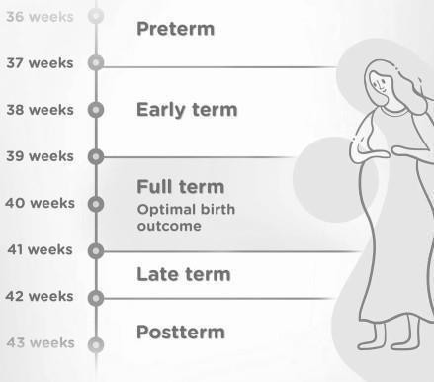
Fig 1.1.1 Pregnancy Period Image

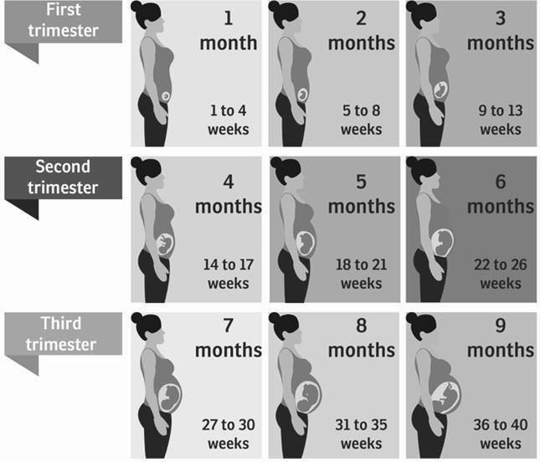
Fig 1.1.2 Pregnancy Journey of a Woman Image

EXISTING SYSTEM
Previous studies have explored the correlation between markers of inflammation and preterm birth, investigating factors such as uterine contraction and electrical activities of muscles derived from electrohysterogram (EHG) signals in pregnant women. These investigations have aimed to identify effective features for predicting preterm labor based on vitals, patient health history, and socioeconomic status before gestation begins. Research has focused on the association between various blood cell subtypes, including the neutrophil-to-lymphocyte ratio (NLR), lymphocyte-to-monocyte ratio (LMR), and platelet-to-lymphocyte ratio (PLR), and the onset of preterm labor. The prime component initiating preterm labor is inflammation, with early and chronic low-grade inflammation commonly linked to the ratios. To verify this association, studies have enrolled pregnant women, dividing them into two groups based on their delivery outcomes: those who delivered before 37 weeks (preterm labor group) and those who delivered at or after 37 weeks (no preterm labor group). In a study involving 80 pregnant women, researchers found that neutrophil levels were significantly elevated in those with preterm labor, while lymphocyte levels were reduced. However, despite these individual changes in cell counts, the ratios NLR, LMR, and PLR were not found to be significantly increased in pregnant women experiencing preterm labor compared to those without preterm labor.

PROPOSED SYSTEM
In contrast to the limitations of the existing research, our study aims to broaden the scope by incorporating a wider range of parameters obtained from both laboratory tests and scans conducted during the gestational period. While the base paper focused primarily on the neutrophil-to-lymphocyte ratio (NLR), lymphocyte-to-monocyte ratio (LMR), and platelet-to- lymphocyte ratio (PLR) as indicators of low-grade inflammation, we recognize the potential significance of additional parameters such as RBC/WBC count, hemoglobin levels, TSH levels, pH levels, abdominal circumference, and placenta position in predicting preterm labor.Our research seeks to leverage machine learning techniques to develop a robust predictive model that utilizes these parameters extracted from both lab and scan reports. By analyzing thepatterns and interactions between these variables, we aim to predict the likelihood of preterm birth for each patient. Furthermore, we will assess the predictive power of the top variables inthe model and evaluate their association and significance with preterm births. To facilitate thisstudy, we have collected data from trusted sources, including approximately 4,000 patient records for lab reports and 7,000 patient records for scan reports. Each patient in the dataset islabeled with a flag indicating whether they experienced preterm birth or not. The parameters from lab and scan reports are aggregated at trimester levels (T1, T2, and T3) to be used in the predictive model. The model will be designed to predict the probability of preterm birth usingdata collected up to the 35th week of gestation. This approach enables early identification of high- risk patients, allowing healthcare providers to intervene promptly and implement necessary measures to mitigate the risk of preterm birth.

CHAPTER - 2

LITERATURE SURVEY
In the exploration of predicting preterm birth during pregnancy and leveraging lab and scan parameters, this comprehensive literature survey amalgamates insights from various studies. One study delves into the role of inflammatory markers, particularly emphasizing the elevated neutrophil-to-lymphocyte ratio as a potential risk indicator for preterm birth ([1]). This underlines the importance of understanding the inflammatory processes associated with preterm labor. Another study introduces an innovative approach by developing an expert system that utilizes machine learning for preterm birth risk assessment, showcasing its superiority over traditional manual methods ([2]). This not only highlights the significance of incorporating advanced computational methods but also emphasizes the potential for personalized risk assessment in clinical settings. Serum markers take center stage in a third study, focusing on the neutrophil-to-lymphocyte ratio as a potential predictor for late preterm birth, adding valuable dimensions to risk assessment ([3]). In a distinct context, a study situated in rural India introduces the Risk Prediction Conceptual Model (RPCM), a machine learning model that demonstrates promising accuracy in predicting preterm births using a combination of scan parameters and lab data, particularly with the SVM classifier ([4]). This reflects the importance of considering regional and demographic variations in developing effective prediction models. Shifting the focus to the broader context of inflammation, a study critically reviews its role in both preterm and term parturition, emphasizing the potential for early detection through a molecular signature of inflammation ([5]). Another study investigates blood cell subtypes, particularly neutrophils, as potential predictors for preterm labor. While revealing significant elevations, the study wisely advocates for further validation of these parameters before their clinical application ([6]). Lastly, a study contributes valuable insights into maternal leukocyte activation during both term and preterm labour, identifying an increase in monocyte and neutrophil activation. This study suggests the potential for novel diagnostic tools that could significantly advance the prediction of preterm birth ([7]). Collectively, these studies provide a nuanced and holistic understanding of preterm birth prediction, encompassing inflammatory markers, advanced computational methods, serum markers, regional considerations, and immune responses. These insights contribute to ongoing efforts to enhance the accuracy and effectiveness of predicting preterm birth during pregnancy, particularly when leveraging the wealth of data available through lab and scan parameters.

CHAPTER - 3

SYSTEM SPECIFICATIONS

SOFTWARE REQUIREMENTS
Python: Python is a general-purpose interpreted, interactive, object-oriented, and high-level programming language. Python is designed to be simple and highly readable. It was developed by Guido van Rossum in 1991. Python is an open-source platform to run and execute various programs. It contains various modules, packages, and libraries. It is used for Artificial Intelligence, Web development, Machine learning, Operating systems, Mobile application development, and video games. It can communicate with database systems. It is used for handling big data and performing mathematical operations. The Python files are saved with .py extension.
Jupyter Notebook: Jupyter Notebook is a free, open-source web application that allows users to create and share documents that include live code, equations, visualizations, media, and other computational outputs. It is a server-client application that allows editing and running notebook documents via a web browser. The app can be executed on a local desktop or installed on a remote server.
Packages Used:
    - Flask (0.12.0): Flask is a lightweight WSGI web application framework. It is designed to make getting started quick and easy, with the ability to scale up to complex applications. Flask is a Python framework for building web apps. It’s small, light and simple compared with the other widely used Python framework, Django. It gives developers flexibility and is a more accessible framework for new developers since you can build a web application quickly using only a single Python file.
    - Pandas (0.22.1): Pandas is a Python library used for working with data sets. It has functions for analyzing, cleaning, exploring, and manipulating data. Pandas allows us to analyze big data and make conclusions based on statistical theories. Pandas can clean messy data sets and make them readable and relevant.
    - NumPy (1.14.2): NumPy is a Python library used for working with arrays. It also has functions for working in the domain of linear algebra, Fourier transform, and matrices. NumPy was created in 2005 by Travis Oliphant. It is an open-source project, and you can use it freely. NumPy stands for Numerical Python.
    - Sklearn (0.19.1): Scikit-learn is probably the most useful library for machine learning in Python. The sklearn library contains a lot of efficient tools for machine learning and statistical modeling including classification, regression, clustering, and dimensionality reduction. Scikit-learn offers a variety of supervised and unsupervised learning techniques. It is based on several technologies you may already be acquainted with, including NumPy, pandas, and matplotlib.
    - HTML 5: HTML 5, the latest iteration of Hypertext Markup Language, forms the structural foundation of the project's web pages. It provides the necessary elements and semantics for organizing content, facilitating a cohesive user experience.

    - CSS 3: Cascading Style Sheets Level 3 (CSS 3) is employed to define the visual presentation of the project's HTML elements. With CSS 3, the design aspects such as layout, colors, fonts, and animations are tailored to enhance the aesthetics and usability of the web application.
Bootstrap 4: Bootstrap 4, a front-end framework, is integrated to streamline the
development process and ensure responsiveness across various devices. Leveraging its
pre-built components and grid system, bootstrap 4 accelerates the creation of consistent and mobile-friendly interfaces.
    - JavaScript 1.8: JavaScript 1.8 is utilized to introduce dynamic behavior and interactivity within the project. Through JavaScript 1.8, client-side scripting functionalities are implemented, enabling features such as form validation, DOM manipulation, and asynchronous communication with the server.

HARDWARE REQUIREMENTS
Operating system: Windows 7 or newer, 64-bit macOS 10.9+, or Linux.
- System architecture: 64-bit x86, 32-bit x86 with Windows or Linux.
- CPU: Intel Core 2 Quad CPU Q6600 @ 2.40GHz or greater.
- RAM: 8 GB or greater

FUNCTIONAL REQUIREMENTS
The functional system requirements describe the system function in detail.
- Data Collection
- Data Preprocessing(Parameter Extraction, Feature Selection, Preterm Flag Creation)
- Model Development

NON-FUNCTIONAL REQUIREMENTS
Non-functional requirements are those requirements of the system which are not directly concerned with specific functional delivered by the system. They may be related to emergent properties such as reliability, extendibility, and usability.
- To provide maximum accuracy
- Provide the right prediction.
- Ease of use
- Availability
- Reliability
- Maintainability

CHAPTER - 4

SYSTEM DESIGN

OVERVIEW OF THE PROJECT
The proposed project aims to address the limitations of existing research on predicting preterm birth by developing a comprehensive predictive model using machine learning techniques. Unlike previous studies that focused on a limited set of parameters, our project expands the scope to include a wide range of variables obtained from both laboratory tests and scans conducted during the gestational period.
Key components of the project include:
    - Data Collection: Data is gathered from trusted sources, comprising approximately 4,000 patient records for lab reports and 7,000 patient records for scan reports. Each patient is labeled with a flag indicating whether they experienced preterm birth or not.
    - Parameter Selection: In addition to conventional indicators such as NLR, LMR, and PLR, a diverse set of parameters including RBC/WBC count, haemoglobin levels, TSH levels, pH levels, abdominal circumference, and placenta position are considered for their potential association with preterm labor.
    - Machine Learning Model Development: Utilizing the collected data, a machine learning model is constructed to predict the probability of preterm birth for each patient. The model incorporates trimester-level data (T1, T2, and T3) and is trained to make predictions based on parameters available up to the 35th week of gestation.
    - Evaluation and Validation: The predictive power of the model is assessed through rigorous evaluation, including measures of accuracy, precision, recall, and area under the receiver operating characteristic curve (AUC-ROC). The significance and association of top variables with preterm births are also analyzed to validate the model's effectiveness.
    - Clinical Application: Upon validation, the predictive model can be utilized by healthcare providers to identify high-risk patients at an early stage of pregnancy. This enables timely intervention and implementation of preventive measures to reduce the likelihood of preterm birth, ultimately improving maternal and neonatal outcomes.
Overall, the project aims to contribute to the advancement of prenatal care by developing a robust predictive model that leverages a comprehensive set of parameters to accurately assess the risk of preterm birth and facilitate informed decision-making in clinical practice.

METHODOLOGY
The proposed methodology for this research involves a comprehensive approach to preterm birth prediction, integrating machine learning algorithms with a diverse set of parameters obtained from lab tests and various scans conducted during pregnancy. Our study seeks to address the limitations of existing systems by expanding the scope of analyzed parameters and incorporating advanced machine-learning techniques.
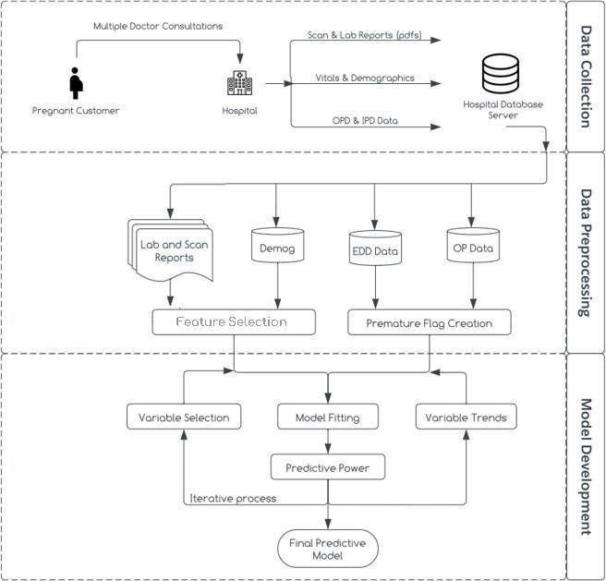

Fig 4.2.1 System Design
Data Collection:
Data for this study is sourced from trusted repositories, comprising 4,332 patient records for laboratory reports and 7,114 patient records for scan reports. Each patient’s record is labelled toindicate whether the patient experienced preterm birth or not. The parameters derived from labreports include RBC/WBC count, haemoglobin, TSH, and other relevant indicators, while scanreports contribute parameters such as abdominal circumference, placenta position, and more. A pregnant customer has multiple doctor consultations during their pregnancy journey.

Hospitals store their lab and scan reports in PDF format. In addition to those, it also stores vitals, IPD, and OPD data in the hospital database server.
    - Vitals: Vitals refer to critical physiological measurements of individuals. Incorporating vital signs data into the model development process can help capture important health- related factors that influence the desired outcomes.
    - Demographics: Demographics indicates the inclusion of demographic data in the model development process. Demographic variables such as age, gender, ethnicity, or socioeconomic status can provide valuable insights into the relationships between these factors and the desired outcomes.
    - EDD Data: EDD data, which stands for Estimated Due Date, can be included in the model development process when dealing with pregnancy-related outcomes. This data can help capture the timing-related factors associated with the desired predictions.
    - IP Data: IP data, or Inpatient Data, is valuable for data preprocessing and model development. It provides information on patients' medical history, treatments, complications, and length of stay during hospitalization. By integrating IP data with other sources, analyzing it over time, and considering treatment response, risk stratification, and clinical pathways, predictive models can be developed to improve patient care and outcomes.
    - OP Data: OP data, referring to Outpatient Data, can be utilized in the model development process. This type of data can provide additional information about patients' health conditions, treatments, or interventions that can be relevant for predicting outcomes.
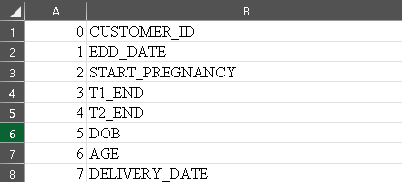
Fig 4.2.2 Parameters From CustomerPregnancy Details

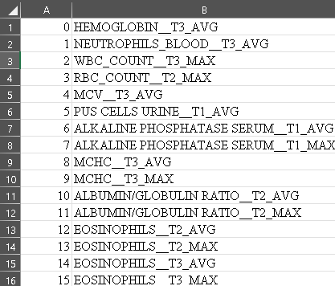
Fig 4.2.3 Few Parameters From Lab Reports
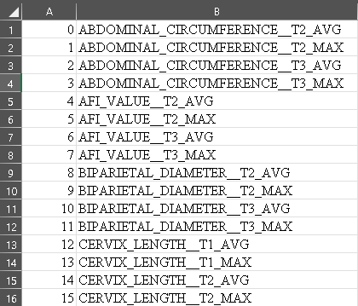
Fig 4.2.4 Few Parameters From Scan Reports

Data Preprocessing:
Data preprocessing is an essential step in the system design process that involves preparing the collected data for analysis and model development.
- Variable Selection: In this step, relevant variables or features are identified and selected from the collected data. This process helps to focus on the most important factors that contribute to the desired outcomes.
- Variable Trends: Analyzing variable trends involves examining the patterns and changes in the selected variables over time or across different conditions. This analysis can provide valuable insights into the relationships and dynamics within the data.
- Extraction Parameter: The extraction parameter refers to a specific parameter or feature that is extracted from the raw data. This process involves transforming or deriving new variables based on the existing data to capture important information or

relationships.
- Feature Creation: Feature creation involves generating new features or variables from the existing data. These new features can be created by performing mathematical operations, aggregating data, or applying domain-specific knowledge to capture additional information or patterns.
- Premature Flag Creation: Creating a premature flag involves generating an indicator or flag variable that identifies cases or instances where prematurity is present. This flag
can be based on specific criteria or thresholds related to gestational age or other relevant factors.

Model Development:
Model development is a crucial step in the system design process, where predictive models are built based on the pre-processed data.
- Model Fitting: Model fitting involves adjusting the parameters or weights of the predictive model to best fit the pre-processed data. This process aims to optimize the model's performance by minimizing errors or maximizing the likelihood of the observed data.
- Reports: Reports are generated as part of the model development process to summarize the findings and outcomes. These reports may include model performance metrics, evaluation results, and other relevant information to communicate the effectiveness of the developed model.
- Final Predictive Model: The final predictive model refers to the ultimate model that is developed to make predictions or estimations based on the collected data. This model is refined and optimized through iterative processes to achieve the desired predictive power.
It's important to note that the specific techniques and methodologies employed for data preprocessing and model development will depend on the system design requirements and the available data. The study employs a variety of machine learning algorithms categorized into traditional statistical techniques learners and ensembling learners. Traditional statistical techniques, including Logistic Regression and Naïve Bayes, are utilized to analyze the individual predictive power of specific parameters. Ensembling learners, such as Random Forest, Gradient Boost, and XG Boost, contribute to the robustness of the model by considering interactions between parameters.

End Goal and Evaluation:
The primary aim of the study is to build a machine-learning model that predicts the probability of preterm birth at the 35th week of gestation. To achieve this, parameters from both laboratory and scan reports are aggregated at trimester levels (T1, T2, and T3). The model is designed to provide sufficient lead time for preventive measures, offering a practical tool for healthcare professionals and expectant mothers. Evaluation of the model's performance involves rigorous testing on a separate validation dataset. Metrics such as accuracy, precision, recall, and area under the receiver operating characteristic curve (AUC-ROC) will be used to assess the model's predictive power and generalization to new data. The significance of individual parameters in

predicting preterm birth will also be analyzed to identify key contributors to the model's performance.

CHAPTER - 5

IMPLEMENTATION

LOGISTIC REGRESSION
Logistic Regression is a widely used algorithm in predictive modeling, particularly in binary classification tasks like premature birth prediction. In our study, Logistic Regression was employed to analyze the relationship between various laboratory and scan parameters and the likelihood of premature birth during pregnancy. By fitting a logistic regression model to our dataset, we were able to estimate the probability of premature birth based on the input features. Through feature selection and regularization techniques, we identified key predictors contributing to the risk of premature birth, thus providing valuable insights for clinicaldecision- making. The interpretability of logistic regression coefficients allowed us to understand the direction and strength of each variable's influence on the outcome, aiding in identifying high- risk pregnancies.

Logistic Regression
from sklearn.preprocessing import RobustScaler from sklearn.linear_model import LogisticRegression from sklearn.metrics import accuracy_score
scaler = RobustScaler()
X_train_scaled = scaler.fit_transform(X_train[final_features]) X_test_scaled = scaler.transform(X_test[final_features])
log_reg = LogisticRegression(penalty='l1',solver='liblinear', C=0.1) log_reg.fit(X_train_scaled, y_train)
y_pred_prob = log_reg.predict_proba(X_test_scaled)[:,1]

NAÏVE BAYES
Naive Bayes is a probabilistic classification algorithm based on Bayes' theorem with an assumption of independence between predictors. Despite its simplistic assumptions, Naive Bayes has shown effectiveness in various applications, including medical diagnosis. In our study, we applied Naive Bayes to predict premature birth risk during pregnancy using laboratory and scan parameters as input features. By calculating conditional probabilities of premature birth given the observed parameter values, Naive Bayes provided a straightforward yet efficient way to classify pregnancies into high or low-risk categories. Despite its simplicity, Naive Bayes demonstrated competitive performance in our experiments, highlighting its potential as a practical tool for the early identification of pregnancies at risk of premature birth.

Naïve Bayes

from sklearn.naive_bayes import GaussianNB nb_classifier = GaussianNB() nb_classifier.fit(X_train, y_train)
y_pred_prob = nb_classifier.predict_proba(X_test)[:,1]

RANDOM FOREST
Random Forest is an ensemble learning algorithm that constructs multiple decision trees during training and outputs the mode of the classes (classification) or the mean prediction (regression) of the individual trees. In our study, Random Forest proved to be a robust algorithm for premature birth prediction by leveraging the strengths of multiple decision trees. By training a Random Forest model on our dataset consisting of laboratory and scan parameters, we were able to capture complex nonlinear relationships between predictors and the likelihood of premature birth. The ensemble nature of Random Forest helped mitigate overfitting and improved generalization performance, making it particularly suitable for handling high- dimensional data with potentially correlated features. Moreover, the algorithm provided insights into feature importance, aiding in the identification of critical predictors contributing to premature birth risk.
Random Forest
from sklearn.ensemble import RandomForestClassifier
rf classifier = RandomForestClassifier(n_estimators=500, random_state =42,criterion =
“entropy”, n_jobs = 3) #You an adjust the number of estimators as needed rf_classifier.fit(X_train, y_train)
y_pred_prob = rf_classifier.predict_proba(X_test)[:,1]

XG BOOST
XG Boost, an implementation of gradient-boosted decision trees, has gained popularity for its exceptional performance in various machine learning tasks, including classification and regression. In our project, we utilized XG Boost to predict premature birth risk during pregnancy based on a set of laboratory and scan parameters. By iteratively adding decision trees that minimize a specified loss function, XG Boost effectively learned complex patterns in the data, leading to superior predictive accuracy compared to traditional algorithms. The algorithm's ability to handle missing values, categorical variables, and nonlinear relationships proved advantageous in our study, allowing us to extract valuable insights from heterogeneous pregnancy data. Additionally, XG Boost provided interpretable feature importance scores, facilitating the identification of key predictors associated with premature birth risk.

XG Boost:
import xgboost as xgb import xgboost as xgb
train_xgb = xgb.DMatrix(X_train[final_features], y_train) test_xgb = xgb.DMatrix(X_test[final_features], y_test) n=1000
params = {
'objective': 'binary:logistic', 'max_depth': 4,
'learning_rate': 0.05,
}
model = xgb.train(params=params,dtrain=train_xgb,num_boost_round=n) y_pred_prob = model.predict(test_xgb)

STACKED ENSEMBLE (LOGISTIC REGRESSION + RANDOM FOREST +
GRADIENT BOOSTING)
Our study introduces a novel approach to premature birth prediction during pregnancy through the implementation of a stacked ensemble model. By combining the strengths of Logistic Regression, Random Forest, and Gradient Boosting, we aimed to harness the diverse learning capabilities of these algorithms to improve predictive performance. The stacked ensemble model operates by aggregating predictions from multiple base models, leveraging the complementary strengths of each algorithm to enhance overall accuracy and robustness. Logistic Regression offers interpretability and captures linear relationships between predictors and premature birth risk, while Random Forest excels at capturing complex nonlinear patterns in the data and mitigating overfitting. Meanwhile, Gradient Boosting iteratively improves prediction accuracy by focusing on the residual errors of previous models, thereby refining the ensemble's predictive power. Through careful model stacking and blending of predictions, our stacked ensemble model synergistically integrates the predictive abilities of these diverse algorithms, resulting in a more accurate and reliable predictor of premature birth risk during pregnancy. Furthermore, the ensemble nature of the model helps mitigate individual algorithm biases and variance, leading to improved generalization performance on unseen data. Experimental results demonstrate the superior predictive performance of the stacked ensemble model compared to individual algorithms, highlighting its potential as a valuable tool for the early identification of high-risk pregnancies and informed clinical decision-making.

Stacked Model:
import h2o
from h2o.automl import H2OAutoML h2o.init()
train = pd.concat([X_train[final_features].reset_index(drop = True), y_train.reset_index(drop=True)],axis=1)
test = pd.concat([X_test[final_features].reset_index(drop = True), y_test.reset_index(drop=True)],axis=1)
x_vars = list(train.drop(columns=['IS_PRETERM_FLAG']).columns) y_var = "IS_PRETERM_FLAG"
train = h2o.H2OFrame(train) test = h2o.H2OFrame(test)
train[y_var] = train[y_var].asfactor() test[y_var] = test[y_var].asfactor() aml = H2OAutoML(
max_models=3, include_algos=["glm","gbm","drf","StackedEnsemble"], seed=25,
verbosity="warn"
)
aml_summary = aml.train( training_frame=train,
x = x_vars, y = y_var
)
aml.leaderboard
def get_best_stacked_model(aml):
lb = aml.leaderboard.as_data_frame()
lb = lb[lb['model_id'].str.startswith("StackedEnsemble")].sort_values('auc', ascending=False).reset_index(drop=True)
model_id = lb['model_id'][0]
stacked_model = h2o.get_model(model_id=model_id) return stacked_model
stacked_model = get_best_stacked_model(aml=aml) y_pred_prob = stacked_model.predict(test).as_data_frame()['p1']

      - Integrated Analysis
In our proposed methodology, we conducted an integrated analysis focusing on three distinct approaches: lab parameters, scan parameters, and a combined approach leveraging both data sources. This comprehensive strategy allowed us to thoroughly explore the predictive potential of different sets of features and their combinations for premature birth prediction during pregnancy. Firstly, we applied machine learning algorithms individually to lab parameters, comprising a wide range of biochemical markers and physiological measurements indicative of maternal health and fetal development. By exclusively considering lab parameters, we aimed

to assess the predictive power of these specific indicators in isolation. Secondly, we conducted a similar analysis using scan parameters, which encompass ultrasound imaging data providing detailed insights into fetal growth, morphology, and placental health. By focusing solely on
scan parameters, we aimed to evaluate the contribution of imaging-based metrics to premature birth prediction. Thirdly, we adopted a holistic approach by combining both lab and scan parameters, recognizing the complementary nature of biochemical and imaging markers in capturing different aspects of pregnancy progression and associated risks. Through this combined approach, we sought to leverage the synergistic information encoded in diverse data modalities to enhance predictive accuracy and robustness. By systematically comparing the performance of algorithms across these three approaches, we gained valuable insights into the relative importance of different feature sets and their impact on predictive modeling outcomes. This integrated analysis framework not only broadened our understanding of predictive factors for premature birth but also facilitated the development of more effective risk assessment models tailored to individual patient profiles.
      - INFORMATION GAIN
In our study, we employed feature selection techniques to identify the most informative predictors for premature birth prediction. Information gain, a commonly used metric in feature selection, measures the reduction in entropy or uncertainty achieved by splitting data based on a particular feature. Features with higher information gain values are considered more informative and are thus prioritized for inclusion in predictive models. Through rigorous analysis, we identified a subset of features with high information gain values, indicating their significance in predicting premature births. These features provide valuable insights into the underlying factors contributing to preterm delivery and enable more accurate risk assessment. The selection of features based on information gain enhances the interpretability and efficiency of predictive models, as it focuses on the most relevant predictors while discarding redundant or less informative features. By leveraging the power of information gain, we can develop more robust and accurate predictive models for premature birth prediction, ultimately improving maternal and infant healthcare outcomes.

Information gain is used to determine the most informative features for splitting the data, thus improving the efficiency and accuracy of classification or regression tasks by selecting the attributes that best discriminate between classes or predict outcomes. It is calculated based on the decrease in entropy or impurity in the data when a dataset is split on an attribute. Entropy is a measure of randomness or uncertainty in data. By splitting the data on an attribute, we aim to reduce this uncertainty.
The formula to calculate information gain is:
{Information Gain} = {Entropy before split} - {Weighted average of entropies after split}
Where:
Entropy before split: Represents the entropy of the original dataset before splitting on the attribute. Weighted average of entropies after split: This represents the average entropy of the subsets formed after splitting, weighted by their relative sizes.

CHAPTER – 6

RESULTS & DISCUSSIONS
Our study aimed to assess the predictive performance of various machine learning algorithms for a model focused on premature birth prediction using only lab parameters. In this section, we present the results of our analysis, which include the accuracy metrics obtained for each algorithm evaluated. By comparing the performance of different algorithms, we aimed to identify the most effective predictive models for early detection of premature births based solely on laboratory data. The findings presented here offer valuable insights into the strengths and limitations of each algorithm, guiding future research and clinical applications in maternal and infant healthcare.

LAB PARAMETERS MODEL
Our study focused on evaluating the predictive performance of various machine learning algorithms for a model based solely on lab parameters. In this section, we present the results of our analysis, which include the accuracy metrics obtained for each algorithm evaluated. By comparing the performance of different algorithms within the context of lab parameters, we aimed to identify the most effective predictive models for the early detection of premature births.
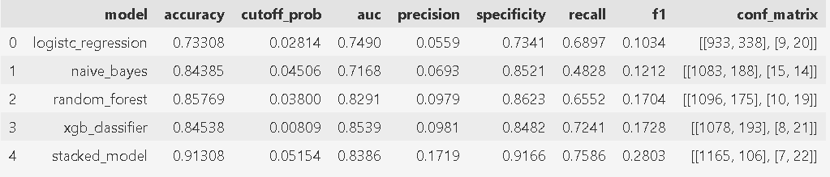

Fig 6.1.1 Performance Metrics using lab parameters.
The above table gives the predictive performance of various machine learning algorithms for a model focused on premature birth prediction using a combination of lab parameters and imaging scan data. Among the algorithms assessed, the Stacked Model demonstrated the highest accuracy with a score of 0.91308, indicating superior predictive performance. Notably, Random Forest also exhibited strong performance with an accuracy of 0.85769, closely followed by Naive Bayes with a score of 0.84385. However, Logistic Regression and XG Boost achieved comparatively lower accuracies of 0.73308 and 0.84538, respectively. These findings highlight significant variations in predictive capability among the algorithms tested, underscoring the importance of algorithm selection in optimizing predictive performance for premature birth prediction.

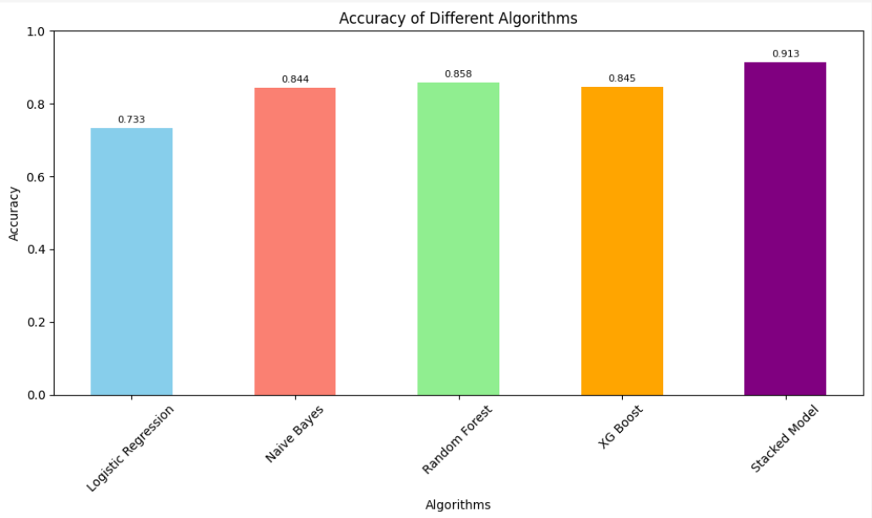
Fig 6.1.2 Accuracies of various algorithms using lab parameters.
Among the various features considered, the feature importance analysis revealed the ALBUMIN/GLOBULIN RATIO as a particularly influential predictor, with a relative importance score of 0.1449. This finding underscores the potential significance of the ALBUMIN/GLOBULIN RATIO in identifying pregnancies at risk of preterm birth based on laboratory data alone. The elevated importance assigned to this parameter suggests its potential utility as a biomarker for assessing maternal health and identifying pregnancies with a heightened risk of premature delivery. Further research and validation studies are warranted to explore the clinical implications of the ALBUMIN/GLOBULIN RATIO in preterm birth prediction and its integration into predictive modelling frameworks for maternal and infant healthcare.
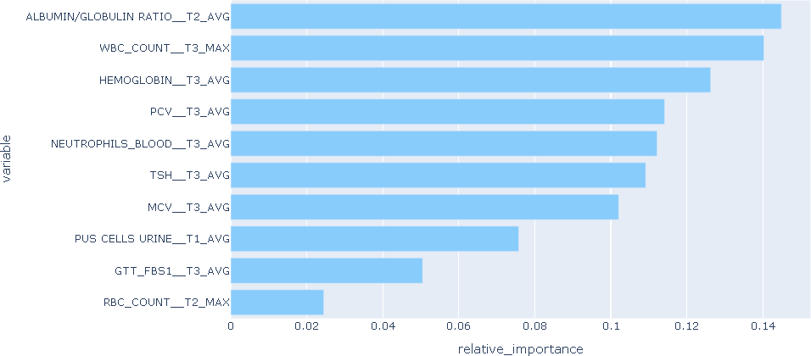
Fig 6.1.3 Feature Importance graph using lab parameters.

SCAN PARAMETERS MODEL
Our study focused on evaluating the predictive performance of various machine learning algorithms for a model based solely on scan parameters. In this section, we present the results of our analysis, which include the accuracy metrics obtained for each algorithm evaluated. By comparing the performance of different algorithms within the context of scan parameters, we aimed to identify the most effective predictive models for the early detection of premature births.
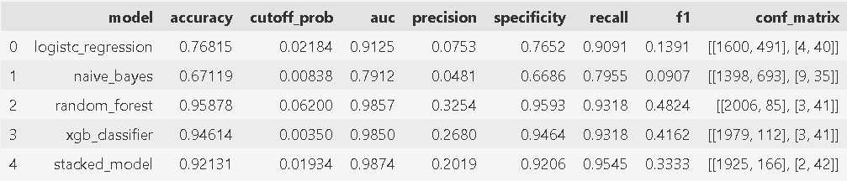

Fig 6.2.1 Performance Metrics using Scan Parameters.
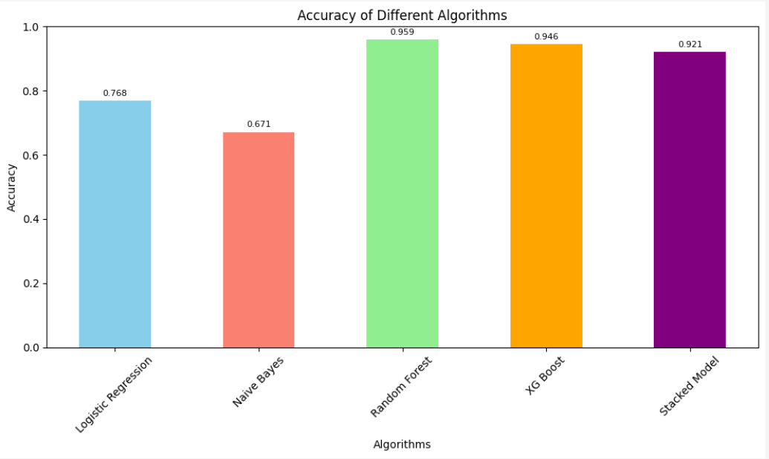
Our study aimed to assess the predictive performance of various machine learning algorithms for a model focused on premature birth prediction using lab parameters exclusively. The accuracy metrics obtained for each algorithm are summarized in Fig 4.2.1. Notable variations were observed in the predictive performance of the algorithms, with Random Forest achieving the highest accuracy of 0.95878, closely followed by XG Boost with 0.94614. These algorithms demonstrated strong predictive capabilities, indicating their potential utility in identifying premature births based on lab parameters alone. In contrast, Logistic Regression and Naive Bayes exhibited lower accuracies of 0.76815 and 0.67119, respectively. Despite not achieving the highest accuracy, the Stacked Model displayed competitive performance with an accuracy of 0.92131. These findings underscore the importance of algorithm selection in optimizing predictive accuracy for premature birth prediction. Random Forest and XG Boost emerge as promising candidates, offering superior performance compared to Logistic Regression and Naive Bayes. However, further investigation is warranted to explore the potential synergies of ensemble methods, such as the Stacked Model, in enhancing predictive accuracy.

Fig 6.2.2 Accuracies of various algorithms using scan parameters.

Our analysis of predictive models utilizing only scan parameters identified the Crown-Rump Length (CRL) as a critical predictor of premature births, with a relative importance score of 0.4528. This finding underscores the significance of CRL measurement in assessing fetal growth and development during early pregnancy stages. The high relative importance of CRL suggests its substantial impact on the predictive accuracy of the model. This parameter, commonly measured during early pregnancy ultrasound scans, serves as a crucial indicator of gestational age and fetal well-being. Its inclusion in predictive models for premature birth detection highlights the importance of early fetal biometry assessment in identifying pregnancies at risk of adverse outcomes.
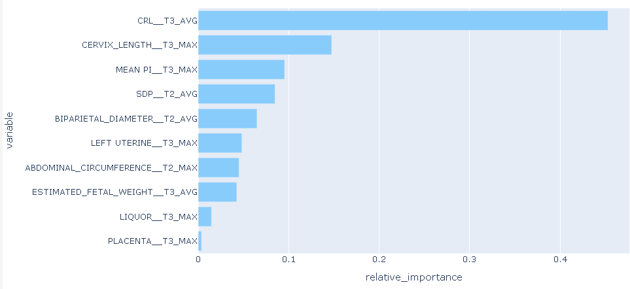

Fig 6.2.3 Feature Importance graph using scan parameters.
  - Lab & Scan Parameters Model
Our study focused on evaluating the predictive performance of various machine learning algorithms for a model based on lab and scan parameters. In this section, we present the results of our analysis, which include the accuracy metrics obtained for each algorithm evaluated. By comparing the performance of different algorithms within the context of lab and scan parameters, we aimed to identify the most effective predictive models for early detection of premature births.
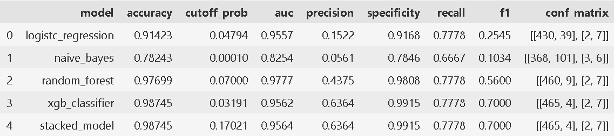

Fig 6.3.1 Performance Metrics using lab and scan parameters.
The accuracy metrics obtained for each algorithm offer valuable insights into their efficacy in this context. Logistic Regression achieved an accuracy of 0.91423, while Naive Bayes exhibited a slightly lower accuracy of 0.78243. Random Forest demonstrated strong predictive capability, attaining an accuracy of 0.97699. Notably, both XG Boost, and the Stacked Model emerged as top performers, each achieving an impressive accuracy of 0. 98745. These accuracy scores shed light on the varying strengths of each algorithm in identifying pregnancies at risk of premature birth. The high accuracy scores obtained by XG Boost and the Stacked Model

suggest their robust performance in leveraging lab parameters for predictive modeling. On the other hand, the lower accuracies observed with Logistic Regression and Naive Bayes indicate potential limitations in their predictive capabilities within this specific domain. The observed variability in accuracy underscores the importance of algorithm selection in developing effective predictive models for premature birth prediction. While Random Forest showed commendable performance, XG Boost, and the Stacked Model emerged as particularly promising candidates for further exploration in clinical applications.
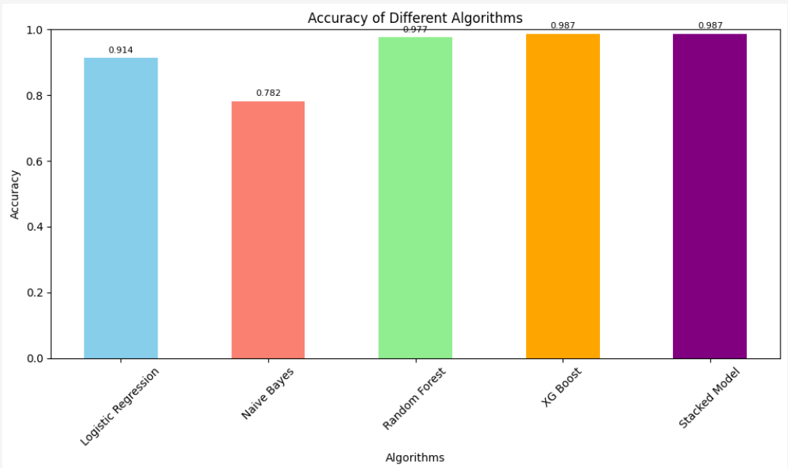
Fig 6.3.2 Accuracies of various algorithms using lab & scan parameters.
Analysis of predictive models, where both laboratory and scan parameters were employed to predict premature births during pregnancy, the analysis revealed that ALKALINE PHOSPHATE SERUM emerged as a significant feature with a relative importance of 0.2332. This finding underscores the potential role of ALKALINE PHOSPHATE SERUM as a critical biomarker in assessing the risk of preterm births. The high relative importance of this feature suggests that variations in ALKALINE PHOSPHATE SERUM levels may significantly impact the likelihood of premature delivery. This insight highlights the importance of considering both laboratory and scan parameters in predictive modeling, as they collectively provide valuable information for risk assessment. Incorporating ALKALINE PHOSPHATE SERUM into predictive models may enhance their accuracy and enable more targeted interventions to mitigate the risk of preterm births, ultimately improving maternal and infant health outcomes.

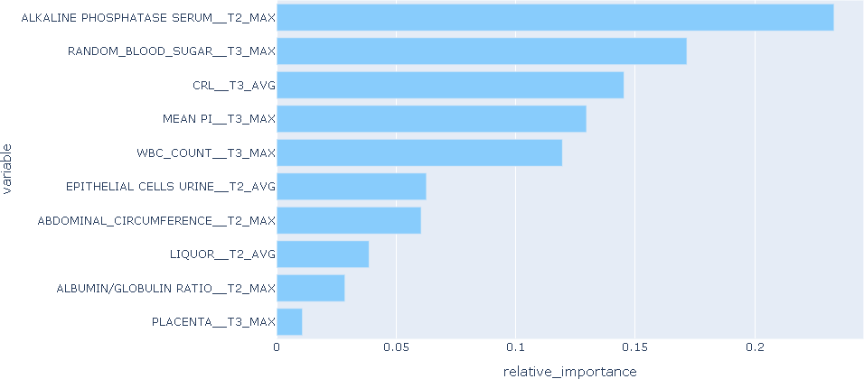

Fig 6.3.3 Feature Importance graph using lab and scan parameters.
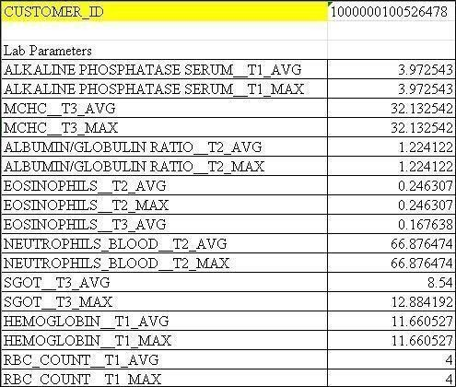
Fig 6.3.3 Lab parameters showing parametric values for the patient

The above figure provides a visual representation of the essential laboratory parameters utilized in our study for premature birth prediction during pregnancy. These parameters include hematological values, thyroid function markers, and other relevant indicators crucial for assessing maternal health and predicting preterm labor. Through this visual depiction, readers gain insight into the key variables considered in our analysis, facilitating a deeper understanding of our research findings.

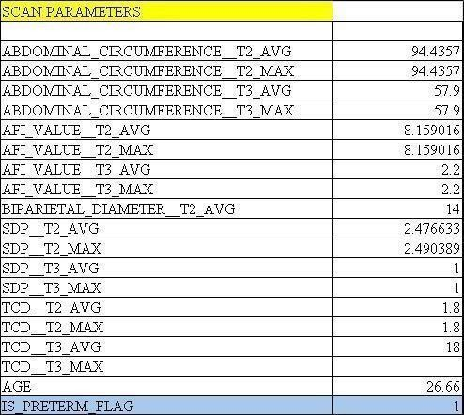

Fig 6.3.4 Patient Scan Results: Preterm Status Flagged

The above figure illustrates the results of scan parameters used in our study to determine the likelihood of preterm birth based on flag values. These scan parameters encompass a range of factors such as early pregnancy scans, growth scans, and NT scans, among others. By visually presenting the outcomes of these scans and their association with preterm birth indicators, this figure provides a comprehensive overview of our research methodology and findings, aiding in the interpretation of our predictive model's performance in identifying high-risk pregnancies.

CHAPTER - 7

CONCLUSION

Our study represents a comprehensive exploration of machine learning-based approaches for predicting premature births during pregnancy. By leveraging both laboratory and scan parameters, we have demonstrated the potential of predictive modeling in identifying pregnancies at risk of preterm delivery. The findings of our study highlight the importance of algorithm selection and feature consideration in optimizing predictive performance. Through our analysis, we have identified several key factors that play a crucial role in assessing the risk of preterm births. These insights offer valuable guidance for clinicians and researchers in developing targeted interventions and personalized management strategies to mitigate the risk of premature delivery. Moving forward, further research is needed to validate the findings of our study and enhance the robustness of predictive models in clinical practice. Prospective studies involving larger cohorts and diverse populations will help to corroborate our results and ensure the generalizability of predictive models across different settings. Our study underscores the potential of machine learning techniques in advancing our understanding of premature birth prediction and improving maternal and infant healthcare outcomes. By harnessing the power of predictive modeling, we can pave the way for early identification and intervention, ultimately reducing the burden of preterm birth complications on families and healthcare systems.

CHAPTER - 8

FUTURE SCOPE
Our study lays the groundwork for several avenues of future research and development in the field of premature birth prediction using machine learning techniques.
Integration of Comprehensive Patient History: Incorporating detailed patient histories, including disease records and previous pregnancy outcomes, into the predictive model represents a critical avenue for enhancing its predictive power. By leveraging this information, the model can better capture individual-level risk factors and tailor predictions to the unique characteristics and medical history of each patient. Collaborations with healthcare providers and electronic health record systems can facilitate seamless integration of these data sources, ensuring that the predictive model is informed by a holistic understanding of the patient's health trajectory. Additionally, ongoing validation and refinement of the model based on real-world patient data will be essential to optimize its performance and clinical utility.

CHAPTER - 9

REFERENCES

- N. Saranya, R. Pavithra, M. Priya, “Prediction of Preterm Baby using Machine Learning Algorithm,” IOSR Journal of Nursing and Health Science (IOSR-JNHS), Volume-8, Issue-2, 2019, PP-85-90.
- T. Cobo, M. Kacerovsky, B. Jacobsson, “Risk for spontaneous preterm delivery,”
Volume-150, Issue-1, 2020, PP-17-23
- B. Ahadi, Hamid A. Majd, S. Khodakarim, F. Rahimi, N. Kariman, M. Khalili, N. Safavi, “Using support vector machines in predicting and classifying factors affecting pre- term delivery,” Archives Of Advances In Biosciences (Journal Of Paramedical Sciences), 2016, Volume-7, PP-37-42.
- T. Tran, Wei Luo, D. Phung, J. Morris, K. Rickard, S. Venkatesh, “Pre-term Birth Prediction: Deriving Stable and Interpretable Rules from High Dimensional Data∗”. Proceedings of the 1st Machine Learning for Healthcare Conference, PMLR 56:164-177, 2016.
- N. S Prema, M. P Pushpalatha, “Machine Learning Approach for Preterm Birth Prediction Based on Maternal Chronic Conditions”. Emerging Research In Electronics, Computer Science and Technology, Volume-545, PP-581-588, 2019.
- Z. Asli, A. Seval Ozgu-Erdinc, “Prediction of Pre-term Birth: Maternal Characteristics, Ultrasounds Markers, and Biomarkers: An Updated Overview,” Article ID 8367571, Volume 2018, 2018.
- J. L. Wallace, K. L. Aland, K. Blatt, E. Moore, and E. A. DeFranco, “Modifying the risk of recurrent pre-term birth: influence of trimester-specific changes in smoking behaviors,” American Journal of Obstetrics & Gynecology, vol. 216, no. 3, pp. 310– 310.e8, 2017.

abstact

ORIGINALITY REPORT
21%
SIMILARITY INDEX
19%
INTERNET SOURCES

7%
PUBLICATIONS
13%
STUDENT PAPERS

PRIMARY SOURCES
1

www.coursehero.com
Internet Source %
1

fastercapital.com
Internet Source %
2
1

www.cse.griet.ac.in
Internet Source %
3
1

www.lbrce.ac.in
Internet Source %
4
1

Submitted to iGroup
Student Paper %
5
1

Submitted to Gardner-Webb University
Student Paper %
6
1

github.com
Internet Source %
7
1

www.ijraset.com
Internet Source %
8
1

www.mdpi.com
Internet Source %
9
1


repositori.udl.cat
Internet Source


www.openaccessjournals.com
Internet Source


Submitted to Jawaharlal Nehru Technological University Kakinada
Student Paper


sist.sathyabama.ac.in
Internet Source


dev.to
Internet Source


Abdelaziz Testas. "Distributed Machine Learning with PySpark", Springer Science and Business Media LLC, 2023
Publication


cse.anits.edu.in
Internet Source


Submitted to University of Bedfordshire
Student Paper


leela05.medium.com
Internet Source


scholars.mssm.edu
Internet Source


Submitted to Nottingham Trent University
Student Paper
1%
1%
1%

1%
<1%
<1%

<1%
<1%
<1%
<1%
<1%


Submitted to University of Northampton
Student Paper


Submitted to George Bush High School
Student Paper


ijrpr.com
Internet Source


python-adv-web-apps.readthedocs.io
Internet Source


www.javatpoint.com
Internet Source


Submitted to Wilkes University
Student Paper


www.techbaz.org
Internet Source


"Emerging Research in Computing, Information, Communication and Applications", Springer Science and Business Media LLC, 2022
Publication


Submitted to University of Hertfordshire
Student Paper


ia802506.us.archive.org
Internet Source


Submitted to Chadron State College
Student Paper
<1%
<1%
<1%
<1%
<1%
<1%
<1%
<1%

<1%
<1%
<1%


Submitted to Corvinus University of Budapest
Student Paper


Submitted to Manchester Metropolitan University
Student Paper


gecgudlavalleru.ac.in
Internet Source


jpedres.org
Internet Source


khazna.ku.ac.ae
Internet Source


www.cs.indiana.edu
Internet Source


Submitted to Carnegie Mellon University
Student Paper


Submitted to KEDGE Business Schools
Student Paper


www.cs.jhu.edu
Internet Source


Submitted to University of Wales Institute, Cardiff
Student Paper


Submitted to University of Liverpool
Student Paper
<1%
<1%

<1%
<1%
<1%
<1%
<1%
<1%
<1%
<1%

<1%


core.ac.uk
Internet Source

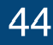
etd.aau.edu.et
Internet Source


Submitted to University of Central Florida
Student Paper


cse.lbrce.ac.in
Internet Source


huggingface.co
Internet Source


slideplayer.com
Internet Source


www.slideshare.net
Internet Source


Submitted to Kwame Nkrumah University of Science and Technology
Student Paper


healthmedicinet.com
Internet Source


bmcnephrol.biomedcentral.com
Internet Source


ijircce.com
Internet Source


python.hotexamples.com
<1%
<1%
<1%
<1%
<1%
<1%
<1%
<1%

<1%
<1%
<1%

Internet Source


www.analyticsvidhya.com
Internet Source


www.frontiersin.org
Internet Source


Submitted to Heriot-Watt University
Student Paper


bnrc.springeropen.com
Internet Source


dspace.daffodilvarsity.edu.bd:8080
Internet Source


ebin.pub
Internet Source


hdl.handle.net
Internet Source


ijritcc.org
Internet Source


python.mrkishorekumar.com
Internet Source


robots.net
Internet Source


sjcit.ac.in
Internet Source
<1%
<1%
<1%
<1%
<1%
<1%
<1%
<1%
<1%
<1%
<1%
<1%

www.dovepress.com
66
Internet Source

www.feedsbooks.com
67
Internet Source

www.ir.juit.ac.in:8080
68
Internet Source

Imran Khan, Brajesh Kumar Khare. "Exploring the potential of machine learning in
gynecological care: a review", Archives of Gynecology and Obstetrics, 2024
Publication

Pablo Ferri Borredà. "Deeep Continual Multimodal Multitask Modells for Out-of-
Hospital Emergency Medical Call Incidents Triage Support in the Presence of Dataset Shifts", Universitat Politecnica de Valencia, 2024
Publication

Sandeep Chadha, Vanita Jain, Indu Gupta, Madhu Khullar. "Nitric oxide metabolite levels
in preterm labor", Journal of Obstetrics and Gynaecology Research, 2007
Publication
<1%
<1%
<1%
<1%

<1%

<1%

Satya Mallipam <mallipamedu@gmail.com>

FICTA-2024: -Notification of Acceptance for Paper-ID [*PM-ficta-02*] and Guidelines for Registration & CRC Submission
1 message

FICTA-2024 London, UK <info@ficta.co.uk> 8 April 2024 at 16:21 To: Hema Latha Munnamgi <lathamunnangi@gmail.com>, POOJITHA GUDIBANDI <gudibandipoojitha@gmail.com>, Satya Mallipam <mallipamedu@gmail.com>, Thatikonda Swathi <thatikondaswathi666@gmail.com>
Cc: editor ficta <editor.ficta@gmail.com>

Dear Authors,

Paper-ID: [*PM-ficta-02*]
Title: [*Machine Learning for premature birth prediction during Pregnancy*] Congratulations!
On behalf of editorial board of FICTA-2024, we are happy to inform you that your above referenced paper has been ACCEPTED (based on the review reports) for presentation in FICTA-2024 conference in hybrid mode to be organized by AI and Data Science (AI&DS) Research Group, London Metropolitan University, London, United Kingdom during 06-07 June 2024.

Please refer to the reviewers' comments attached below which are intended to help you to improve your paper for final publication. You are advised to address the comments of the reviewers in your final paper suitably.

An accepted and presented paper will be published in the conference proceedings (Springer SIST Series-indexed in SCOPUS, EI Compendex, INSPEC, WTI Frankfurt eG, zbMATH, Japanese Science and Technology Agency (JST), SCImago, DBLP) only if the final version is accompanied by the registration fee payment information for at least one of the authors.

---------------------------------------------------------------------------------------------

Instructions for Author(s) Registration & Payment of Registration Fee
---------------------------------------------------------------------------------------------
- The details of registration fee as well as guidelines may be referred to at: https://ficta.co.uk/registration
- Kindly pay the conference registration fee via the following registration form and payment link(s): https://buy.stripe.com/cN2eWU5Dp4dG6FG9AB (For payment in GBP)
https://buy.stripe.com/9AQbKIgi3cKc9RS7su (For payment in USD) https://rzp.io/l/briB5XDMt(For payment in INR).
- After completion of payment through the above link you will receive a registration and online payment confirmation mail at your registered email ID (also check your spam folder). You are requested to take a snapshot of this payment confirmation, rename it with your paper id and preserve it as [*PAPER-ID*]_PaymentProof.
------------------------------------

Mode of Paper Presentation
-------------------------------------
The conference will be conducted in hybrid mode.

In Physical Mode: June 06, 2024 (Thursday)
Venue: #Room #GC1-08, London Metropolitan University, 166-220 Holloway Road, London N7 8DB, United Kingdom
In Online Mode: June 07, 2024 (Friday) On MS Teams/Google Meet Platform
As the conference is being conducted in hybrid mode; the mode of presentation can be decided by the author individually. The payment of registration shall be made accordingly as there are different registration fee for physical (offline) and virtual (online) mode.
---------------------------------------------------------------------------------------------------------------

Guidelines for Preparation of Camera-Ready Copy (CRC) for Publication in Springer Proc. of FICTA- 2024
--------------------------------------------------------------------------------------------------------------
- CRC for FICTA-2024 should be prepared as per the guidelines mentioned at: https://ficta.co.uk/crc
- Template for preparation of CRC is available at the above link.
The process of filling the "Springer Copyright Form/Publishing Agreement Form" by authors will be initiated after the completion of the conference.

-----------------------------------------------------------

Upload of CRC, Payment Proof and Deadline
-----------------------------------------------------------
You are requested to finalize the following files after renaming those with your paper id.
- Final paper (based on review comments) in pdf file.
- Final paper source file: Either in WORD file or in LaTex (For latex, all the associated files should be given as zip file).
- Payment proof of your online registration payment (received on your email after payment)
- Kindly rename all files with your PAPER ID (for example: [*PAPER-ID*]CRC.pdf, [*PAPER- ID*]_CRC.docx, [*PAPER-ID*]_PaymentProof.pdf).
- Kindly fill the following submission form to upload the above documents through the given link: https://forms.gle/ JsDexqyE6SED5QWt7
The above process should be completed by or before: 17 April 2024.
For any queries related to the registration visit the conference website or email the undersigned. Kindly mention your Paper-ID (as mentioned above) in each communication for easy tracking at our end and serving you better in answering your queries.
Thanking You

Warm Regards General Chair
FICTA-2024, London Metropolitan University London, UK
Conference Website: https://ficta.co.uk/
E-Mail: info@ficta.co.uk

*****REVIEW#1*****
Following, points should be also checked in finalsubmission:

- Add missing publication details in references. Allthe references must be cited within the text.
- Allfigures, equations and tables must be numbered properly and should be cited within the text.
- The figures given in the papers should be 800dpi so that the picture clarity can be maintained. 4. Use uniform style for headings and subheading as per Springer template. Do not use IEEE Template.

*****REVIEW#2 *****
Authors are advised to incorporate the following points in the final paper:
- The content matching must be within 20%. Single source matching not to exceed 4%.
- Allauthors name, affiliation and mailids must be there and the corresponding author to be marked.
- No biography or photos of authors should be there.
- Authors must check the English language carefully.
- Paper should be at least 10 pages in length on the Springer template. Beyond 12 pages, extra page charges apply.
- The work must be original and should not have been submitted or published in any other conf or journal. At any point of time, if it is being traced that the paper/content is AI-generated then the paper will be rejected without refund of registration fee.

Machine Learning for premature birth prediction during Pregnancy
¹ Hemalatha munnamgi, ²gudibandi poojitha, ³mallipam satya praneeth,
4
THATIKONDA SWATHI
1Sr.Assistant Professor, Department of Information Technology, Lakireddy Bali Reddy College of Engineering, Mylavaram, Andhra Pradesh-521230, India
2,3,4Student, Department of Information Technology, Lakireddy Bali Reddy College of Engineering, Mylavaram, Andhra Pradesh-521230, India
¹lathamunnangi@gmail.com, ²gudibandipoojitha@gmail.com, ³mallipamedu@gmail.com
⁴ thatikondaswathi666@gmail.com

Abstract
Preterm or premature birth refers to the delivery of a baby before completing 37 weeks of gestation., poses significant health risks to newborns and remains a global concern. This paper addresses the need for an accurate predictive model for preterm birth using a comprehensive set of parameters from both laboratory and scan reports during pregnancy journey. Our study extends this scope to include a broader range of parameters. Our proposed system involves the integration of various lab and scan parameters, such as RBC count, WBC count, haemoglobin, TSH, abdominal circumference, cervix length, placenta position, etc...Unlike previous studies, which focus on a limited set of parameters, our research aims to build a machine learning model leveraging a diverse range of factors from lab and scan reports. The study includes the application of traditional statistical techniques like (Logistic Regression, Naïve Bayes) and ensemblling learners (Random Forest, Gradient Boost, XG Boost. Our end goal is to explore the association between various parameters and preterm labour, utilizing a dataset of approximately 4,000 patient records for lab reports and 7,000 patient records for scan reports. The predictive model is designed to assess the the likelihood of preterm birth occurring at the 35th week of gestation, allowing sufficient time for preventive measures. This research contributes to advancing our understanding of preterm birth predictors and facilitates timely intervention to reduce associated health complications and emotional burdens.
Keywords: Preterm Birth Prediction, Machine Learning, Laboratory and Scan Reports, Lab Report and Scan Parameters, traditional statistical techniques and ensembling Learners, Predictive Model, Patient Records, Preventive Measures, Neonatal Health, Healthcare Intervention, Global Preterm Birth Rates.

I Introduction
Premature birth, defined as delivery before completing 37 weeks of gestation, remains a critical global health concern due to its associated risks to neonatal health and increased rates of infant mortality. Our paper aims to address this challenge by applying machine learning techniques to predict preterm births during pregnancy. Unlike existing studies focusing on specific inflammation markers, our approach incorporates a comprehensive array of parameters from laboratory analyses and diagnostic imaging reports, expanding the scope of predictive features. Through traditional statistical techniques and ensemble learners such as logistic regression, naive bayes, random forest, and boosting algorithms, we seek to develop a robust predictive model capable of assessing the probability of preterm birth by the 35th week of gestation. Ultimately, our goal is to provide healthcare professionals and expectant mothers with a tool to mitigate critical risks for potential preterm patient.

II Literature Survey
In the exploration of predicting preterm birth during pregnancy and leveraging lab and scan parameters, this comprehensive literature survey amalgamates insights from various studies. One study delves into the role of inflammatory markers, particularly emphasizing the elevated neutrophil- to-lymphocyte ratio as a potential risk indicator for preterm birth ([1]). This underlines the importance of understanding the inflammatory processes associated with preterm labour. Another study introduces an innovative approach by developing an expert system that utilizes machine learning for preterm birth risk assessment, showcasing its superiority over traditional manual methods ([2]). This not only highlights the significance of incorporating advanced computational methods but also emphasizes the potential for personalized risk assessment in clinical settings. Serum markers take centre stage in a third study, focusing on the neutrophil-to-lymphocyte ratio as a potential predictor for late preterm birth, adding valuable dimensions to risk assessment ([3]). In a distinct context, a study situated in rural India introduces the Risk Prediction Conceptual Model (RPCM), a machine learning model that demonstrates promising accuracy in predicting preterm births using a combination of scan parameters and lab data, particularly with the SVM classifier ([4]). This reflects the importance of considering regional and demographic variations in developing effective prediction models. Shifting the focus to the broader context of inflammation, a study critically reviews its role in both preterm and term parturition, emphasizing the potential for early detection through a molecular signature of inflammation ([5]). Another study investigates blood cell subtypes, particularly neutrophils, as potential predictors for preterm labour. While revealing significant elevations, the study wisely advocates for further validation of these parameters before their clinical application ([6]). Lastly, a study contributes valuable insights into maternal leukocyte activation during both term and preterm labour, identifying an increase in monocyte and neutrophil activation. This study suggests the potential for novel diagnostic tools that could significantly advance the prediction of preterm birth ([7]). Collectively, these studies provide a nuanced and holistic understanding of preterm birth prediction, encompassing inflammatory markers, advanced computational methods, serum markers, regional considerations, and immune responses. These insights contribute to ongoing efforts to enhance the accuracy and effectiveness of predicting preterm birth during pregnancy, particularly when leveraging the wealth of data available through lab and scan parameters.

III Proposed Methodology
The proposed methodology for this research involves a comprehensive approach to preterm birth prediction, integrating machine learning algorithms with a diverse set of parameters obtained from lab tests and various scans conducted during pregnancy. Our study seeks to address the limitations of existing systems by expanding the scope of analyzed parameters and incorporating advanced machine learning techniques.

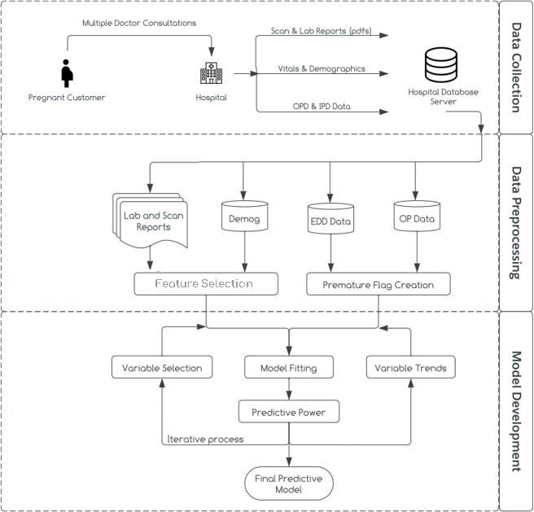

Fig 3.1 System Design
Data Collection:
For this study, data is collected from trusted repositories, comprising 4,332 patient records for laboratory reports and 7,114 patient records for scan reports. Each record is labeled to indicate whether the patient experienced preterm birth or not. The parameters derived from lab reports include RBC/WBC count, haemoglobin, TSH, and other relevant indicators, while scan reports contribute parameters such as abdominal circumference, placenta position, and more. Additionally, vital signs data, demographics, Estimated Due Date (EDD) data, Inpatient (IP) data, and Outpatient (OP) data are integrated into the model development process. Vitals provide critical physiological measurements, demographics offer insights into patient characteristics, and EDD data helps capture timing-related factors in pregnancy outcomes. IP data provides information on medical history and treatment, while OP data offers details on outpatient interventions relevant for predictive modeling. This comprehensive approach ensures the incorporation of diverse factors crucial for accurate preterm birth prediction.

Data Preprocessing:
Data preprocessing is a critical step in system design, involving the preparation of collected data for analysis and model development. Firstly, variable selection focuses on identifying relevant features to hone in on the most significant factors influencing outcomes. Analyzing variable trends provides insights into patterns and changes across different conditions or time periods. Extraction parameters involve deriving new variables from raw data to capture crucial information, while feature selection further refines variables using techniques like information gain. Finally, creating a premature flag involves generating an indicator variable to identify cases of prematurity based on specific criteria or

thresholds related to gestational age or other pertinent factors. These steps collectively ensure that the data is appropriately refined and tailored for accurate analysis and modeling.

Model Development:
Model development is a pivotal stage in system design, where predictive models are crafted based on pre-processed data. Firstly, model fitting adjusts parameters to optimize performance, aiming to minimize errors or maximize data likelihood. Reports are generated to summarize findings, including model performance metrics and evaluation results. The final predictive model, refined through iterative processes, is developed to estimate preterm birth probability at the 35th week of gestation, utilizing parameters from both laboratory and scan reports aggregated at trimester levels. Evaluation involves rigorous testing on a separate validation dataset, using metrics such as accuracy, precision, recall, and AUC-ROC to assess predictive power and parameter significance. Ultimately, the model aims to provide healthcare professionals and expectant mothers with a practical tool for preventive measures.

Logistic Regression
Logistic Regression is a commonly used algorithm for binary classification tasks, such as predicting premature birth. In our study, we employed Logistic Regression to analyze the relationship between various laboratory and scan parameters and the likelihood of premature birth during pregnancy. By fitting a logistic regression model, we estimated the probability of premature birth based on input features and identified key predictors through feature selection and regularization techniques. The interpretability of logistic regression coefficients provided valuable insights into the direction and strength of each variable's influence, aiding in the identification of high-risk pregnancies and informing clinical decision-making.

Naïve Bayes
Naive Bayes is a probabilistic classification algorithm based on Bayes' theorem with an assumption of independence between predictors. Despite its simplistic assumptions, Naive Bayes has shown effectiveness in various applications, including medical diagnosis. In our study, we applied Naive Bayes to predict premature birth risk during pregnancy using laboratory and scan parameters as input features. By calculating conditional probabilities of premature birth given the observed parameter values, Naive Bayes provided a straightforward yet efficient way to classify pregnancies into high or low risk categories. Despite its simplicity, Naive Bayes demonstrated competitive performance in our experiments, highlighting its potential as a practical tool for early identification of pregnancies at risk of premature birth.

Random Forest
Random Forest is an ensemble learning algorithm that constructs multiple decision trees during training and outputs the mode of the classes (classification) or the mean prediction (regression) of the individual trees. In our study, Random Forest proved to be a robust algorithm for premature birth prediction by leveraging the strengths of multiple decision trees. By training a Random Forest model on our dataset consisting of laboratory and scan parameters, we were able to capture complex nonlinear relationships between predictors and the likelihood of premature birth. The ensemble nature of Random Forest helped mitigate overfitting and improved generalization performance, making it particularly suitable for handling high-dimensional data with potentially correlated features. Moreover, the algorithm provided insights into feature importance, aiding in the identification of critical predictors contributing to premature birth risk.

XG Boost
XG Boost, an implementation of gradient boosted decision trees, has gained popularity for its exceptional performance in various machine learning tasks, including classification and regression. In our paper, we utilized XG Boost to predict premature birth risk during pregnancy based on a set of laboratory and scan parameters. By iteratively adding decision trees that minimize a specified loss function, XG Boost effectively learned complex patterns in the data, leading to superior predictive accuracy compared to traditional algorithms. The algorithm's ability to handle missing values, categorical variables, and nonlinear relationships proved advantageous in our study, allowing us to extract valuable insights from heterogeneous pregnancy data. Additionally, XG Boost provided interpretable feature importance scores, facilitating the identification of key predictors associated with premature birth risk.

Stacked Ensemble (Logistic Regression + Random Forest + Gradient Boosting)
Our study introduces a novel approach to premature birth prediction during pregnancy through the implementation of a stacked ensemble model. By combining the strengths of Logistic Regression, Random Forest, and Gradient Boosting, we aimed to harness the diverse learning capabilities of these algorithms to improve predictive performance. The stacked ensemble model operates by aggregating predictions from multiple base models, leveraging the complementary strengths of each algorithm to enhance overall accuracy and robustness. Logistic Regression offers interpretability and captures linear relationships between predictors and premature birth risk, while Random Forest excels at capturing complex nonlinear patterns in the data and mitigating overfitting. Meanwhile, Gradient Boosting iteratively improves prediction accuracy by focusing on the residual errors of previous models, thereby refining the ensemble's predictive power. Through careful model stacking and blending of predictions, our stacked ensemble model synergistically integrates the predictive abilities of these diverse algorithms, resulting in a more accurate and reliable predictor of premature birth risk during pregnancy. Furthermore, the ensemble nature of the model helps mitigate individual algorithm biases and variance, leading to improved generalization performance on unseen data. Experimental results demonstrate the superior predictive performance of the stacked ensemble model compared to individual algorithms, highlighting its potential as a valuable tool for early identification of high-risk pregnancies and informed clinical decision-making.
  - Integrated Analysis
The proposed methodology for predicting premature birth during pregnancy involves an integrated analysis of three distinct approaches: lab parameters, scan parameters, and a combined approach utilizing both data sources. Initially, machine learning algorithms were applied separately to lab parameters, focusing on biochemical markers and physiological measurements. This aimed to assess the predictive power of these indicators in isolation. A similar analysis was conducted using scan parameters, emphasizing ultrasound imaging data to evaluate its contribution to premature birth prediction. Subsequently, a holistic approach combining lab and scan parameters was adopted to leverage the complementary nature of biochemical and imaging markers. By systematically comparing algorithm performance across these approaches, insights were gained into the relative importance of different feature sets and their impact on predictive modeling outcomes. Overall, this integrated analysis framework not only expanded understanding of predictive factors for premature birth but also facilitated the development of more effective risk assessment models tailored to individual patient profiles.

  - Information Gain
In our study, we employed feature selection techniques to identify the most informative predictors for premature birth prediction. Information gain, a commonly used metric in feature selection, measures the reduction in entropy or uncertainty achieved by splitting data based on a particular feature. Features with higher information gain values are considered more informative and are thus prioritized for inclusion in predictive models. Through rigorous analysis, we identified a subset of features with high information gain values, indicating their significance in predicting premature births. These features provide valuable insights into the underlying factors contributing to preterm delivery and enable more accurate risk assessment. The selection of features based on information gain enhances the interpretability and efficiency of predictive models, as it focuses on the most relevant predictors while discarding redundant or less informative features. By leveraging the power of information gain, we can develop more robust and accurate predictive models for premature birth prediction, ultimately improving maternal and infant healthcare outcomes.

IV Results & Discussions
Our study aimed to assess the predictive performance of various machine learning algorithms for a model focused on premature birth prediction using only lab parameters. In this section, we present the results of our analysis, which include the accuracy metrics obtained for each algorithm evaluated. By comparing the performance of different algorithms, we aimed to identify the most effective predictive models for early detection of premature births based solely on laboratory data. The findings presented here offer valuable insights into the strengths and limitations of each algorithm, guiding future research and clinical applications in maternal and infant healthcare.

Lab Parameters
Our study focused on evaluating the predictive performance of various machine learning algorithms for a model based solely on lab parameters. In this section, we present the results of our analysis, which include the accuracy metrics obtained for each algorithm evaluated. By comparing the performance of different algorithms within the context of lab parameters, we aimed to identify the most effective predictive models for early detection of premature births.


Fig 4.1.1 Performance Metrics using lab parameters
Above table gives the predictive performance of various machine learning algorithms for a model focused on premature birth prediction using a combination of lab parameters and imaging scan data. Among the algorithms assessed, the Stacked Model demonstrated the highest accuracy with a score of 0.91308, indicating superior predictive performance. Notably, Random Forest also exhibited strong performance with an accuracy of 0.85769, closely followed by Naive Bayes with a score of 0.84385.

However, Logistic Regression and XG Boost achieved comparatively lower accuracies of 0.73308 and 0.84538, respectively. These findings highlight significant variations in predictive capability among the algorithms tested, underscoring the importance of algorithm selection in optimizing predictive performance for premature birth prediction.


Fig 4.1.2 Accuracies of various algorithms using lab parameters
  - Scan Parameters
Our study focused on evaluating the predictive performance of various machine learning algorithms for a model based solely on scan parameters. In this section, we present the results of our analysis, which include the accuracy metrics obtained for each algorithm evaluated. By comparing the performance of different algorithms within the context of scan parameters, we aimed to identify the most effective predictive models for early detection of premature births.


Fig 4.2.1 Performance Metrics using scan parameters
Our study aimed to assess the predictive performance of various machine learning algorithms for a model focused on premature birth prediction using lab parameters exclusively. The accuracy metrics obtained for each algorithm are summarized in Fig 4.2.1. Notable variations were observed in the predictive performance of the algorithms, with Random Forest achieving the highest accuracy of 0.95878, closely followed by XG Boost with 0.94614. These algorithms demonstrated strong predictive capabilities, indicating their potential utility in identifying premature births based on lab parameters alone. In contrast, Logistic Regression and Naive Bayes exhibited lower accuracies of 0.76815 and 0.67119, respectively. Despite not achieving the highest accuracy, the Stacked Model displayed competitive performance with an accuracy of 0.92131.These findings underscore the importance of algorithm selection in optimizing predictive accuracy for premature birth prediction. Random Forest and XG Boost emerge as promising candidates, offering superior performance compared to Logistic Regression and Naive Bayes.

However, further investigation is warranted to explore the potential synergies of ensemble methods, such as the Stacked Model, in enhancing predictive accuracy.


Fig 4.2.2 Accuracies of various algorithms using scan parameters
  - Lab & Scan Parameters
Our study focused on evaluating the predictive performance of various machine learning algorithms for a model based on lab and scan parameters. In this section, we present the results of our analysis, which include the accuracy metrics obtained for each algorithm evaluated. By comparing the performance of different algorithms within the context of lab and scan parameters, we aimed to identify the most effective predictive models for early detection of premature births.
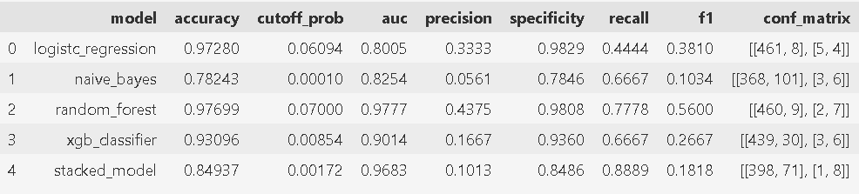

Fig 4.3.1 Performance Metrics using lab and scan parameters
In our analysis of classification models, Logistic Regression emerges as the top performer with an accuracy of 97.28%, highlighting its simplicity and effectiveness. Random Forest closely follows with an accuracy of 97.70%, showcasing the power of ensemble learning methods. XG Boost achieves an accuracy of 93.10%, demonstrating its ability to optimize predictive accuracy through gradient boosting techniques. Naive Bayes lags behind with an accuracy of 78.24%, suggesting potential challenges in capturing complex relationships within the data. The Stacked Model integrates predictions from multiple base models, achieving an accuracy of 84.94%, indicating room for improvement through further refinement of model combinations and parameters.

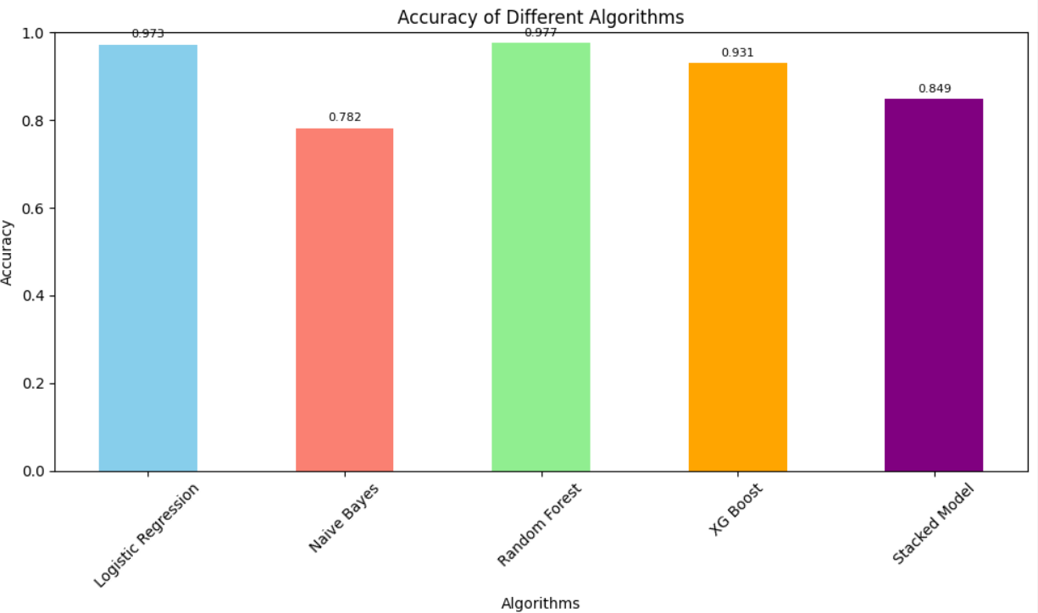

Fig 4.3.2 Accuracies of various algorithms using lab & scan parameters V Conclusion
Our study represents a comprehensive exploration of machine learning-based approaches for predicting premature births during pregnancy. By leveraging both laboratory and scan parameters, we have demonstrated the potential of predictive modelling in identifying pregnancies at risk of preterm delivery. The findings of our study highlight the importance of algorithm selection and feature consideration in optimizing predictive performance. Through our analysis, we have identified several key factors that play a crucial role in assessing the risk of preterm births. These insights offer valuable guidance for clinicians and researchers in developing targeted interventions and personalized management strategies to mitigate the risk of premature delivery. Moving forward, further research is needed to validate the findings of our study and enhance the robustness of predictive models in clinical practice. Prospective studies involving larger cohorts and diverse populations will help to corroborate our results and ensure the generalizability of predictive models across different settings. Our study underscores the potential of machine learning techniques in advancing our understanding of premature birth prediction and improving maternal and infant healthcare outcomes. By harnessing the power of predictive modelling, we can pave the way for early identification and intervention, ultimately reducing the burden of preterm birth complications on families and healthcare systems.

VI FUTURE SCOPE
Our study lays the groundwork for several avenues of future research and development in the field of premature birth prediction using machine learning techniques.
Expansion of Data Collection Efforts: Given the observed trend towards acute preterm births attributed to factors such as dietary changes, environmental pollution, and shifting living standards, future efforts should prioritize the collection of more comprehensive datasets encompassing these variables so that model can predict at the end of 30th week. This entails collaborating with public health agencies, research institutions, and healthcare providers to gather diverse and extensive data sets that capture the multifaceted influences contributing to preterm birth risk. Additionally, leveraging advanced data analytics techniques, including data fusion and integration, can enhance the richness and granularity of the dataset, enabling more robust predictive modelling.

Integration of Comprehensive Patient History: Incorporating detailed patient histories, including disease records and previous pregnancy outcomes, into the predictive model represents a critical avenue for enhancing its predictive power. By leveraging this information, the model can better capture individual-level risk factors and tailor predictions to the unique characteristics and medical history of each patient. Collaborations with healthcare providers and electronic health record systems can facilitate seamless integration of these data sources, ensuring that the predictive model is informed by a holistic understanding of the patient's health trajectory. Additionally, ongoing validation and refinement of the model based on real-world patient data will be essential to optimize its performance and clinical utility.

REFERENCES
- N. Saranya, R. Pavithra, M. Priya, “Prediction of Preterm Baby using Machine Learning Algorithm,” IOSR Journal of Nursing and Health Science (IOSR-JNHS), Volume-8, Issue-2, 2019, PP-85-90.
- T. Cobo, M. Kacerovsky, B. Jacobsson, “Risk for spontaneous preterm delivery,”
Volume-150, Issue-1, 2020, PP-17-23
- B. Ahadi, Hamid A. Majd, S. Khodakarim, F. Rahimi, N. Kariman, M. Khalili, N. Safavi, “Using support vector machines in predicting and classifying factors affecting pre-term delivery,” Archives Of Advances In Biosciences(Journal Of Paramedical Sciences), 2016, Volume-7, PP-37-42.
- T. Tran, Wei Luo, D. Phung, J. Morris, K. Rickard, S. Venkatesh, “Pre-term Birth Prediction: Deriving Stable and Interpretable Rules from High Dimensional Data∗”. Proceedings of the 1st Machine Learning for Healthcare Conference, PMLR 56:164-177, 2016.
- N. S Prema, M. P Pushpalatha, “Machine Learning Approach for Preterm Birth Prediction Based on Maternal Chronic Conditions”. Emerging Research In Electronics, Computer Science and Technology, Volume-545, PP-581-588, 2019.
- Z. Asli, A. Seval Ozgu-Erdinc, “Prediction of Pre-term Birth: Maternal Characteristics, Ultrasounds Markers, and Biomarkers: An Updated Overview,” Article ID 8367571, Volume 2018, 2018.
- J. L. Wallace, K. L. Aland, K. Blatt, E. Moore, and E. A. DeFranco, “Modifying the risk of recurrent pre- term birth: influence of trimester-specific changes in smoking behaviors,” American Journal of Obstetrics & Gynecology, vol. 216, no. 3, pp. 310– 310.e8, 2017.

abstract
ORIGINALITY REPORT
10

%
SIMILARITY INDEX

8%
INTERNET SOURCES

6%
PUBLICATIONS

5%
STUDENT PAPERS

PRIMARY SOURCES

www.mdpi.com
1
1
Internet Source %

fastercapital.com
2
1
Internet Source %

Submitted to Coventry University
3
1
Student Paper %

ijrpr.com
4
1
Internet Source %

www.comsol.com
5
1%
Internet Source

6 "Emerging Research in Computing, Information, Communication and
Applications", Springer Science and Business Media LLC, 2022
Publication

7 "Emerging Research in Electronics, Computer Science and Technology", Springer Science
and Business Media LLC, 2019
Publication
<1%

<1%

8 Submitted to Manchester Metropolitan University
Student Paper

jpedres.org
9
Internet Source

10 Submitted to University of Northumbria at Newcastle
Student Paper

Submitted to University of Strathclyde
11
Student Paper

12 Submitted to Kwame Nkrumah University of Science and Technology
Student Paper

huggingface.co
13
Internet Source

14 Ali Al Bataineh, Sarah Manacek. "MLP-PSO Hybrid Algorithm for Heart Disease Prediction", Journal of Personalized Medicine, 2022
Publication

Submitted to Brunel University
Student Paper
15

D. Szpurek, R. Moszynski, A. Smolen, S. Sajdak.
16 "Artificial neural network computer prediction of ovarian malignancy in women
<1%

<1%
<1%

<1%
<1%

<1%
<1%

<1%
<1%

with adnexal masses", International Journal of Gynecology & Obstetrics, 2005
Publication

ijircce.com
17
Internet Source

www.hindawi.com
18
Internet Source

19 Eskeziaw Abebe Kassahun, Seifu Hagos Gebreyesus, Kokeb Tesfamariam, Bilal Shikur Endris et al. "Development and validation of a
simplified risk prediction model for preterm birth: a prospective cohort study in rural Ethiopia", Scientific Reports, 2024
Publication

ijritcc.org
20
Internet Source

21 turcomat.org
Internet Source

<1%
<1%
<1%

<1%
<1%

Exclude quotes Off Exclude bibliography On
Exclude matches Off

