Case Study: ICERs

|  |
| --- |
| Important |
| Please note that you can download PDF and Microsoft Word versions of this case study using the links on the right. |

# Case 1 Description

You seek to explore different drug strategies to treat HIV infection. Single agent therapy with retrocyclovir at 200mg per day has a mean discounted lifetime cost of $20,000 and results in a quality-adjusted life expectancy of 70 years. Single agent therapy with retrocyclovir at 400mg per day has a mean discounted lifetime cost of $22,000 and a quality adjusted life expectancy of 65 years (given the increased incidence of side effects with the higher dose). Another drug, centroflexavir (which comes only in one dose of 250 mg/day) has a mean total lifetime cost of $10,000 and a quality-adjusted life expectancy of 50 years. The combination of centroflexavir with low-dose retrocyclovir has a mean-life time cost of $40,000 and an average quality adjusted life expectancy of 80 years, while the combination of centroflexavir with high-dose retrocyclovir has a mean lifetime cost of $35,000 and a quality-adjusted life expectancy of 75 years.

Newer ARTs are also available and their lifetime costs/QALYs are detailed below:

Cost and QALY Outcomes for ARTs

|  | Cost | QALY |
| --- | --- | --- |
| ART 1/2 | 11,000 | 63.4 |
| ART 1 | 15,525 | 73.52 |

## Instructions

*Perform a cost-effectiveness analysis of the treatment options using QALYs as the measure of health effects. Which strategy would you choose and why, if the willingness-to-pay threshold is $50,000 per quality-adjusted life year?*

| Treatment | Costs | QALYs |
| --- | --- | --- |
| Do nothing | 36,000 | 43.8 |
| ART 1 | 15,525 | 73.52 |
| ART 1/2 | 11,000 | 63.4 |
| Retro 200 | 20,000 | 70.0 |
| Retro 400 | 22,000 | 65.0 |
| Centro | 10,000 | 50.0 |
| Centro / Retro 200 | 40,000 | 80.0 |
| Centro / Retro 400 | 35,000 | 75.0 |

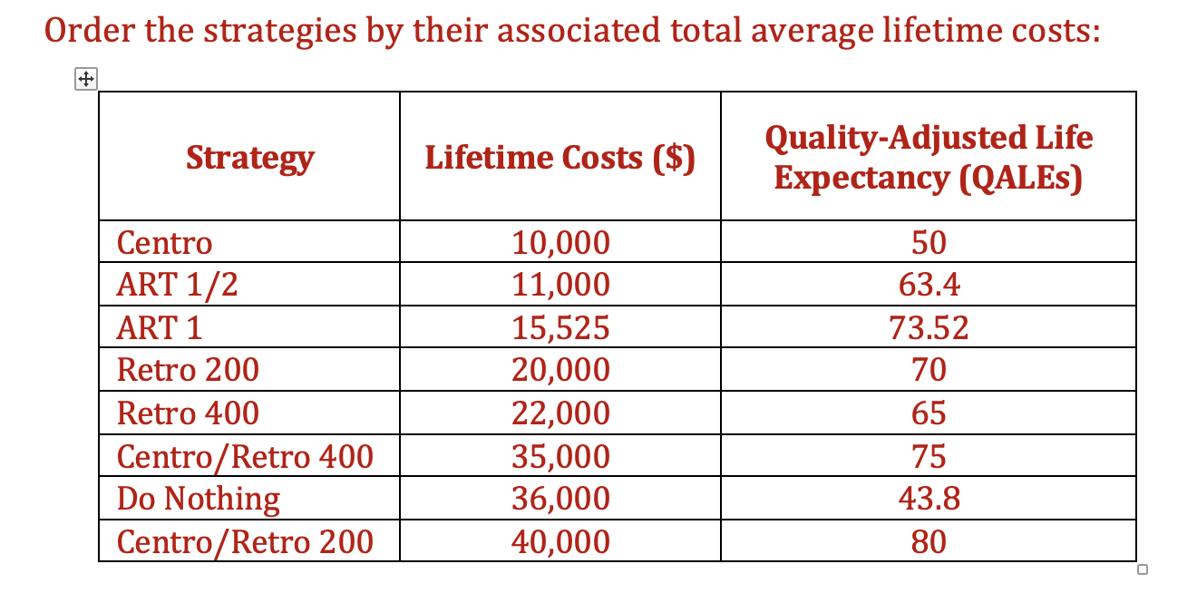

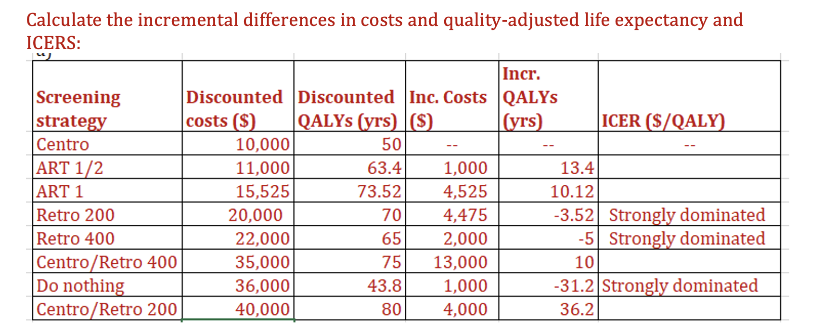



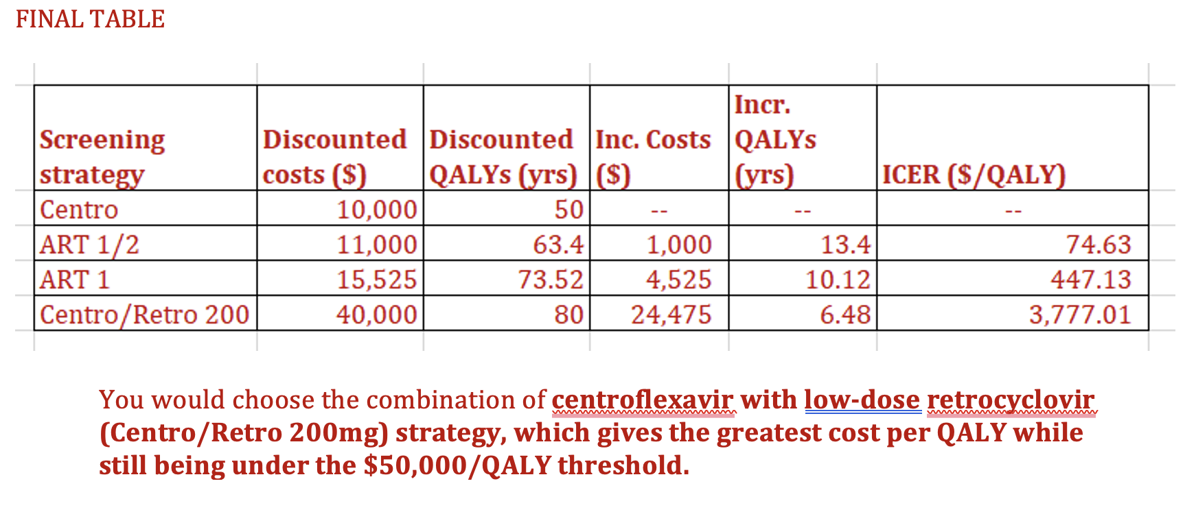

Treatment Options

| Strategy | Discounted Costs | Discounted QALYs | Incremental Costs | Incremental QALYs | ICER ($/QALY) |
| --- | --- | --- | --- | --- | --- |
|  |  |  |  |  |  |
|  |  |  |  |  |  |
|  |  |  |  |  |  |
|  |  |  |  |  |  |
|  |  |  |  |  |  |
|  |  |  |  |  |  |
|  |  |  |  |  |  |
|  |  |  |  |  |  |

ICER Calculation Table 1

| Strategy | Discounted Costs | Discounted QALYs | Incremental Costs | Incremental QALYs | ICER ($/QALY) |
| --- | --- | --- | --- | --- | --- |
|  |  |  |  |  |  |
|  |  |  |  |  |  |
|  |  |  |  |  |  |
|  |  |  |  |  |  |
|  |  |  |  |  |  |
|  |  |  |  |  |  |
|  |  |  |  |  |  |
|  |  |  |  |  |  |

ICER Calculation Table 2

| Strategy | Discounted Costs | Discounted QALYs | Incremental Costs | Incremental QALYs | ICER ($/QALY) |
| --- | --- | --- | --- | --- | --- |
|  |  |  |  |  |  |
|  |  |  |  |  |  |
|  |  |  |  |  |  |
|  |  |  |  |  |  |
|  |  |  |  |  |  |
|  |  |  |  |  |  |
|  |  |  |  |  |  |
|  |  |  |  |  |  |

: ICER Calculation Table 3 {tbl-colwidths=“[20,20,20,20,20,20]”}

# Case 2 Description

You are interested in performing a cost-effectiveness analysis of different cancer screening recommendations for anal squamous intraepithelial lesions and anal cancer in men.

Below is a table of the costs and quality-adjusted life years gained associated with different screening strategies over a six-year time span.

## Instructions

*Calculate incremental cost-effectiveness ratios for each strategy and determine which screening strategy you would choose if, as a decision maker, you were prepared to pay $50,000/QALY (using discounted quality-adjusted life years)*

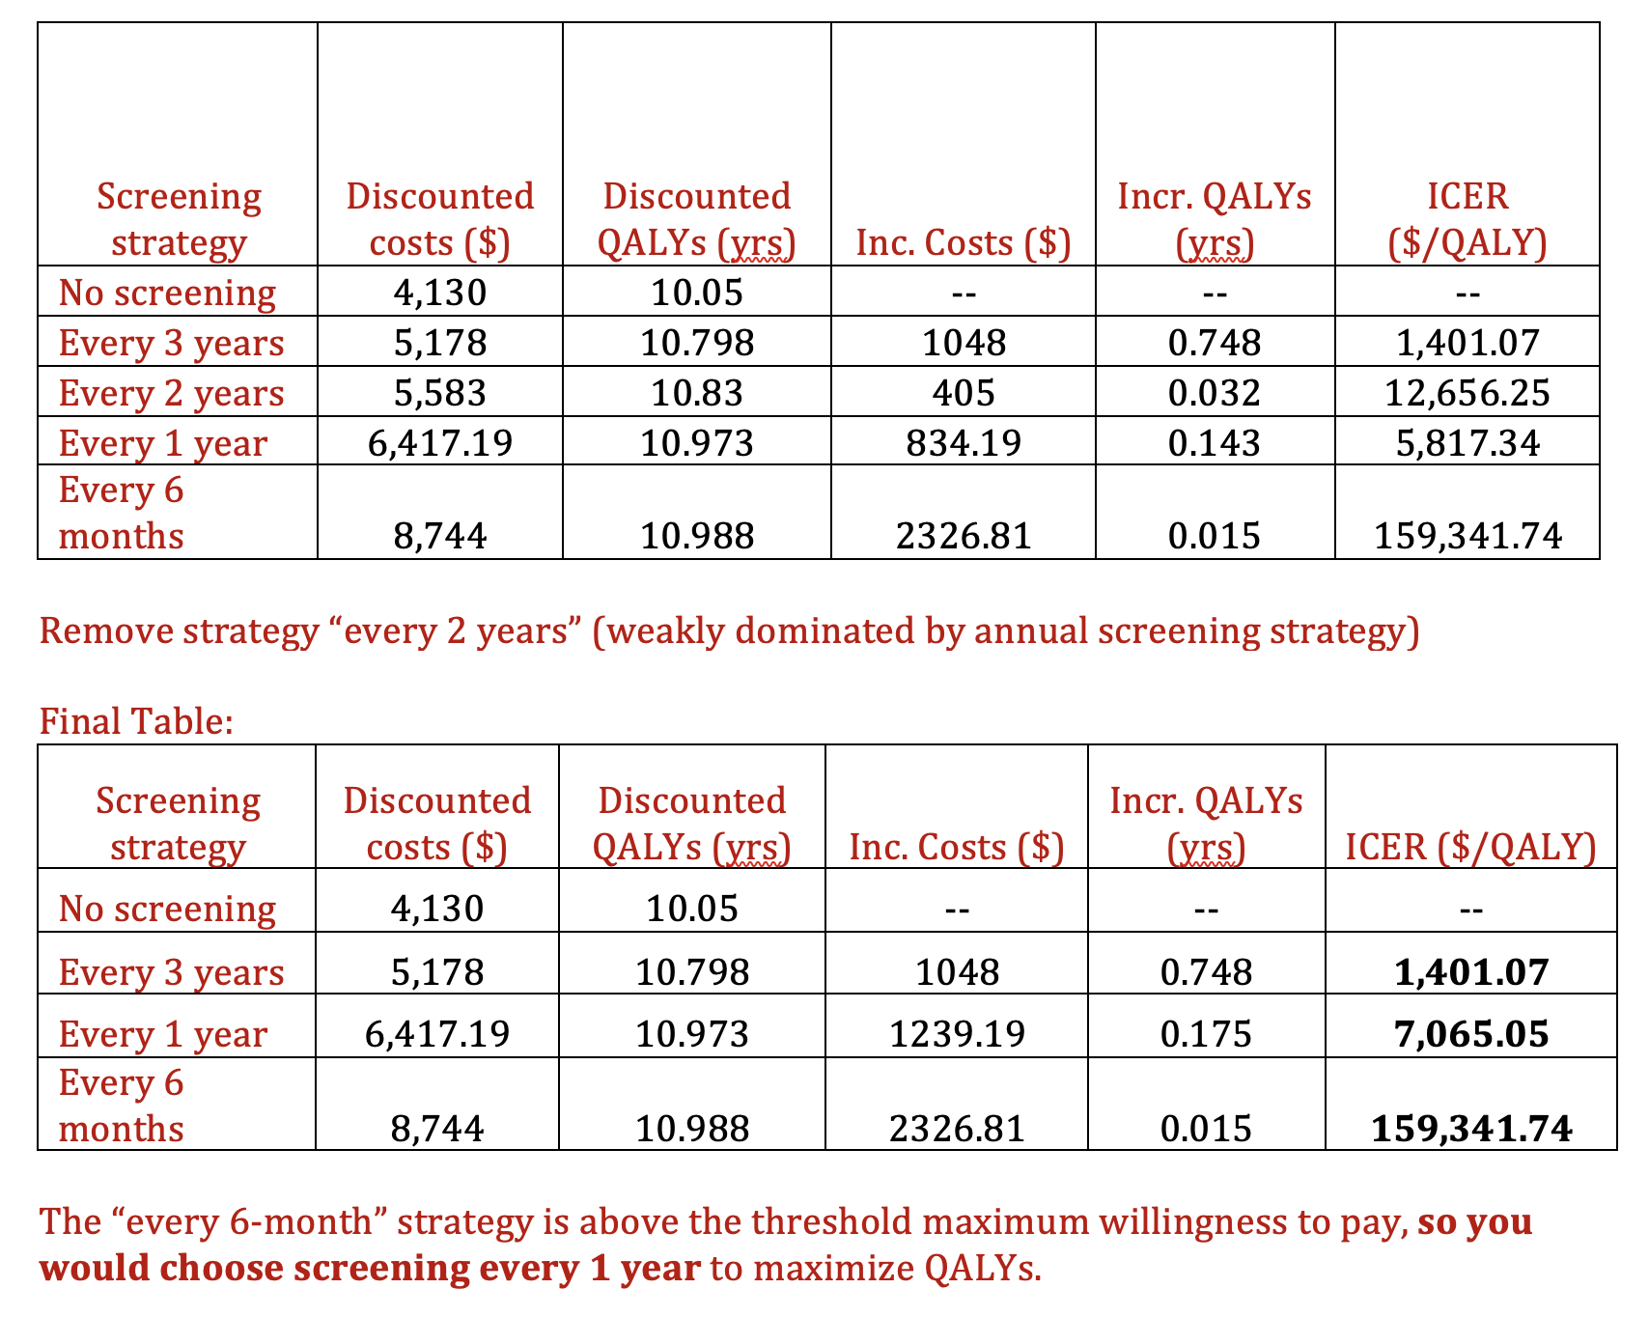

Cost and QALY Outcomes, by Strategy

| Screening Strategy | Discounted QALYs | Discounted Costs ($2022) |
| --- | --- | --- |
| No screening | 10.05 | 4,130 |
| Every 3 years | 10.798 | 5,178 |
| Every 2 years | 10.830 | 5,583 |
| Every 1 year | 10.973 | 6,417 |
| Every 6 months | 10.988 | 8,744 |

ICER Calculation Table 1

| Strategy | Discounted Costs | Discounted QALYs | Incremental Costs | Incremental QALYs | ICER ($/QALY) |
| --- | --- | --- | --- | --- | --- |
|  |  |  |  |  |  |
|  |  |  |  |  |  |
|  |  |  |  |  |  |
|  |  |  |  |  |  |
|  |  |  |  |  |  |

ICER Calculation Table 2

| Strategy | Discounted Costs | Discounted QALYs | Incremental Costs | Incremental QALYs | ICER ($/QALY) |
| --- | --- | --- | --- | --- | --- |
|  |  |  |  |  |  |
|  |  |  |  |  |  |
|  |  |  |  |  |  |
|  |  |  |  |  |  |
|  |  |  |  |  |  |