Firework Injury: Markov Model

# Introduction and Overview of Decision Problem

This case study will build on the initial analysis of firework-related injuries in Columbia using a decision tree model. We will extend our evaluation by employing a Markov cohort model. While the decision tree provided immediate outcomes and costs for various strategies, the Markov model offers significant advantages for examining long-term health and cost impacts.

Our Markov model will allow us to capture the progression of firework-related injuries over an extended period, allowing us to consider long-term implications. By modeling injury events and transitions between different health states over time, we can better understand the chronic effects of injuries and the long-term benefits of intervention strategies.

This approach will provide a more comprehensive assessment of the lifetime health and economic impacts of the proposed strategies, considering factors such as long-term healthcare costs, changes in injury rates, and compliance levels. The Markov model’s ability to incorporate these extended horizons and recurring events will yield deeper insights into the most effective and sustainable approaches to mitigating firework-related injuries in Columbia.

# Alive-Dead Model

We will start by constructing a simple Markov model to represent the progression of firework-related injuries in Columbia. Our initial model will consist of two health states: “Alive” and “Dead.” We will assume that individuals can transition between these states based on the probabilities of surviving as calculated using life table data.

## Markov Structure: Alive-Dead

The structure of the Markov model for the Alive-Dead model is shown in the figure below. Amua has a special Markov node (represented by ). The branches that lead off a Markov node designate all the Markov states (and only Markov states).

In this example, there are two health states: (1) Alive, (2) Dead. Off each health state, you can create a subtree (also called a cycle tree) that reflects those events that can occur during a cycle. The last branch at the end of each pathway will be a state transition, which defines what state to go to for the next cycle.

|  |  |
| --- | --- |
|  | Note that in a Markov model, outcomes are defined elsewhere – NOT at the end of the branch, but at the state. |

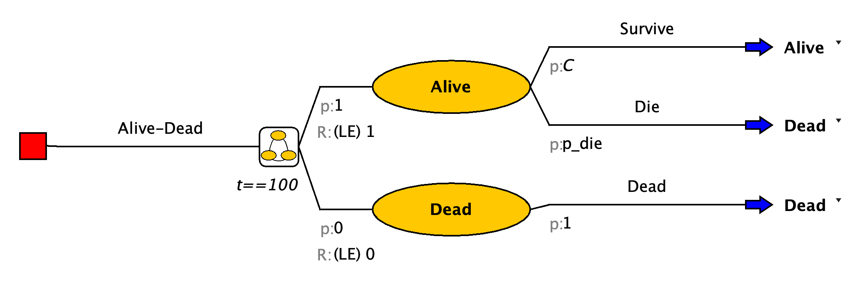

## Building the Tree

### Structure

After you open Amua, click Model New Markov Model.

* Save your model right at the start.
* Now select the decision node , Right-click Add Markov Chain .
* Start by developing the structure of the Markov model using Alive and Dead for the different health states. The branches of the Markov chain should correspond to the states of the model. Label the name option to the right of the decision node as Alive-Dead.

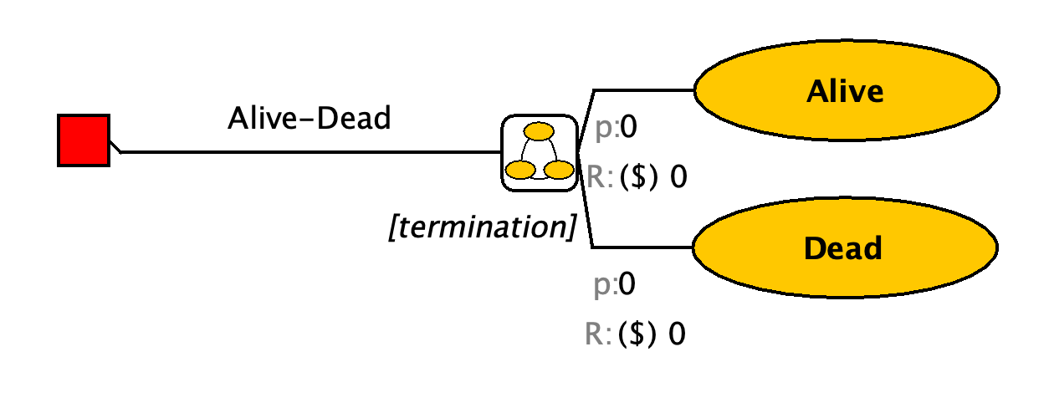

|  |
| --- |
| **Complete the structure of the Markov model using the information above. Note: focus on adding the branches and transitions for this step; Parameters will be added later.** |

* When you reach the end of the branch, select the chance node you would like to turn into a state transition, right click, select Change to State Transition. This will give you the blue arrow . On the right of this arrow, you can find a dropdown menu with the different health states you specified. Select the health state this part of the cohort will transition to.
* With this button you can align the end nodes.

### Cohort size and starting probabilities

* Go to Model Properties select the Simulation tab. The default cohort size is 1,000. Change cohort size to 1, so that all outputs will be at the individual level (i.e., per person).

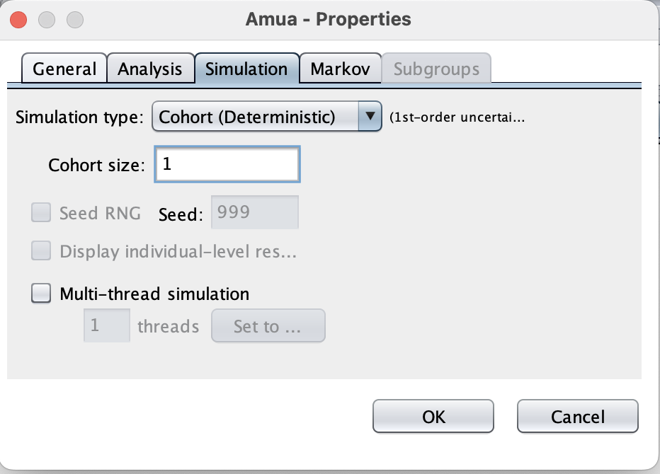

* At the Markov Chain , change the initial probabilities of health states. Since all patients start in the Alive state, change the p:0 on the left of the Local state to p:1 (see blue box below).

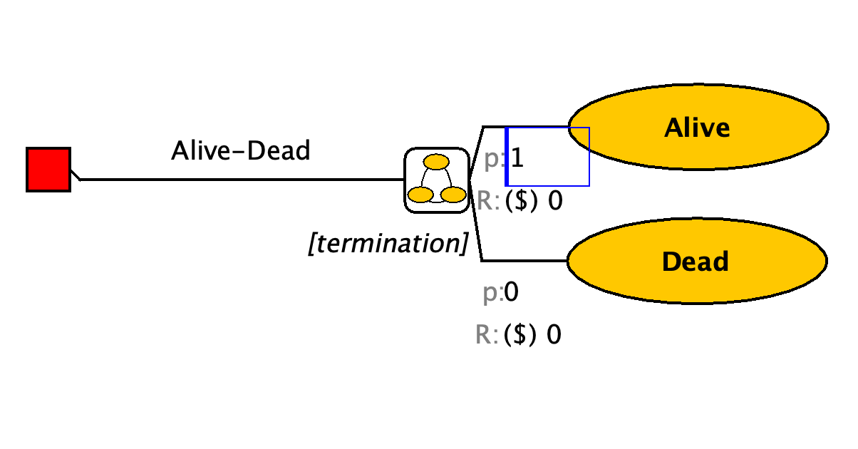

## Model Parameters

First, define the following time-constant parameters for the model in the “Parameters” panel.

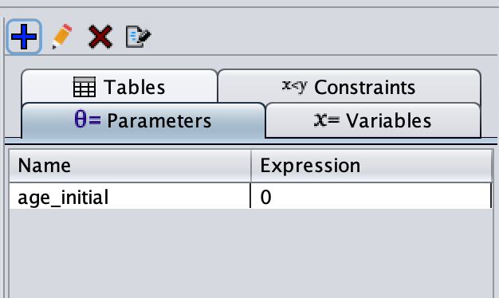

This variable tells Amua that we will model a cohort of newborns. However, we could easily adapt this to model a cohort of 20 year-olds, etc.

## Transition Probabilities

The underlying transition probability matrix has the following form:

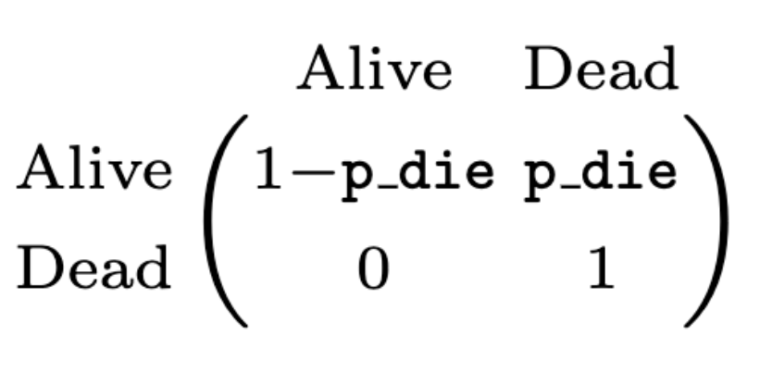

However, because we are modeling a cohort of newborns until death, we need to include death transition probabilities that vary by age (i.e., cycle) in the model. In other words, there will be a different death probability in each cycle.

|  |  |
| --- | --- |
|  | In Amua, **time-varying inputs are operationalized as variables** rather than parameters.  Variables can be defined to keep track of model events and dynamically update expressions as the model runs. Thus, unlike parameters which are fixed for a given run of the model, variables can change within a simulation. Variables may change across individuals, allowing heterogeneity to be modeled, or they may change over time. |

Therefore, we will define p_die as a **variable** that references values in a **lookup table** , following the steps below.

|  |  |
| --- | --- |
|  | A lookup table returns the value that corresponds to a particular index. The first column in a lookup table contains the table indices, and one or more columns of lookup values can be defined. Index values must be unique and in ascending order. There are 3 lookup methods, (1) exact, (2) interpolate, and (3) truncate, for details about these methods visit the [Amua Wiki on GitHub](https://github.com/zward/Amua/wiki/Tables). |

We first define a lookup table tbl_death to read in the age-dependent background mortality constructed from the Columbian life tables.

### Download Data

[Download the file titled columbia-life-table-death-probabilities.csv](https://graveja0.github.io/bogota-vital-strategies/case-studies/columbia-life-table-death-probabilities.csv) from the workshop website. This table contains the age-indexed annual mortality probability for Columbia. A screenshot of the first few rows of this .csv file is shown below. The index column is the age, while p_die is the annual probability of death at each age.

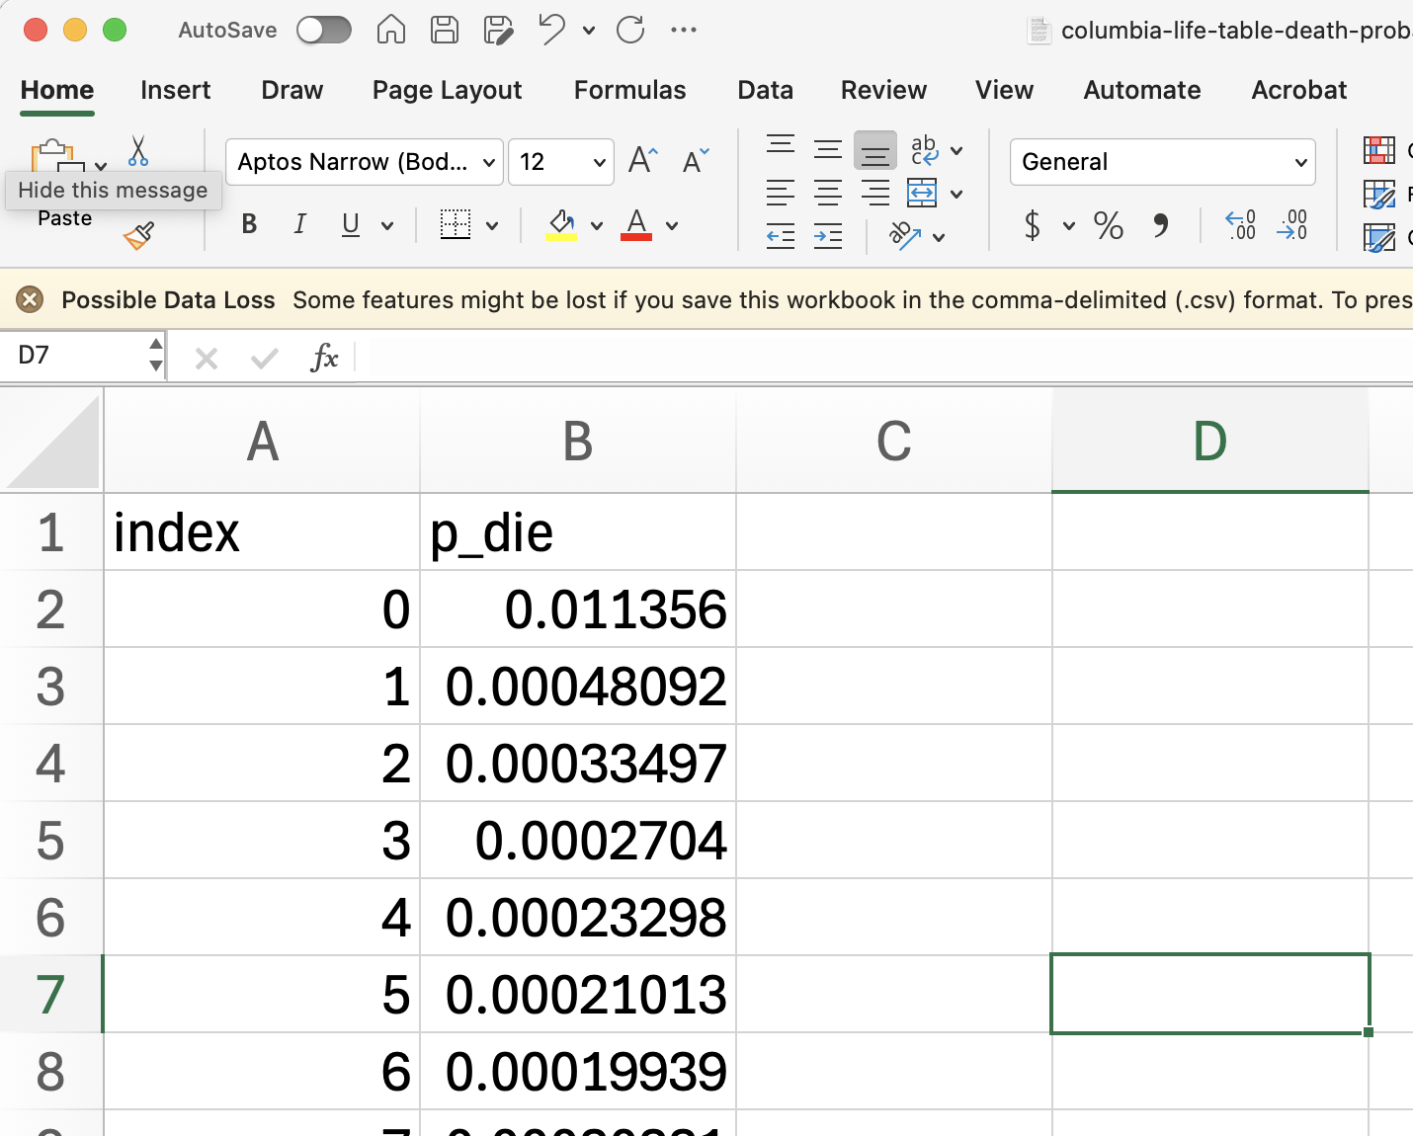

Go to the “Tables” panel, click to add a table, and you should see a “Define Table” window (see screenshot below). Click the Import button and select the downloaded .csv file to import. The table will automatically be resized to fit the imported data. The first row in the file will be used as table headers.

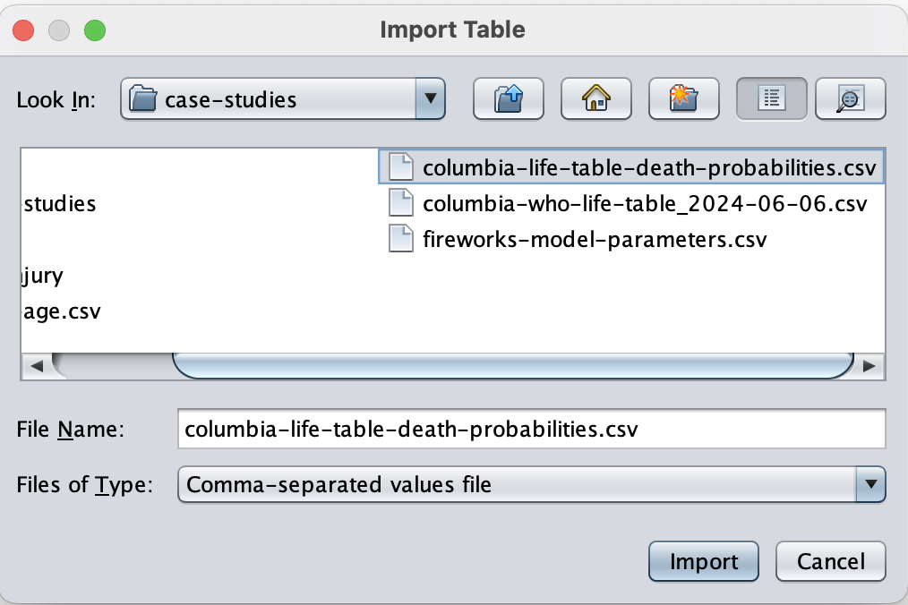

Enter “tbl_p_die” as the name for this variable. “Lookup” is the default table type (which is what we want here). Choose “Interpolate” as the Lookup Method. Click Save to apply.

Next, we can define the *time-varying variable* p_die (which reads from the table we just defined and operates as the background mortality probability in the current model cycle, $t$).

*Make sure you create a variable and not a parameter.* Under “Variables”, click to add a variable p_die = tbl_p_die[age_initial + t, 1].

The first column of a table is always used for indexing in tables. Therefore, the number “1” here will actually indicate the second column in your table as the corresponding value. You can also use the name of the column to read a value, e.g., tbl_p_die[age_initial + t, “p_die”].

|  |  |
| --- | --- |
|  | In Amua, “***t***” is a built-in variable that tracks the number of cycles. It automatically updates when the model runs. For example, in the 10th cycle on the Markov model, *t = 10*. Therefore, in the formula “tbl_p_die[age_initial + *t*, 1]”, age_initial + *t* will equal the modeled age of the individual in cycle *t*, and the full formula will read the age-dependent background mortality based on the individual’s current age (instead of the initial age).  Amua defaults to a cycle time of $t=0$. Therefore, if you hit “Evaluate” the Expected Value field should calculate the death probability for a newborn as shown in the .csv lookup table. |

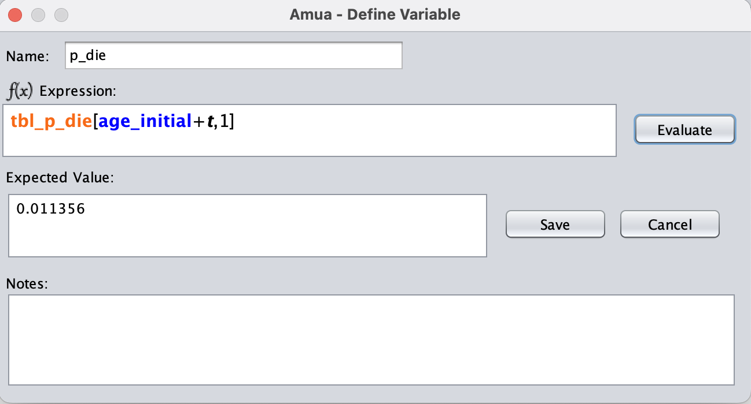

We now have all transition probabilities defined. Add these inputs to the branches of the model. Remember to add the complementary probabilities using “C” as well.

## Termination Condition

* Specify the termination of the model by selecting [termination] and type t==110. This will allow your model to run for 110 cycles, then the model will terminate.

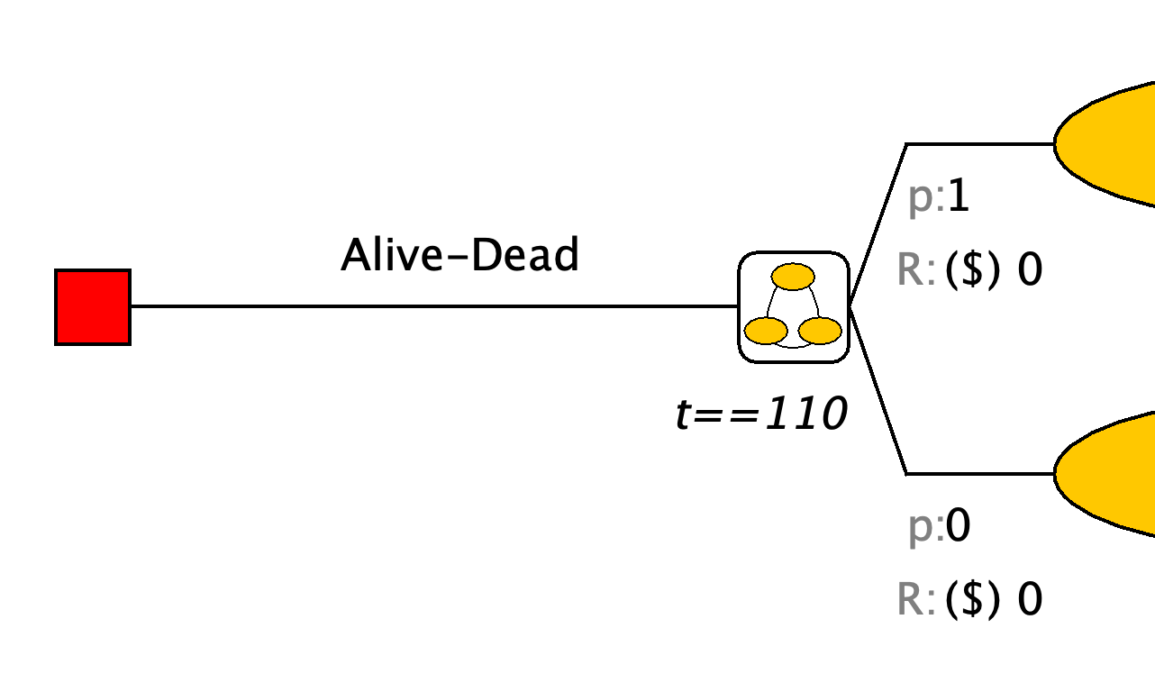

## Rewards

The default reward in Amua is cost. We need to change this to have life-expectancy (LE) as a reward. Go to Model Properties select the Analysis tab and change the cost dimension to LE. Use LE as the symbol and set to 4 decimal places.

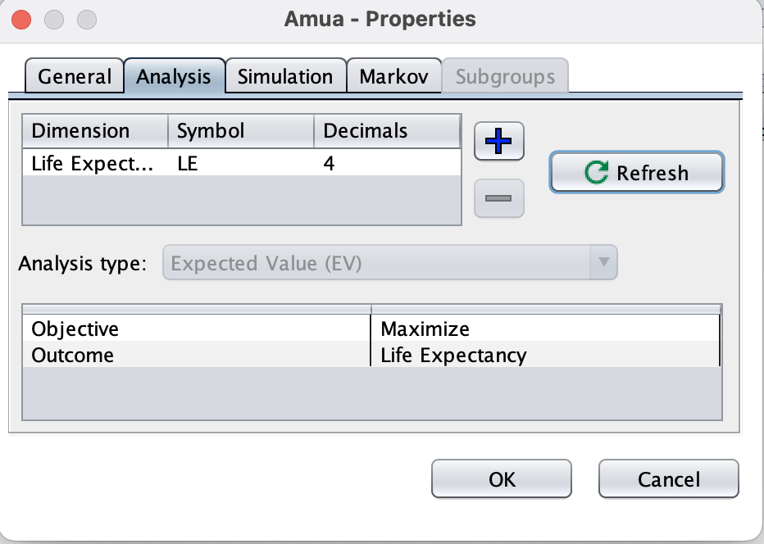

Add the life-expectancy “payoff” on the left of each health state after “R: (LE)”.

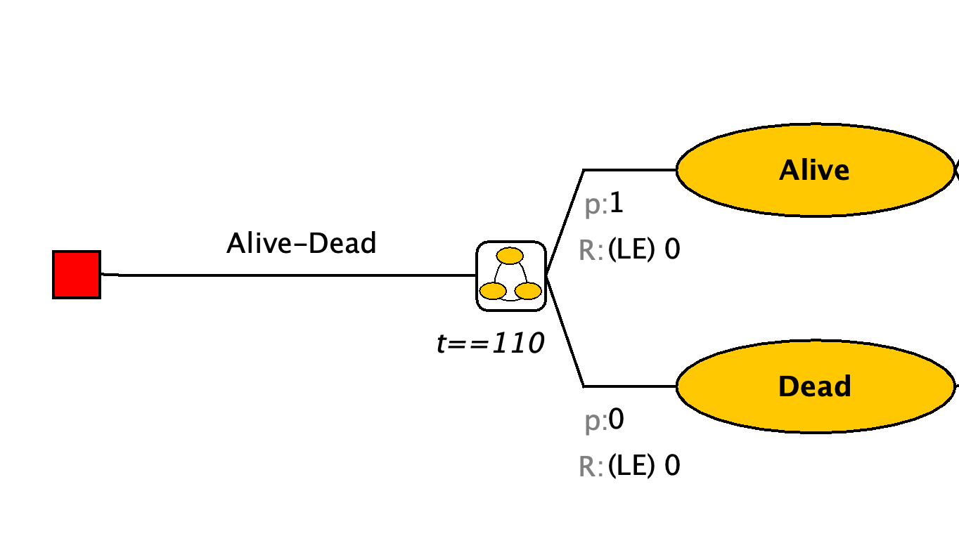

Apply Half-cycle correction. Go to **Model** **Properties** select the **Markov** tab and check the Half-cycle correction box. Click **OK** to apply.

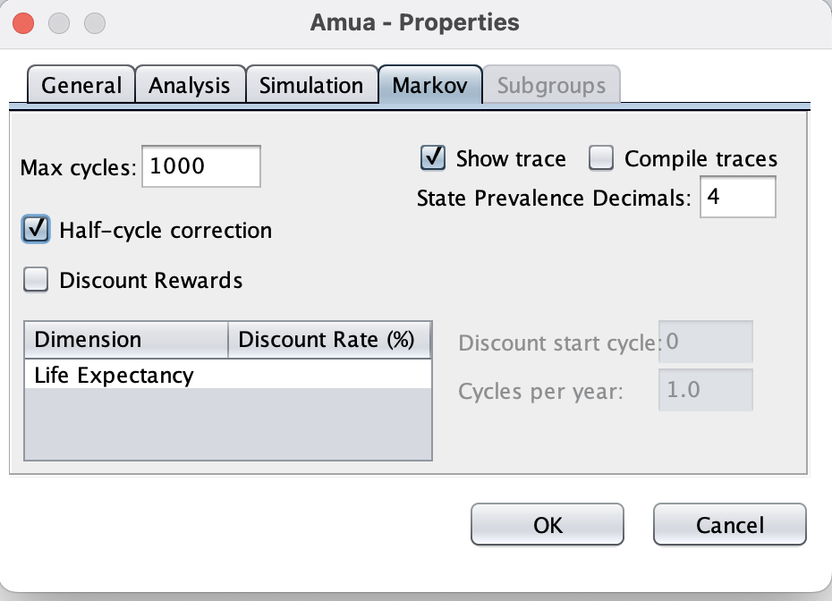

Now, we have finished constructing the Alive-Dead model. Analyze the model using a cohort simulation by clicking **Run Run Model**.