# Introduction

Decision analytic assessments of health policies and technologies play an important role in determining the availability, pricing and reimbursement of health care services worldwide. These assessments draw on a range of modeling methods to inform decision making from a variety of perspectives (e.g., societal, health system, patients, etc.). Commonly used methods include decision trees, cohort and individual state transition (Markov) models, discrete event simulation (DES), systems dynamics (e.g., differential equations) models, and hybrid models that blend elements across approaches (e.g., Discretely Integrated Condition Event models) (Caro 2016; Stahl 2008).

For a given health technology assessment or research question, best practice recommends model choice based on consultation among clinical, metholological, and policy experts (Caro and Möller 2016; Stahl 2008). This ensures that the model accurately represents essential elements of the underlying disease or therapeutic processes, as well as the alternative strategies under consideration.

In practice, however, considerations over model transparency, detail, ease of use, and even regulatory disclosure requirements also come into play. In addition, the application of Value of Information (VOI) methods may also guide model selection because the computational demands of VOI can be considerable (Jalal and Alarid-Escudero 2018). Thus, different modeling choices may be made depending on the relative weight placed on maximizing model transparency and resolution on the one hand, and on understanding parameter uncertainty to guide the scope and direction of future research on the other.

Our objective for this study was to develop and compare four models of the same underlying decision-making scenario. In doing so, we provide replicable, open-source simulation code that crosswalks across diverse modeling approaches: cohort state transition (Markov) models, discrete event simulation (DES), microsimulation, and systems dynamics modeling based on time delay differential equations (DE). Importantly, these models draw on an identical set of underlying parameters that should, we hypothesized, lead to equivalent (in expectation) cost and quality-adjusted life year (QALY) estimates and decision outcomes. Our results demonstrate that under common situations (e.g., the use of tunnel states in Markov models) they do not.

A key contribution of our study is the mathematical derivation of adjustment factors that must be applied to individual- and cohort state transtiion (Markov) models to produce equivalent model estimates as discrete event simulation or differential equations models. These adjustments are necessary due to an interaction between competing risks and the coarsening of time into discrete cycles in a Markov model. Notably—-and somewhat counterintuitively—-neither half-cycle corrections (or its alternatives) or reducing the time cycle to continuous time will remove this source of bias. Our results demonstrate that depending on the circumstances, these biases are not trivial and can lead to differences in decision-making that arise simply due to differences in model choice.

The remainder of this paper proceeds as follows. The next section provides brief detail on the four simulation methods we consider. Thereafter, we describe a specific application in pharmacogenomics. Specifically, we outline a simple scenario under which decision makers consider genotyping a population at the time of drug exposure. This genetic test can guide drug selection to ensure that the chosen therapy maximizes drug metabolism, thereby reducing the likelihood of a severe drug-related adverse event. Initial model comparison results for this simple pharmacogenomic scenario lead directly into the exposition of adjustment factors for models based on Markovian processes (e.g., cohort state transition and microsimulation). We then demonstrate (stochastic) equivalence in model results across all four approaches after the adjustment factors are applied. We conclude with ….

# Background

## Cohort State Transition (Markov)

## Microsimulation

Whereas cohort state transition models trace out the mean outcome response for a homongenous cohort, micrisimulation models simulate indivdiual health and costtrajectories.

## Discrete Event Simulation

Discrete Event Simulation (DES) is a modeling methodology designed to incorporate the timing and interdependency of events (Karnon et al. 2012; **???**; **???**). Though its origins are in industrial engineering and operations research, DES is increasingly used in health technology assessments (**???**; **???**; **???**).

## Time Delay Differential Equations

# Methods

## Simple Pharmacogenomic Decision Scenario

Our models rely on an underlying structure derived from an application to our ongoing work in pharmacogenomics (PGx). PGx involves the use of genetic testing to guide drug selection and/or dosing based on known associations between genetic variants and drug metablolism. We have written on the cost-effectiveness and value of alterantive PGx strategies elsewhere (Graves et al. 2018), though for our purposes here we focus on a simple decision problem: whether to perform a genetic test to guide drug selection in a population at risk of developing an indication for a condition with a standard maintenance medication therapy, but where there is a (more expensive and more effective) pharmacogenomic alternative available for individuals with a genetic variant. We compare a reference case scenario in which everyone who develops the condition receives the standard therapy to a PGx-guided scenario in which all individiuals with the condition receive a genetic test, and those with the varaint receive the more effective alternative therapy.

Details of the underlying PGx scenario are summarized below and in the model schematic figure:

* A population of 40-year old women is at risk for developing a condition (A) with a 10% incidence rate over a 10-year period.
* All who develop condition A incur a one-time treatment cost of $10,000 ($2018), a transient one-year 0.05 utility decrement, and are placed on daily maintenance medication ($0.50 / day) for life.
* Individuals on the maintenance drug are at risk of a rare but serious adverse event (B) occuring with probability 0.02 over the first 1 year period. Event B has a 5% case fatality rate with a $15,000 cost among the decedents and, among the survivors, incurs a one-time $25,000 cost and a 0.1 disutility for life.
* There is a ($200) genetic test available that can identify individuals with a drug metabolism-associated variant (variant prevalance=20%). Individuals with the variant are placed on alternative maintenance medication that lowers the rate of event B (relative risk = 0.70), but costs $5 / day. There is no change in the risk of adverse event B among individuals without the variant.
* Events are not recurrent (i.e., an indiviudal can only experience up to 1 condition and 1 adverse event).
* Standard annual discounting of 0.03 applies. Prices are all in $2018.

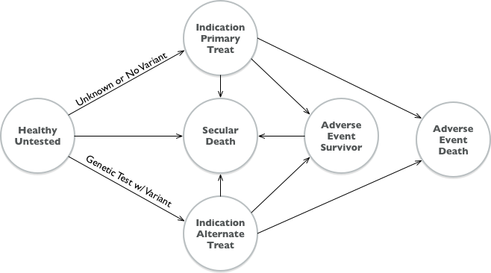

Model Diagram

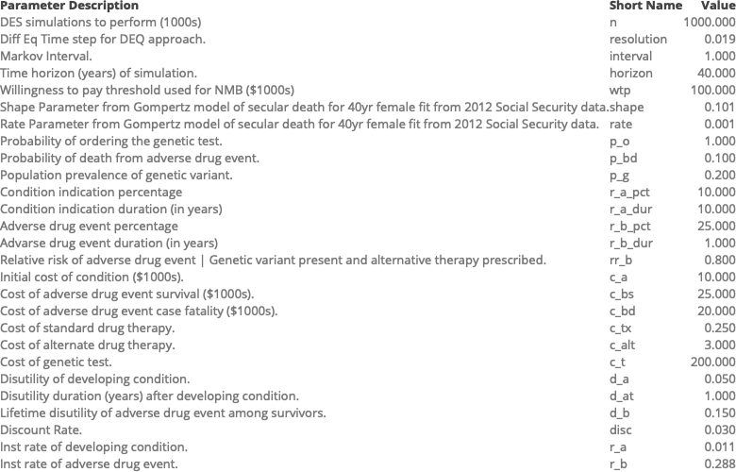

# Unadjusted Model Comparison Results

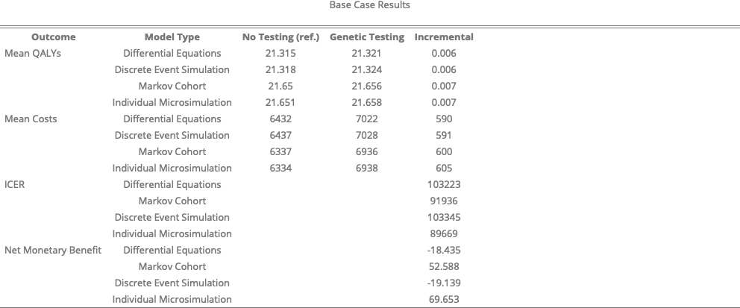

Caro, J. Jaime. 2016. “Discretely Integrated Condition Event (DICE) Simulation for Pharmacoeconomics.” *Pharmacoeconomics* 34 (7): 665–72.

Caro, J. Jaime, and Jörgen Möller. 2016. *Advantages and Disadvantages of Discrete-Event Simulation for Health Economic Analyses*. Taylor & Francis.

Graves, John A., Zilu Zhou, Shawn Garbett, and Josh F. Peterson. 2018. “The Value of Pharmacogenomic Information.” In *Economic Dimensions of Personalized and Precision Medicine*. University of Chicago Press.

Jalal, Hawre, and Fernando Alarid-Escudero. 2018. “A Gaussian Approximation Approach for Value of Information Analysis.” *Medical Decision Making* 38 (2): 174–88.

Karnon, Jonathan, James Stahl, Alan Brennan, J. Jaime Caro, Javier Mar, and Jörgen Möller. 2012. “Modeling Using Discrete Event Simulation: A Report of the ISPOR-SMDM Modeling Good Research Practices Task Force4.” *Medical Decision Making* 32 (5): 701–11.

Stahl, James E. 2008. “Modelling Methods for Pharmacoeconomics and Health Technology Assessment.” *Pharmacoeconomics* 26 (2): 131–48.