A Unified Approach for Ex Ante Policy Evaluation

John A. Graves

*Vanderbilt University*

August 2019

Evaluation of policy change is the lifeblood of applied economic research. Often, evaluation is retrospective: a policy changes, data are collected, and researchers evaluate impact on welfare-relevant outcomes. This exercise is frequently conducted in service of a greater goal—namely, to make predictions based on theory about economic behavior, and to use policy change as a lens through which these predictions are tested. Knowledge produced through this exercise is then (ideally, but not always) applied to future policy to improve economic efficiency and human welfare.

The primary focus here is on a related but inverse exercise: ex antepolicy evaluation. Under this approach, empirical estimates serve as inputs *to* rather than outputs *from* the policy evaluation process. Typically, a model of economic behavior is conceptualized around a theoretic scaffold (e.g., utility maximization in a model of discrete choice). The theoretic framework is then coupled with micro-data on individuals, firms, and other decision-making agents. Combined, these elements constitute a simulation model of human behavior or some other policy-relevant decision-making process (e.g., the progression of a disease or the adoption of a new technology). The model is further adorned with structural and behavioral parameters derived from existing evidence or, in cases where the empirical literature has not yet rendered reliable estimates, from judgment calls consistent with the underlying theory. Policy reforms are propagated through the model by simulating responses to changes in price, choice sets, health technologies, tax schedules, etc. Models then summarize an array of policy- and welfare-relevant outputs (e.g., changes in demand for goods and services, quality-adjusted life expectancy, changes in health insurance coverage and premiums, changes in federal tax revenues and outlays, etc.). These outputs are (again, ideally, but not always) disseminated to inform policymakers’ decisions on the design and/or adoption of policy.

In the United States, the Congressional Budget Office (CBO) is the most important practitioner of ex ante evaluation. CBO analyses have played a central role in shaping the trajectory of federal policymaking over the last generation. As one Senator famously said, the recent history of U.S. health reform can be summarized as Congress “sending health legislation off to the Congressional Budget Office to die.”[1]

Ex ante policy evaluation also plays an important role in determining the pricing and reimbursement for goods and services worldwide. Entities such as the National Institute for Health Care Excellence (NICE) in the United Kingdom (UK) commission simulation analyses of the cost and quality-adjusted life year (QALY) benefits of health technologies. Results from these studies are used to determine coverage policy within the National Health Service in the UK and in other government-sponsored health systems. Simulation models have also been developed to project the consequences of changes to tax and transfer policy, education policy, and food policy, among others (TK CITES).

Despite the central role played by simulation modeling in the policymaking process, scant formal attention has been paid to the theory, design and integration of ex ante evaluation within the broader economic research enterprise. The one notable exception is health technology assessment, where rigorous standards for conduct, methods and reporting have been developed by the Panel on Cost-Effectiveness in Health and Medicine (Weinstein et al. 1996; Sanders et al. 2016).

To the extent there are explicit linkages between ex post and ex ante evaluation, they are typically relegated to simple, back-of-the-envelope counterfactual policy exercises that appear at the tail end of research manuscripts. Rarely do these exercises draw on a formal approach to comparative welfare analysis (Hendren and Sprung-Keyser 2019). Even more rarely do they grapple rigorously with the role of estimation, sampling and structural model uncertainty in guiding policy recommendations and the direction of future research.

These shortcomings extend to many policy simulation models as well. For example, models often produce an array of welfare-relevant outputs and leave it to policymakers to weigh these factors when making decisions (Finkelstein, Hendren, and Luttmer 2019; Finkelstein, Hendren, and Shepard 2019). This is particularly true in U.S. health policy, where federal policy decisions based on cost-effectiveness are prohibited through both legislation and administrative rulemaking. But even absent a specific legislative or regulatory decree, the CBO and other modelers have generally avoided producing overall welfare assessments.

Compounding these shortcomings are four related challenges. First, while simulation models often draw on standard economic theory and a shared evidence base, the underlying evidence is estimated with uncertainty (and possibly with bias) and is not always in uniform agreement. Relatedly, it is not often clear whether well-identified evidence can extrapolate to different populations, time periods, and settings. Second, models also differ in their underlying structure, input data sources and assumptions. Third, the microsimulation process is often opaque, making it difficult for researchers to understand whether and how their work can inform modeling efforts. Finally, the costs of development, execution, and maintenance of microsimulation models are considerable.

Combined, these factors contribute to high barriers to conducting rigorous ex ante policy evaluation and a muddled sense of how the economic research enterprise could be refined to improve both modeling efforts and policy decision making. In short, few economists have a concrete sense of how their research can impact CBO modeling, nor is it clear whether existing research is focused on questions of highest importance to informing policy decisions.

This study outlines an approach to ex ante policy evaluation that addresses many of the above shortcomings. The first major contribution is the linkage of theories related to the Value of Information (VOI) and the Marginal Value of Public Funds (MVPF) in the context of ex ante policy modeling. Specifically, I demonstrate that embedding welfare analyses based on components of the MVPF within a policy evaluation model provides a powerful lens for both comparative policy assessments and rigorous evaluation of model sensitivity to uncertain parameters and assumptions. These assessments can then guide current policy decisions and future research.

For example, at a given policy efficiency threshold (e.g., a MVPF value of 0.8, above which a policy might be desirable but below which it may not), parameter uncertainty may or may not affect policy adoption decisions. If policy decisions are insensitive to varying parameter values, then the value of obtaining further information on uncertain parameters is low—that is, it is not worth additional research effort to reduce information uncertainty around model parameters since the same decision would be made today as it would if we had better information. If decisions are sensitive to this uncertainty, however, then VOI methods quantify the opportunity cost of making policy decisions based on *current* information versus if we had perfect information on uncertain parameters. Variation in modeled outputs can be further decomposed to isolate how specific model parameters contribute to the overall value of information. These assessments, in turn, can provide guidance so that future research can be refined to focus on domains where the information value is high.

To showcase these methods I turn to an application germane to an ongoing debate in U.S. health policy: whether to further expand health insurance coverage and if so, through what means (e.g., expansions of in-kind public insurance programs like Medicaid or Medicare, or through cash assistance for premiums and cost-sharing for private plans). To do this, I develop a generalized modeling approach based on a discrete time and choice framework. I demonstrate that this framework encompasses common approaches to health policy microsimulation based on utility maximization and price elasticities. Notably, however, this framework also facilitates simulation of insurance policy reforms based on a small set of reduced form parameters. As such, the framework provides a template for overall welfare assessment and VOI estimation for existing microsimulation models, and for researchers who wish to conduct counterfactual policy simulations based on their own research and without the need for a detailed microsimulation model.

Within this framework I parametrize a model of insurance market reform based on evidence on the impact of Medicaid expansion on coverage valuation and take-up (Graves, McWilliams and Hatfield 2019; Finkelstein, Hendren and Luttmer 2018) and on individuals’ valuation and take-up of subsidized private health insurance derived from regression-discontinuity estimates (Finkelstein, Hendren and Shepard 2019). I further embed the assumptions and components needed for calculating key components of the MVPF (i.e., policy benefits and costs). By specifying all model parameters in terms of both expected value and their underlying uncertainty, I am able to conduct large-scale probabilistic sensitivity analysis (PSA) by iteratively re-estimating model outputs after drawing from the joint distribution of parameters. The parameter values and outcome results of this sensitivity exercise are primary inputs into a “metamodel”—that is, a regression model of how simulated outputs vary as a function of model parameters. This metamodel is then used to produce estimates of the VOI overall and for individual parameters.

The results of this exercise produce several valuable insights for both policymaking and research. First, …. TK

**Background**

This framework provides a useful launching point for two reasons. First, I demonstrate that the framework encompasses existing approaches to health policy microsimulation, including elasticity-based and utility maximization-based models used by the CBO and others.[2] Thus, it provides a specific VOI and MVPF template to which existing models can be mapped. Critically, however, the approach also facilitates simple yet powerful counterfactual policy assessments based on reduced form estimates. In other words, the framework alsoprovides researchers with a template for conducting rigorous ex ante evaluations without the need for a detailed (and costly) individual-level microsimulation model.

Second, this generalized framework facilitates efficient estimation of the VOI. This is important because in practice, estimating the VOI requires considerable computational time and power. Model parameters must be defined in terms of both their expected value and their underlying uncertainty. Modelers must then iteratively re-estimate key outputs by sampling from the joint distribution of parameters. By specifying an initial modeling framework in terms of reduced form “sufficient statistics,” as I do here, model execution is exceptionally fast. Preliminary VOI analyses can identify influential parameters within the simplest possible model, and this model can be further parameterized and analyzed to most efficiently peel back layers of the onion.

Within this generalized framework I demonstrate how can be harnessed to model the coverage and cost impact of further expansion of coverage via public programs versus via increased subsidies for private coverage. I then embed MVPF

Before outlining a formal definition, we begin by laying out the basic intuition that ties together ex ante policy evaluation with the theory underlying the MVPF and the VOI. As outlined by Hendren (TK), estimates of the MVPF are based on a simple ratio of the “benefits” of a policy to their costs:

$$MVPF=\frac{Benefit}{Cost}$$

The MVPF measures the marginal value of an additional dollar spent on a policy—it asks the question: how do the welfare benefits accrued by implementing the policy compare to the costs of adopting that policy? These costs could be mechanical (e.g., the dollar value of a subsidy or cash transfer) and also the result of economic frictions brought about through policy implementation (e.g., behavioral changes that result in changes in labor force participation, tax revenue, etc.). From a normative standpoint, however, the MVPF is agnostic: it simply measures the ratio of benefits to costs and does not make affirmative statements about whether a policy is “worth it.”

We can also think about specifying a threshold $(λ = 1/MVPF)$ that summarizes society’s willingness to adopt a policy. This threshold value could simply be based on a MVPF of 1 or, if society values some redistributive consequence of the policy, could be set at some other value. For example, Finkelstein, Hendren and Shepard (2018) make comparative assessments of health insurance subsidization policies by specifying a social welfare function over CRRA utility and a defined coefficient of risk aversion. This results in a MVPF benchmark of 0.2. But researchers do not necessarily have to take a firm stance on the curvature and structure of the social welfare function to define a decision-making benchmark. A value tied to an existing policy with strong support across a variety of ideological perspectives could also suffice. For instance, Finkelstein, Hendren and Shepard (2018) also consider a benchmark (0.88) based on the MVPF of the Earned Income Tax Credit (EITC)—a popular means-tested cash transfer program.[3]

For example,

Figure 1. MVPF Intuition

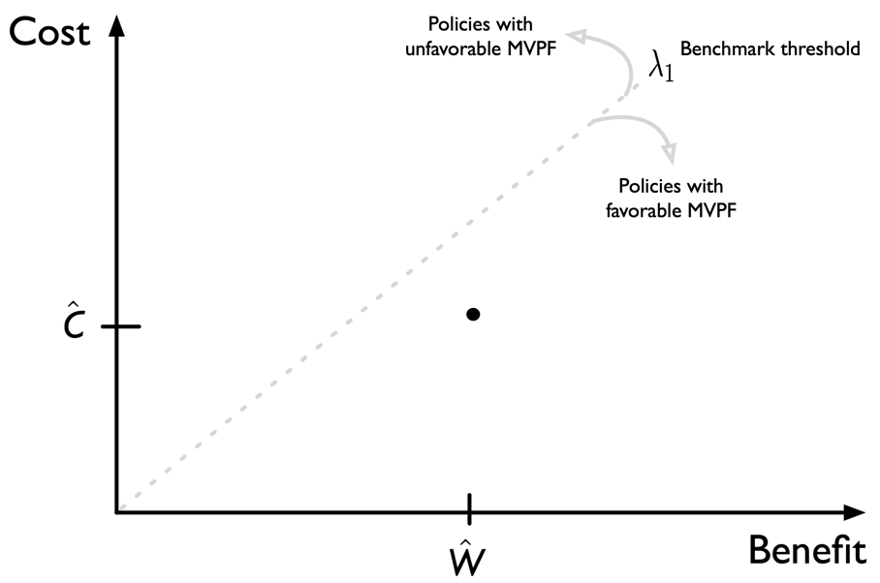

1. Most recently, Congressional attempts to repeal and replace the 2010 Affordable Care Act (ACA) were hampered by public outcry after the Congressional Budget Office (CBO) [projected](https://www.nytimes.com/2017/05/24/us/politics/cbo-congressional-budget-office-health-care.html) that upwards of 23 million people would become uninsured. The [twists](https://prescriptions.blogs.nytimes.com/2009/10/07/analysis-sees-baucus-bill-meeting-obamas-cost-and-deficit-targets/) [and](https://www.nytimes.com/2009/10/19/us/19iht-letter.html) [turns](https://www.nytimes.com/2009/10/06/health/policy/06health.html) of earlier debates over the ACA—and before it, the Clinton health plan, also were shaped by modelers' assessments of how reform would affect insurance coverage, premiums, health care spending, and government costs.
2. Historically, U.S. CBO relied on an elasticity-based model to simulate health reform policy, but recently (as of 2018) switched to a utility maximization framework.
3. Similarly, the origin of the often-used $50,000 per quality-adjusted life year (QALY) threshold used in health technology assessments has been traced, in part, to the incremental cost effectiveness ratio for hemodialysis for end-stage renal disease—an explicit disease-based criterion used to determine Medicare eligibility for nonelderly adults in the United States (Grosse 2008; Neumann, Cohen and Weinstein 2014).