**Practical – 7**

**Aim: Configure and implement secure web communication using SSL/TLS protocols, including certificate management and secure session establishment.**

Steps: Go to Control Panel->Program and Features->Turn Windows Feature on

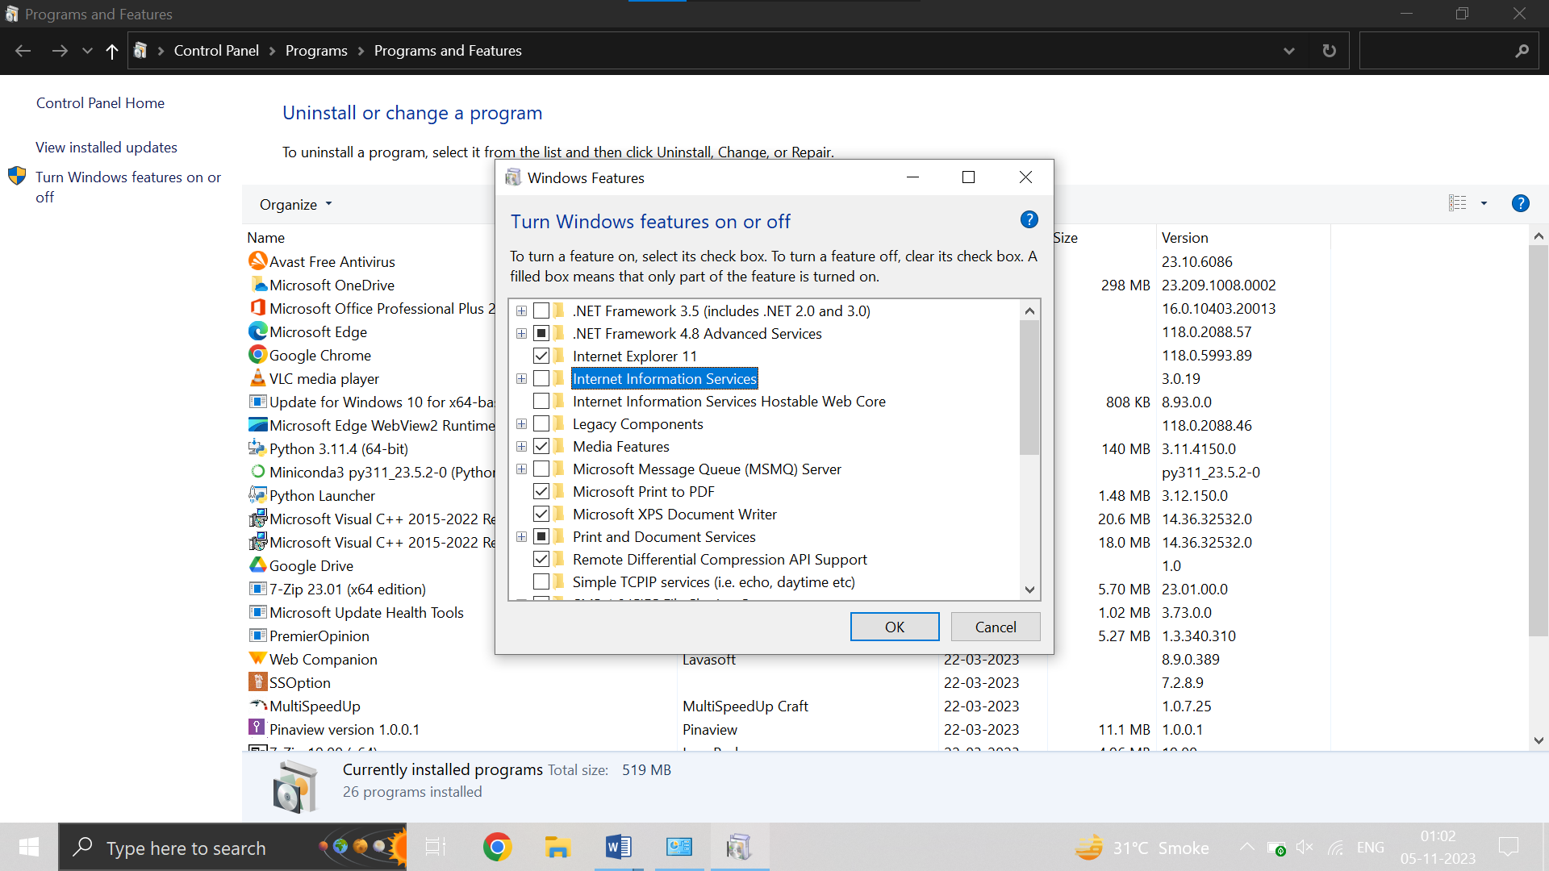

Turn On Internet Information Service

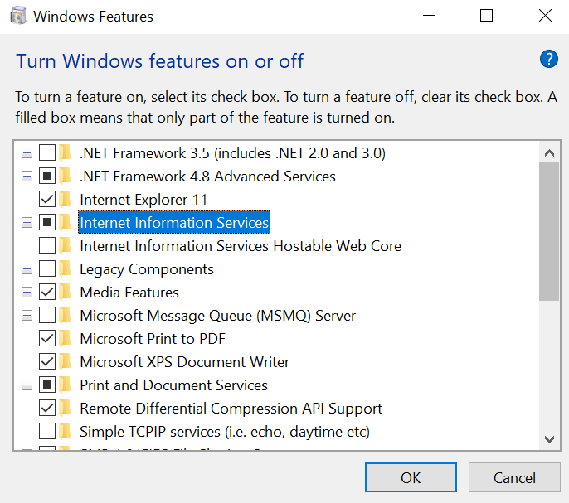

Turn on the IIS Management Console and World Wide Web services

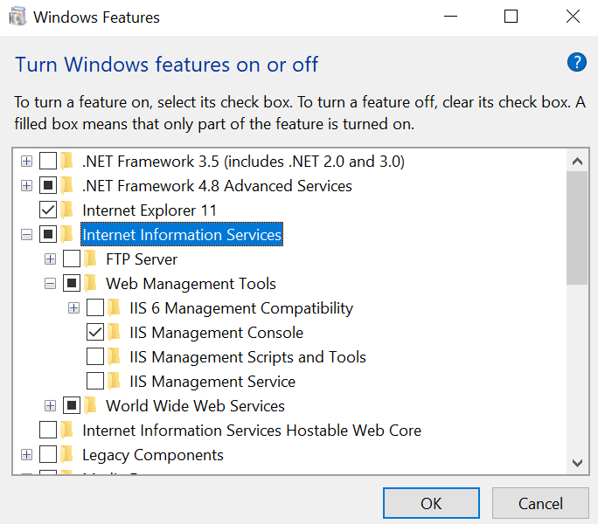

Now from window explorer, open IIS Manager

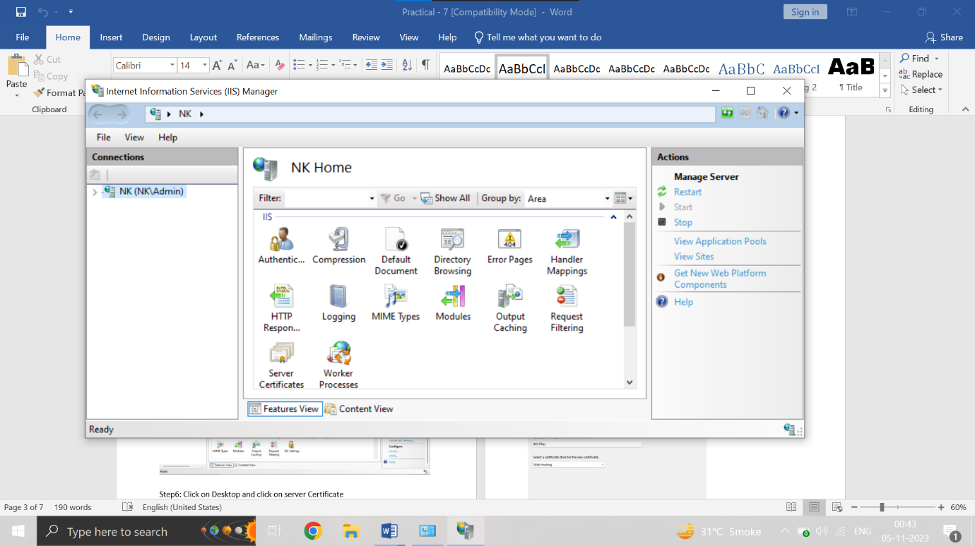

Click on server in the left pane and Choose default web site.

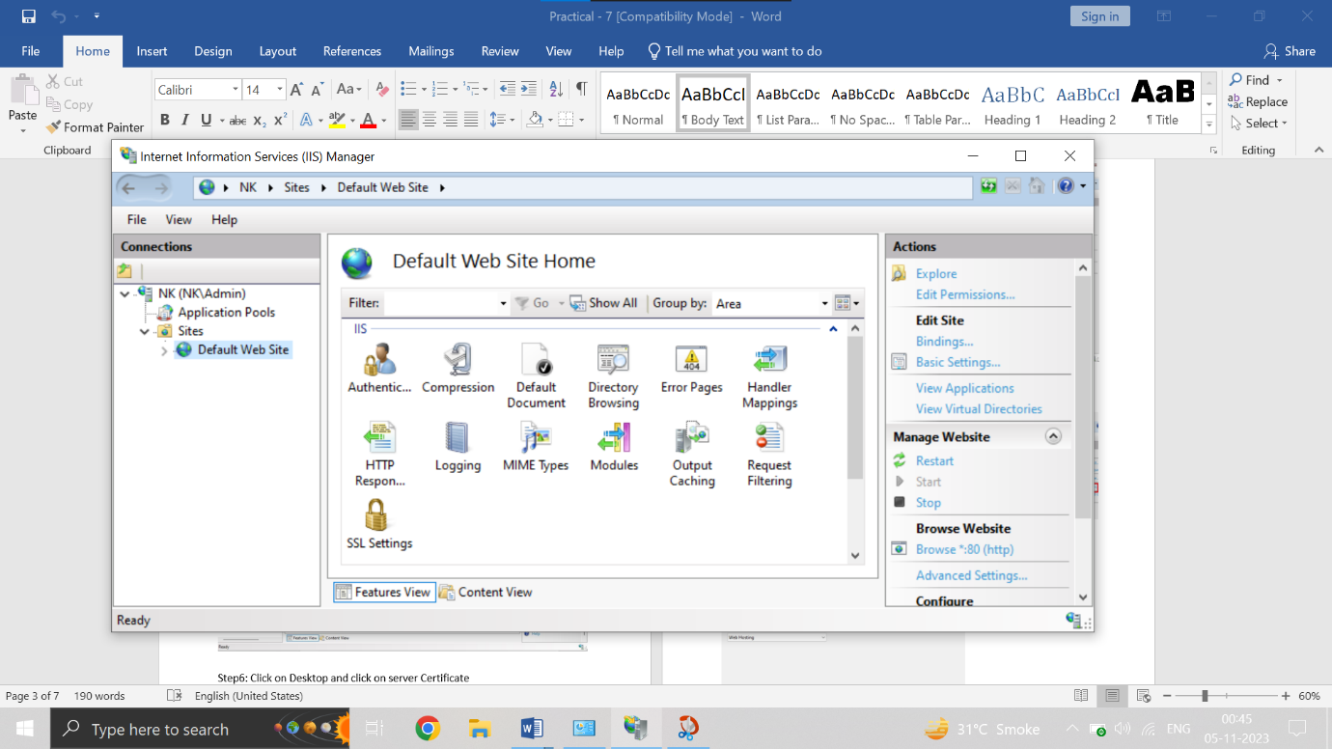

Click on Desktop and click on server Certificate

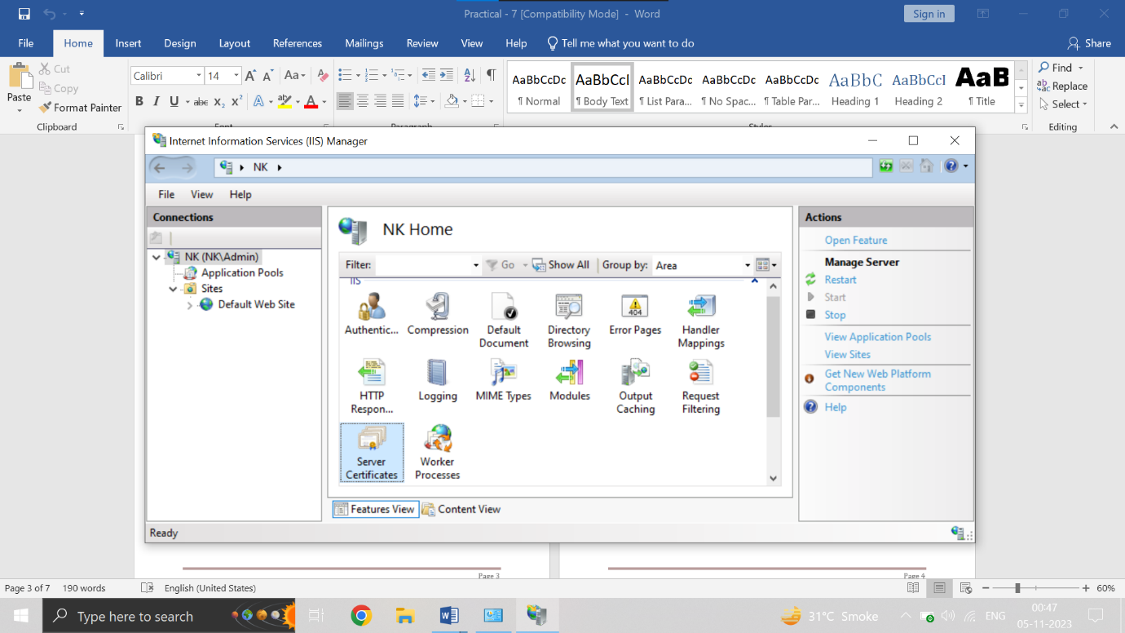

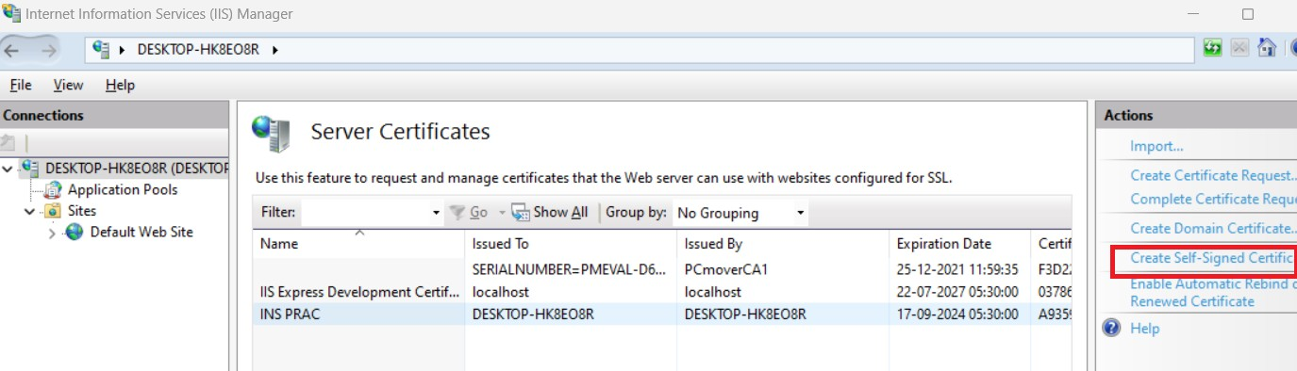Create Self Signed Certificate, give a proper name and certificate store as Web hosting

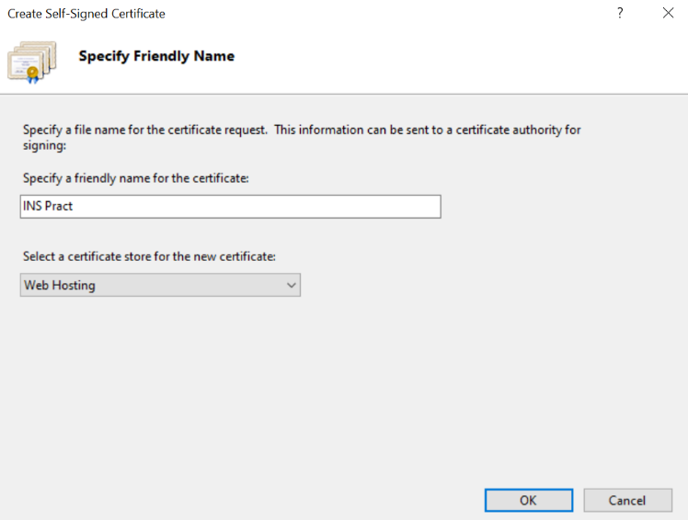

Click on Default Website & Click on bindings and bind with type **https** port **443** by clicking Add btn.

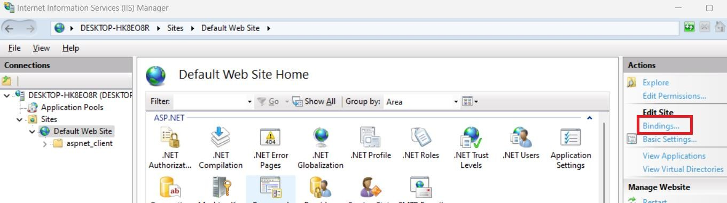

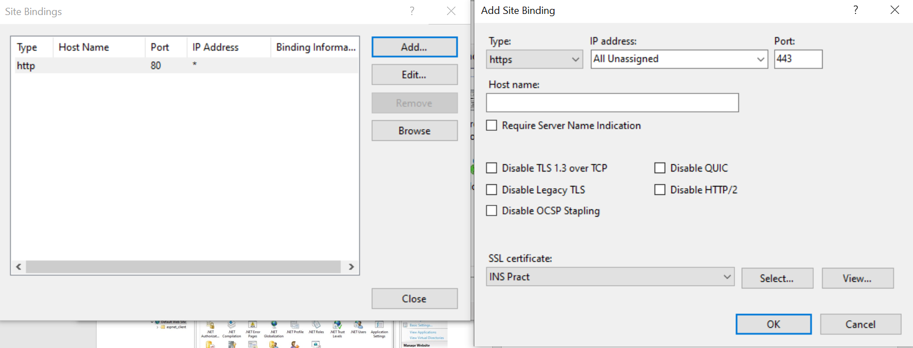

Click on Default Website and click SSL Settings

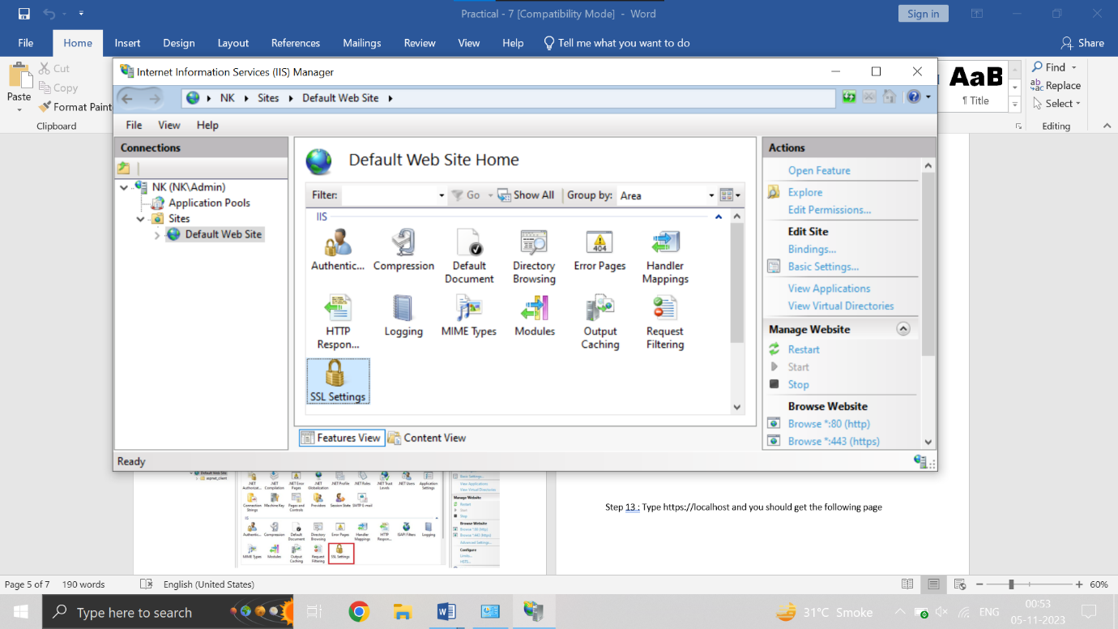

Click on Require SSL Checkbox and click Apply in the right pane , it is successfully changed.

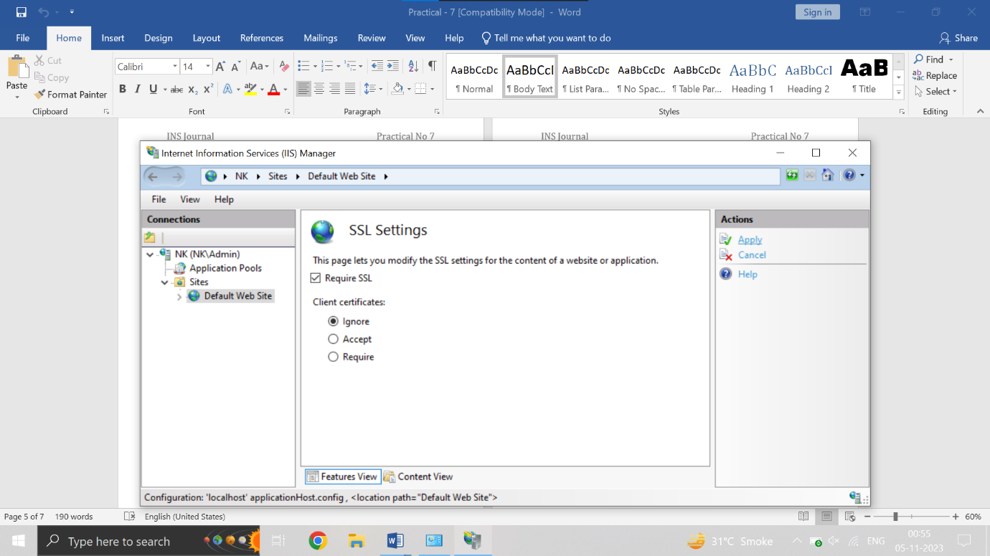

Type **localhost** in google URL and you would get the following page

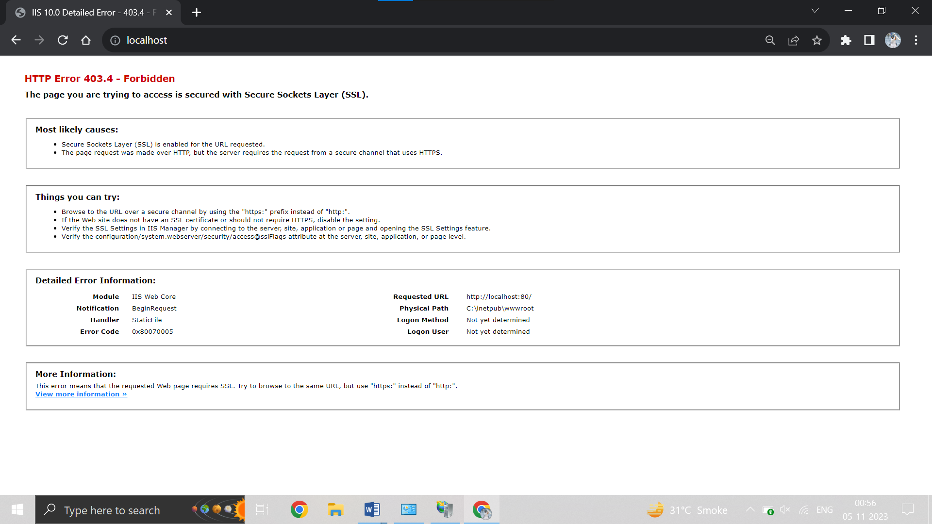

Now, Type **https://localhost** in google URL and you would get the following page

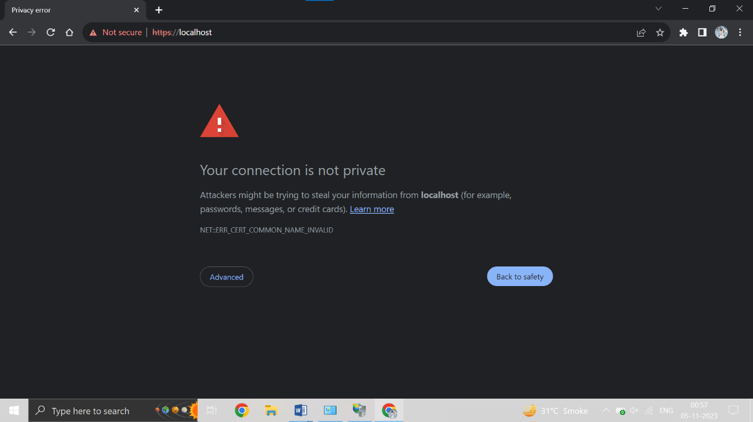

Now, click on **Advanced** and then click on proceed to localhost and you will get the following screen.

