# Syrian Refugee Analysis Tutorial

**Objective:** To gain an understanding of the Syrian refugee crisis in Lebanon by creating a density plot of the clinic locations in R that can be further analyzed and compared to previous years or other humanitarian crises

Before you start, you should:

Visit the Syria Regional Refugee Response Inter-agency Information Sharing Portal webpage at <http://data.unhcr.org/syrianrefugees/regional.php> .

Install and call into function

library(rJava)

library(xlxs)

library(XLConnect)

library(zoo)

library(lubridate)

library(date)

library(ggmap)

library(ggplot2)

library(gdata)

**Create a Syrian Refugee in Lebanon Density Plot:**

# Get file from UNHCR Lebanon Data Portal

url <- <https://www.dropbox.com/sh/6gw6c971791i7za/AAA7_niGXo-jgQd4paTOZAZGa/2.%20Mapping%20and%20P-codes?dl=0>

Next, you should do a direct download of the drop box file and save it onto your computer. Use the getwd() and setwd() commands to set your working directory to the folder where you saved the document.

# Read .xlsx file

tents<-read.xlsx2("List of Informal Settlements_2014_10_03.xlsx",sheetName="IAMP7")

tents<-as.data.frame(tents)

# Convert for date the tents settlement was created/documented

tents$date<-as.numeric(as.character(tents$Date.the.site.was.created))

tents$date<-as.date(tents$date)

tents$date<-as.POSIXct(tents$date)-(60*365*24*60*60)

tents$date<-as.Date(tents$date)

tents$Longitude<-as.numeric(as.character(tents$Longitude))

tents$Latitude<-as.numeric(as.character(tents$Latitude))

tents$Number.of.tents<-as.numeric(as.character(tents$Number.of.tents))

tents$Number.of.Individuals<-as.numeric(as.character(tents$Number.of.Individuals))

# The nas command eliminates data that is not applicable to the data frame we are using

nas<-tents[(is.na(tents$date)),]

nas$date<-mdy(nas$Date.the.site.was.created)

nas<-subset(nas,!is.na(date))

# The following commands will look at the single variable ‘tents’ within the large data set. ‘Tents’ contains the location (latitude, longitude) of the refugee clinic locations in Lebanon and the number of people at each location.

tents<-subset(tents,!is.na(date))

tents<-rbind(tents,nas)

tents$month<-as.yearmon(tents$date)

tents$year<-as.numeric(format(tents$date,"%Y"))

tents$pplptent<-tents$Number.of.Individuals/tents$Number.of.tents

# Create map of locations

bl<-get_map(location=c(35.8244200,33.8889400),source="google", maptype="terrain",crop=FALSE)

# Overlay of density of tent locations with Kernel Density

overlay<-stat_density2d(aes(Longitude,Latitude,fill=..level..),data=tents,geom="polygon")

# Map Refugees and Density of Tents in Lebanon

ggmap(bl)+overlay+geom_point(aes(Longitude,Latitude,color=tents$pplptent)

+,size=2,data=tents)+scale_colour_gradient(expression(People_Per_Tent),low="red",high="black +")

# Do not forget to save your working code in a post to GitHub and save your density plot map as a jpeg!

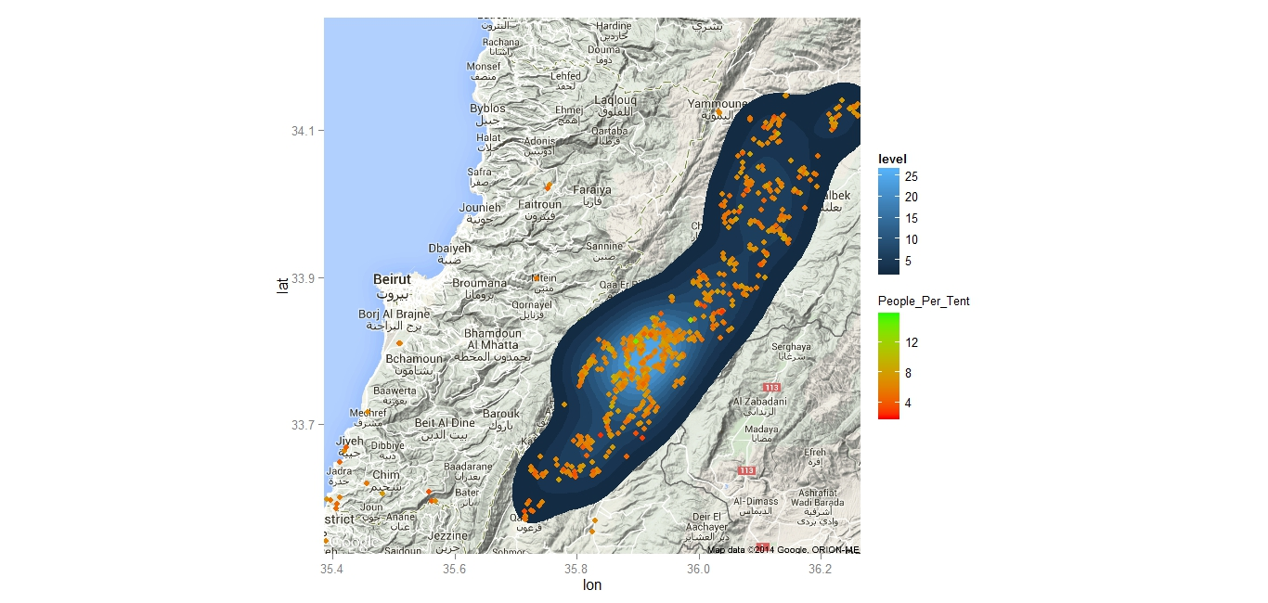

**Now What?**

Now you have the ability to compare the current Syrian refugee crisis to the situation in Lebanon in previous years. The programming techniques discussed may also be used to analyze other humanitarian crises worldwide.

*The idea for this tutorial came from Justin Lebeau at R bloggers:*

*http://www.r-bloggers.com/syrian-refugee-density-in-lebanon/*