## Polar M430 Smartwatch

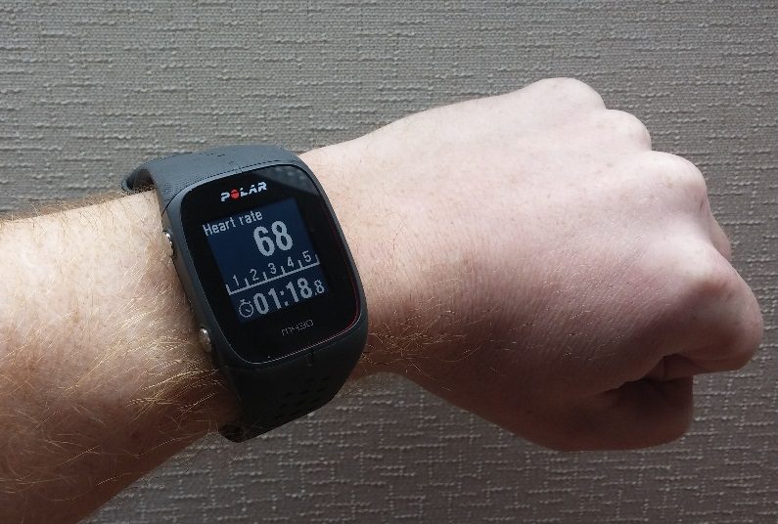

**The Polar M430**.

# Features

* Second-by-second continuous heart rate. More accurate when paired with the Polar H10 chest strap.
* GPS every 60s for up to 30 hours.
* Actigraphy-based sleep monitoring.
* Step counter.
* Fitness coaching and workout-monitoring features through Polar Flow's online service.

# Example data

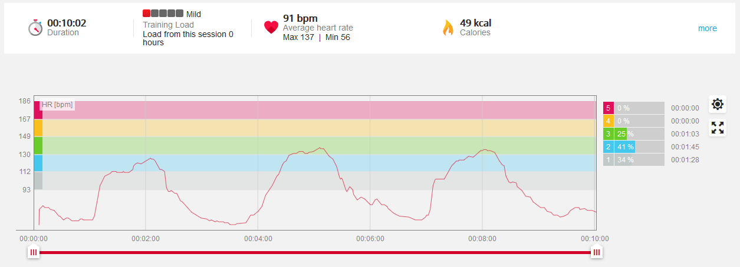

**Heart rate monitoring**, as visualized in the Flow interface. This data was captured using a paired Polar H10 heart monitor strap. Rest periods alternate with 1-minute running intervals from starting at 1, 4, and 7 minutes.

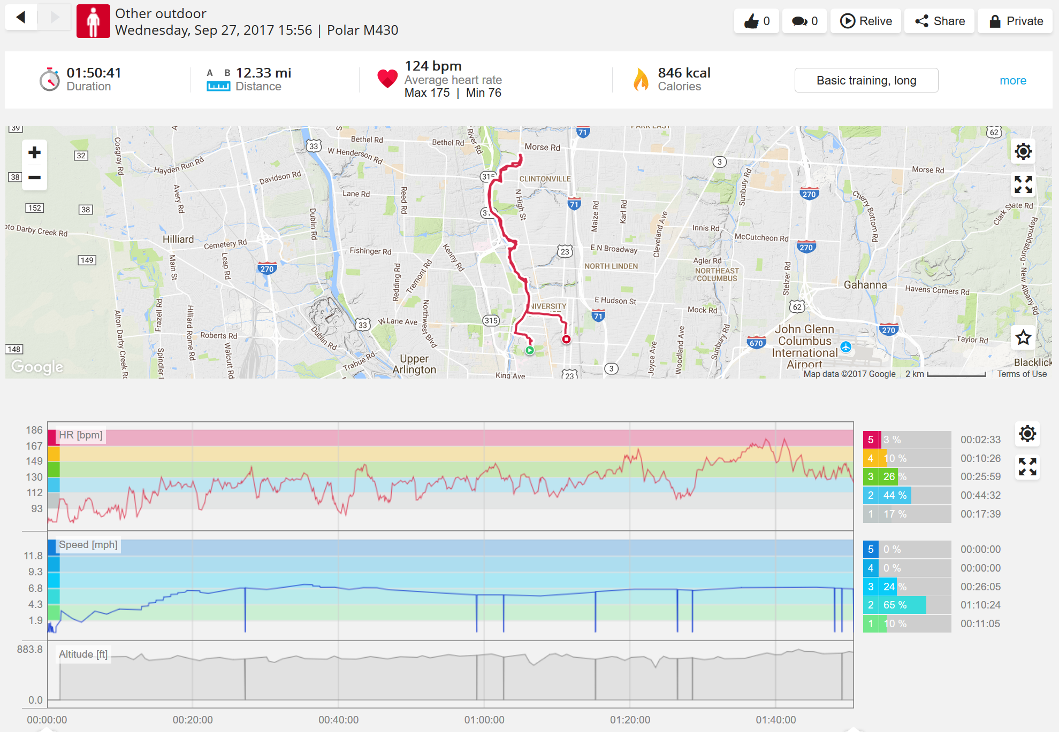

**GPS**, as visualized in the Flow interface. You can zero in on heart rate and speed for any point along the route.

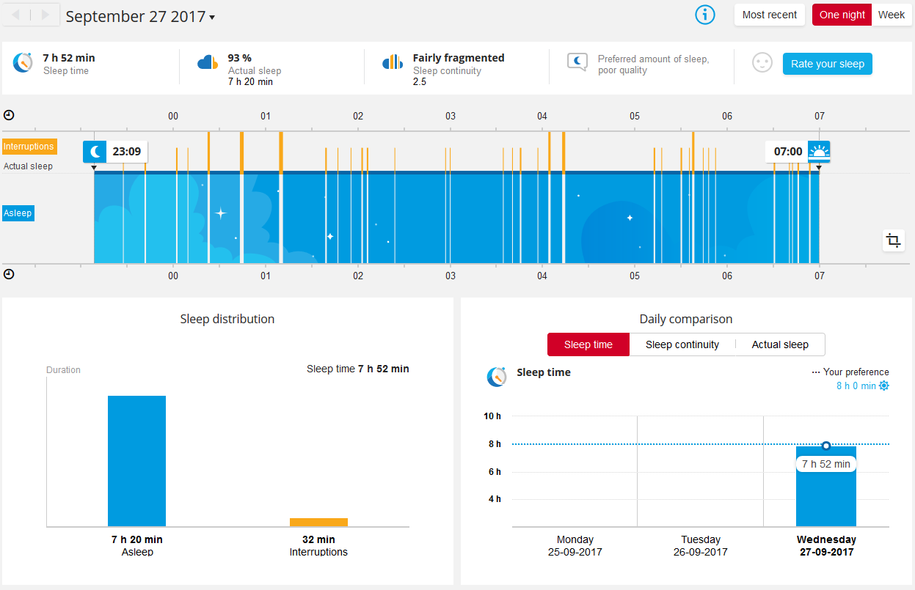

**Sleep monitoring**, as visualized in the Flow interface.

# Demo

* **Heart-rate monitoring:** From the Time screen, press the red button twice. You will see your heart rate displayed after a moment. Move around a bit and watch as it tracks your activity. Mention that the watch is also collecting GPS every minute. Hold the Back button (bottom left side) 5 seconds to exit the heart monitor.
* **Explore the** [**Polar Flow**](https://flow.polar.com/diary) **app's features and functions**. The demo account can be logged into using the email gravina.2@osu.edu and the password 2euroMod. The heart rate example above is [here](https://flow.polar.com/training/analysis/1783868650), and the GPS example is [here](https://flow.polar.com/training/analysis/1786815052#).