Software Requirements Specification
FOR
Share Karo! App

Version 1.0 approved

Prepared by Share Karo Group member:

Jharana Shrivastava: U101114FCS073 (S3)

NIIT University, Neemrana

September 17, 2016
Table of Contents

1. Introduction
1.1 Purpose
1.2 Document Conventions
1.3 Intended Audience and Reading Suggestions
1.4 Product Scope
1.5 References

2. Overall Description
2.1 Product Perspective
2.2 Product Functions
2.3 User Classes and Characteristics
2.4 Operating Environment
2.5 Design and Implementation Constraints
2.6 User Documentation
2.7 Assumptions and Dependencies

3. External Interface Requirements
3.1 User Interfaces
3.2 Hardware Interfaces
3.3 Software Interfaces
3.4 Communications Interfaces

4. System Features
4.1 System Feature 1
4.2 System Feature 2 (and so on)

5. Other Nonfunctional Requirements
5.1 Performance Requirements
5.2 Safety Requirements
5.3 Security Requirements
5.4 Software Quality Attributes
5.5 Business Rules

Introduction

Purpose
The purpose of our project is to create a sharing application that lets the University students sign up and share their means of entertainment like novels, movies and TV series that are generic means of leisure in hostels. Our app also provides them with sharing conveyance to a common route or sharing their academic resources to juniors. The app is university or local area specific and can be generalized for any physical contact span.

Document Conventions
This SRS was inspired and written on the IEEE convention guidelines. The document is written in simple “Arial” font type with font size 11 so as to make the document comprehendible and lucid. The document presents equal priorities for each requirement statement. The high level requirements are however highlighted wherever required.

Intended Audience and Reading Suggestions
The document is defined for various readers like developers, project managers, marketing people, testers and documentation writers. The users are the end viewers and the target audience for the whole documentation and the product. The SRS is indexed and the sequence is top-down approach starting from Overviews and Sub-Sections are further inherited and documented according to priorities.

Product Scope
The end product “Share Karo app” is designed for University students and provides them with a lucid platform to share their means of leisure with fellow students. This way the students get to interact with people beyond their social circles and get to exchange sharable items like novels, movies and TV series along with project presentations etc. The app/software can be a generic sharing and socializing portal for local areas where physical contact can easily be established. However, the major focus initiates from University students.

References
This System Requirements Specification document majorly refers to IEEE standards of documentation. The Use case documents are designed over Argo UML software and derived from the same.

The references are:

- https://www.google.co.in/url?sa=t&rct=j&q=&esrc=s&source=web&cd=1&cad=rja&uact=8&ved=0ahUKEwiD9syNjpbPAhWLt48KHbmQCUAQFggdMAA&url=http%3A%2F%2Fwww.csse.monash.edu.au%2F~sitar%2FCSE4002%2FLectures%2Fsrs_template-1.doc&usg=AFQjCNF2DZX7_wbYlZyeAcrgjpYYTOhF6g

- http://searchsoftwarequality.techtarget.com/answer/Software-requirements-specification-and-the-IEEE-standard

- https://www.google.co.in/url?sa=t&rct=j&q=&esrc=s&source=web&cd=4&cad=rja&uact=8&ved=0ahUKEwiD9syNjpbPAhWLt48KHbmQCUAQFggvMAM&url=https%3A%2F%2Fredmine.studenti.famnit.upr.si%2Fattachments%2Fdownload%2F138%2FIEEE%2520Standard%2520SRS%2520Template.doc&usg=AFQjCNEZkGaUM7s_C5yXUV6hbbgJ3kfQhw

- https://www.google.co.in/url?sa=t&rct=j&q=&esrc=s&source=web&cd=6&cad=rja&uact=8&ved=0ahUKEwiD9syNjpbPAhWLt48KHbmQCUAQFgg6MAU&url=http%3A%2F%2Fitech.fgcu.edu%2Ffaculty%2Fzalewski%2Fism4331%2Fwritingsrs.doc&usg=AFQjCNFCiaSyICS3fjOGPtLJAZxBmAXPJA

- http://techwhirl.com/writing-software-requirements-specifications/

- https://www.google.co.in/url?sa=t&rct=j&q=&esrc=s&source=web&cd=10&cad=rja&uact=8&ved=0ahUKEwjI7PuqjpbPAhVJPY8KHeydDTkQFghTMAk&url=https%3A%2F%2Fcs.gmu.edu%2F~dfleck%2Fclasses%2Fcs421%2Fspring10%2Fproject%2Fsrs_template.doc&usg=AFQjCNFLKrMJFVl2haJg_G4905Q2PCddnQ&bvm=bv.133178914,d.c2I

Overall Description

Product Perspective
The seeding idea of the product is derived from the basic needs and requirements of fellow college friends who are unable to procure the entertainment stuff they require due to lack in communication and contacts. This idea has been implemented on smaller scales in different university across the country and is now being developed as a completely new model with features of cab sharing and socializing. This app is basically going to be the interface between two users to intend to exchange data with mutual consent and interests.

Product Functions
The functions that product is capable of performing are:

The user can sign up with the university/domain login and share their contact (email/phone no) if they feel like. The user needs to explain their interests in particular movie/novel genres so that other users can request them. The user is also allowed to upload the ppts and presentations they created for the juniors to refer. He/she can draw out the details of their journey so as to check if anybody else matches the same. The user can look up under specific headings (entertainment, studies, conveyance) and check if their requirements match any of the ones uploaded and can then contact the concerned person. The user is also allowed to make requests to a specified person for contact regarding the requirement.

User Classes and Characteristics
The app basically focuses upon the student within specific/local contact areas. The other user classes can be of faculty and parents who are interested in similar entertainment options and require conveyance modes. The most frequent users will definitely be the hostel students who indulge into movies, TV series etc. for most of their entertainment in hostels. The other local users can belong to a common housing society or clubs. Since the app is mainly focused on leisure activities and doesn’t involve much of technical knowledge.
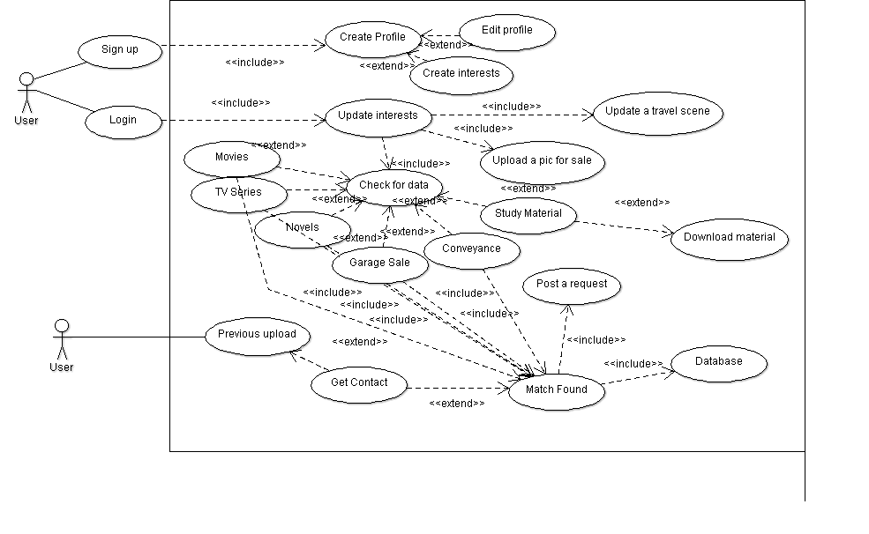
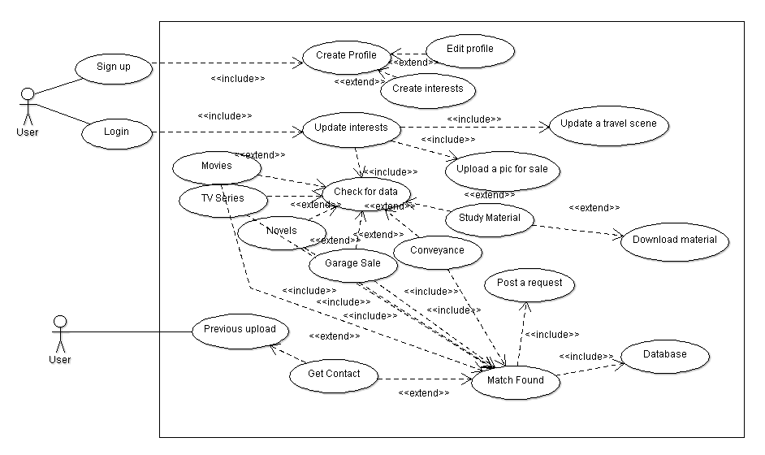

S.no | Use case | Use Case ID
1. | Sign up | UC 1
2. | Create Profile | UC 2
3. | Edit Profile | UC 3
4. | Create interests | UC 4
5. | Login | UC 5
6. | Update interests | UC 6
7. | Update a travel scene | UC 7
8. | Upload a picture for sale | UC 8
9. | Check for data | UC 9
10. | Movies | UC10
11. | TV series | UC 11
12. | Novels | UC 12
13. | Garage Sale | UC 13
14. | Conveyance | UC 14
15. | Study Material | UC 15
16. | Download Material | UC 16
17. | Match found | UC 17
18. | Post a request | UC 18
19. | Get Contact | UC 19
20. | Previous upload | UC 20
21. | Database | UC 21

Operating Environment

The software is cross-platform and can operate on all Windows, Linux and iOS operating systems over all current versions. Since, the software is designed in a social fashion, the app will function fully on android environment.

Design and Implementation Constraints

The app is location specific. Hence, the software requires a mail system login. The privacy policy however provides the users with the authority of whether they want to share their contacts/files on the portal or a specific person. The app is planned to be designed with lower RAM requirements and would require the user to stay online for updates. The software’s database is highly secured for privacy purposes. The app/software is designed in English language only and is designed to provide the users with contact information, not involving any virtual chat station protocols. The programming has been done with html and Java script formats and would provide basic html standards. The app isn’t organization based, hence doesn’t require any institution’s maintenance.

User Documentation
The app is designed to be completely lucid and comprehendible for the users and will be a self-start guides within itself.

Assumptions and Dependencies
The app/software is designed keeping in mind the fact that people are willing to share their entertainment measures. There have been surveys performed regarding the same and the results have been positive. The software design is completely original and newly planned for the purpose and the only the language frameworks have been implied for the app/software.

External Interface Requirements

User Interfaces

The app matches with the common interests & availability
The contacts of matched people are displayed

The users enter their needs and interests

Hardware Interfaces
The front-end User Interface is developed with html, CSS and Java Script. This interface is the window to what the end user sees. However, the external layer interacts with the stored Mongo database with the help of node JS scripting. The data flow is simple and is defined on the Visual Studio software framework with interactive coding.

Software Interfaces
The software is built with the definition of following frameworks:
- The database is designed using the Mongo DB framework.
- The languages (html, CSS, java script, node JS) are built upon the Visual Studio 2015 Enterprise software.
- The software is majorly designed upon the Microsoft Windows OS. However, it is created as a cross-platform forum to work over Linux and iOS as well.
- The Node JS framework: Integration with other Visual Studio features and 3 rd party tools. (Node.js, io.js, JavaScript, TypeScript, HTML, CSS, and JSON support)
- Communication protocols that interface between the front-end and back-end codes.

Communications Interfaces
The requirements associated with the product are:
- Login details: E-Mail login
- Cross platform on majorly all browsers
- Sign-up and user information via forms created by Java Script.
- HTTP is defined as the major communication standard.

System Features

Movie Sharing
4.1.1 Description and Priority
Students (hostellers) mainly like to indulge into movies to pass most of their time in the hostels. Thus, this feature is on the high priority level on the app. The app gives them an option to put up their preferred movies and search for the ones that they feel like watching.
4.1.2 Stimulus/Response Sequences
- The user can sign up and put his/her genre preferences on the app. The movies are going to be categorized into genres and languages so that the user can update the movies they own.
- If a user needs to find a movie, the user can match the genres with the ones already uploaded and make a request to the people with the same genre listed.
- If one user matches with other one and they are willing to share contacts, the contacts are made visible.
4.1.3 Functional Requirements

Sequence number | Requirement | Service provided | Constraints
4.1.1 | Login | Allows user to login | Compulsorily required
4.1.2 | Update movie preferences like genres, languages. | Lets people reach out to you looking at your list. | Needs to be correct in order to stimulate exchange process
4.1.3 | Look up for needed movies | Helps to find people with similar interests. | The user with matched interests should be willing to share the contact.
4.1.4 | Post a request to a particular user | When matched, the user can post request to a particular person | TBD

Novel Sharing
4.2.1 Description and Priority
Students (hostellers majorly) like to indulge into novels to pass their time in the hostels and to widen their horizons into the world of literature. Thus, this feature is again on the high priority level on the app. The app gives them an option to put up their collection of novels and search for the ones that they feel like watching.
4.2.2 Stimulus/Response Sequences
- The user can sign up and put his/her novel collection on the app. The novels are going to be categorized into genres and languages so that the user can update the novels they own.
- If a user needs to find a novels, the user can match the genres with the ones already uploaded and make a request to the people with the same genre listed.
- If one user matches with other one and they are willing to share contacts, the contacts are made visible.
4.2.3 Functional Requirements

Sequence number | Requirement | Service provided | Constraints
4.2.1 | Login | Allows user to login | Compulsorily required
4.2.1 | Update novels preferences like genres, languages. | Lets people reach out to you looking at your list. | Needs to be correct in order to stimulate exchange process
4.2.3 | Look up for needed novels | Helps to find people with similar interests. | The user with matched interests should be willing to share the contact.
4.2.4 | Post a request to a particular user | When matched, the user can post request to a particular person | TBD

TV-Series Sharing
4.3.1 Description and Priority
Students (hostellers mainly) indulge into TV series (American mostly) to get an insight into the affairs happening all around the world and to get a peek into the life beyond a particular space. Thus, this is another feature on the high priority level on the app. The app gives them an option to put up their preferred movies and search for the ones that they feel like watching.
4.3.2 Stimulus/Response Sequences
- The user can sign up and put his/her series collection on the app. The series are going to be categorized into genres and languages so that the user can update the TV series that they own.
- If a user needs to find a particular series, the user can match the genres with the ones already uploaded and make a request to the people with the same genre listed.
- If one user matches with other one and they are willing to share contacts, the contacts are made visible.
4.3.3 Functional Requirements

Sequence number | Requirement | Service provided | Constraints
4.3.1 | Login | Allows user to login | Compulsorily required
4.3.2 | Update TV-series preferences like genres, languages. | Lets people reach out to you looking at your list. | Needs to be correct in order to stimulate exchange process
4.3.3 | Look up for needed movies | Helps to find people with similar interests. | The user with matched interests should be willing to share the contact.
4.3.4 | Post a request to a particular user | When matched, the user can post request to a particular person | TBD

Study Material Sharing
4.4.1 Description and Priority
Students prefer their course ppts, projects, important questions papers and presentations with juniors, without any hesitation. Thus, this is another feature on the low priority level on the app. The app gives them an option to put up their used projects and ppts as reference for juniors and search for the ones that their seniors have uploaded and they feel like downloading.
4.4.2 Stimulus/Response Sequences
- The user can sign up and put his/her projects on the app. The projects are going to be categorized into courses so that the user can update the projects that they own.
- If a user needs to find a particular project under one course, the user can download from the ones already uploaded.
4.4.3 Functional Requirements

Sequence number | Requirement | Service provided | Constraints
4.4.1 | Login | Allows user to login | Compulsorily required
4.4.2 | Update their projects to be available for download. | Lets people download looking at the list. | Needs to be correct in order to stimulate exchange process
4.4.3 | Look up for needed projects and ppts. | Lets user to download their required | Simple download

Conveyance Sharing
4.5.1 Description and Priority
Students prefer sharing cabs (conveyance) to a common destination to reduce upon the travel costs and increase feasibility. Thus, this is another feature on the low priority level on the app. The app gives them an option to put up their travel schedule (date, time, source and destination) and search for the ones with same interests. This would provide them with an option to pool.
4.5.2 Stimulus/Response Sequences
- The user can login and put his/her travel schedule on the app. Then the user can come back and check if anyone matched up with the same.
- If a user needs to find pooling option, the user can click on the similar conveyance schedule already uploaded by someone and get their contact for the same.
4.5.3 Functional Requirements

Sequence number | Requirement | Service provided | Constraints
4.5.1 | Login | Allows user to login | Compulsorily required
4.5.2 | Update their travel schedule. | Lets people to pool up conveyance. | Needs to be correct in order to stimulate pooling.
4.5.3 | Look up for people with similar travelling plans. | Lets user to obtain contacts of the person for pool. | Contact display.

Garage Sale
4.6.1 Description and Priority
Students prefer sharing the reusable items with their colleagues and peers. The app provides them with a photo upload option so as to upload and share what they want to sell in second hand. Thus, this is another feature on the low priority level on the app. The user can search for the items they desire and can procure the contact of the person concerned with the item.
4.6.2 Stimulus/Response Sequences
- The user can login and put his/her travel sharable item on the app. Then the user can come back and check if anyone requested up for the same.
- If a user needs to buy the item, the user can click on the contact uploaded for the item interest and buy it.
4.6.3 Functional Requirements

Sequence number | Requirement | Service provided | Constraints
4.6.1 | Login | Allows user to login | Compulsorily required
4.6.2 | Update their selling item | Lets people to find what they want to sell | Needs to be correct and clear for better buyers
4.6.3 | Look up for desired items. | Lets user obtain contacts of seller. | Contact display.

Other Nonfunctional Requirements

Performance Requirements
The performance requirements are stated as follows:
- The app is successful only amongst users that are open to sharing and knowing new people.
- The app works better if people live in a specific local area where physical sharing is possible.
- The users prefer simple UI where they don’t have to waste much time. Hence, the design is completely lucid and simple.
- The sign up function (4.1.1, 4.2.1, 4.3.1, 4.4.1, 4.5.1) requires a user login through Gmail (Google accounts) and FaceBook.

Safety Requirements
The product is specially designed keeping the sense of sharing in mind. In case the user doesn’t want the contact going public, the user should only provide E-mail details. Contacts can be provided in case of one on one mode (if desired). The app admin can remove content, disable accounts, and work with law enforcement when we believe there is a genuine risk of physical harm or direct threats to public safety.

Security Requirements
The app is designed to keep the user account secure and protect their personal information. By joining the app and signing up, the user agrees to provide their authentic name and identity. The app cannot publish the personal information of users without their consent.

Software Quality Attributes
Some quality attributes of the app are: adaptability, availability, correctness, flexibility, interoperability, maintainability, portability, reliability, reusability, robustness, testability, and usability. Write these to be specific, quantitative, and verifiable when possible.

Business Rules
The admins of the database have the right to remove or block a specific user and cease their rights to usage in case of any breach of privacy.

Other Requirements
Since the app is locality specific, the app can’t be generalized across demographics. It can only be used in physical space areas and the database doesn’t require a physical stake hold.

********************************************************************************

