Feasibility Analysis

FOR

Share Karo App

Prepared by Share Karo App members:
Akshay Gupta: U101114FCS039
Anshul Sharma: U101114FCS046 (S2)
Ayushi Jain: U101114FCS055
Ishitaa Sayal: U101114FCS070 (S3)
Jatin Kakkar: U101114FCS072 (S3)
Jharana Shrivastava: U101114FCS073 (S3)

<NIIT UNIVERSITY>
<17 September 2016>
TABLE OF CONTENTS

- Executive summary

- Description of products and services

- Seeding Survey

- Technical Feasibility

- Product and Service Marketplace

- Operational Feasibility

- Threats

- Marketing

- Findings and recommendations

- Conclusions

- References

EXECUTIVE SUMMARY

The project “Share Karo” App has been done as a Vth Semester software engineering project development assignment. The Project has been developed by six third year students Akshay Gupta: U101114FCS039 (S2), Anshul Sharma: U101114FCS046 (S2), Ayushi Jain: U101114FCS055 (S2), Ishtaa Sayal: U101114FCS070 (S3), Jatin Kakkar: U101114FCS072 (S3) and Jharana Shrivastava: U101114FCS073 (S3).

The admin rights of the app and the first installment presentation lies with the developers and founders of this app. The app has been purely developed by its founding members with proper division of workforce.

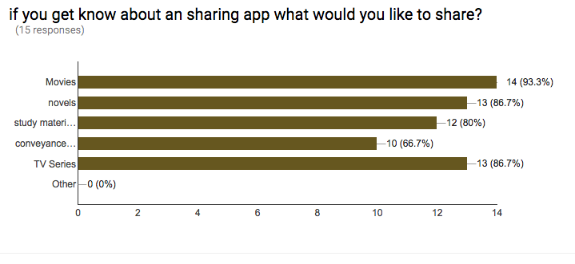
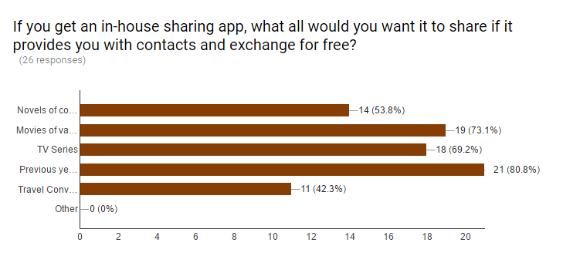

DESCRIPTION OF PRODUCTS AND SERVICES

The project is mainly focused on three features.

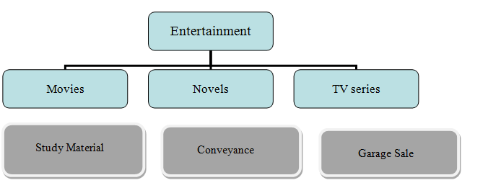

Movie Sharing:

The students mainly hostellers indulge in watching movies during their leisure time in hostels. It’s again put in high priority level of the app. Users put up their collection of movies on the app and search for those movies they fell like watching.

Novel Sharing:
The students mainly hostlers indulge in reading in their leisure time. They love to read in order to improve their vocabulary and reading skills. It’s again in a high priority level of the app. User can put up their collection of books on the app and search for the ones they like to read
TV-Series Sharing:
Students mainly hostler indulge themselves in watching TV Series (American). They love to know about what’s happening around the world in get a insight into different kind of lifestyle. They get to know about the lifestyle of people outside their country. The app provides them with option to put up preferred TV Series or the genres they like the most and search what they want to watch.
Study Material Sharing:
Students prefer to get their course ppts and project materials on Internet. Our app provides the facilities to update the reference materials for their juniors. Its put on a low priority level of our app. Students can also search for the reference materials they require uploaded by their seniors
Conveyance Sharing:
Students prefer to share a cab to a common destination in order to reduce the travel cost. It’s again put up in a low priority level of the app. Students can put their travel details like date and time of journey and destination and search for the users travelling around same time. This would provide them with a option to share the conveyance.

SEEDING SURVEYS
The company decided to first survey if the project is worth efforts in real-time. The seeding idea was then presented to a few friends who helped in deciding the same.
The app has been designed keeping in mind the interest of students (college/universities) and targets the same. Through thorough research and survey within the college campus, it has been observed how hostellers tend to look out for sharable movies, novels and TV series to watch for entertainment in the leisure time in hostel.
Through surveys have been conducted on college/university students and the results have led to development of the project. Two kinds of surveys have been conducted.
One of the surveys was done to know whether the idea is feasible or not? This is the Seeding idea survey.
Another survey was done to know the response of the students towards the app, weather they are going to use it or not.
Here is the link for the seeding:
https://docs.google.com/a/st.niituniversity.in/forms/d/e/1FAIpQLSdQRok8juXlh7KKhXiNcEUZWWn9YxTKTtLWmKertD9MFtg0fA/viewform
Responses recorded while initial surveys:
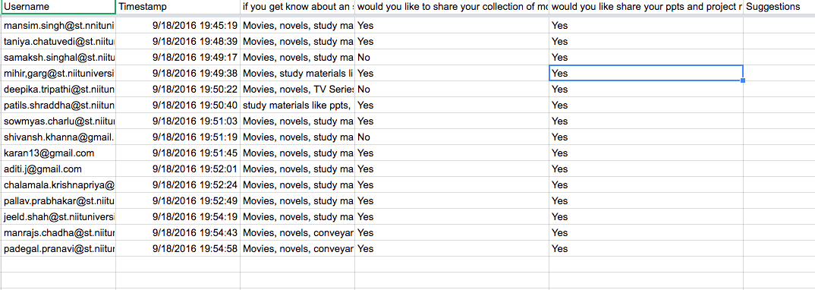
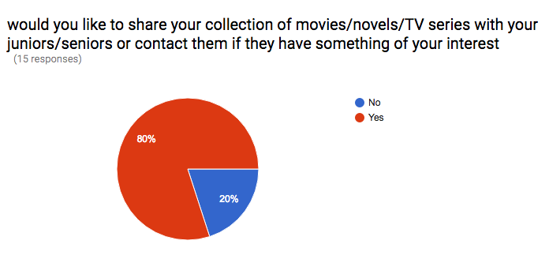

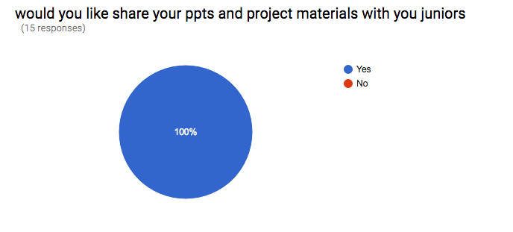

TECHNICAL FEASIBILITY
The project is designed based on the following framework.

Definition of following frameworks has been used to build this software:
- Mongo DB framework has been used to design database framework.
- HTML, CSS, Java Script, Node js are built on Visual code 2015 enterprise software.
- Despite software being built on Microsoft Windows OS, it has been built as cross platform for linux, Mac also.
- Node JS framework is as follows: Integration with other Visual Studio features and 3rd party tools. (Node.js, io.js, JavaScript, TypeScript, HTML, CSS, and JSON support)
- Interface between front end codes and back end codes is carried out by these communication protocols.
Heavy or complicated software is not required for the design. Minimal requirements have been there for build up of this software. Most of the tools mentioned have already been itegrated and all of the developers are well versed with front-end development. They are pursuing courses on respective languages to build up the back-end framework.
The following site of Cousera has been a guding principle for the learning.
https://www.coursera.org/

PRODUCT/SERVICE MARKETPLACE

The software has been designed majorly for University students. However, it can be generalized and extended to local area space where people can interact and share their entertainment, study material and conveyance through the app.
Here are the responses that have been recorded for the surveys:
The user can sign up through university/domain login and can share their email/contacts if they want so that other users can contact. Users are required to describe their interest in type of TV Series or particular movie or novel garner. The can share study materials ppts or pdf for the juniors. The user can sketch the details of their journey and check if anyone’s matches with theirs. Users can search for their needs under headings like entertainment, studies and conveyance and if their requirement matches with any uploaded ones can then contact the consent person. The user can send request to the consent person for his/her contact.

Survey form link:
https://docs.google.com/a/st.niituniversity.in/forms/d/e/1FAIpQLSdQRok8juXlh7KKhXiNcEUZWWn9YxTKTtLWmKertD9MFtg0fA/viewform

OPERATIONAL FEASIBILITY
The app will be operating with simple steps on both android and windows platforms. The user can sign up with lucidity and can navigate through all the pages with icons clearly provided on each page. The app wouldn’t require a guide to understand the operations. The design is such that any layman can freely operate the product with ease.
We discussed the design with a few of our friends (potential users) and received positive responses for the same. The final design however will be presented in a user friendly manner.

THREATS
The project idea could face serious oppositions or failures if the following conditions are somehow invalidated:
- The people are not willing to share their private collections.
- People are not open to interacting with new people or getting to socialize.
- The physical exchange is not possible between two interested parties.
- The people don’t sign up or update data on the concerned forum and don’t make it visible.
The threats are taken care of in the manner where the app is made completely interactive and lucid for usage. It is considered that students are generally open to socializing and procuring their needed stuff from sources.

MARKETING STRATEGY

The marketing strategy has been designed to promote the application through the various social media platforms such as Facebook, Google+, Snapchat, etc.
The application would be promoted on in the campus by putting flex banners and posters all around the campus. The application link will be available on University’s official website also.

FINDINGS AND RECOMMENDATIONS

The application has been approved by most of the people as an effective measure and a breakthrough as a sharing portal where people can come up and share their entertainment measures.
The app is highly recommended for anybody who wishes to share stuff and reduce upon the costs while doing so.

CONCLUSIONS

The “Share Karo” application is perfectly fine to go for the designing and development phase.
The application comes with advantages listed below:
- Low memory requirements for database and size of software.
- Cross platform application.
- Open source functioning to invite other developers to contribute after the completion of college project.
- Simple User friendly interface with latest guidelines in market.
- Privacy protection for the users.
- Simple interaction and exchange of things between users.

REFERENCES
- https://www.google.co.in/search?q=feasibility+analysis+pdf&oq=feas&aqs=chrome.1.69i59l3j69i57j0l2.3767j0j7&sourceid=chrome&ie=UTF-8
- http://thenextweb.com/apps/2015/07/10/9-of-the-best-apps-for-sharing-files-between-devices-and-friends/
- https://www.google.co.in/forms/about/
- https://teamtreehouse.com/tracks/front-end-web-development
- http://www.inc.com/murray-newlands/15-marketing-strategies-that-inspire-strategic-thinkers.html

******************************************************************************

