Software Requirements Specification

for

Share Karo App!

Version 1.0

Prepared By

Akshay Gupta U101114FCS039 (S2)

Anshul Sharma U101114FCS046 (S2)

Ayushi Jain U101114FCS055 (S2)

Ishtaa Sayal U101114FCS070 (S3)

Jatin Kakkar U101114FCS072 (S3)

Jharana Shrivastava U101114FCS073 (S3)

NIIT University, Neemrana

September 17, 2016

Table of Contents
1. Introduction………………………………………………………………
1.A Purpose
1.B Document Conventions
1.C Intended Audience and Reading Suggestions
1.D Product Scope
1.E References

2. Overall Description……………………………………………………
2.A Product Perspective
2.B Product Functions
2.C User Classes and Characteristics
2.D Operating Environment
2.E Design and Implementation Constraints
2.F User Documentation
2.G Assumptions and Dependencies

3. External Interface Requirements…………………………………....
3.A User Interfaces
3.B Hardware Interfaces
3.C Software Interfaces
3.D Communications Interfaces

4. System Features………………………………………………………..
4.A System Feature 1
4.B System Feature 2 (and so on)

5. Other Nonfunctional Requirements…………………………….......
5.A Performance Requirements
5.B Safety Requirements
5.C Security Requirements
5.D Software Quality Attributes
5.E Business Rules

6. Other Requirements…………………………………………………...
Appendix A: Glossary
Appendix B: Analysis Models
Appendix C: To Be Determined List

1. Introduction

Purpose
The aim of our project is to build a platform which lets the university students share their means of entertainment by signing up on our web application. They will be able to share movies, novels, TV series etc that are a generic means of leisure in hostels. Our app does not restrict itself to just entertainment, it will also provide a means to share study materials amongst students or sharing conveyance to a common route. This app is university or local area specific and can be generalized for any physical contact span.

Document Conventions
This SRS was inspired and written on the IEEE convention guidelines. The document is written in simple “Arial” font type with font size 11 so as to make the document comprehendible and lucid. The document presents equal priorities for each requirement statement. The high level requirements are however highlighted wherever required.

Intended Audience and Reading Suggestions
The intended audience of this SRS document is our overseeing project professor, Mr. Amit Kumar, and various readers like developers, project managers, marketing people,testers and documentation writers. The document is meant as a means for them to easily see and refer to our overall product goals and commitments. It also serves an ancillary purpose of allows the project team to make sure that intended goals and functionalities of the product are being met. The SRS is indexed and the sequence is top-down approach starting from Overviews and Sub-Sections are further inherited and documented according to priorities.

Product Scope
“Share Karo App” is designed to provide support for university students, in different ways. The primary benefit of the application is that the users can coordinate with other students of the university for sharing various means of entertainment, study materials & carpooling. Not only does this allow users to easily find way to get and share resources, but the synchronization of the application provides a unified means of communication with people beyond their social circles. The app/software can be a generic sharing and socialising platform for local areas where physical contact can be established. However, the major focus is towards the University students.The goal of the application is that users find a direct value in using the product, therefore encouraging other students to use the application. This will gather further support and customer loyalty to both the app and the service.

References

This SRS document is fundamentality written abiding by the IEEE standards of documentation. The Use Case Diagrams have been designed using Argo UML software.

The references are:

- https://www.google.co.in/url?sa=t&rct=j&q=&esrc=s&source=web&cd=1&cad=rja&uact=8&ved=0ahUKEwiD9syNjpbPAhWLt48KHbmQCUAQFggdMAA&url=http%3A%2F%2Fwww.csse.monash.edu.au%2F~sitar%2FCSE4002%2FLectures%2Fsrs_template-1.doc&usg=AFQjCNF2DZX7_wbYlZyeAcrgjpYYTOhF6g

- http://searchsoftwarequality.techtarget.com/answer/Software-requirements-specification-and-the-IEEE-standard

- https://www.google.co.in/url?sa=t&rct=j&q=&esrc=s&source=web&cd=4&cad=rja&uact=8&ved=0ahUKEwiD9syNjpbPAhWLt48KHbmQCUAQFggvMAM&url=https%3A%2F%2Fredmine.studenti.famnit.upr.si%2Fattachments%2Fdownload%2F138%2FIEEE%2520Standard%2520SRS%2520Template.doc&usg=AFQjCNEZkGaUM7s_C5yXUV6hbbgJ3kfQhw

- https://www.google.co.in/url?sa=t&rct=j&q=&esrc=s&source=web&cd=6&cad=rja&uact=8&ved=0ahUKEwiD9syNjpbPAhWLt48KHbmQCUAQFgg6MAU&url=http%3A%2F%2Fitech.fgcu.edu%2Ffaculty%2Fzalewski%2Fism4331%2Fwritingsrs.doc&usg=AFQjCNFCiaSyICS3fjOGPtLJAZxBmAXPJA

- https://www.google.co.in/url?sa=t&rct=j&q=&esrc=s&source=web&cd=1&cad=rja&uact=8&ved=0ahUKEwjI7PuqjpbPAhVJPY8KHeydDTkQFggbMAA&url=https%3A%2F%2Fwww.ibm.com%2Fdeveloperworks%2Fcommunity%2Fwikis%2Fform%2Fanonymous%2Fapi%2Fwiki%2F336d1dbb-5203-4eb3-8542-f4a2d1af056c%2Fpage%2Fd9b0b712-ac9d-43ac-b430-0bc76b7edc31%2Fattachment%2F921e2bcf-2349-42d3-976b-0e23f7d6ff61%2Fmedia%2Fsrs%2520format.pdf&usg=AFQjCNG5oXPXYDtLmBCD1S1bdInIIDQ5Og&bvm=bv.133178914,d.c2I

- http://techwhirl.com/writing-software-requirements-specifications/

- https://www.google.co.in/url?sa=t&rct=j&q=&esrc=s&source=web&cd=10&cad=rja&uact=8&ved=0ahUKEwjI7PuqjpbPAhVJPY8KHeydDTkQFghTMAk&url=https%3A%2F%2Fcs.gmu.edu%2F~dfleck%2Fclasses%2Fcs421%2Fspring10%2Fproject%2Fsrs_template.doc&usg=AFQjCNFLKrMJFVl2haJg_G4905Q2PCddnQ&bvm=bv.133178914,d.c2I

2. Overall Description

Product Perspective
The very idea of this product is derived from the fact that college students are unable to procure the resources they need due to the sheer lack of communication and contacts. This idea has been implemented on smaller scales in different university across the country and is now being developed as a completely new model with features of cab sharing and socializing. This app is going to act as a mode of communication for those people who wish to exchange data with mutual consent and interests.

Product Functions
Major Functions:

-Allow the user/student to sign up with the university/domain login.
-Allow the user/student to share the contact(email/contact number) according to their convenience.
-Allow user/student to specify their interests in particular movie/novel genres, so that other users can request them.
-Allow user/student to upload any study material that they wish to share like presentations, documents etc.
-Allow the user/student member to specify their travel means, so as to get carpools and rides.
- Allow the user/students to specify that they are available to give carpool ride and then notify users on the same team.
-Allow the user/student to browse under specific fields(entertainment, studies, conveyance) and get the deatils of the concerned person.
-Allow the user/student to request a specific person for contact so as to fulfill their requirements.

User Classes and Characteristics
This application’s primary user would be students withing a specific contact area. We can obviously take this to another level by expanding its reach to other customers but our first version would focus on hostel students in a particular university.

Operating Environment

The “Share Karo App” client requires a device running on operating systems like Windows, Linux, iOS and an active internet connection. Since, the software is designed in a social fashion, the app will function fully on android environment.

Design and Implementation Constraints

The app is location specific. Hence, the software requires a mail system login. The privacy policy however provides the users with the authority of whether they want to share their contacts/files on the portal or a specific person. The app is planned to be designed with lower RAM requirements and would require the user to stay online for updates. The software’s database is highly secured for privacy purposes. The app/software is designed in English language only and is designed to provide the users with contact information, not involving any virtual chat station protocols. The programming has been done with html and Java script formats and would provide basic html standards. The app isn’t organization based, hence doesn’t require any institution’s maintenance.

User Documentation
The app is designed to be completely lucid and comprehendible for the users and will be a self-start guide within itself.

Assumptions and Dependencies
This app/software will be built on this assumption that people are willing to share their resources and acquire the same from others. The software design is entirely unique and made from scratch. The idea was finalised after acquiring substantial statistics from thesurvey conducted in the university.

3.External Interface Requirements

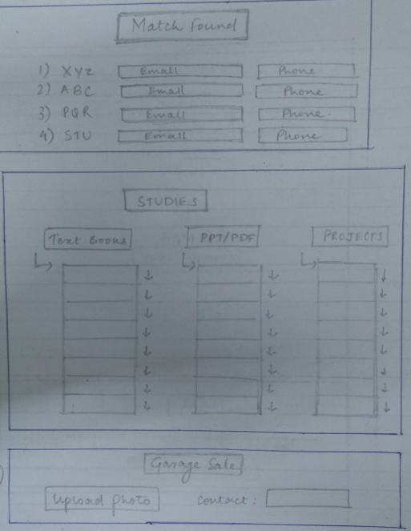
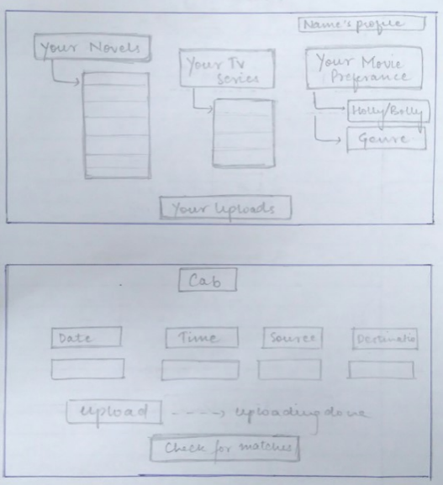

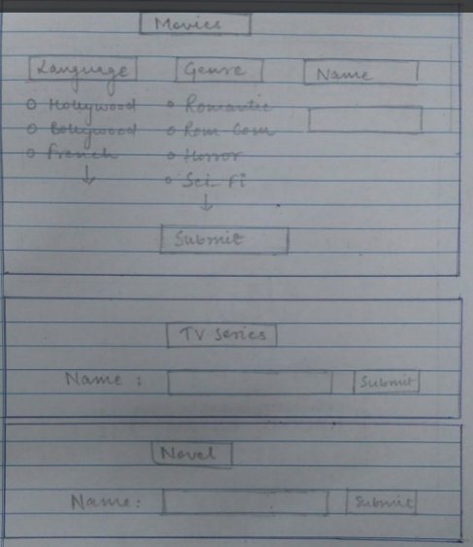
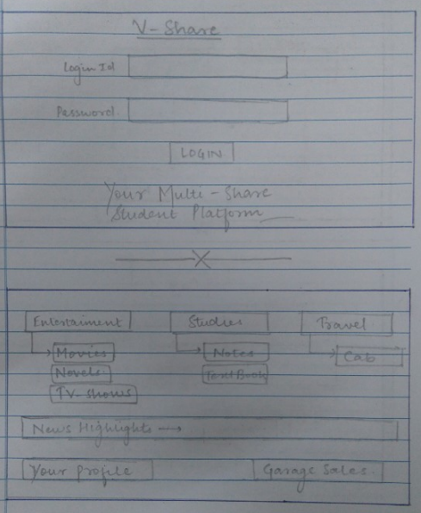
User Interfaces

Hardware Interfaces
The UI is developed with html, CSS and Java Script.However, this external layer interacts with the stored Mongo database with the help of node JS scripting. The data flow is simple and is defined on the Visual Studio software framework with interactive coding.

Software Interfaces
The software is built with the definition of following frameworks:
- The database is designed using the Mongo DB framework.
- The languages (html, CSS, java script, node JS) are built upon the Visual Studio 2015 Enterprise software.
- The software is majorly designed upon the Microsoft Windows OS. However, it is created as a cross-platform forum to work over Linux and iOS as well.
- The Node JS framework: Integration with other Visual Studio features and 3 rd party tools. (Node.js, io.js, JavaScript, TypeScript, HTML, CSS, and JSON support)
- Communication protocols that interface between the front-end and back-end codes.

Communications Interfaces
The requirements associated with the product are:
- Login details: E-Mail login
- Sign-up and user information via forms created by Java Script.
- HTTP as the major communication standard.
Users
Name
Login ID
Password
Movie Interest
Novel Interests
TV Series
Get match ()

4. System Features

Movie Sharing
4.1.A Description and Priority
This feature is on the top priority as movies are the primary source of entertainment for students. They can set their preferences like the genres and look for movies that they feel like watching
4.1.B Stimulus/Response Sequences
- The user has to sign up.
- The user will have to set his/her preferences (genres, language)
- User can look for similar genres and place a request for the same.
- If the other user accepts this request and allows to share his/her contact. the contact is made visible.
4.1.C Functional Requirements

Sequence number | Requirement | Service provided | Constraints
Req 4.1.A | Sign up | Allows user to login | Compulsorily required
Req 4.1.B | Update movie preferences like genres, languages. | Lets people reach out to you looking at your list. | Needs to be correct in order to stimulate exchange process
Req 4.1.C | Look up for needed movies | Helps to find people with similar interests. | The user with matched interests should be willing to share the contact.
Req 4.1.D | Post a request to a particular user | When matched, the user can post request to a particular person | TBD

Novel Sharing
4.2.A Description and Priority
This feature is also a part of the app’s priority list, since reading is something done by most of the students and they would love to have more books and novels to read. They would update the names of the novels they have, and can look for other novels.
4.2.B Stimulus/Response Sequences
- The user has to sign up
- Update his novel collection.The novels will be categorized in terms of genres and languages.
- The user can look up for their preferred genres and place request to that particular person who owns the novel.
- If the other uses grants the request to share contacts. The contacts are made visible.
4.2.C Functional Requirements

Sequence number | Requirement | Service provided | Constraints
Req 4.2.A | Sign up | Allows user to login | Compulsorily required
Req 4.2.B | Update novels preferences like genres, languages. | Lets people reach out to you looking at your list. | Needs to be correct in order to stimulate exchange process
Req 4.2.C | Look up for needed novels | Helps to find people with similar interests. | The user with matched interests should be willing to share the contact.
Req 4.2.D | Post a request to a particular user | When matched, the user can post request to a particular person | TBD

TV-Series Sharing
4.3.A Description and Priority
Tv-series have become really popular these days, be it from different countries,cultures or languages. Therefore, this feature is again on the priority list. User can update their preferences and look up for the ones they would like to watch.
4.3.B Stimulus/Response Sequences
- The user can sign up and put his/her series collection on the app. The series are going to be categorized into genres and languages so that the user can update the TV series that they own.
- If a user needs to find a particular series, the user can match the genres with the ones already uploaded and make a request to the people with the same genre listed.
- If one user matches with other one and they are willing to share contacts, the contacts are made visible.
4.3.C Functional Requirements

Sequence number | Requirement | Service provided | Constraints
Req 4.3.A | Sign up | Allows user to login | Compulsorily required
Req 4.3.B | Update TV-series preferences like genres, languages. | Lets people reach out to you looking at your list. | Needs to be correct in order to stimulate exchange process
Req 4.3.C | Look up for needed movies | Helps to find people with similar interests. | The user with matched interests should be willing to share the contact.
Req 4.3.D | Post a request to a particular user | When matched, the user can post request to a particular person | TBD

Study Material Sharing
4.4.A Description and Priority
Resource sharing is very important in colleges, students would love to have study material from fellow college mates like presentations, projects, reviews etc. This feature is again on our priority list for this application. They can upload their study material and can look amongst the other documents uploaded by their classmates or seniors. They can directly download it.
4.4.B Stimulus/Response Sequences
- The user has to sign up.
- Update their database by uploading all the material that they would want to share. They will be categorised into courses.
- They can download any other course material present on the platform.
4.4.C Functional Requirements

Sequence number | Requirement | Service provided | Constraints
Req 4.4.A | Sign up | Allows user to login | Compulsorily required
Req 4.4.B | Update their projects to be available for download. | Let people download looking at the list. | Needs to be correct in order to stimulate exchange process
Req 4.4.C | Look up for needed projects and ppts. | Lets user to download their required | Simple download

Conveyance Sharing
4.5.A Description and Priority
Students prefer to travel in groups for both security and reduced cost. They prefer sharing cabs to a common destination and hence this platform will provide them with the option to update their travel schedules and look for similar ones. They can provide them with the option to travel together.
4.5.B Stimulus/Response Sequences
- The user has to sign up.
- The user can update his/her travel schedules.
- The user can check up later if the details match.
- User can click on the already uploaded schedules for carpooling and get the contact.
4.5.C Functional Requirements
Sequence number | Requirement | Service provided | Constraints
Req 4.5.A | Sign up | Allows user to login | Compulsorily required
Req 4.5.B | Update their travel schedule. | Lets people to pool up conveyance. | Needs to be correct in order to stimulate pooling.
Req 4.5.C | Look up for people with similar travelling plans. | Lets user to obtain contacts of the person for pool. | Contact display.

Garage Sale
4.5.A Description and Priority
In college life one is always in need of money and daily accessory items. There is another feature in this app with which you can share the pics of your reusable items and if someone wants it, he can contact the concerned user. This feature is on the low priority list of this app.
4.5.B Stimulus/Response Sequences
- User has to sign in.
- User has to click picture of the item that he/she wishes to sell and upload it.
- If any user wants to buys a particular item, they can click on the uploaded item picture and contact the concerned person

4.5.C Functional Requirements

Sequence number | Requirement | Service provided | Constraints
Req 4.6.A | Sign up | Allows user to login | Compulsorily required
Req 4.6.B | Update their selling item | Lets people to find what they want to sell | Needs to be correct and clear for better buyers
Req 4.6.C | Look up for desired items. | Lets user obtain contacts of seller. | Contact display.

5. Other Nonfunctional Requirements

Performance Requirements
The performance requirements are stated as follows:
- The success of the app depends upon people’s willingness to share and acquire resources.
- The app works for areas where physical contact is possible.
- The design with be lucid and simple, keeping in mind the ease of access and usability.
- Sign up function requires a login through Gmail & Facebook.

Safety Requirements

The product is fundamentally designed keeping the sense of sharing in mind. The user is free to choose whether he/she will share their contact details or not, the user should only provide E-mail details if they prefer. Contacts can be shared on mutual consent. The admin will have the authority to disable accounts, remove content & work with the law enforcement when their will be a genuine risk of physical harm or threats to public safety.

Security Requirements
The product will be developed keeping public security on top priority. The App cannot publish personal information of user without their consent.

Software Quality Attributes
Some quality attributes of the app are: adaptability, availability, correctness, flexibility, interoperability, maintainability, portability, reliability, reusability, robustness, testability, and usability. Write these to be specific, quantitative, and verifiable when possible.

Business Rules
The admin has full authority to remove or block any user and cease their rights to usage in case of any breach of privacy.

Appendix A: Glossary
Appendix B: Analysis Models
Appendix C: To Be Determined List

