VISVESWARAIAH TECHNOLOGY UNIVERSITY
BELGAUM-590014

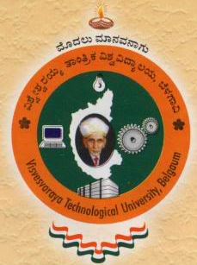

PROJECT REPORT

On

“Power Aware Distributed File-System”
Submitted in partial fulfilment of the requirement for the award of the degree of

BACHELOR OF ENGINEERING
In
INFORMATION SCIENCE AND ENGINEERING
Submitted by

Rahul Venkataramani 1NT07IS042
Sachin A Navale 1NT07IS047
G Vinay 1NT07IS020
Prabhanjan S M 1NT07IS046
Under the guidance of

Dr.Sanjay H.A
Prof. & Head,
Dept. of IS&E
NMIT, Bangalore.

Mr.D B Srinivas Professor,
Dept. of IS&E
NMIT, Bangalore.



DEPARTMENT OF INFORMATION SCIENCE & ENGINEERING
NITTE MEENAKSHI INSTITUTE OF TECHNOLOGY
(An Autonomous Institution)

NITTE MEENAKSHI INSTITUTE OF TECHNOLOGY
(Govindapura, Gollahalli, Yelahanka, Bangalore-560064)

DEPARTMENT OF INFORMATION SCIENCE & ENGINEERING

CERTIFICATE

Certified that the project work entitled “Power Aware Distributed File System” is a bonafide work carried out by Mr. Sachin A Navale(1NT07IS047), Rahul Venkataramani (1NT07IS042), Prabhanjan S M (1NT07IS046), G Vinay (1NT07IS020) in partial fulfillment for the award of degree of Bachelor of Engineering in Information Science and engineering of the Nitte Meenakshi Institute of technology during the year 2010-11. It is certified that all corrections/suggestions indicated for internal Assessment have been incorporated in the report deposited in the department library. The project report has been approved as it satisfies the academic requirements in respect of project work prescribed for the said degree
Name and signature of the
Guide
Name and signature of the
Guide

Mr D B Srinivas
Dr.Sanjay H A
Name and signature of the
HOD
Name and signature of the
Principal

Dr.Sanjay H A
Dr. H C Nagaraj

External Viva
Name of Examiners Signature with date

- _____________ _____________

- _____________ ______________

- _____________ _____________

