Abstract

Cloud computing has emerged as one of the most popular ways of providing services to users across internet. With the emergence of cloud computing, Map Reduce has established itself as the predominant programming model in these environments.
The designers of Map Reduce envisioned the framework to be extremely simple in design and use. This has led to many trade-offs in design with simplicity in design being given more preference compared to efficiency. There have been some efforts to reduce the power consumption in Map Reduce framework. However, such efforts are often limited to task level scheduling of applications or hardware level optimization.
Power aware systems are increasingly becoming necessary because of the huge amounts of carbon emissions from the data centers. Towards this end, we have proposed a novel block placement strategy for distributed file systems like Hadoop Distributed File System (HDFS) which exploits node heterogeneity in a cluster to provide power performance savings without drastic reductions in performance or violations of QoS
In our approach, the proposed block placement strategy places the blocks of data on such nodes where if execution takes places leads to optimum performance and power savings. Our goal is to define an architectural framework and principles for energy-efficient distributed computing; investigate energy-aware resource provisioning and allocation algorithms that provision data center resources to client applications in a way that improves the energy efficiency of the data center, without violating the negotiated Service Level Agreements (SLA). To meet this objective we formulated our problem to Liner programming model.

CHAPTER 1
INTRODUCTION

CHAPTER 1
Introduction

Optimizing performance in computer clusters has been a topic of interest in a number of recent research works. It is true that research has been, to a certain extent, successful in accomplishing this goal but on the other hand, energy consumption has been mostly neglected. Reducing energy consumption in computer clusters has become a necessity for many reasons. First of all, for a large cluster which consumes signiﬁcant amounts of energy, it can be necessary to use expensive cooling equipment. Cooling equipment can consume up to 50% of the total energy consumption in some commercial servers (see Rajamani et al. []). Also, because of the growing cost of electricity, reducing energy consumption has become an economic necessity (see Bianchini et al. []).
Scheduling for such systems is complicated due to several factors. The state of the system dynamically changes and a scheduling policy should adapt its decisions to the state of the system. Another factor contributing to the complexity of scheduling for clusters is related to the heterogeneous nature of such systems. These systems interconnect a multitude of heterogeneous machines (desktops with various resources: CPU, memory, disk, etc.) to perform computationally intensive applications that have diverse computational requirements. Performance may be signiﬁcantly impacted if information on task and machine heterogeneity is not taken into account by the scheduling policy.
There are two main reasons for need of power aware computing in cluster systems: operational cost and system reliability. One dominating factor in the operational cost of data centers comes from electricity cost consumed by server systems. As the number of managed servers increases, data centers can consume as much electricity as a city [2, 3].
Another reason is related to reliability of systems due to increased temperature caused by large power consumption. It is well known that computing in high temperature is more error-prone than one in appropriate environment. The expected failure rate of an electronic device doubles for every 10 C increased temperature according to the Arrenhius’ equation [4]. In addition, the increased number of nodes in a cluster system results in lowering availability of the system. Thus, efficient power management of cluster systems becomes important issue of data centers not only for reducing their operational cost but also for system reliability.
In addition, many studies on cluster computing have been done in order to support Service Level Agreements (SLAs) between users and resource providers. SLAs define the negotiated agreements between service providers and consumers and include Quality of Service (QoS) parameters, such as deadline. Although it is important to reduce the system power, QoS parameters specified in SLAs should not be violated or the degradation should be minimized. Most of previous work has focused on minimizing performance degradation due to power reduction.
1.1 Motivation
With the advent of Cloud computing, large-scale virtualized compute and data centers are becoming common in the computing industry. These distributed systems leverage commodity server hardware in mass quantity, similar in theory to many of the fastest Supercomputers in existence today. However these systems can consume a cities worth of power just to run idle, and require equally massive cooling systems to keep the servers within normal operating temperatures. This produces CO2 emissions and signiﬁcantly contributes to the growing environmental issue of Global Warming. Green computing, a new trend for high-end computing, attempts to alleviate this problem by delivering both high performance and reduced power consumption, effectively maximizing total system efficiency.

Currently, Hadoop is the de-facto platform for data intensive distributed applications capable of processing peta-bytes of data. However, till the latest release (Hadoop 0.20.1) none of the power aware techniques used in grid computing are incorporated into this framework. A major issue involved in designing the power aware techniques is that the native performance of Hadoop should not be compromised.
An intelligent placement of data blocks in the heterogeneous nodes in a cluster would lead to power savings. However, the major challenge before us was to make sure that the QoS provided should not be violated. The dual challenges of reducing power consumption and not allowing the performance to suffer thereby made it an interesting project for us to ponder on.
1.2 Issues and challenges
The following are some of the issues involved in designing power aware systems.
- Any changes to the existing framework to achieve energy efficiency will result in the system’s performance being affected.
- The underlying base file system and the overlying programming framework are closely related. Any changes to one component will affect the other component adversely.
- Hadoop was designed to keep the architecture simple. These design goals should not be compromised by our algorithm.
- The scheduling mechanism used should not consume much computation resulting in lesser throughput.
- Different applications require different scheduling mechanisms. Our approach should be generic enough to encompass all these requirements.

1.3 Problem Statement
“To develop a heuristic for the block placement strategy in a distributed file system and execution strategy of the overlying execution strategy to consume the least power without compromising on the binding SLA in a cloud environment.”
1.4 Literature Survey
As our work exploits the heteroginity of the nodes in a cluster, we found many of current approaches in leveraging heteroginity to be related. Jiong Xie et. al.[8] proposed ranking nodes in terms of relative computing ratios for effecient block placement so that high performance nodes can have more blocks in their local hard disks compared to the low performance nodes.
Hadil Al-Daoud et. al[3] proposed a power-aware linear programming model for task execution. An important difference between this work and ours is our work concentrates on block placement at a file system level while this work mainly deals with task scheduling. Rini T Kaushik et al [8] profiles the application data on a timeline and seperates the data into different zones called Hot Zone and Cold Zone depending on the data usage.
Kyong Hoon Kim1 et. al[8] deal with provisioning of virtual machines in a power-effecient manner. However, these works do not address the issue from high computing platform point of view.Nitesh Maheshwari et. al[YYYY] deal with effecient and placement and re-organisation of data in a cluster. They try to reduce the power consumption by switching off the unused nodes.
Zaharia et. al[9] use the LATE scheduler to improve map-reduce performance in heterogeneous environments. Their work is mainly inspired by work on improving Map reduce performance in heterogeneous environments and power aware scheduling of tasks.
Kyong Hoon Kim, Rajkumar Buyya in the paper “Power Aware Scheduling of Bag-of-Tasks Applications with Deadline Constraints on DVS-enabled Clusters”, deals with power-aware scheduling problem in cluster systems to minimize the Qos degradation in terms of meeting deadlines. The paper propose DVS scheduling algorithms for Bag-of-tasks applications with deadline constraints based on two different resource sharing policies: one for space sharing and the other for time-sharing.

The paper “Power-Aware Scheduling under Timing Constraints for Mission-Critical Embedded Systems” by Jinfeng Liu, Pai H. Chou, Nader Bagherzadeh, Fadi Kurdahi presents a new scheduling technique for supporting the design and evaluation of a class of power-aware systems in mission-critical applications. It satisfies stringent min/max timing and max power constraints. It also makes the best effort to satisfy the min power constraint in an attempt to fully utilize free power or to control power jitter.

CHAPTER 2
PRE-REQUISITE
& INSTALLATION
CHAPTER 2
PRE REQUISITE & INSTALLATION
In brief, the pre-requisites involved in our project are:
i.Hadoop 0.20.2
ii. GNU Linear programming toolkit.
2.1 Hadoop 0.20.2
Hadoop – a popular open-source implementation of the Google’s Map Reduce model is primarily developed by Yahoo. Hadoop is used by Yahoo servers, where hundreds of terabytes of data are generated on at least 10,000 cores. Facebook makes use of Hadoop to process more than 15 terabytes of new data per day. In addition to Yahoo and Facebook, a wide variety of websites like Amazon and Last.fm are employing Hadoop to manage massive amount of data on a daily basis. Apart from Web data-intensive applications, scientiﬁc data-intensive applications (e.g., seismic simulation and natural language processing) take maximum beneﬁts from the Hadoop system.
Apache Hadoop is a framework for running applications on large cluster built of commodity hardware. The Hadoop framework transparently provides applications both reliability and data motion. Hadoop implements a computational paradigm named Map/Reduce, where the application is divided into many small fragments of work, each of which may be executed or re-executed on any node in the cluster. In addition, it provides a distributed file system (HDFS) that stores data on the compute nodes, providing very high aggregate bandwidth across the cluster. Both Map/Reduce and the distributed file system are designed so that node failures are automatically handled by the framework.

The Hadoop project is a collection of many sub-projects like
i.Hadoop Distributed File System
ii.Map Reduce framework.
iii. Hadoop Common
Some Hadoop sub-projects are Avro,Chukwa,Zoo-keeper,HBase,Mahout,Pig etc. .However, we have not used them in our project We have briefly described the components of Hadoop used in our project in the following lines.
2.1.1 Hadoop Distributed File System
The HDFS is a distributed, scalable, and portable filesystem written in Java for the Hadoop framework. Hadoop Distributed File System (HDFS) is the primary storage system used by Hadoop applications. HDFS creates multiple replicas of data blocks and distributes them on compute nodes throughout a cluster to enable reliable, extremely rapid computations. Each node in a Hadoop instance typically has a single datanode; a cluster of datanodes form the HDFS cluster. The filesystem uses the TCP/IP layer for communication; clients use RPC to communicate between each other. The HDFS stores large files (an ideal file size is a multiple of 64 MB]), across multiple machines. It achieves reliability by replicating the data across multiple hosts, and hence does not require RAID storage on hosts. With the default replication value, 3, data is stored on three nodes: two on the same rack, and one on a different rack. Data nodes can talk to each other to rebalance data, to move copies around, and to keep the replication of data high. The HDFS is not fully POSIX compliant because the requirements for a POSIX file system differ from the target goals for a Hadoop application. The tradeoff of not having a fully POSIX compliant file system is increased performance for data throughput. The HDFS was designed to handle very large files. The HDFS does not provide High Availability.
An advantage of using the HDFS is data awareness between the jobtracker and tasktracker. The jobtracker schedules map/reduce jobs to tasktrackers with an awareness of the data location. An example of this would be if node A contained data (x,y,z) and node B contained data (a,b,c). The jobtracker will schedule node B to perform map/reduce tasks on (a,b,c) and node A would be scheduled to perform map/reduce tasks on (x,y,z). This reduces the amount of traffic that goes over the network and prevents unnecessary data transfer. When Hadoop is used with other file systems this advantage is not available. This can have a significant impact on the performance of job completion times, which has been demonstrated when running data intensive jobs.
Another limitation of HDFS is that it cannot be directly mounted by an existing operating system. Getting data into and out of the HDFS file system, an action that often needs to be performed before and after executing a job, can be inconvenient. A Filesystem in Userspace (FUSE) virtual file system has been developed to address this problem, at least for Linux and some other Unix systems.
File access can be achieved through the native Java API, the Thrift API to generate a client in the language of your choosing (C++, Java, Python, PHP, Ruby, Erlang, Perl, Haskell, C#, Cocoa, Smalltalk, and OCaml), the command line interface, or browsed through the HDFS-UI webapp over HTTP.
2.1.2 Map Reduce Engine
MapReduce is a programming model for data processing. The model is simple, yet not too simple to express useful programs in. Hadoop can run MapReduce programs written in various languages; in this chapter, we shall look at the same program expressed in Java, Ruby, Python, and C++. Most importantly, MapReduce programs are inherently parallel, thus putting very large-scale data analysis into the hands of anyone with enough machines at their disposal. MapReduce comes into its own for large datasets.
The Map Reduce framework is mainly composed of two phases
- The Map Phase
The master node takes the input, partitions it up into smaller sub-problems, and distributes those to worker nodes. A worker node may do this again in turn, leading to a multi-level tree structure. The worker node processes that smaller problem, and passes the answer back to its master node.

- The Reduce Phase
The master node then takes the answers to all the sub-problems and combines them in some way to get the output — the answer to the problem it was originally trying to solve.
The following diagram explains how the map-reduce framework processes a simple word count example.
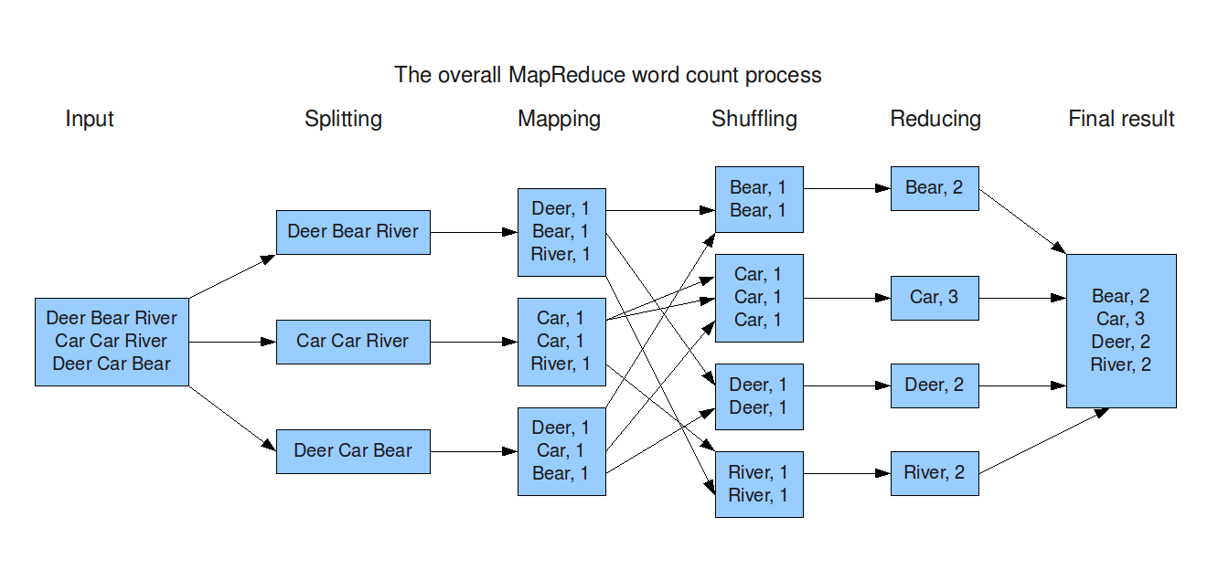

Installation
The bulk of Hadoop is written in Java, and can therefore run on any platform with a JVM, although there are enough parts that harbor Unix assumptions to make it unwise to run on a non-Unix platform in production. In fact, Windows operating systems are not supported production platforms, although they can be used with Cygwin as a development platform.

2.2 Setting up Single Node cluster

Hadoop can be run in one of three modes:
- Standalone (or local) mode: There are no daemons running and everything runs in a single JVM. Standalone mode is suitable for running MapReduce programs during development, since it is easy to test and debug them.
- Pseudo-distributed mode The Hadoop daemons run on the local machine, thus simulating a cluster on a small scale.
- Fully distributed mode The Hadoop daemons run on a cluster of machines

2.2.1 Setting up single node cluster (Pseudo-distributed mode)

2.2.1.1 Configuring SSH Access
Hadoop requires SSH access to manage its nodes, i.e. remote machines plus the local machine if we want to use Hadoop on it. For single-node setup of Hadoop, we need to configure SSH access to localhost for the hadoop user.
First, we have to generate an SSH key for the hadoop user.
ssh-keygen –t rsa –p “”
cat $HOME/.ssh/id_rsa.pub >> $HOME/.ssh/authorized_keys
Now check for the passphraseless access to localhost
ssh localhost

2.2.1.2 Installing Hadoop
Hadoop is downloaded from apache mirrors. Hadoop tar ball is extracted as follows:
cd /usr/local
tar –zxvf hadoop-0.20.2.tar.gz
Before Hadoop is run, we need to tell it where Java is located on the system. If the JAVA_HOME environment variable set to point to a suitable Java installation, That will be used, and further configuration is not required. Otherwise, The Java installation that Hadoop uses is set by editing conf/hadoop-env.sh, and specifying the JAVA_HOME variable.
export JAVA_HOME=/usr/local/jdk1.6/
HADOOP_HOME can also be set to point to the hadoop directory as an option. It is convenient to use if it is set.
Export HADOOP_HOME=/usr/local/hadoop-0.20.2/
export PATH=$PATH:$HADOOP_INSTALL/bin
2.2.1.3 Configuration Files
Each component in Hadoop is configured using an XML file. Core properties go in core-site.xml, HDFS properties go in hdfs-site.xml, and MapReduce properties go in mapred-site.xml. These files are all located in the conf subdirectory.

The description about the configuration files are as shown below
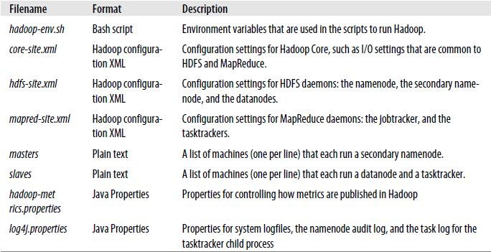
The configurations are specified in the form of a <property> tag within <configuration> tag. Hadoop reads this property tag and then assigns the corresponding value to the name. If a particular tag is not specified then the default values are used for that particular configuration.
For instance if the property dfs.replication is not specified in the configuration then the default value 1 will be used. If specified in the configuration then the default value will be overridden.

conf/core-site.xml (Configuration file)
<property>
<name>fs.default.name</name>
<value>hdfs://localhost/</value>
</property>
This indicates the default file system. The URI defines the hostname and port that the job tracker’s RPC server runs on. This property should be set in core-site.xml.
To run HDFS, we need to designate one machine as a namenode. In this case, the property fs.default.name is a HDFS filesystem URI, whose host is the namenode’s hostname or IP address, and port is the port that the namenode will listen on for RPCs. If no port is specified, the default of 8020 is used. If fs.default.name is used to specify both the HDFS namenode and the default filesystem means HDFS has to be the default filesystem in the server configuration.
<property>
<name>hadoop.tmp.dir</name>
<value>/home/apache/hadoop/tmp</value>
</property>
This indicates the base for all temporary directories.
conf/hdfs-site.xml: (Configuration file)
<configuration>
<property>
<name>dfs.replication</name>
<value>1</value>
</property>
</configuration>

It indicates the default block replication. The actual number of replications can be specified when the file is created. The default is used if replication is not specified in create time.
conf/mapred-site.xml:
<configuration>
<property>
<name>mapred.job.tracker</name>
<value>localhost:8021</value>
</property>
</configuration>
To run MapReduce, we need to designate one machine as a jobtracker, which on small clusters may be the same machine as the namenode. To do this, set the mapred.job.tracker property to the hostname or IP address and port that the jobtracker will listen on. This property is not a URI, but a host-port pair, separated by a colon. The port number 8021 is a common choice.
The conf/masters file defines the namenodes of the cluster. The conf/slaves file lists the hosts, one per line, where the Hadoop slave daemons (datanodes and tasktrackers) will be run. The conf/masters conf/slaves files has the default values localhost in them.
2.2.1.4 Formatting the Namenode:
Before it can be used, a brand-new HDFS installation needs to be formatted. The formatting process creates an empty filesystem by creating the storage directories and the initial versions of the namenode’s persistent data structures. Datanodes are not involved in the initial formatting process, since the namenode manages all of the filesystem’s metadata, and datanodes can join or leave the cluster dynamically. For the same reason, you don’t need to say how large a filesystem to create, since this is determined by the number of datanodes in the cluster, which can be increased as needed, long after the filesystem was formatted.
The first step to starting up Hadoop installation is formatting the Hadoop filesystem which is implemented on top of the local filesystem of the single node cluster. This is done for the first time the hadoop cluster is setup.
Run the command:
hadoop namenode –format

2.3 Starting and stopping the single node cluster:
2.3.1 Starting and stoppping single node cluster
Run the command:
bin/start-all.sh
The daemons will be started on the local machine. The log files can be monitored to determine if the daemons have started successfully or not in the logs directory or by looking at the web UIs, at http://localhost:50030/ for the jobtracker, and at http://localhost:50070/ for the namenode or use Java’s jps command to see whether they are running
The following daemons are started:
- Tasktracker
- Jobtracker
- Datanode
- Namenode
- Secondary Namenode

Or Run the command:
bin/start-dfs.sh script Starts a namenode on the local machine. It also starts a datanode and a secondary namenode.
bin/start-mapred.sh starts all the MapReduce daemons. It starts a jobtracker on the local machine and a tasktracker.
2.3.2 Stopping the Single Node Cluster:
Run the command:
bin/stop-all.sh
Tasktracker, Jobtracker, Datanode, Namenode and Secondary Namenode are stopped.
Or Run the command:
bin/stop-dfs.sh
bin/stop-mapred.sh
These scripts stop the daemons started by the corresponding start script.
2.4 Running a Map Reduce job:
We will use the WordCount example job which reads text files and counts how often words occur. The input is text files and the output is text files, each line of which contains a word and the count of how often it occurred, separated by a tab.
The input and output text files are in HDFS. To copy the input file to HDFS, Run the command
hadoop dfs –copyFromLocal /home/apache/Desktop/input.txt input
copyFromLocal option will copy the file from local file system to HDFS.
The input file available on HDFS is input.
To check if the file is in HDFS, Run the following command
hadoop dfs –ls
To run the Map Reduce job, use the following command
hadoop jar hadoop-0.20.2-examples.jar wordcount input output

hadoop-0.20.2-examples.jar contains all example Map Reduce programs that can be run. One among them is wordcount. The argument 4 specifies the class file in the hadoop-0.20.2-examples.jar that is to be used to run the wordcount program.
output is the folder in which the output of the Map Reduce word count job will result in.
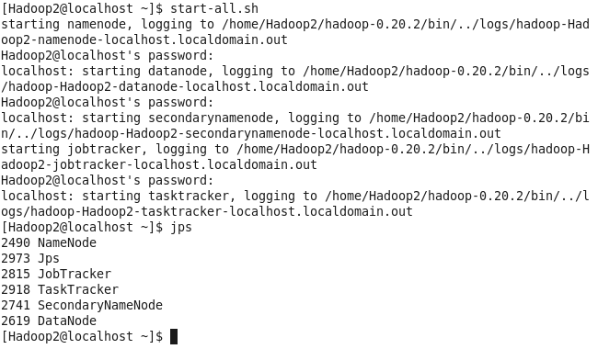

2.5 Setting up multi-node cluster (Fully-distributed mode)
For a small cluster (on the order of 10 nodes), it is usually acceptable to run the namenode and the jobtracker on a single master machine (as long as at least one copy of the namenode’s metadata is stored on a remote filesystem). As the cluster and the number of files stored in HDFS grow, the namenode needs more memory, so the namenode and jobtracker should be moved onto separate machines. The secondary namenode can be run on the same machine as the namenode, but again for reasons of memory usage (the secondary has the same memory requirements as the primary), it is best to run it on a separate piece of hardware, especially for larger clusters
2.5.1 Configuring single-node clusters first
After setting up all the machines of the cluster to work on single node, the same settings (environment variables, path of the installation directory, hadoop temporary and other storage directory path, etc) are retained for the Fully Distributed mode. The xml files are modified to suit the multi node needs. Shutdown all the daemons running in single node.
2.5.2 Networking
Machines must be able to reach each other over the network. The easiest is to put both machines in the same network with regard to hardware and software configuration, for example connect both machines via a single hub or switch and configure the network interfaces to use a common network such as 192.168.0.x/24.
Update the /etc/hosts file specifying the IP address of all the machines in the cluster with their aliases (master, slave1, slave2, etc).
2.5.3 SSH Access
The hadoop user on the master must be able to connect to its own user account on the master i.e. ssh master (not necessarily ssh localhost) and to the hadoop user account on the slave via a passphraseless SSH login.
To achieve this the public keys of all the machines are copied to masters authorized_keys file. And the public key of the master is copied to authorized_keys file of all the slave nodes in the cluster.
Run the command to check for passphraseless ssh login from master to master node itself
ssh master and from master to all the slave nodes:
ssh slave1
ssh slave2
ssh slave3
and so on.
2.5.4 Cluster Overview
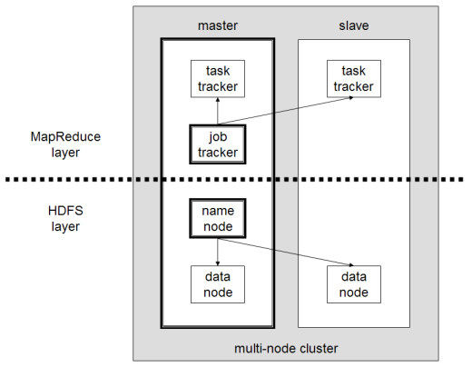

The master node will run the master daemons for each layer: namenode for the HDFS storage layer, and jobtracker for the MapReduce processing layer. Basically, the master daemons are responsible for coordination and management of the slave daemons while the latter will do the actual data storage and data processing work.
2.5.5 Configuration:

conf/masters (on master node only):
The conf/masters file defines the namenodes of our multi-node cluster. Namenode and secondary Namenode can be on master machine or namenode and secondary namenode can run on different machines.
The secondary NameNode merges the fsimage and the edits log files periodically and keeps edits log size within a limit. It is usually run on a different machine than the primary NameNode since its memory requirements are on the same order as the primary NameNode. the machine on which bin/start-dfs.sh is run will become the primary namenode.
Update this file to “master” or the IP address of the master machine replacing the “localhost”. The same must be done on all machines in the cluster.

conf/slaves (on master node only):
This file lists the hosts, one per line, where the Hadoop slave daemons (datanodes and tasktrackers) will be run. This file on master is used only by the scripts like bin/start-dfs.sh or bin/stop-dfs.sh.
Update this file listing the IP address of all the slave nodes or the aliases as specified in the /etc/hosts. On all slave nodes this file must contain “localhost” as the only slave.
- conf/core-site.xml (on all machines in the cluster):
First, we have to change the fs.default.name variable which specifies the NameNode host and port.
<property>
<name>fs.default.name</name>
<value>hdfs://master:54310</value>
</property>
This indicates the default filesystem. The URI defines the hostname and port that the jobtracker’s RPC server runs on. This property should be set in core-site.xml.
To run HDFS, we need to designate one machine as a namenode. In this case, the property fs.default.name is a HDFS filesystem URI, whose host is the namenode’s hostname or IP address, and port is the port that the namenode will listen on for RPCs. If no port is specified, the default of 8020 is used. If fs.default.name is used to specify both the HDFS namenode and the default filesystem means HDFS has to be the default filesystem in the server configuration.
<property>
<name>hadoop.tmp.dir</name>
<value>/home/apache/hadoop/tmp</value>
</property>
This indicates the base for all temporary directories.
<property>
<name>hadoop.security.authorization</name>
<value>false</value>
</property>

- conf/hdfs-site.xml (on all machines in the cluster):
<configuration>
<property>
<name>dfs.replication</name>
<value>3</value>
</property>
</configuration>
It indicates the default block replication. The actual number of replications can be specified when the file is created. The default is used if replication is not specified in create time.
<property>
<name>dfs.datanode.ipc.address</name>
<value>192.168.0.154:50020</value>
</property>
This indicates the datanode ipc server address and port. If the port is 0 then the server will start on a free port.
<property>
<name>dfs.name.dir</name>
<value>/home/apache/hadoop/tmp/dfs/name</value>
</property>
Determines where on the local filesystem the DFS name node should store the name table(fsimage). If this is a comma-delimited list of directories then the name table is replicated in all of the directories, for redundancy. It’s common to configure dfs.name.dir so that the namenode metadata is written to one or two local disks, and a remote disk Such a setup guards against failure of a local disk, and failure of the entire namenode. The secondary namenode takes only periodic checkpoints of the namenode, so it does not provide an up-to-date backup of the namenode.
<property>
<name>dfs.permissions</name>
<value>false</value>
</property>
If "true", enable permission checking in HDFS. If "false", permission checking is turned off, but all other behavior is unchanged. Switching from one parameter value to the other does not change the mode, owner or group of files or directories.
<property>
<name>dfs.data.dir</name>
<value>/home/apache/hadoop/tmp/dfs/data</value>
</property>

Determines where on the local filesystem a DFS data node should store its blocks. If this is a comma-delimited list of directories, then data will be stored in all named directories, typically on different devices. Directories that do not exist are ignored. Unlike the namenode, which uses multiple directories for redundancy, a datanode round-robins writes between its storage directories
<property>
<name>dfs.hosts</name>
<value></value>
</property>
Names a file that contains a list of hosts that are permitted to connect to the namenode. The full pathname of the file must be specified. If the value is empty, all hosts are permitted.

- conf/mapred-site.xml (on all machines in the cluster):
<property>
<name>mapred.job.tracker</name>
<value>192.168.0.154:54311</value>
</property>
To run MapReduce, we need to designate one machine as a jobtracker, which on small clusters may be the same machine as the namenode. set the mapred.job.tracker property to the hostname or IP address and port that the jobtracker will listen on.
<property>
<name>mapred.local.dir</name>
<value>/home/apache/hadoop/tmp/mapred/local</value>
</property>
    - Formatting the Namenode:
This step is similar to formatting the namenode on single system and uses the following command.
hadoop namenode –format
  - Starting and Stopping the Multi-Node cluster:
2.6.1 Starting multi node cluster:
Run the command:
bin/start-all.sh
All the daemons will be started on the master. The log files can be monitored to determine if the daemons have started successfully or not in the logs directory or by looking at the web UIs, at http://localhost:50030/ for the jobtracker, and at http://localhost:50070/ for the namenode or use Java’s jps command to see whether they are running
Or Run the command:
bin/start-dfs.sh
bin/start-mapred.sh

2.6.2 Stopping the Multi-Node Cluster:
The commands for these steps are similar to the ones used in single step.
Run the command:
bin/stop-all.sh
Or Run the command:
bin/stop-dfs.sh
bin/stop-mapred.sh
These scripts stop the daemons started by the corresponding start script.

2.7 Challenges Faced during the Installation:
2.7.1 Datanodes unable to connect to Namenode
This was mainly because the conf/slaves and conf/masters files was not configured properly on the Datanodes. The conf/masters file had the default value “localhost” which was informing the datanodes that they themselves are the master nodes and the process at port 54310 was not running on them. But the process was being run on master. The process at a particular port can be determined on the master machine by the following command:
netstat –anp | grep java
This command lists all the java processes running on the master machine. By seeing the process at port 54310, we can determine if it is running or not.
When the conf/masters file was changed to point to master node, the data nodes were able to connect to the master machine on port 54310. Thus the problem was overcome.

2.7.2 Incompatible Namespace ID’s
This is a Hadoop Bug. When this error occurs, any HDFS operations like copying, ls, cat, etc. will show an error message. The data nodes will not start when this error occurs. In the datanode logs this error would have been resulted. When the namenode is formatted each time a new ID is being assigned to it. The Hadoop will access this ID each time an HDFS operation is performed. After formatting the namenode the old namespace ID will be corrupted. The possible cause of this may be because the hadoop will store temporary files in /tmp directory. A possible solution to this is to delete all the temporary files in /tmp as well as data directory and map reduce local directory and reformat the namenode.
2.7.3 Data Replication to zero nodes
This is because of namenode is in safe node. When this occurs the cluster might not been able to verify that all the data nodes necessary to replicate the data are up and responding. The possible solution to this is to wait for sometime for the cluster to initialize completely. If this dosent help then check the logs and then reconfigure the cluster.
Also using the same output directory everytime will result in a File already exists exception. Use a different directory for the output each time or delete the output directory using the following command:
hadoop dfs –rmr <output directory name on HDFS>

CHAPTER 3
Problem Formulation

CHAPTER 3
Problem Formulation
3.1 Power Aware Data Placement
We have proposed an algorithm to reduce the power consumed by an application when it’s executed in a cloud environment without violating the QoS promised. The QoS is a time constraint given by the client. Our model aims to reduce the power consumed by an intelligent placement of data blocks across the Hadoop cluster without compromising on SLA.
In a heterogeneous cluster, it is necessary to take into account the power consumption of individual nodes and processing rate of every node to schedule the tasks of a application for efficient performance with reduced power consumption. However, having an intelligent scheduling policy at the programming framework level has its own set of advantages and disadvantages. The advantage lies in the fact that the dynamic scheduling decisions can be made with respect to the varying load conditions in the cluster. Data intensive workloads can be classified as computations where the scale of data is the limiting factor compared to the computing power involved. Hadoop is one of the most popular frameworks used to perform data intensive computations.If task scheduling is done at task execution level; it would lead to blocks of data having to be re-organized. This not only leads to performance overheads in terms of increasing delay due to block transfer time, but affects the network also. A large amount of data being exchanged during the scheduling phase will lead to network bottlenecks.
After a thorough literature survey we have observed for any efficient implementation of a high computing platform, the synchronization between the underlying file system and the corresponding programming framework is extremely essential. As seen earlier, Hadoop exploits data locality of files by attempting to run the compute tasks at the nodes where the data blocks are present. Hence, the block placement strategy that we propose should not compromise the performance by data re-organization during the scheduling phase. Instead we shift our scheduling intelligence to the block placement strategy of the file system. The main advantage lies in the fact that during the scheduling phase, Hadoop will find that most of the blocks already are in favorable nodes thereby avoiding the overhead of block transportation.
The block placement strategy that we propose takes into consideration the dual constraints of time and power consumed. This ensures that all blocks are not placed at the most efficient node (time) in the cluster nor would they be placed in the most power efficient node in the cluster. The problem has been formulated in the form of a linear programming model. The solution to this problem is the number of blocks to be placed in each node.
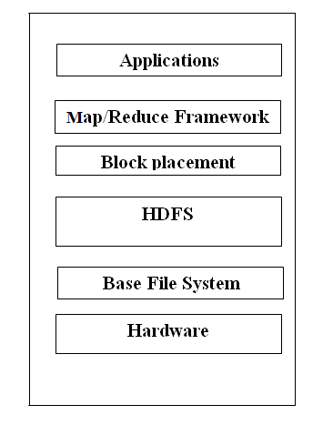
3.2 Linear Programming Model Solution
The problem can be expressed mathematically as follows.
For simplicity, let us consider a cluster with only 3 nodes. Let the nodes be named n1,n2 and n3 respectively. Let the power consumed for the same task by nodes n1,n2 and n3 be p1,p2 and p3 units/(block of data) respectively. Let the time taken to execute the same job on n1,n2 and n3 be t1,t2 and t3 respectively. Let’s assume a particular job requires n blocks of data.
Let the deadline to execute a job be fixed as C and is determined by the client. The deadline is reduced by a constant as our framework considers only the map phase and the constant is assumed to account for the reduce time. Although the constant may not accurately model the reduce time, however this approach would not fail as our primary concern is the block placement strategy and only the map phase in the map-reduce framework is affected by the block placement.

The Problem in LPP
Minimize Z=a*p1 + b*p2 + c*p3 (The Objective function for power.)
Where P1, P2 and P3 are power consumed by each block in nodes n1,n2 and n3 respectively.
Subject to:
- a+b+c=n(total number of blocks)
  - a*t1<C (C is predetermined time constraint.)
  - b*t2<C (C is predetermined time constraint.)
  - c*t3<C (C is predetermined time constraint.)

The problem can be explained as follows. a*p1 implies the power consumed by node n1 for processing a blocks of data. Likewise, b*p2 and c*p3 denote the total power consumed by nodes n2 and n3 respectively.

The sum of a,b and c denote the total number of blocks,i.e. n. As the nodes process the blocks of data in parallel node n1 takes a*t1 to execute the a blocks of data assigned to node n1.

CHAPTER 4
Experiments & Results

CHAPTER 4
4.1 Experimental Setup:
The tested cluster consists of 3 heterogeneous nodes. The parameters of the individual nodes are given in the table 6.2.
We first executed a simple Word Count example on an input file of 640 mb size using the default Hadoop package. Hadoop splits the input file into 10 blocks and the blocks were distributed using its psuedo-random block distribution policy. The time taken to execute each block of data in individual node is measured along with the power consumed by each data block.
To test the results of our proposed block placement algorithm, we run our LPP to determine the number of blocks to be placed in each node. Using this block placement strategy, Hadoop is run once again to determine the total consumed and power consumed.
We find that our proposed block placement strategy results in a power saving of XXXX%.
As finding the power consumed was a tedious task and due to time constraints, we assumed the power consumed by each block in nodes n1, n2 and n3 as 37,22 and 9 units respectively. The time consumption of each block in these nodes are taken as 12,23 and 34 units respectively.
We have assumed the time constraint given by client to be 100 units.
We have used the GNU Linear programming toolkit to solve the LPP. Some details about the GNU Linear programming toolkit is described below:

4.1.1 The GNU Linear Programming Kit

"Linear programming is a tool for solving optimization problems. In 1947, George Dantzig developed an efficient method, the simplex algorithm, for solving linear programming problems. Since the development of the simplex algorithm, linear programming has been used to solve optimization problems in industries as diverse as banking, education, forestry, petroleum, and trucking. In a survey of Fortune 500 firms, 85% of the respondents said they had used linear programming."
Many tools are available to solve linear programming problems. The proprietary tools are well known, but many members of the open source community may not know about the free GLPK tool.
The GNU Linear Programming Kit (GLPK) is a library of routines that use well-known operations research algorithms to solve linear problems. The routines implement the simplex, branch and bound, primal-dual interior point, and many other algorithms.
GLPK is not a program -- it can't be run and has no main() function. Instead, clients feed the problem data to the algorithmic routines through the GLPK API and receive results back. GLPK has a default client, the glpsol program, that interfaces with this API. Usually, a program like glpsol is called a solver rather than a client.

4.1.2 Execution using default Hadoop pseudo random placement strategy
We run the default Hadoop algorithm twice to check its efficiency.
Run 1:
The default Hadoop block placement strategy results in the HDFS placing 4, 4 and 2 blocks on nodes n1,n2 and n3 respectively.
Hence,
Power consumed= 4*37 +4*22 + 2*9 =254 units.
Run 2:
The default Hadoop block placement strategy results in the HDFS placing 3, 5 and 2 blocks on nodes n1,n2 and n3 respectively.
Hence,
Power consumed= 3*37 +5*22 + 2*9 =239units.
4.1.3 Execution using our proposed block placement strategy
We run the GNU Linear Program to solve the linear programming problem that we have devised to find the number of blocks to be placed in each node.
Screenshot of go.sol (The solution file of GNU Linear programming toolkit)
Problem: gm
Non-zeros: 9
Status: OPTIMAL
Objective: z = 222.4296675 (MINimum)

No. Row name St Activity Lower bound Upper bound Marginal
------ ------------ -- ------------- ------------- ------------- -------------
1 z B 222.43
2 machineA B 32.532 100
3 machineB NU 100 100 -0.652174
4 machineC NU 100 100 -0.823529
5 total NS 10 10 = 37

No. Column name St Activity Lower bound Upper bound
------ ------------ -- ------------- ------------- ------------- -------------
1 x1 B 2.711 0
2 x2 B 4.34783 0
3 x3 B 2.94118 0

Karush-Kuhn-Tucker optimality conditions:

KKT.PE: max.abs.err = 7.11e-15 on row 4
max.rel.err = 3.54e-17 on row 4
High quality

KKT.PB: max.abs.err = 0.00e+00 on row 0
max.rel.err = 0.00e+00 on row 0
High quality

KKT.DE: max.abs.err = 1.33e-15 on column 3
max.rel.err = 1.78e-17 on column 3
High quality

KKT.DB: max.abs.err = 0.00e+00 on row 0
max.rel.err = 0.00e+00 on row 0

From the above screen shot, and after rounding off values, we see that our strategy distributes 3,4 and 3 blocks of data to nodes n1, n2 and n3 respectively.
Hence, Power consumed= 3*37 +4*22 + 3*9 =222 units.
Our approach does not compromise on the SLA(time constraint) and also provides a power saving upto 14%. This number might change in clusters as these numbers have only being assumed using theoretical logic.

CHAPTER 5
Conclusion & Future Work
CHAPTER 5
5.1 Conclusion:
During the course of the project, we came across the various issues involved in scheduling applications like block transport time, fairness, throughput etc. All these issues are magnified in distributed systems like Map Reduce where co-ordination among various tasks is kept at minimal.
We also realized that reducing the power consumed by applications by running them on systems which consume lesser power could result in performance degradation and a solution to this problem is to find an optimum mix of machines where the tasks should be executed.
We also realized that a close co-ordination between the underlying file system and overlying programming framework is essential for efficient execution of parallel applications and any modifications to any of the component could adversely affect the performance of the other component.
Hence, we have devised our block placement strategy in such a way that the overall system performance is not affected by changes to default Hadoop’s block placement strategy.
5.2 Future Work:
One enhancement to the current work could be modeling the reduce time more accurately so that QoS constraints could be modeled accurately. Other features of SaaS like admission control which are already explored could be integrated with this project. We also plan to extend the current framework beyond node level scheduling to class-based node level scheduling which would allow us to extend this model to extremely large clusters. Another aspect is considering the case when multiple jobs are executed on this cluster and maintaining fairness among the jobs. Another interesting work could be implementing the above work on a real Hadoop system and testing it in large clusters.
BIBLIOGRAPHY
- Grid scheduling divisible loads from multiple sources via linear programming

- A Linear Programming Driven Genetic Algorithm for Meta-Scheduling on Utility Grids
- Power-Aware Linear Programming Based Scheduling for Heterogeneous Computer Clusters
- Scheduling data flow applications using linear programming
- Fault-aware Scheduling in Grid Environment based on Linear Programming
- Data Placement for Scientific Applications in Distributed Environments
Statistical Prediction of Task Execution Times through Analytic Benchmarking for Scheduling in a Heterogeneous Environment

- Rini T Kaushik and Milind Bhandarkar, “GreenHDFS: Towards An Energy-Conserving, Storage-Efficient, Hybrid Hadoop Compute Cluster.”

- A Time Optimization Algorithm for Scheduling Bag-of-Task Applications in Auction-based Proportional Share Systems
- Improving Map Reduce Performance Through Data Placement in Heterogeneous Hadoop clusters.
- http://www.michael-noll.com/tutorials/running-hadoop-on-ubuntu-linux-single-node-cluster/ - Michael Noll Single Node Setup
- http://www.michael-noll.com/tutorials/running-hadoop-on-ubuntu-linux-multi-node-cluster/ - Michael Noll Multi Node Setup
- http://www.ibm.com/developerworks/linux/library/l-glpk1/ - GNU Linear Programming tool kit.

