A Brief History of the Infinity Stones/Gems – Part 4 Infinity Gauntlet

The last post documented how the Thanos tricked the Elders of the Universe out of each of their Soul Gems, now and hereafter known as Infinity Gems. Having obtained the ultimate power in the universe, Thanos found that the assembling of the Infinity Gauntlet, an accomplishment intended to elevate him on par with his love Mistress Death, to be a pyrrhic victory as she found yet another reason to spurn him; this time because he had exceeded her in cosmic significance.

Stung with this defeat, Thanos throws himself into a childish exploration of his own inner demons and revenge fantasies. His rise and fall form the storyline explored in the six-issue *Infinity Gaunlet* limited series.

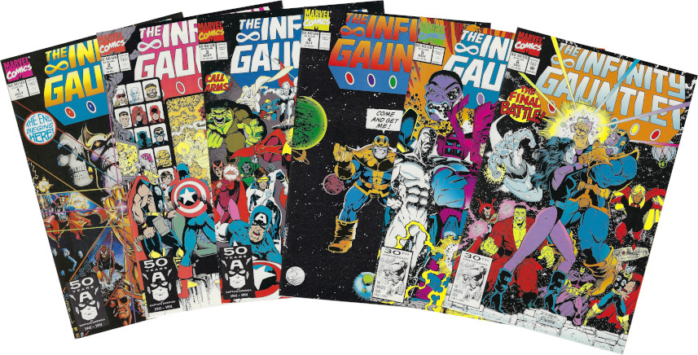

When the story opens, Thanos is contemplating his next move with his power. His only companion and advisor is the demon Mephisto, who has effectively served as the Satan figure in Marvel Comics. Already, the psychological issues of the Mad Titan are on display for of all the possible travel mates why does he pick the most vile, self-centered, duplicitous being available to stand at his right hand?

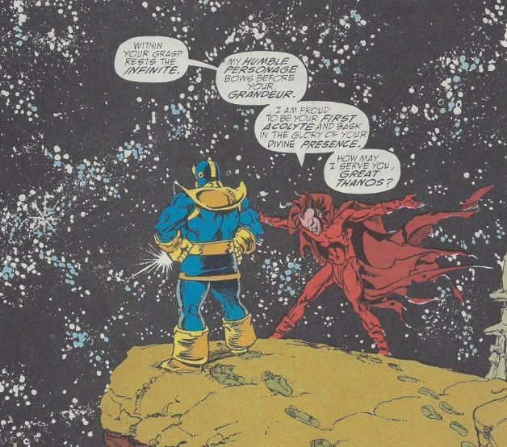

Always a consummate comics story teller, Starlin likes to bring any new readers up to speed using one of his characteristic summary scenes/pages and, as usual, they are a pleasure to look at even for those who are already informed. The one used for the Infinity Gauntlet

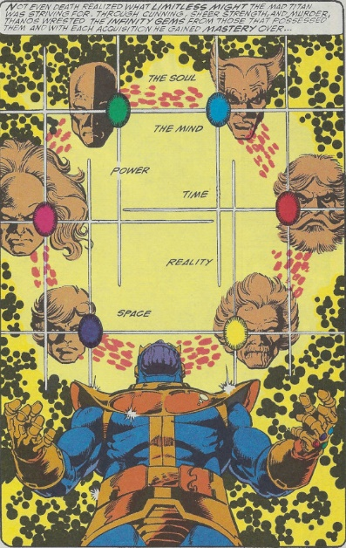

doesn’t disappoint in style, art design or layout.

With the preliminary matters out of the way, Starlin once again sends Thanos to court Mistress Death

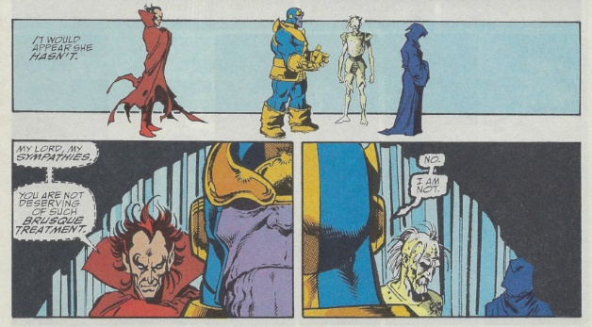

only to be once again rebuffed. This time, however, Mephisto’s presence, much like the proverbial devil perched upon a character’s shoulder, spurs Thanos into new depths of depravity. Convinced by his demonic advisor that Death is a dark soul in need of dark gifts, Thanos turns his grand-daughter Nebula – a minor villain introduced in the Marvel universe years earlier and essentially incinerated by him upon his resurrection – into a shambling, rotting monstrosity doomed to a mute agony in his court and forever denied death.

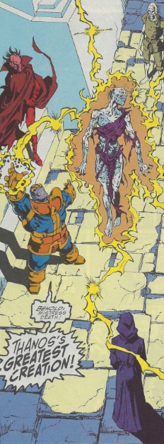

Finding that his grotesque offering has garner no favor, Thanos then reminds himself that he has yet to fulfill his original vow to eliminate half of the universe’s population

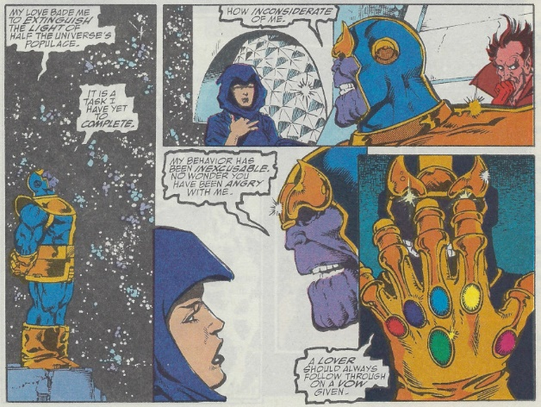

an oversight he quickly remedies with a snap of his fingers,

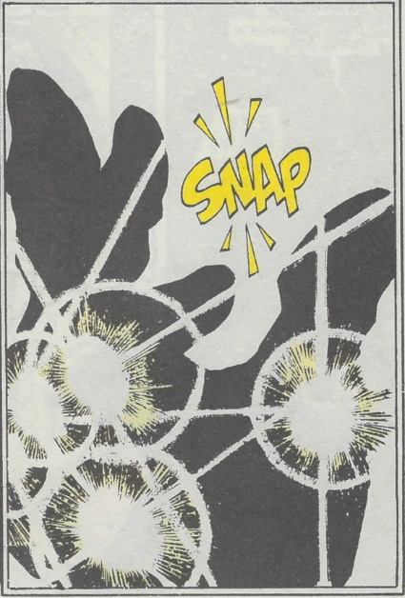

but even this incredible sacrifice fails to soften Death’s heart.

When the full ramifications of the mad god’s ambition become clear, all the remaining forces in the universe begin to align against Thanos. The various pantheons of the gods (embodiments of belief in the Marvel universe) set aside their individual differences and plot a strategy.

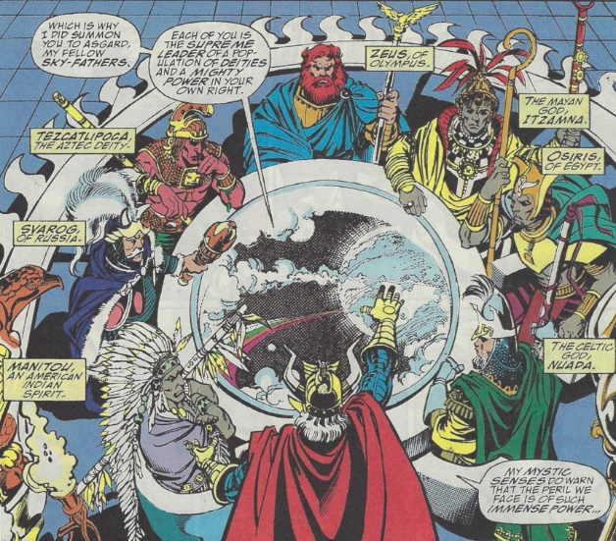

Likewise, the remaining heroes begin to come together as do the abstract cosmic entities (see earlier posts in this series).

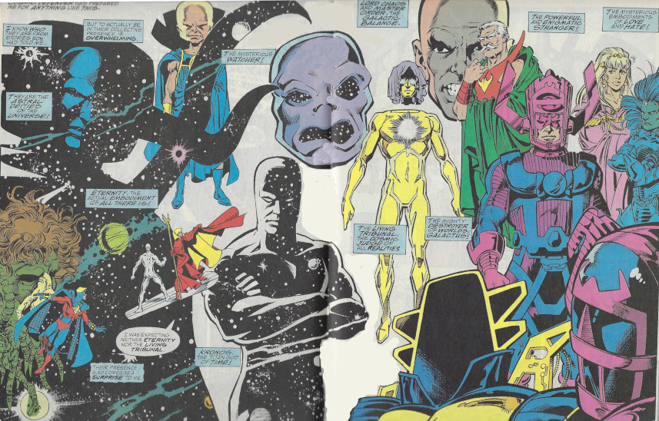

Despite this incredible marshalling of force, the most important stratagem in the opposition to Thanos comes from an unexpected quarter. Adam Warlock, who had died at the hands of Thanos during the original battle over the Infinity Gems, abandons his peaceful existence with the Soul gem and once again takes corporal form.

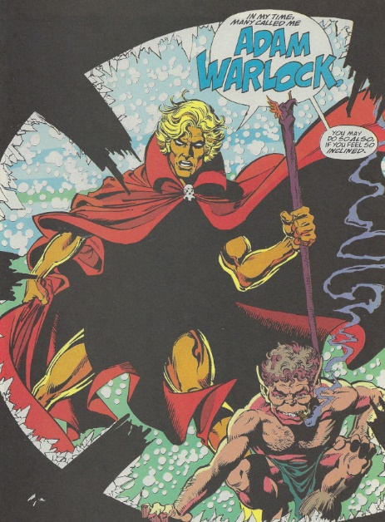

Acting as a general for all sides, Warlock organizes Earth’s superheroes and then turns his attention to the cosmic entities, where he proves that he may have the skill to deal with Thanos.

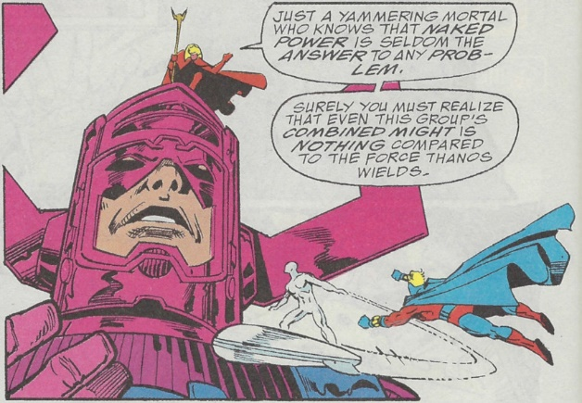

Meanwhile, a petulant Thanos now tries to make Mistress Death jealous for his attentions by creating his perfect mate Terraxia.

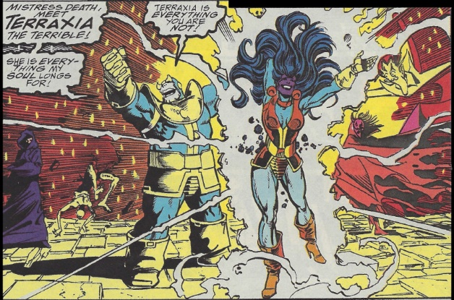

While he plays with his new toy, Warlock sets the first strike against Thanos. Summoning the remaining members of the Avengers, Fantastic Four, and X-men as well as the Hulk, Drax, Spider-Man, Doctor Strange, and a handful of additional characters, Warlock has them confront Thanos while he and the Silver Surfer wait for an opportune moment to steal the gauntlet. During the battle, which consume the better part of issue #4, the reader is treated to the horrific spectacle of his favorite character being gruesomely defeated and usually killed. Sadly, when the moment comes, the Silver Surfer misses his mark by a fraction of second.

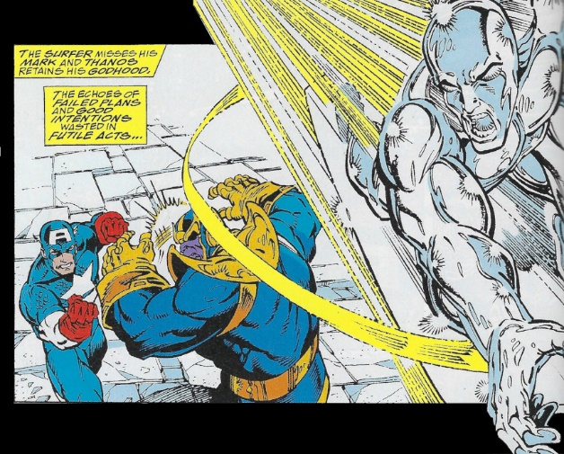

Having failed at his ‘easy’ stratagem, Warlock reluctantly directs the cosmic abstract entities into the fray, praying as he does that the resulting battle doesn’t destroy the very universe he is trying to save.

Despite their awesome might, these godlike figure fare little better and they are also either soon destroyed or subdued. But the seeds of Thanos’s undoing are sowed in this defeat when Mistress Death actively opposes him

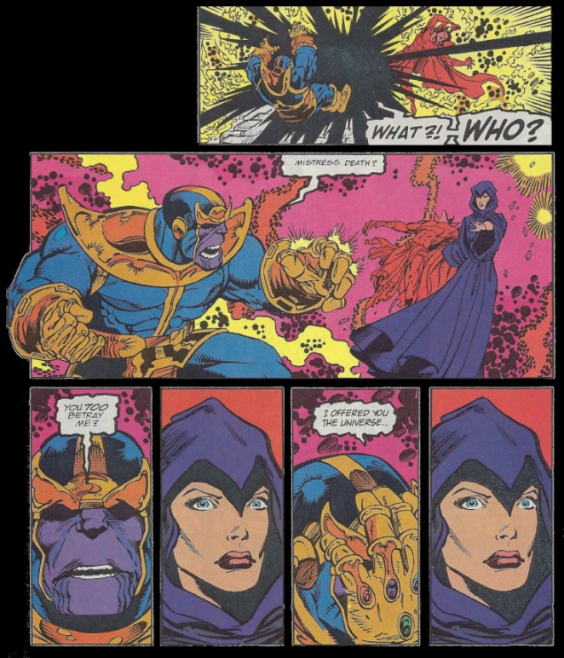

Feeling betrayed, Thanos decides that he must forever more be above the petty squabbles of the flesh. He abandons his body and assumes a spiritual godhead, with his only witnesses being Terraxia, his manufactured consort, Eros, his brother who has been forced to watch the carnage and insanity in mute impotence, and Nebula.

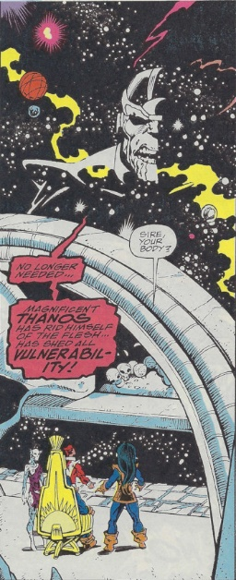

At this point in the story, Starlin employs a similar device as he used in unseating Thanos’s first ascension when he opposed Captain Marvel and the Avengers. Distracted by cosmic grandeur, Thanos fails to secure his body upon which rest the Infinity Gauntlet, the source of all his might.

Pushing her deformed body slowly but surely towards her grand-father, Nebula succeeds in claiming the infinite power for her own.

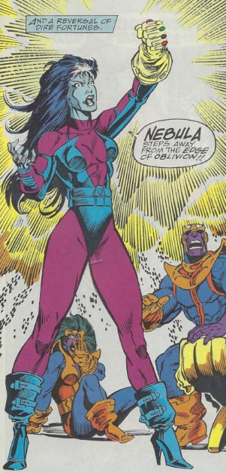

After a rocky start, Nebula begins to understand how to wield her unbridled power. She soon undoes all of the Thanos’s actions and then set herself to remake the cosmic order in her own image.

Warlock persuades Thanos to align himself with their efforts to stop Nebula in a way only Warlock can do (and Starlin can dream up as a story).

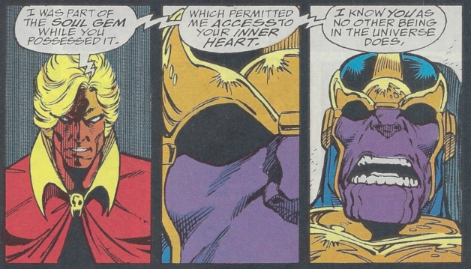

This time, Warlock’s distraction ploy works. While a strike team comprised of Earth’s heroes and their new purple ally distract Nebula on the physical plane, Warlock returns to the Soul Gem and sows dissension among the other Infinity Gems

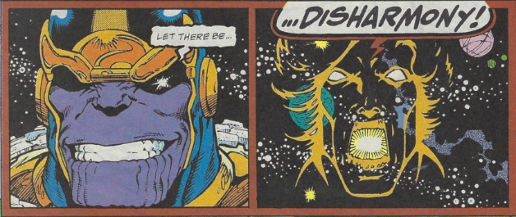

thereby corrupting the gauntlet, causing to fall from Nebula’s hand. The disharmony doesn’t last for long, and as all sides scramble to reclaim it, Warlock steps in first. During the aftermath, it appears that Thanos is destroyed and that the universe is finally free of his menace.

The epilogue finds Warlock, now reunited with his old companions Pip the Troll and Gamora, contemplating what to do with his new-found godlike status. As a first step, he seeks advice from a most curious farmer living on a sparsely populated world far from the galactic centers. This farmer is none other than Thanos, who has retired from dark ambitions and universal conquest to reflect on his many defeats. As the *Infinity Gauntlet* closes, the reader is treated to a new Thanos, philosophical and at peace for the first time in his many lives.

