# Real Questions on Real Wages

At first read, a recent article entitled [‘Real wages are essentially back at 1974 levels, report shows’](https://www.msn.com/en-us/money/markets/real-wages-are-essentially-back-at-1974-levels-report-shows/ar-BBLUiNe?OCID=ansmsnnews11), by Daniel B. Kline of the Motley Fool, argues persuasively that wages, after accounting for inflation, have only just recently returned to the ‘purchasing power’ they had in 1974. However, after some reflection, his argument stirs up a lot more questions in its wake – questions that suggest that the real situation is a lot more complicated and nuanced.

Central to Kline’s argument is the idea of purchasing power and the associated statistics that show its trend over time. To define purchasing power, Kline starts his piece with the following:

<If you get a $1,200 annual raise on the same day that your rent goes up by $100 a month, you don’t need an accountant to tell you that you didn’t actually make any financial progress.>

Of course, Kline is right on this point. The absolute value of wages is totally irrelevant. The important factor is the ratio of wages to the things that they can purchase.

But how should that ratio be measured? Each of us values different things. Each of us purchases different items. A statistically accurate study would analyze a cross-section of workers to determine what they could purchase as a fraction of their take-home pay. But this approach is extremely difficult to do and, as a proxy, Kline uses data on inflation-adjusted wage growth (essential the ratio of wage growth to inflation) as reported by the Pew Research Center writer Drew DeSilver in his article [‘For most U.S. workers, real wages have barely budged in decades’](http://www.pewresearch.org/fact-tank/2018/08/07/for-most-us-workers-real-wages-have-barely-budged-for-decades/).

Below, is the original graph from DeSilver’s article clearly showing two things. The first, contrary to what the caption says, these data are no independent measure of ‘purchasing power’; they simply are the inflation-adjusted average wages. The second is exactly what both authors conclude, that wages over the past 50 years have fluctuated between $20 and $25 per hour (in real 2018 dollars) with no discernable trend and that the current level is the highest it has been since 1978.

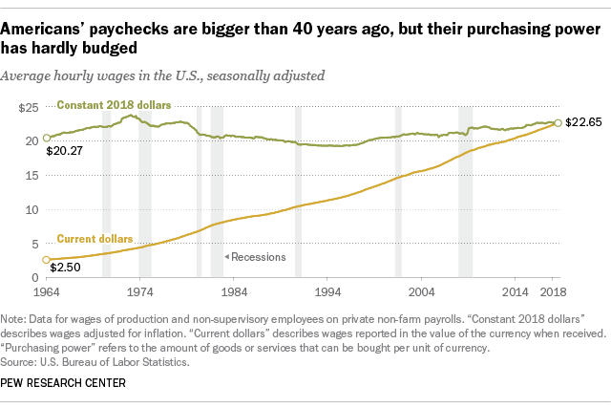

The reason I object to DeSilver’s characterization that

<”[p]urchasing power” refers to the amount of goods and services that can be bought per unit currency.>

is that it is a gross simplification of what actually happens in an economy, even a simple one, let alone something as complex as a modern, multi-faceted one like we enjoy in the US.

Consider electronics. A simple LED calculator in May of 1977 cost $40 and it could only do a few mathematical functions. That same $40 would purchase over $165 worth of computing power today, which would easily secure a refurbished laptop or tablet with orders-of-magnitude more computing power. The same could be said for entertainment, access to information, and durable goods and car purchases (factoring in quality and capability). The purchasing power of a dollar for anything associated with the digital economy is the highest it has ever been.

Alternatively, the cost of higher education and health care have outpaced inflation by large amounts and so the wages of even the most highly compensated worker couldn’t match; larger and larger amounts of income need to be devoted to these two sectors. But it isn’t correct to infer that the purchasing power in medicine is the lowest it has ever been. The quality of medical care is so substantially greater than it was in 1978 that it is hard to determine just how better or worse off a worker is who earns the average wage. Higher education is a different story entirely.

These types of problems plague the measure and characterization of inflation and so one must consume inflation adjustment calculations with some caution and not try to over generalize, as seems to be the case with Kline and DeSilver.

There is another objection to raised here. DeSilver’s data shows average rather than median wages. The distribution of wage is clearly skewed to higher values (nobody earns a negative wage but the upper wage is effectively unbounded) and, for such distributions, it is more appropriate to use the median. It isn’t at all clear how different that measure is from the average as a function of time, although frequently-expressed concerns about rising income inequality tends to suggest that the gap is growing rather than shrinking.

DeSilver does try to provide some additional insight into the distribution by providing Pew Research Center data showing how various percentiles faired.

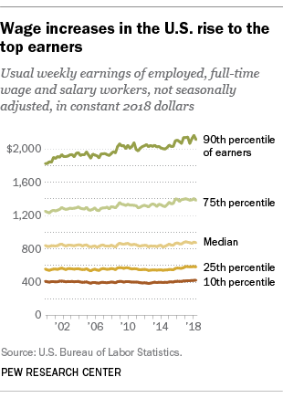

DeSilver cites the wages of the lowest tenth increasing at 3.0 % since 2000 (essentially at the rate of inflation – point returned to below) while the top tenth increased by 15.7%. But again, there is no simple way to map these increases into changes in purchasing power since the analysis would have to look at the actual purchases members in each tier of the distribution.

These objections are important but the real objection to Kline’s analysis is in how time is treated. In his anecdote, the raise in wages and rent happened at the same time. But when looking over 50 years of data many factors enter into play that aren’t there for short-term analysis.

The first is that the type of work being performed in the US has evolved significantly in the last 50 years. In large measure, manufacturing jobs have fled overseas and the lower skilled worker is now performing work that requires even lower skills and, perhaps, nets lower wages. Additional factors include a rise in benefits being offered that offset set wage growth (DeSilver cites a 22.5% inflation-adjusted growth in benefits compared with the 5.3% growth in wages since 2001) and lagging educational attainment compared with other countries.

These considerations certainly play a role, but a central question not broached in either Kline’s piece or by DeSilver’s study is the speed in which an individual moves between percentiles. Each point in the time series shown in each figure is a statistical snapshot of the economy in the year in question. It is tempting but wrong to conclude that those who start in the lowest decile remain in the lowest decile.

Consider the following scenario. Suppose that entry-level workers enter the economy each year and take their place for one year in the lowest tenth before moving upwards. Suppose further, that each of them, on average, has just a basic skill set worthy of the modest wage that comes in being in this bottom decile. Then the expectation we would have for the wage growth in this decile is simply to match inflation, nothing more. The skill equity they earn is their greatest compensation since it enables them to ‘graduate up’ to more highly paying jobs.

This simple model, far more complex than the ‘excessively simplified example’ Kline uses to begin his piece, more than accounts for the data that DeSilver compiled. But it is just a model. The truth, no doubt, is for more nuanced and requires that we ask a lot more questions before forming a conclusion.