In his set of lectures *What is Seen and What is Unseen* and *Economic Sophisms*, [Frederick Bastiat](https://en.wikipedia.org/wiki/Fr%C3%A9d%C3%A9ric_Bastiat) argued for classic, liberal economic thinking and against the ignorance that he judged so dominated French thought in the mid-1800s.

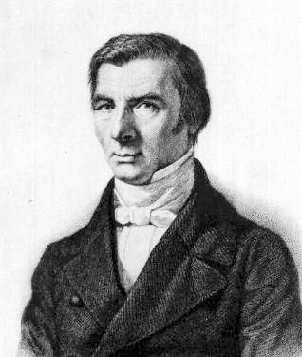

In particular, he railed against the lazy-minded thinking that evaluated any economic situation in the most simplistic way thereby dooming the individual or group that embraced such thought into a tragic failure to see what opportunity costs existed. As a result of ignoring opportunity costs, the individual or group makes unsound decisions all the while thinking of himself or themselves wise.

Unfortunately, economic illiteracy is not confined to 19th century France but rather is alive and well today. Many of the columns that have appeared in this blog have dealt with the prevalence of poor economic thinking and argumentation within the US border. Soviet Russia’s and China’s communist approaches to human economic freedom demonstrate that poor economic thinking doesn’t confine itself to the West. Although, to be fair, certain individuals within those regimes knew full well that they were scamming the public; in fact, they counted on widespread economic idiocy to further their own selfishness. And one need only look at the incredible misery inflicted on Venezuela by a poor understanding of economic principles (and a failure of the body politic to institute checks against government corruption) in order to grasp why Bastiat went to so much trouble constructing parables designed to educate the masses.

One such modern-day example, which comes from Peru, provides an excellent case study in the kind of surface-deep thinking and argumenation that Bastiat warned against so often in his writings.

In a recent rant, Peruvian congressman Manuel Danmert labeled Francisco Atilio Ísmodes Mezzano, [Peru’s current Minister of Energy and Mines](https://www.gob.pe/institucion/minem/alta-direccion/524), a traitor for putting an end to a proposed natural gas pipeline in southern Peru. It seems that the congressman primarily objects Mezzano’s proposed alternative plan to ship natural gas to Chile via tanker ship from Ica rather than have it consumed in Peru, predominantly in Lima where the bulk of the national population exists, for the benefit of Peruvians. A summary of Danmert’s complaints and accusations can be [found here](https://www.agenciadenoticiaspucallpa.com/2018/11/15/otros-intereses-estarian-detras-la-masificacion-del-gas-segun-denuncia-del-congresista-manuel-danmert/) (but don’t blame Google translate for the poor quality of the article; it is just as grammatically bad in Spanish as in English).

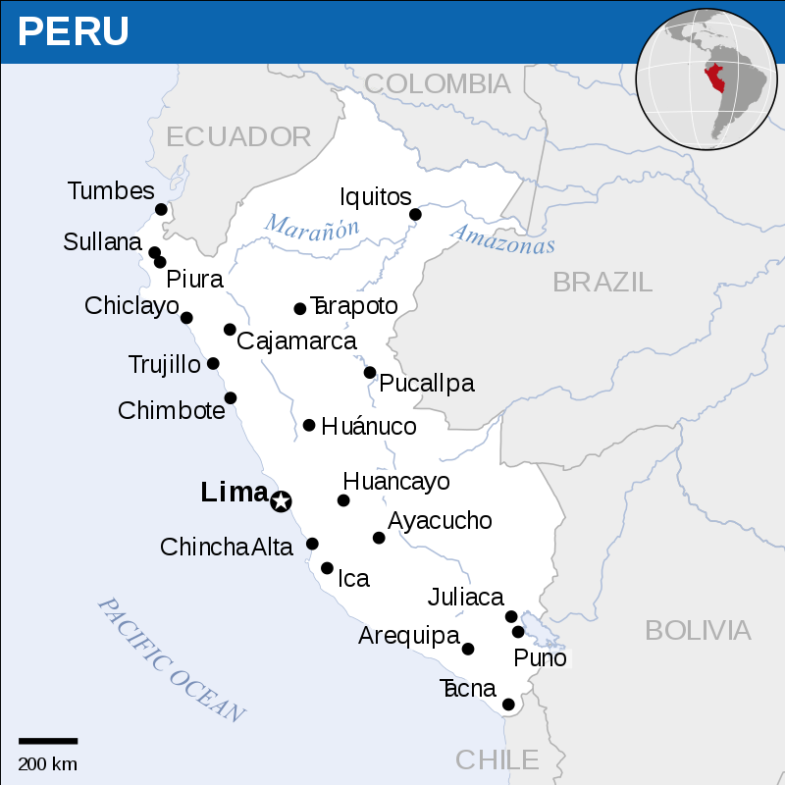

Of course, Danmert may be correct. After all, corruption is not a new concept in governments, whether in Peru or the United States. But for all his rhetoric Danmert doesn’t have details or specifics to back up the idea that Mezzano is selling Peru out to Chilean interests.

Charity demands that we examine the possibility that Mezzano is making a rational, honest decision in the Peruvian interest. To this end, let’s examine some of the particulars of energy consumption in Peru. All of the source data for the charts presented come from the [*BP Statistical Review of World Energy, June 2018*](https://www.bp.com/content/dam/bp/en/corporate/pdf/energy-economics/statistical-review/bp-stats-review-2018-full-report.pdf). The following chart shows Peru’s energy consumption by sector in millions tonnes oil equivalent (Mtoe).

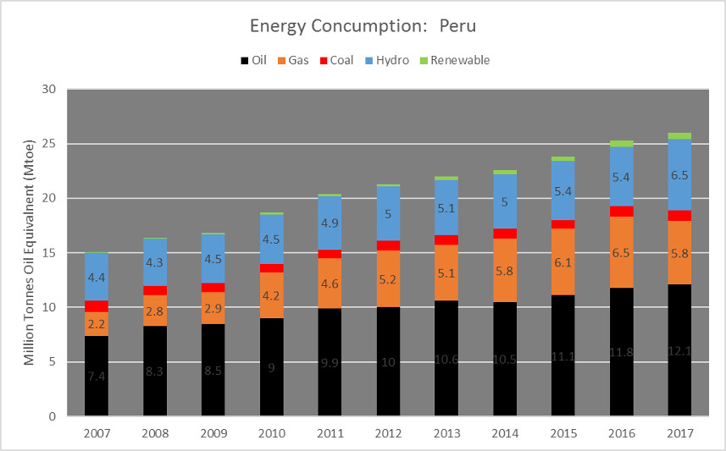

In the decade spanning 2007 to 2017, natural gas consumption in Peru increased steadily from 2.2 Mtoe to a peak of 6.5 Mtoe before falling back by about 11% to 5.8 Mtoe in 2017. During that time span, natural gas production rose even more markedly with supply being twice as abundant than demand. In contrast, the demand for oil outstripped national production by a factor of more than 2 in 2017. These latter two trends can be seen easily in the following energy deficit chart

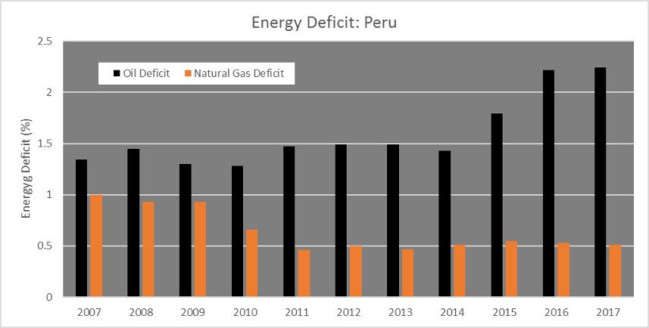

that shows the percentage of oil or natural gas consumed relative to the domestic production of the same.

The data demonstrate that Peru’s overall demand for energy has increased, that the demand for oil far exceeds domestic production, and that the demand for natural gas falls far short of the domestic supply.

Danmert argues that Peru should be using its own natural gas for domestic generation of electricity but that claim isn’t supported by additional details from the BP report. Peru’s electricity generation went from 29.9 Terawatt-hours in 2007 up to 52.5 Terawatt-hours in 2017, an increase of 1.8 times. Over this same time period, natural gas production went from 2.6 billion cubic meters to 13 billion cubic meters, an increase of a factor of 5. Assuming that all the electricity generation comes from natural gas consumption, there is still over a factor of 2.5 greater growth in natural gas production than there is electricity generation. And the story becomes even less in favor of Danmert when one considers that the South American regional percentage of electricity generation from natural gas is around 17% and that the world-wide maximum is 65% in the middle east.

Put simply, Peru produces more natural gas than exists a demand for it. Lima, the most populous city in Peru, where one out of every 3 Peruvians lives, is geographically close to the areas producing the natural gas and yet propane is the preferred method for running stoves, water heaters, and the like. The cost to refit Lima to be able to use the surplus natural gas is probably far higher than the benefit that would result. So, it is only natural for Peru to do what all members of an economy does, sells the surplus on the open market for money to buy goods in higher demand.

What to make of Damert’s accusations that Mezzano is a traitor? At best, his complaints amount to the ignorant ravings of an economically illiterate politician who argues on emotional ground. The fact that the excess natural gas is heading to Chile, a country Peru deeply hates, makes his objections take hold more easily, but even in the absence of that hot button item, his average listener may well fall into “why aren’t we using our resources to help our own” mentality that Bastiat warned against. At worst, one may suspect that Danmert is a demagogue who appeals to the prejudices of his listeners and depends on their economic ignorance to give him the cover he needs to use his influence to benefit his cronies. In either case, his arguments are as vapid and harmful as those that circulated in France nearly 180 years ago.