The inspiration for this month’s column came from a casual conversation about college football I had with my mom. She remembers the heady days of the 1950s and 60s before the NCAA became a multi-billion-dollar business. During some the course of that exchange, she expressed particular hatred for the Ohio State University because they always beat her favorite teams. Why I asked her why the Buckeyes always won, she answered with one of the most interesting and telling response: “I guess they paid their guys more than we did.”

I reflected on that remark for some time and realized the truth in the matter. Despite the fig-leaf of respectability that the NCAA tries to hide behind by keeping money away from college football while maintaining that the players are ‘student-athletes’, each university really does pay their players.

Here I’m not talking about the various recruiting scandals that have plagued the NCAA in the past. They are a natural outgrowth of the economics legitimately in play and I’ll discuss them later in their proper context. What really passes for pay are the reciprocal compensation that players receive from the university in exchange for their on-field talent and the sporting entertainment they deliver to the audience.

To illustrate this point let’s consider your average, high school all American linebacker being recruited for a spot on a college football team. To keep the argument compact and convenient, let’s suppose that there are only two teams in the running for Jack’s talent (the name of our linebacker is Jack for subtle reasons best left unsaid). The first team is that top tier football school Alabama University home of the Crimson Tide. The second team is Iowa University with its Hawkeye football program, which is a tier lower than Alabama’s (even if its academics are clearly a tier above).

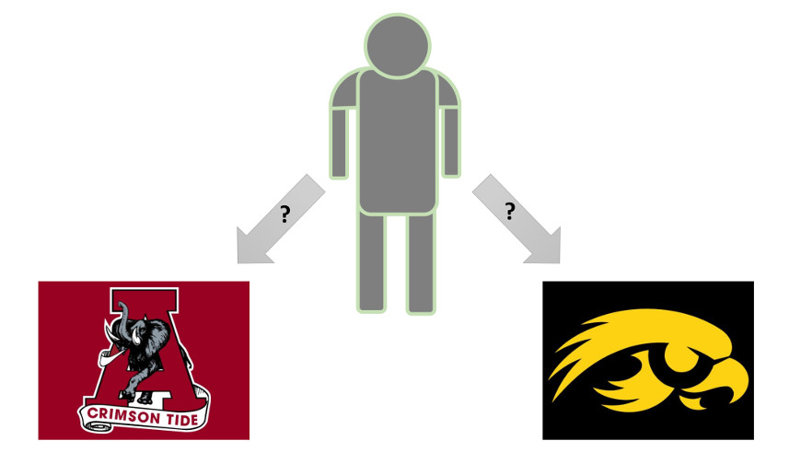

Consulting [ESPN’s online college football revenue/epxenses database](http://www.espn.com/college-sports/revenue) and current college rankings, one sees a direct correlation between the amount of revenue each school enjoys and the quality of their football program.

Revenue (2008) Outlays (2008) College Ranking

Alabama: $123,769,841 $123,370,004 1st

Iowa: $81,515,865 $71,602,594 21st

It is in the economic interest of each school to secure Jack’s attendance since the better the team the greater the revenue. The greater the revenue they each have the greater economic power they yield and college presidents and administrators love yielding power.

Given that it is a buyer’s market, how does Jack decide where to go? It depends on Jacks’ goal, aspirations, and dreams, but it is a safe bet to assume that the typical all-American like Jack is interested in the college limelight as a showcase for his talent. He wants to play for a team with a large national exposure; one which appears on television often; is nationally ranked in the poles; has a good chance at the national championship; and attracts the attention of NFL scouts. In this way, Jack maximizes his chances of receiving a lucrative professional football deal at the end of his rainbow. With this logic in hand, Jack examines the two programs and sees that Alabama is the place for him.

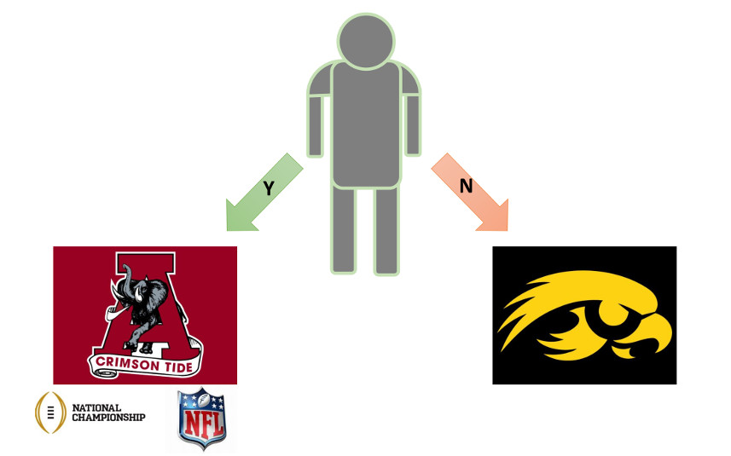

To the casual observer, this probably seems like a perfectly fine way of doing business. Jack and Alabama are a good fit for each other – Alabama has a top-flight football program always looking for great talent and Jack gets all the prestige associated with being able to yell ‘Roll Tide’.

But what about Iowa? The standard response is that they’ll be able to attract better talent once they start winning more decisively, becoming a recognized national powerhouse. But there is an obvious catch 22, how does Iowa become a national powerhouse without being able to attract talent?

In a free market scenario, when business B has weaker human capital compared to business A, Business B can improve its market position by hiring equal or better talent by recruiting them with better pay and/or benefits. In this scenario, Iowa could sweeten the deal for Jack, making a payout available today stand against or overshadow the possibility of a greater earnings in the distant future and serving as an insurance policy against injury. And since Iowa has a higher margin between revenues and outlay, it has a decisive advantage compared to Alabama.

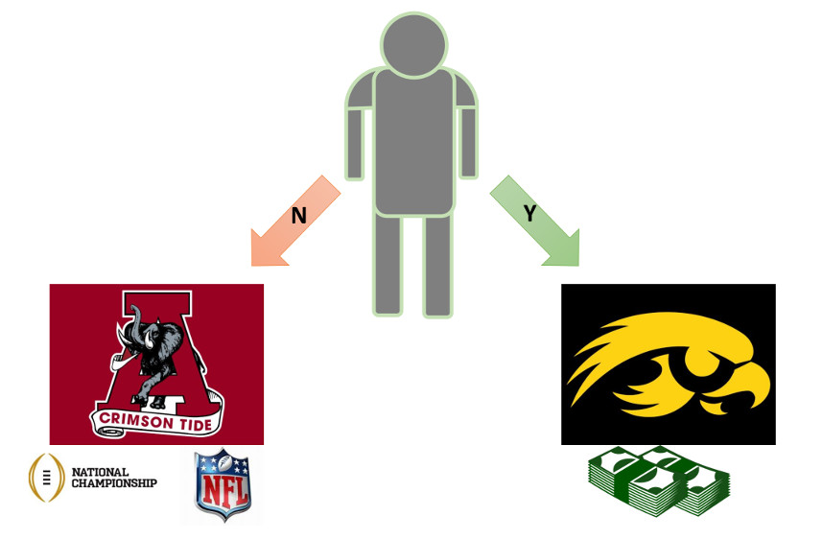

Unfortunately, the NCAA doesn’t implement a free market. Instead, if favors some and disfavors others. It erects facades of rectitude for public consumption and then feigns surprise and outrage when recruiting violations occur, but recruiting violations should be expected when so much is economically on the line and the desire for revenue runs so strong.

There is a direct parallel to the situation here and what happened under FDR’s wage controls during World War II. During the war, the businesses were forbidden to raise wages but they, nonetheless, found a way to compete with each other for labor by offering a host of fringe benefits that represented real economic benefit to their employees even if it wasn’t in the form of money. The opportunities and open doors to the NFL that Alabama provides is equivalent to the valuable but not-monetized fringe benefits. Iowa, who can’t offer these fringe benefits precisely because of their exclusive nature, can only compete by providing hard, cold cash but they can’t because of the NCAA rules. The only choice open to them is to provide some other type of benefit on the side. It doesn’t appear that Iowa had but other Universities have been known to provide all sorts of ‘side benefits’, which one can learn about with the simple search string ‘college football recruiting scandals’.

These rules violations happened precisely because different organization were tried to level the playing field at all costs and because the NCAA was economically illiterate in failing to recognize that prestige is a form of capital. Now I am not saying that one should boycott the NCAA or protest for fundamental change. All I’m suggesting is that next time you sit down to enjoy college football, especially during the holidays, consider the pros/cons of the free market and the problems that inevitably arise when governing bodies seek to suppress it.