The Blog Wyrm staff had an occasion to travel to southern climes in the month of April and while on our adventure in the deep south we encountered an incredible phenomenon: a [Buc-ee’s](https://en.wikipedia.org/wiki/Buc-ee's). For those who don’t know (like we didn’t), Buc-ee’s is a convenience store but a better description would be an amusement park masquerading as a convenience store, country store, gas station, apparel and outdoor goods store. There is perpetual bigger-than-life atmosphere that is reminiscent of going to Disney World. To explain this point-of-view, let’s look at some of the photos our staff took in our visit to Buc-ee’s.

First the traffic was backed up on the exit ramp from the highway to the parking lot.

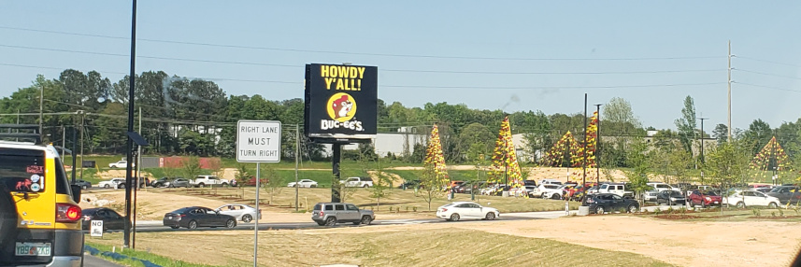

The only available spaces were far from the front door



and we expected to have to wait for a shuttle to drive us from our spot to the entrance. The scale of the gas station was immense

and everywhere there were colorful, cartoon-like characters to amuse children ages 1 to 100.

Also, the pay scale for the employees was both generous and freely advertised.

Inside, there was an incredible press of people in every direction, and queues for food, products, and the like were numerous. Parents were accompanied by children everywhere one looked. It was a far cry from just a convenience store.

Sadly, Buc-ee’s didn’t have much in the way of stimulating internet content but for that we can turn to this month’s columns.

When it first became known in 1902, Russell’s paradox shook the faith of many mathematicians that the foundations of mathematics could be shown as resting a logical base with no cracks. Years later, the math community has reached an uneasy détente with patches that have been made to set theory. But, as this month’s [Aristotle2Digital](http://aristotle2digital.blogwyrm.com/?p=1563) begins to explore in the first of a two-part series, the notion that the paradox’s reach is confined to academic pursuits and that the cracks that have been weakly patched are the parlance of the intellectual few is quite wrong. The roots of Russell’s paradox spring from the very way we all think.

A common guiding theme in economics is the notion of incentives that lead all sorts of unintended consequences. As we get a sense of perspective on the March spate of bank failures, inevitable questions start to emerge as to what messages are being sent by the government response to the demise of SVB and Signature Bank. [CommonCents](http://commoncents.blogwyrm.com/?p=1143) presents some very uncomfortable indications that the bailouts of the depositors who suffered by these events may be doing more harm than good.

One of the most ubiquitous macroscopic physical phenomena is the notion of friction. Frictional forces, at familiar human scales, result in the loss of mechanical energy and the creation of heat – in other words the transfer of bulk momentum into disorganized microscopic motion. For fluids, this transfer manifests itself as viscosity. This month, [UndertheHood](http://underthehood.blogwyrm.com/?p=1949) continues its tour of kinetic theory showing how the mean free path and molecular motion relate to the viscosity of a gas. Along the way, some interesting and nonintuitive effects are explained and a good time is had by all (although not quite in the same way as at Buc-ee’s)

Enjoy!